■ Listening ☐ Speaking ☐ Reading ☐ Grammar ☐ Writing

Topic: Money can buy happiness

Instructor:  Kim Hayoung(Karen) | Level:  Low Intermidiate | Students:  10 | Length:  30 Minutes

Materials:

- Audio clip (Money can buy happiness)
- Debate Worksheet
- Listening Worksheet
- Vocabulary worksheet
- Image of person with money (Eliciting)
- Image of Cambridge University library

Aims:

Main aim- Student will improve in listeining by listening worksheet

Secondary aim- Student will learn how to open discussion and think of their opinion by debate worksheet

Personal aim- Student will learn vocabulary buy answering vocabulary worksheet and listening worksheet

Language Skills:

Listening- listening worksheet (Fill in the blank), listening classmates opinion
Speaking- Debating and comparing their thoughts, comparing answers within groups
Reading- Reading the script after fillinf the blank
Writing- Writing student own opinion by debate worksheet

Language Systems:

Phonology- listening the pronunciation from audio clip
Lexis- Vocabulary used in Money can buy Happiness
Grammar- writing on debate worksheet
Fuction- Critical thinking about money can buy happiness
Discourse- Group discuss by debate worksheet

Assumptions:

1. Some students might know well about the topic
2. Some students don’t agree that money can buy happiness
3 Students already know what to do when they receive the worksheet.

Anticipated Errors and Solutions:

- (problem) If the times running out, shorten the discussion time
> (solution) cut-off plan

- (problem) If the time is enough,
> (solution) tell them to make sentence using vocabulary

- (problem) If student have hard time to think the plan
> (solution) provide the example for them.

References:

Auditory & script : http://bit.ly/2A3kwpT

Lead-In
Materials:
- Picture of person with moeny

Time | Set Up | Student Activity | Teacher Talk
2min | Whole class | Looking at the picture and discuss what person doing in the picture | Good afternoon everyone!  How is your day?  If you have money what will you buy?  How do you feel when you buy something?  Elicit  (show an image to students )  What do you see in the picture?  What does he doing?  Today, we will listen to the audio about “Money can buy happiness.”  But first, let’s learn some vocabularies.

Pre-Activity
Materials:
- Vocabulary worksheet

Time | Set Up | Student Activity | Teacher Talk
3mins  1mins  5mins | Whole class  Whole class  Whole class | Answering vocabulary worksheet  Check the answer  Listening and guessing Teacher’s gesture | I. Vocabulary  (Distribute Vocabulary worksheet)  Please work individually and complete the crosswords below. You have 2minutes.  CCQ  Who are you working with?  How much time do you have?  II. Compare the answer  Times up! Lets check the answers together  What’s the answer number 1?  (Ss: Cambridge University)  Number2?  (Ss: Happiness)  Number3?  (Ss: Personality)  Number4?  (Ss: Spending)  Number5?  (Ss: Good and service)  Number6?  (Ss: Spending Habit)  III. Understand Vocabulary  For number 1, This is library in Cambridge University.  (Showing image of Cambridge University library)  For number 2, what emotion gives you when you got a present?  (Ss: Happy, Excited)  For number 3, what kind of personality do you have?  (Ss: shy, artistic, imaginative, energetic)  For number 4, what do we spend in our life?  (Ss: money, time )  For number 5, where can we get god and service?  (Ss: in the restaurant, supermarket, grocery, department store)  Number 6, what do we spend your money on? For me, I spend money on exercising.  How about you?  (Ss: beauty, medical, gadjet, shopping)

Main Activity
Materials:
- Audio
- Listening worksheet (Fill in the blank)

Time | Set Up | Student Activity | Teacher Talk
4mins  4mins | Whole class  Whole class  Individually  Pair | Listening and get the reason.  Listening the clip and Answering listening worksheet  Correcting the answer | I. Listening for the main idea  Put your pens down and listen to the audio. Lets think why money can buy happiness.  CCQ  Can you take down notes?  What supposed to think about?  (Play clip 1)  II. Listening for the details  This time, please try to fill out the blank as much as possible. Work individually.  (distribute listening worksheet to students)  (Play clip 2)  Do you want to listen again?  (-yes: one more  - no: check the answer with students they filled out)  Now compare the answers with your partner  (Let students check the correct answers)

Post Activity
Materials:
- Debate worksheet

Time | Set Up | Student Activity | Teacher Talk
4mins  4mins | Whole class  Individually  Whole class | Debate  Writing on Debate Worksheet  Discussion and sharing | I. Discussion with partner  Do you think that money can buy happiness or not? Write 3 reasons why or why not. Write down your own opinion. You have 2 minutes.  Demonstration  Let me give you my opinion each reason.  “I think Money can buy happiness because money can get luxurious items”  “I think Money can’t buy happiness because money doesn’t buy time.”  CCQ  Who are you working with?  What do you wirte on the worksheet?  (students have discussion with their patner and write down 3 reasons each)  II. Discussion with group  Can anyone share your partner’s opinion?  Yes, ______. Please share your partner’s opinion.  How about the others?

SOS Activity
Materials:
- (n/a)

Time | Set Up | Student Activity | Teacher Talk
3mins | pair | Making sentences with new vocabularies | Can you tell me new voacbularies we learned today?  Let’s make your own sentences with these voacbularies.  Choose two voacbulraies and make one sentence each voacbulary.  Demonstration  For example we can make a sentence using the word ‘Happiness’  “When I receive a gift, it gives me happiness.”  CCQ  How many vocabularies do you choose to make sentences?

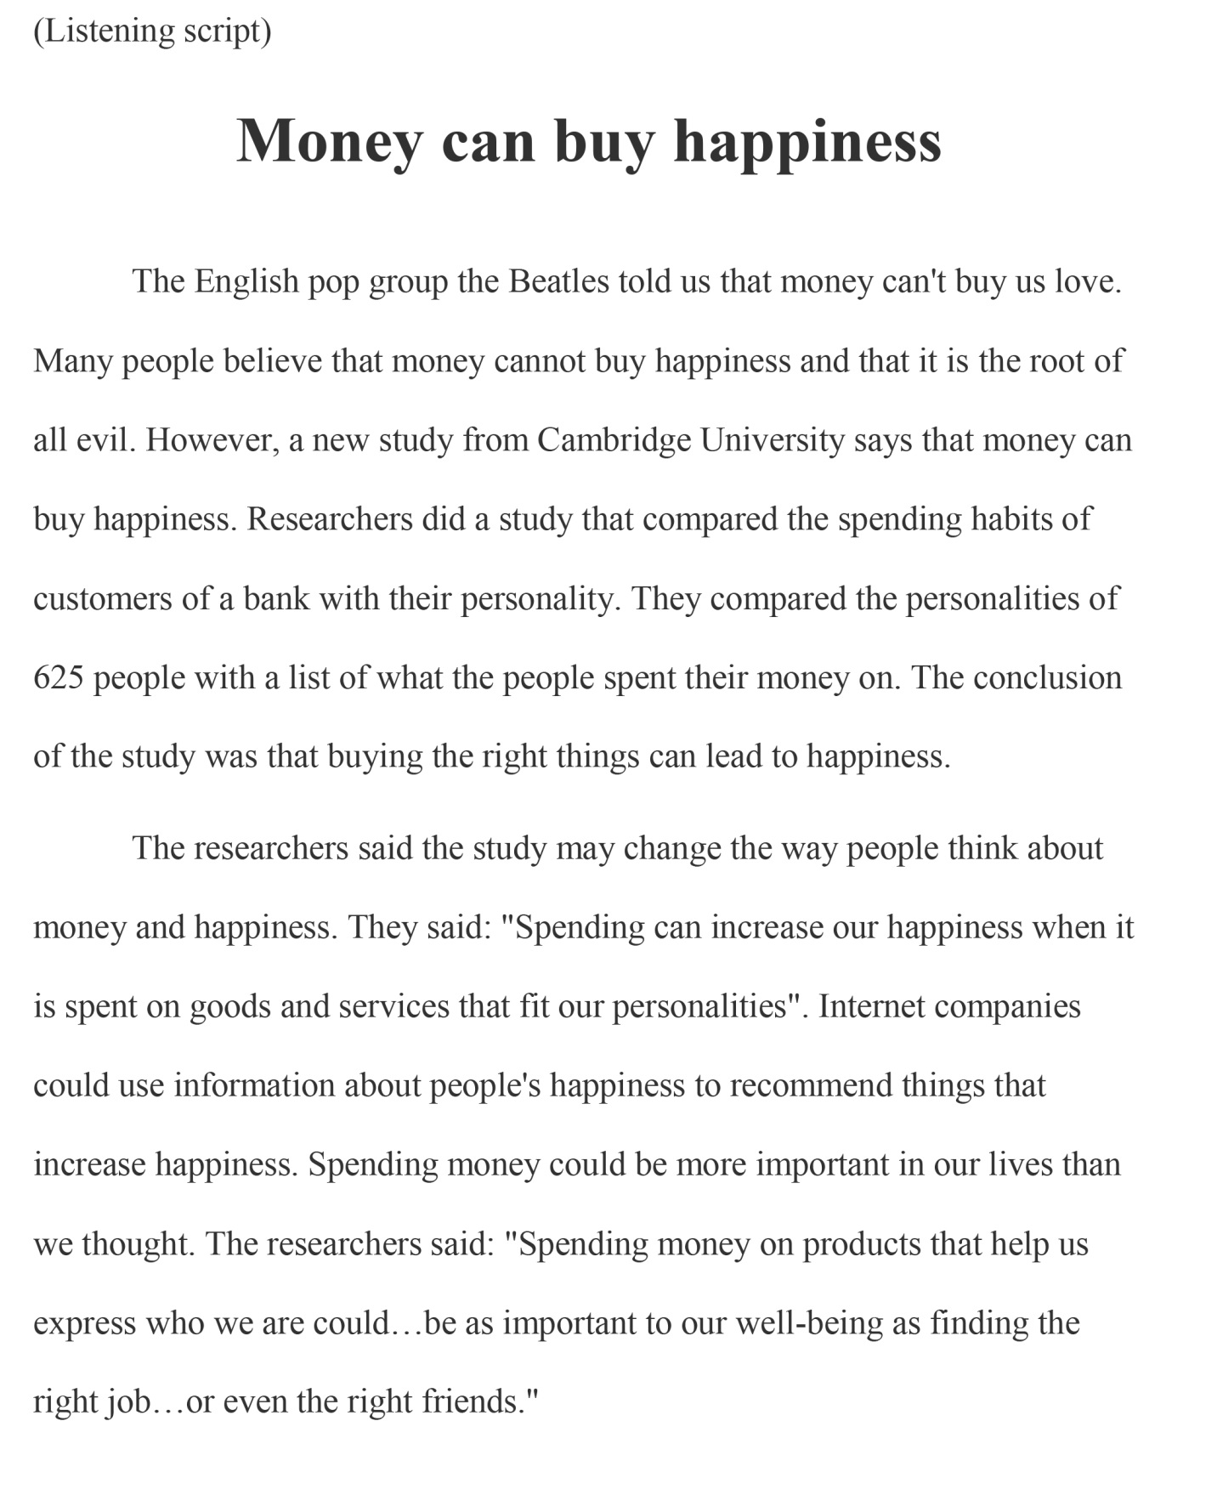
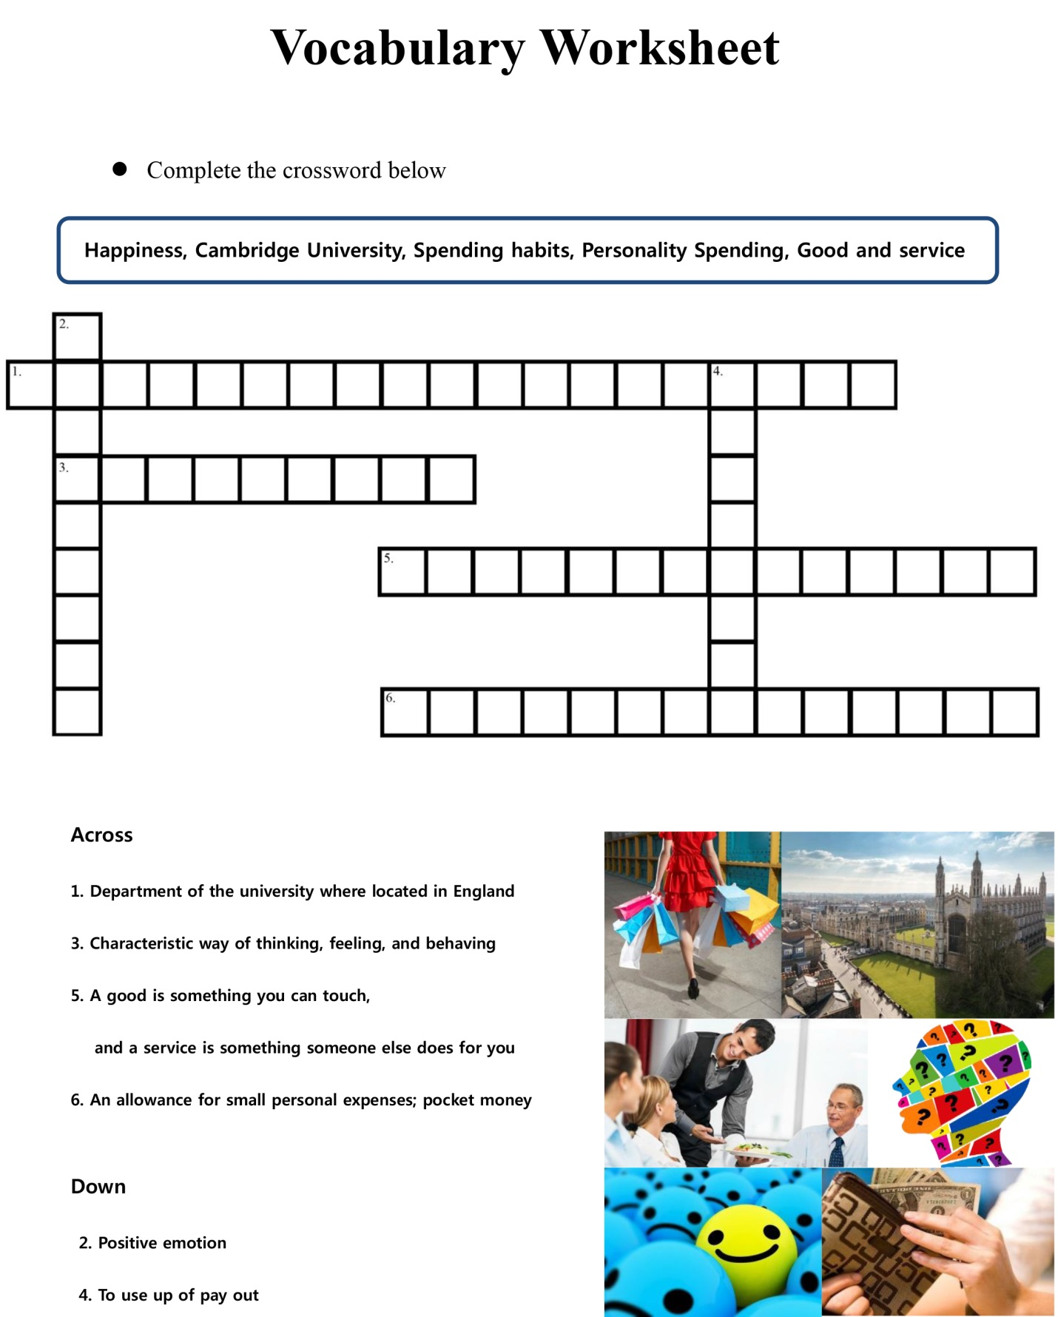

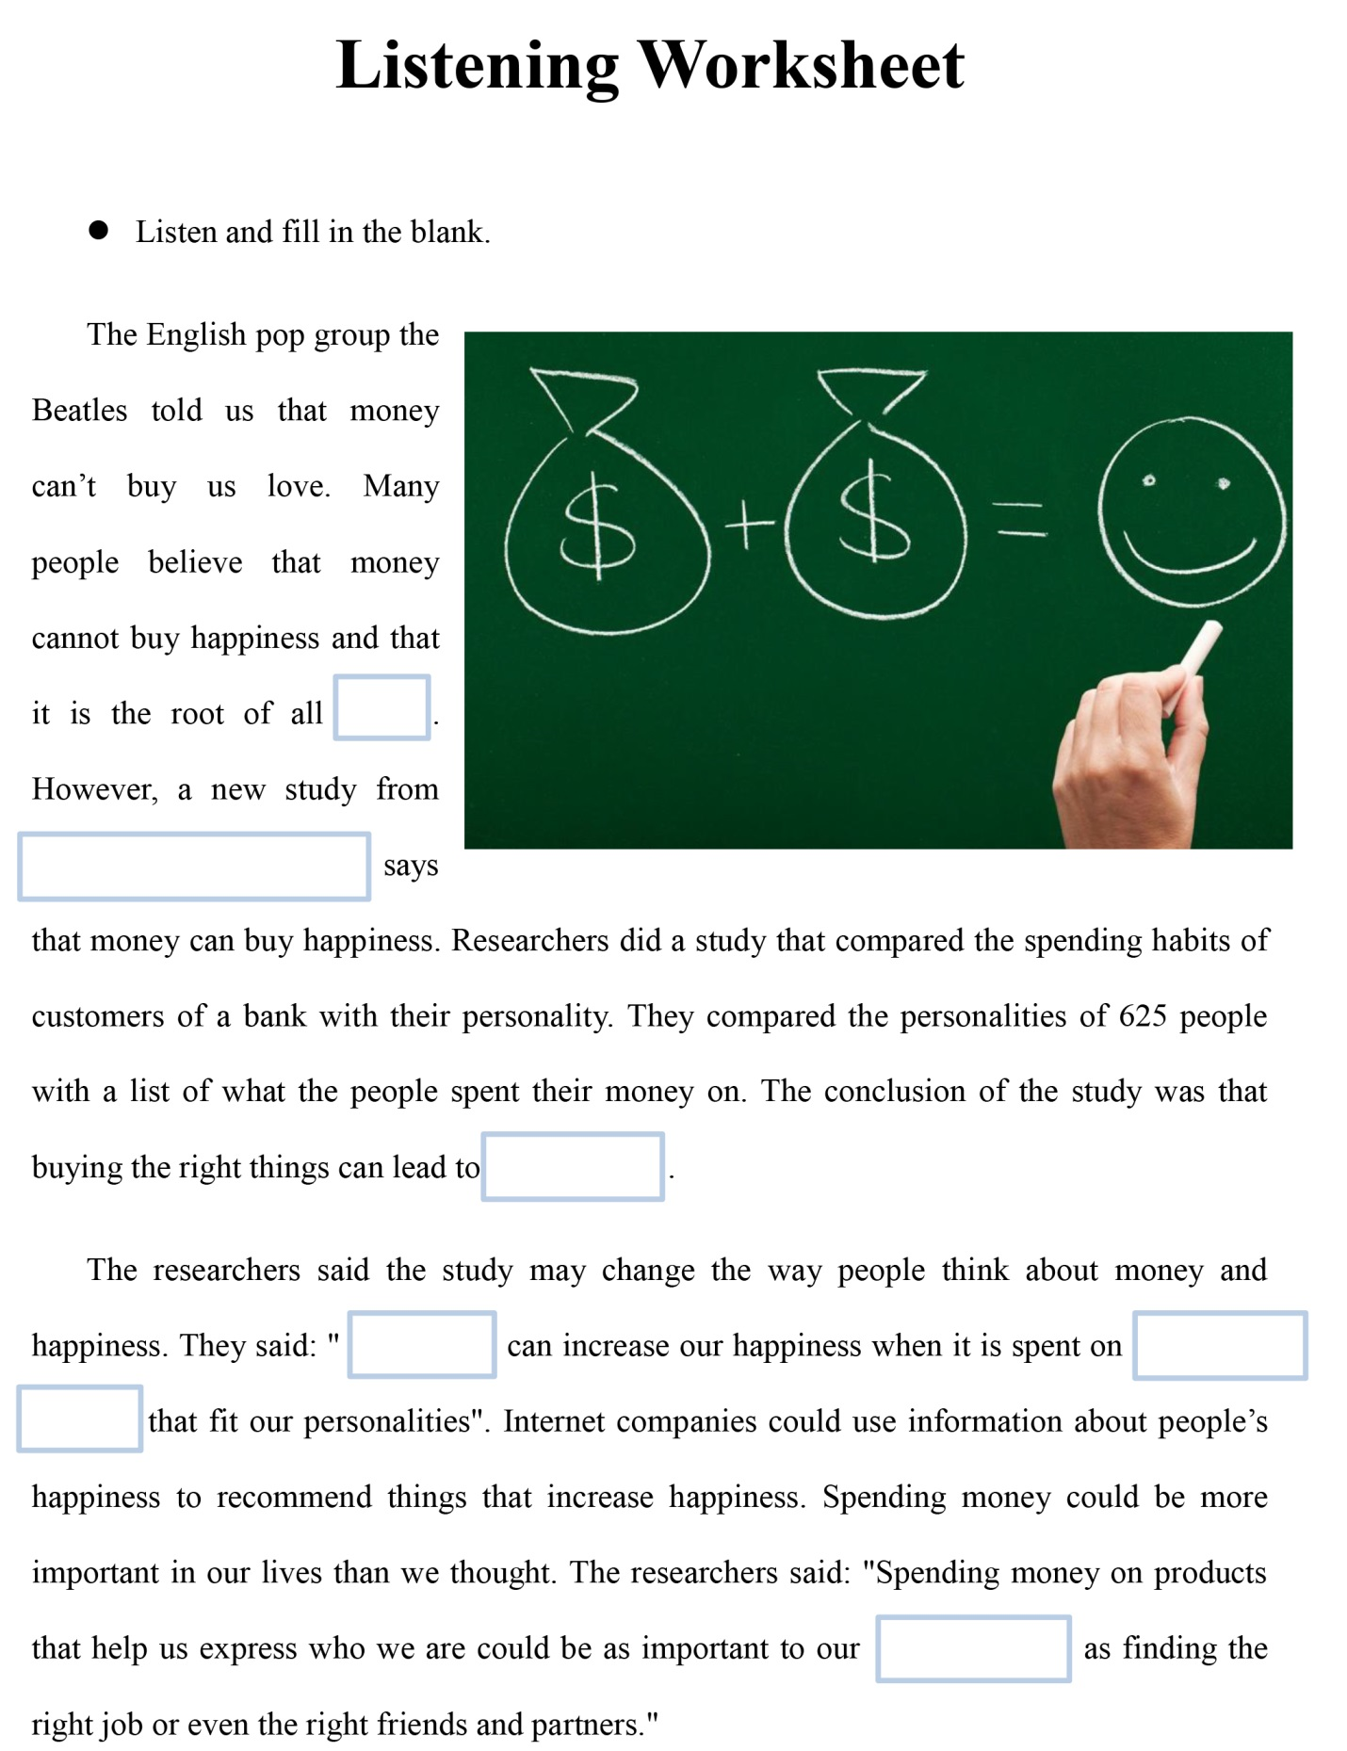
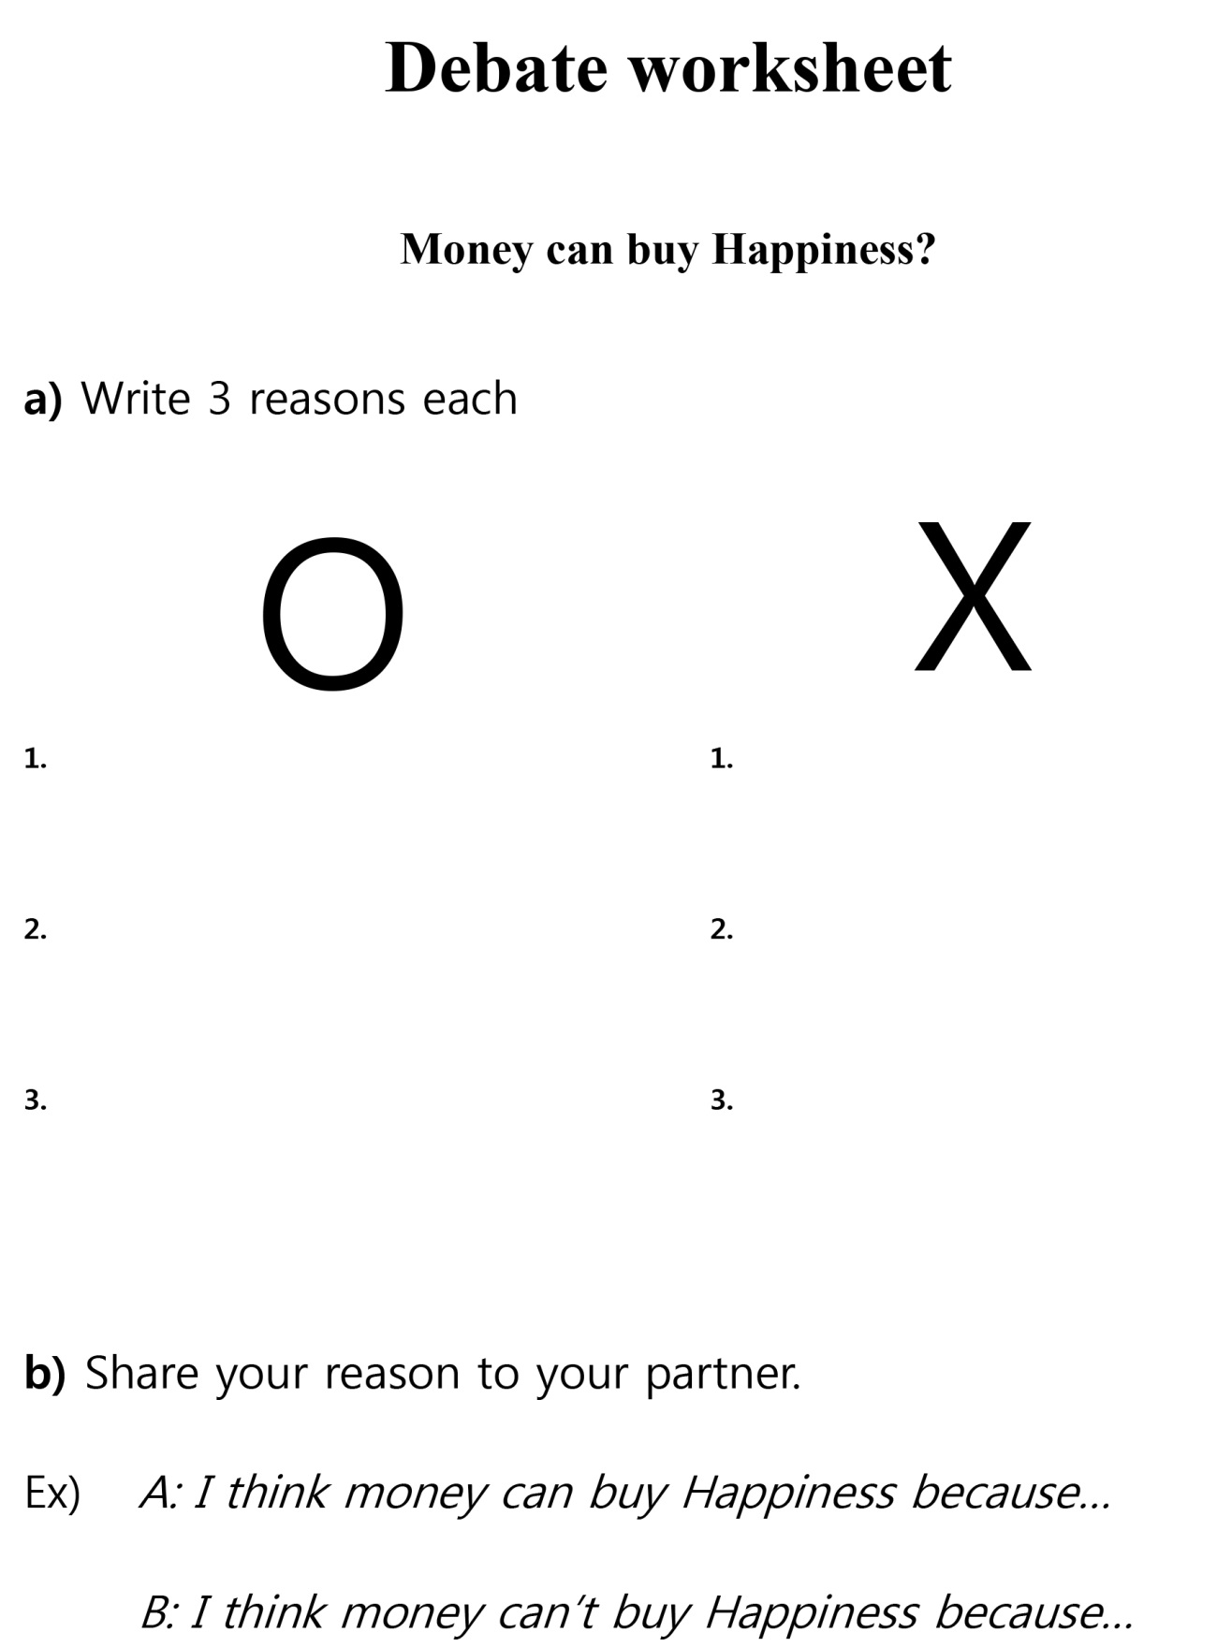
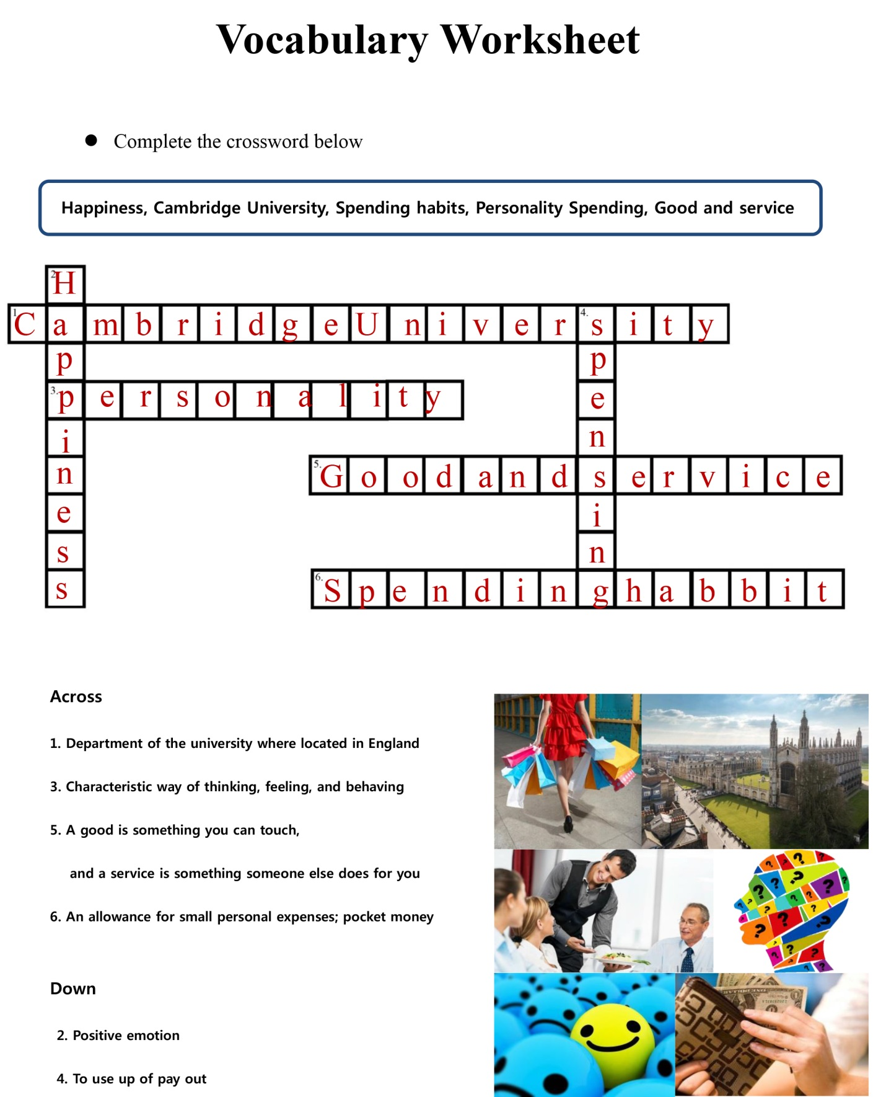
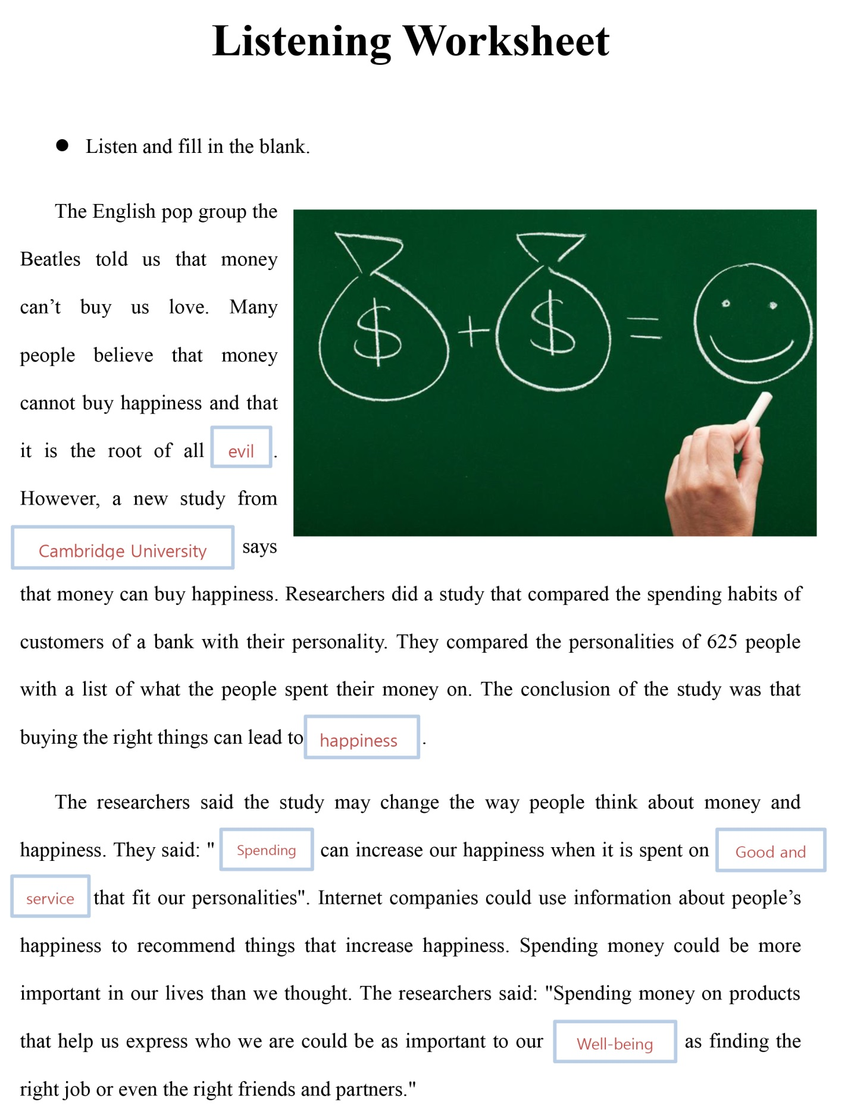
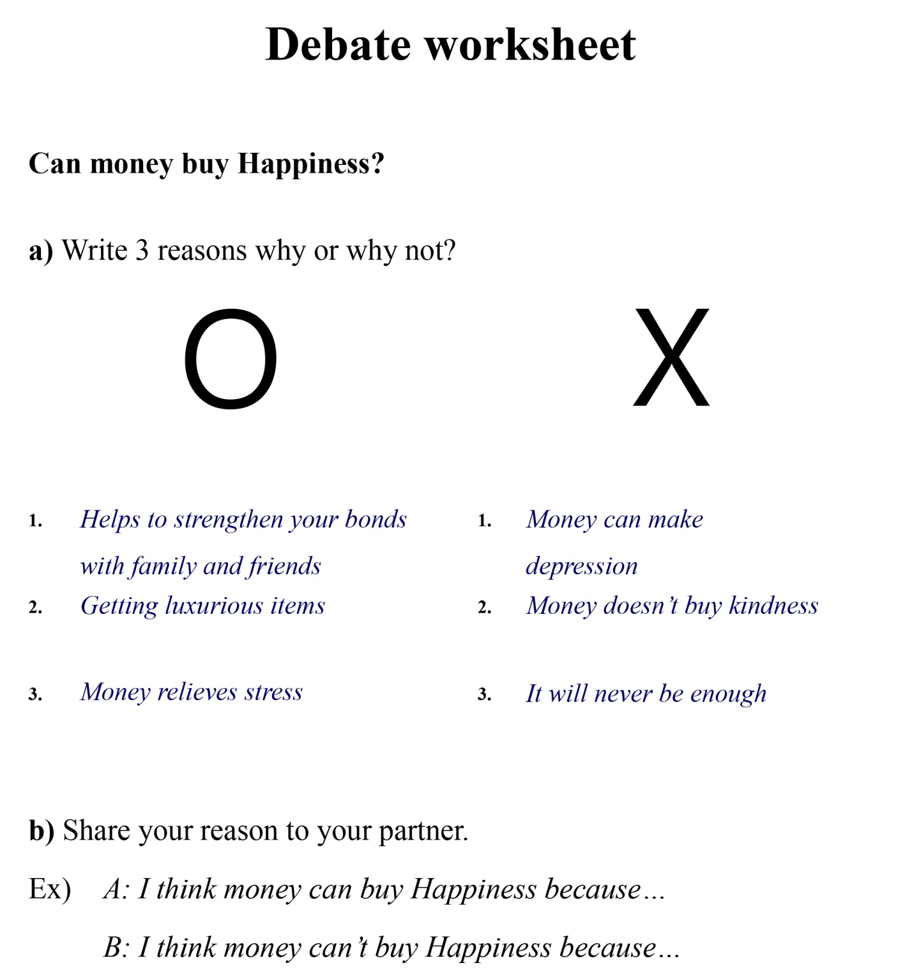

****Include all materials here at back of plan!
(including pictures of all pictures, flashcards, realia, audio scripts, worksheets & worksheet answer sheets etc)

Good luck
*^^*

