163th WK TESOL
Annie / Seonju Oh
Listening Lesson Plan

■ Listening ☐ Speaking ☐ Reading ☐ Grammar ☐ Writing

Topic: Personality

Instructor:  Annie /Seonju Oh | Level:  Intermediate | Students:  10 | Length:  30 Minutes

Materials: The poster of movie intern
Five word cards
ScotchTape
A white board
A picture about trustworty
Pictures about hip
Intern worksheet1,2
Intern movie clip
Intern audiofile
(SOS plan) Describing character work sheet

Aims:

Main aim
-Students will understand speakers personality by listening some part of movie, Intern.

Secondary aim
- Students will find out their personalities by writing sentences about themselves in the Intern worksheet 2.
- Students will be able to describe their personalities by doing the Intern worksheet 2.
- Students will be able to pronounce some words corretly by repeating after the teacher.

Personal aim
- The teacher will be more confident following the lesson plan.

Language Skills:

Listening-Listening to the movie clip and audio
-Listening to other people’s personality sentences.
Speaking-Sharing about personality sentences with the class.
Reading-Reading the questions on the Internworksheet1
Reading the instruction in the Internworksheet2.
Writing-Answering the questions in the intern worksheet1
Writing personality sentences about students themselves

Language Systems:

Phonology- -ed ending pronunciation eg) Be challenged[d], be needed [id]
Lexis-Personality adjective eg) Loyal, Trustworthy, eager…
Grammar- The more~, the more eg) the more I think about this idea, the more
tremendous I think it is
Function-Presenting oneself
Discourse- video cover letter to apply to a company

Assumptions:

1 Some students know the movie Intern
2 Students know some vocabulary of personality
3 Students can write and speak English with some errors

Anticipated Errors and Solutions:

- Students may not complete three sentences in four minutes when they are doing the Intern worksheet 2
> Stop students if they have completed one or more sentences.

- Students may not be able to think of anypositive personality about themselves while doing the intern worksheet 2.
> Ask students questions that draw some adjectives.
Eg. Do you help others often?/Do you work hard?/Do you
consider others much?
- Students may be too shy to share their sentences in the class.
> Encourage them to share only one sentence.

References:
https://goo.gl/4j5REJ
https://goo.gl/TrL5Hv
https://goo.gl/Vovfsa
https://goo.gl/7v7UKD
https://goo.gl/yibfuJ
http://www.yourdictionary.com/

Lead-In
Materials: The poster of movie intern
Time | Set Up | Student Activity | Teacher Talk
2mins | Whole class | Students answer | Hellow everyone, how are you?  Do you like watching movies?  What’s your favorite movie?  Have you seen movie called intern?  (showing the poster)  Intern is one of my favorite movies.  There are lots of good expressions in this movie and of course Robert De Niro is awesome.

Pre-Activity
Materials: Five word cards
ScotchTape
A white board
A picture about trustworty
Pictures about hip
Time | Set Up | Student Activity | Teacher Talk
6mins | Whole class | Repeat after the teacher  Talk about the word tremendous  Repeat after the teacher  Talk about the word loyal  Repeat after the teacher  Talk about the word trustworthy  Repeat after the teacher  Talk about the word hip  Repeat after the teacher  Talk about the phrase | Before we watch the movie clip, let’s learn some vocabulary.  I. Vocabulary  Elicitation and Presentation words  1.tremendous  Does anyone have ideas about this word?  ‘Tremendous’  (read the word)  repeat after me please (read it again)  (show the word card and attach it on the board)  Any idea?  (write what students say on the board)  Ok, I will give you some example sentences so that you can guess the meaning  (write example sentences on the board)  And for better understanding, I will show you this  (draw a diagram on the board)  2.Loyal  Next word is ‘loyal’  (read the word)  repeat after me please (read it again)  (show the word card and attach it on the board)  Do you have any ideas about this word?  (write students say on the board)  Alright, can you guess what is synonym for loyal?  It is faithful  And here are some examples with loyal.  3. Trustworthy  The third word is ‘trustworthy’  (read the word)  repeat after me please (read it again)  (show the word card and attach it on the board)  Do you have any ideas about this word?  (write students say on the board)  Good, look at this picture. It will give you some ideas what trustworthy feels like.  And some the synonyms are …..  4. hip  The fourth word is ‘hip’  (read the word)  repeat after me please (read it again)  (show the word card and attach it on the board)  I know you know the hip as a part of you body, but this is not the same one.  This is adjective.  Can you think of anything?  Okay, see this pictures and example sentences here.  (Show the pictures and write example sentences on the board)  People who are hip dress trendy and some of the may go Iytaewon, Gangnam, Clubs.  The fifth one is ‘positive about’  (read the word)  repeat after me please (read it again)  (Show the word card and attach it on the board)  If I say ‘I am positive about that’ what does this mean?  Some examples, to understand better, are here (write the example sentences on the board)  CCQs  -Do you believe what trustworthy person says?  -If I say “I will go to the party tonight. I’m positive about that”, can you see me at the party?

Main Activity
Materials: Intern worksheet 1
Intern movie clip
Intern audiofile
Time | Set Up | Student Activity | Teacher Talk
14  mins | Pairs  Whole class  Groups  Whole class | Students answer the teacher’s questions.  Watching the video clip  Students answer the question.  Listening the audio  Writing the answers on the intern work sheet1.  Listening the audio  Saying the answers  (1st~4th students answerT/F  5th student answers Q no.2  6th student answers Q no.3  7th student answers Q no.4  8th~10th students answer Q no.5)  Saying some other adjectives | I. Listening for the Main Idea  Before we watch the video you have one more thing to do.  (Distribute the Intern worksheet 1)  Instruction  Look at the picture and answer the first two questions on the Intern worksheet1. You can work with your partner.  ICQs  -Who do you work with?  Work with a partner  -What will you do?  Answering the questions  T: It seems most of you are done. So, can you tell me what he is doing?  Have you experienced a job interview? Was that in Korean or in English?  Good.  Now, we are watching a short movie clip and I want you to think about what he is doing and why he is doing this while you are listening.  (Play the videoclip)  Did you get the idea what he is doing and why?  Yes, the man is applying to a senior intern program and the company asked him a video cover letter instead of paper one. This is a part of his cover letter.  II.Listening for details  Instruction  Now, I am going to play only audio so that you can concentrate on listening. And this time I want you to focus on details and anwer to the question no.3 to 7 in the Intern worksheet 1. Don’t look at the questions yet.  ICQs  -What number of questions you should answer?  3 to 7  -Do I play movie clip or audio?  Audio  (play the audio)  I will give you 5 minutes to answer the questions. You can work with your group.  (grouping-3 or 2 people in a group)  Everyone seems done. I am going to play the audio one more time. If you have answers unsure, you can listen more carefully that part.  (play the audio)  okay, from here, tell me one answer each on the intern work sheet.  (point the very left student)  (When students say the question no.5, write the adjectives students say on the board)  Can you think of any other adjectives you can descibe your positive personalities?  Tell me more please?  Think about yourself, what adjective can describe yourself?  I think we have enough list of adjectives for next activity

Post Activity
Materials: Intern work sheet 2
Wallposter of personality adjectives
Time | Set Up | Student Activity | Teacher Talk
8mins | Individauls | Writing sentences  Sharing(speaking) the sentences | I. Production  Instruction  And now, I want you to write three sentences about yourself using the adjectives that you just mentioned.  (distribute the Intern worksheet 2)you have 4minutes to write.  Demonstration  Look at the sample examples on the Intern worksheet 2. Can you read it please?  ICQs  -How many sentences you are suppoed to write? Three  -What words you should use in the sentences? Personal ajectives that we mentioned  Good, you have 4minutes  Does everyone has at least one sentence?  From here(point the very right-side person) share sentences with the class.  Great.  I think this is enough for today.  II. Feedback  Do you have any questions?  What was the useful part today?  What was the most difficult part?  I hope you to grab some vocabulary when you go out this room.

SOS Activity
Materials: Describing character work sheet

Time | Set Up | Student Activity | Teacher Talk
6mins | Pairs  Whole class | Find the characters and write it in the right blank.  Check the answers | Since you have a little more time, let’s do a small acivity.  (distribute the Describing character worksheet)  I.Completeing the blanks  Instruction  Read people talk in the speech bubles and find which word from the box is suitable for each person. You can work with your partner.  CCQs  -Where do you find the words?  In the box  -Where can you find what the people talk?  In the speech bubles  You all seems finished.  What is the first persons charater?  (Check the answers 1 to 12 with whole class)  Ok, you are done today.  II.Feedback  Do you have any questions?  What was the useful part today?  What was the most difficult part?  Thank you very much. Have a nice day

Movie Intern Listening script
*About 50 seconds

So here I am, applying to be one of your interns because the more I think about this idea, the more tremendous I think it is.

I love the idea of having a place I can go every day.

I want the connection, the excitement.

I want to be challenged, and I guess I might even want to be needed.

The tech stuff might take a bit to figure out.

I had to call my 9-year-old grandson

just to find out what a USB connector was.

But I'll get there. Eager to learn.

Also, I want you to know I've been a company man all my life.

I'm loyal, I'm trustworthy, and I'm good in a crisis.

And I love that you're right here in Brooklyn.

I've lived here all my life, and lately I feel

I may not be hip enough to live in Brooklyn, so this could help with that, too.

I read once, musicians don't retire.

They stop when there's no more music in them.

Well, I still have music in me, absolutely positive about that.

Tremendous

Loyal

Trustworthy

Hip

Positive about

Pre-activity/Word presentation

1.Tremendous
- Example: He is a tremendous basketball player, the best I've seen in years.
It was a tremendous movie, I will never forget it.
- Synonyms: excellent, splendid, wonderful, marvelous, magnificent superb, sulime

Tremendous
Excellent
Good

2. Loyal
-Example: She is loyal to her family
Why should I be loyal to a company that pays me the lowest wage possible?
Carolyn remained loyal to her husband even after he cheated on her, and she refused to consider
a divorce.
Kirsten has always been a loyal friend, and would never do anything to hurt me.
-Synonym: allegiant, constant, faithful, fast, firm, liege, staunch, steadfast, true

3. Trustworthy
-Example: The population is estimated at about 1000, but no trustworthy data are available.
He is trustworthy, you don’t need to recheck his work.
-synonym: trustful, believable, accurate, always there, all right, convincing

4. Hip
Hip-hipper-hippest
-Example: a group of hip miami teenagers
The hippest club in town.
He is just trying to be hip.

5. Positive about
-example: he is going to say something I am positive about that
It was him. I saw him take it. / Are you positive about that?

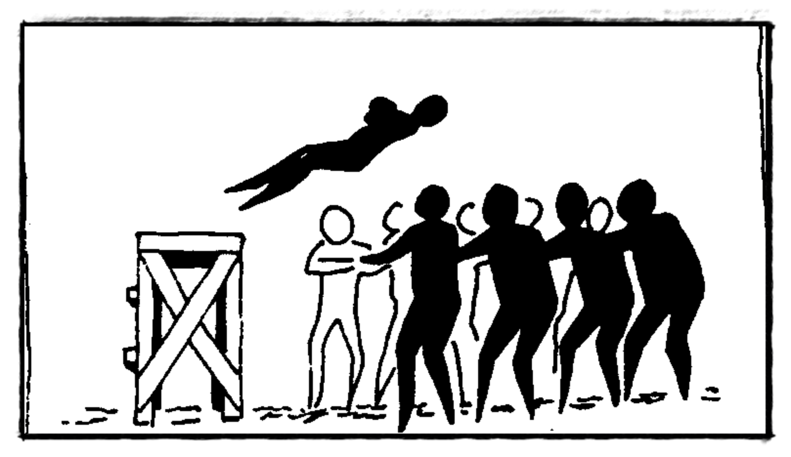
Trustworthy

These are hip people

Listening: Intern Work sheet 1

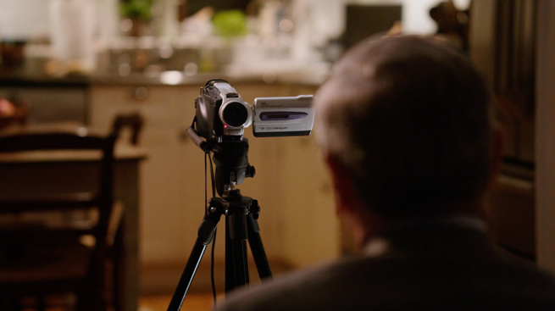

Before you watch the video, look at the pictures and answer the questions
(Work with your partner)

- What is he doing?

- Have you experienced a job interview in Korean and in English?

_ _ _ _ _ _ _ _ _ _ _ _ _ _ _ _ _ _ _ _ _ _ _ _ _ _ _ _ _ _ _ _ _ _ _ _ _ _ _ _ _ _ _ _ _ _ _ _ _
After you listen the audio, answer the questions.
(Work with your partner)

- True / False
- He wants to be challenged T / F
- His grandson is 9 years old T / F
- He doesn’t know what a USB connector is now T / F
- He is a musician T / F

- Why is he applying for an internship?

- How is he feeling?

- Would you apply for a senior internship after you retire, and why?

- What other adjectives can be used in a cover letter?

Adventurous | - The island attracts adventurous travelers.
Ambitious | She was ambitious, driven by her need for power.
Creative | Creative is the quality of a unique painter.
Calm | The night was calm and fresh.
Careful | Please promise me you will be extra careful, though?
Communicative | One of the attitudes, syn) communicable
Diligent | diligent is a worker who always stays late to get projects done on deadline.
Determined | Determined is a voter who goes into a voting booth knowing exactly who they'll be voting for.
Enthusiastic | someone enthusiastic is a child eagerly awaiting her first trip to Disney
Energetic | Energetic is a person who works at full speed for 12 hours a day.
Generous | generous is a small business giving their employees an end of year bonus.
Optimistic | a person who believes that he will get a promotion and that everything will turn out alright.
Sincere | a friend who helps you without an expectation of you doing something for them in return.
Sociable | A friendly little town with lots of opportunities for social activities is an example of a sociable town
Listening: Intern Work sheet 1-Answer sheet
- Recording video
- Yes/No
- T/T/F/F/
- He loves the idea of having a place he can go everyday
Or He wants the connection, the excitement.
Or He wants to be challenged, and needed
- He is excited
or comfortable taking the video,
or nervous etc…
- I would apply for a senior internship after I retire because…
Or I wouldn’t apply because…
- Kind, honest, funny, brave, calm, Easygoing, Friendly, hard-working, humorous, Energetic, Generous, Intelligent, Patient, Intelligent

Listening: Intern Work sheet 2

1. Write 3 sentences about yourself using some adjective you wrote down on the worksheet 1 (Think about what I should write in my resume)

• Example: I am trustworthy, so you can trust my work.

1.

2.

3.

2. Share what you wrote with your classmates.

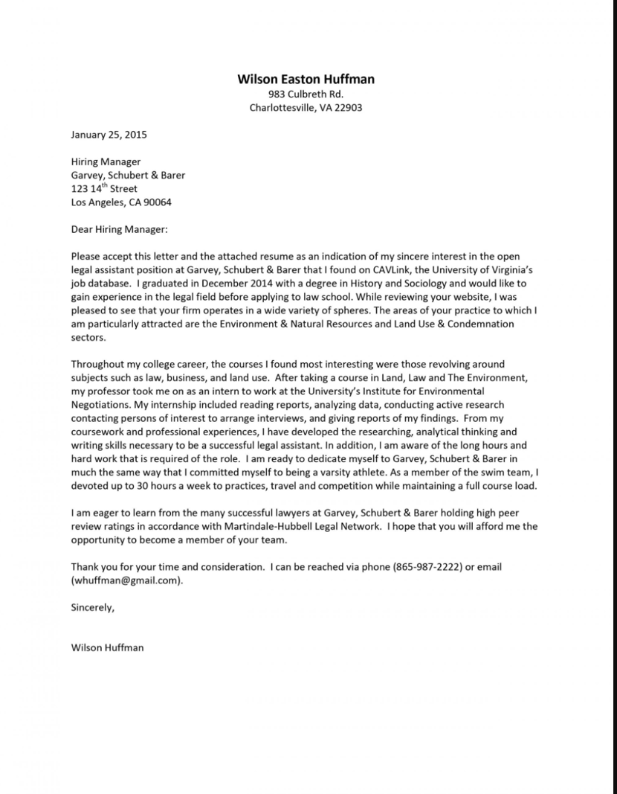
<Real cover letter looks like this>
I am trustworthy, so you can trust my work.

Listening: Intern Work sheet 2 – Answer sheet

- I am diligent, so I am never late for work and done my work on deadline.
- I am energetic so that I can work along time sometimes.
- I am a patient person, so I can endure many difficulties and problems.
- Etc…

Describing Character worksheet

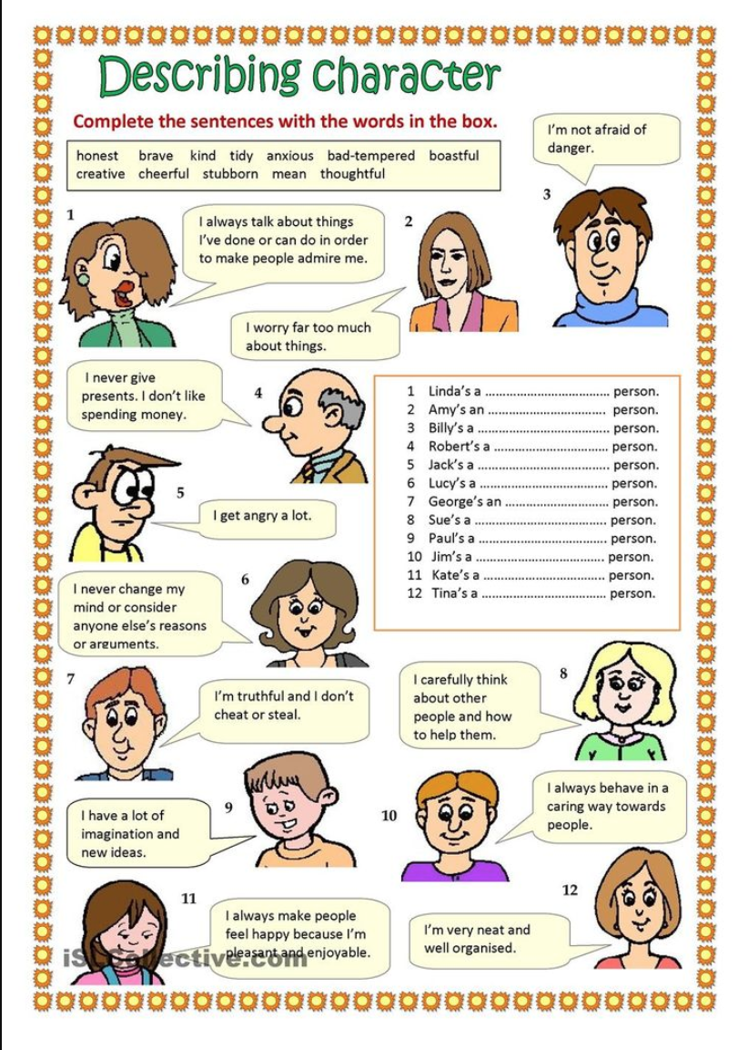

Describing Character worksheet – Answer sheet
- Boastful
- Anxious
- Brave
- Mean
- Bad-tempered
- Stubborn
- Honest
- Thoughtful
- Creative
- Kind
- Cheerful
- tidy

