☑ Listening ☐ Speaking ☐ Reading ☐ Grammar ☐ Writing

Topic: Leaves, stems, and roots

Instructor:  Belle | Level:  Intermediate | Students:  10 | Length:  30 Minutes

Materials:

- Audio file , speakers and computer
- Worksheet1 10 copies(vocabulary matching)
- Worksheet2 10 copies(Dictation & Summarization)
- Worksheet3 10 copies(Q & A and Discussion)
- Worksheet4 10 copies(word puzzle for SOS activity)
- A plant(realia)

Aims:

Main aim - Students will develop their listening skill by doing activities with worksheet
(vocabulary matching, Dictation & Summarization,
Q&A and Discussion)

Secondary aim - Students will improve their speaking skill while they work together,
and will be able to have a chance to build a relationship each other

Personal aim - To make Students feel confident and comfortable through the the lesson

Language Skills:

Listening - Students listen the audio
Speaking - Students speak while they question and discuss each other
Reading - Students read the script and worksheets
Writing - Students write their question and sentences on their worksheets

Language Systems:

Phonology- Plants, Roots, Transports 'ts' consonants
Lexis - Transport, Support, Hold, Absorb, Produce, Function
Grammar - Simple present ( formed by using the root form or
in the third person singular the verb always ends in -s)
Function - Get to know the knowledge of General science
Discourse - Discuss, Q & A, casual dialogue

Assumptions:

1 Students know about the three words of the title
2 Students are able to work in pairs
3 Students enjoy doing activities

Anticipated Errors and Solutions:

- If students don't know about the words of title,
- Give them time to guess , checking their understanding and explanation
- If students don't understand the instructions of each worksheet,
- Give them time to explain each other, and explanation
- If students didn't finish on time(listening, doing activities)
- Let them know to finish, If possible give them time to finish

References: https://youtu.be/B7wv4yVYrN4

Lead-In

Materials: A plant (realia)

Time | Set Up | Student Activity | Teacher Talk
1-2  min | Whole  class | Ss : Hello, Hi~, etc  Ss : 'good', or etc  Ss : 'yes', 'no', etc  Ss looking at a plant  Ss tells their thoughts | Procedure  Greeting (warm up, eliciting)  Hello, everyone  How are you feeling today?  (listening their answers, give feedback)  Have you seen plants today?  (in your home or on your way to here)  We're going to look at a picture for a moment.  (panning a plant for the students  to look at it)  Have you thought about their bodies  before?  (feedback)

Pre-Activity

Materials: 10 copies of worksheet (vocabulary matching)

Time | Set Up | Student Activity | Teacher Talk
6 min | whole  class  individually  whole  class | Ss are looking at their worksheets(vocabulary)  Ss : 'yes' or ...etc  Ss : answers may vary  Ss are doing their work  Ss are checking their worksheets together | Procedure  Today, we're going to listen about the plant Before listen, Let's learn some new vocabulary  (Hand out worksheet)  - vocabulary matching  Vocabulary  There are several words on the worksheet. Do you see that?  Instructions  You're going to match the word with the right meaning  You can draw a line.  Work individually  You have 3 minutes.  ICQ  Are you working with your partner?  What are you going to do?  (If Ss don't know well, give them time to explain each other, and explanation)  Now, Start now  (give them time to do)  OK. please stop.  Now let's check out your results together.  (check all the answers orally with the Ss)

Main Activity
Materials: Audio file , speakers and computer,
10 copies of worksheet(Dictation & Summarization)
Time |  | Set Up |  | Student Activity | Teacher Talk
14  min |  | whole  class  individually  whole  class  individually  paris |  | Ss : 'yes' or etc  Ss : answers may vary  Ss looking at their  worksheets  Ss : answers may vary  Ss do their worksheet  while they're listening  S : 'yes' or etc  Ss share their answers  and compare each other | Procedure  1. Listening to main topic  Instructions  Now, we're going to listen about the functions of the three parts of the plant  Do you know the three parts of the plant?  (Eliciting) Can anyone tell us?  First, I'm going to give you this  (Hand out worksheets)  -Dictation & Summarization  Look at the worksheet  There are several gaps on your worksheet  while you are listening the audio  you're going to fill the gaps(Dictation)  Do it individually  ICQ  What do you have to make? and how?  Are you going to do it with your partner?  (If Ss don't understand, give them explanation, checking their understanding)  Now, let's listen to the audio  Play the audio file  (Listening...)  Now this time,  I'm going to play the audio once again  2. Listening for details  Instructions  You're going to make a summary with what you hear from the script  (Summarization)  There are four statement about the script  You can make the statements with the words in the box right side on your worksheet  Do it individually  ICQs  What are you going to do with the words of the box?  Are you going to do with your partner ?  (If they don't understand well, give them explanation)  Now you may start now  (give them time to do)  O.k Did you finish it?  You're going to check your answers  with the person next to you  (sharing their results)  O.k  You have heard about the functions  of the three part of the plant  (Lead into the post activity)
Post Activity
Materials: 10 copies of worksheet(Q&A and Discussion)
Time | Set Up |  | Student Activity |  |  | Teacher Talk
8 min | whole  class  individually  individually  pairs  pairs  whole class  pairs |  | Ss : What is it, or etc  Ss are looking at their  worksheets  Ss : answers may vary  Ss are making questions individually  Ss are exchanging their worksheets and answering their partner's question by handwriting  Ss are checking their answers together  Ss are making a position  (face to face)  Ss start to discuss with their partner  Ss stop their discussion  Ss are sharing their ideas  Ss : Leaves, stems, and roots.  Ss : Their functions are...  etc  Ss : answers may vary  Ss are reminding the words by saying...  Ss : Bye or See you next time |  |  | Procedure  It's time to do another activity together  what do you think it is?(eliciting)  (give them time to answer)  Here, I'm going to give you this.  (Hand out worksheets)  -Q&A and Discussion  Instrucions  You're going to make your  own questions(for Q&A)  individually (based on the script)  After you made questions,  Exchange your worksheet (in pair) and  Answering your partner's questions by  handwriting  ICQs  What are you going to do first?  When you made a question, what's next?  (If they don't understand  give an explanation again  and checking their understanding)  Now, you may begin  (Give them time to make questions  individually)  If you made your question,  Exchange your worksheets for the Q&A  (Give them time to do the Q&A)  O.K. please stop everyone  Now you're going to check your answers  together  (Give them time to check their answers  together)  Now it's about time to discuss  You're looking at each other with your  partner,  Instructions  You're going to have a discussion  with your partner, about  which is the most important part of the  plants, and why do you think so?  Write your partner's idea on the  worksheet  CCQ  What are you going to discuss about?  You can start now  (Discussion)  (Give them time to discuss about)  O.k. please stop everyone  How was your discussion?  What was the most important function do  you think?  Was there any special idea about it?  Is there anyone who wants to share ?  (Sharing some ideas)  Close the activity  O.k Let's talk about today's topic again  What was the three part of a plant?  Leaves, stems, and roots  Feedback  What do you know about the each part of  the functions?  Elicit today's vocabulary  How many words did you learn about  today?  Why don't you remind those words with  meaning by list it verbally?  Good job everyone.  See you next time.  Close the lesson)
SOS Activity
Materials: 10 copies of Word puzzle
Time | Set Up |  | Student Activity |  |  |  | Teacher Talk
 | whole  class |  | Ss are looking at their paper  Ss : It's a puzzle game  Ss are doing puzzle game |  |  |  | Procedure  We have more time to do another activity  Now I'm going to give you a piece of  paper  (Hand out the worksheets)  -word puzzle  What is it?  Now, do your puzzle individually  (Give them time to do puzzle)  Did you finish it?  Let's check out the answers together  End

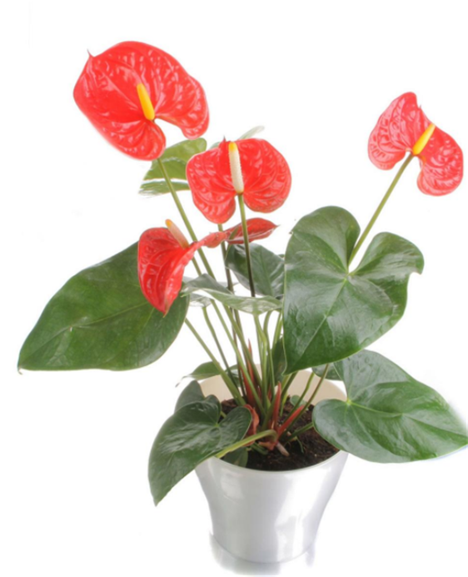

A photo of a plant

Script : Leaves, stems and roots

Objective : recognize leaves, stems and roots & know their functions.
flowering plants come in all shapes and sizes.
Most flowering plants have leaves, stems and roots.
These organs work together to keep the plant alive.
Leaves, Absorb energy from sunlight and make the plant's food.
The stem, Transports water and food, and supports the leaves and flowers.
The roots, Hold the plant in place and absorb water and minerals from the soil.
Flowers produce seeds so that the plant can reproduce.
In some plants, organs have extra functions.
for example the cactus, don't have leaves, they have spines instead for protection.
The stem takes over the job of making food and also stores water.
Some plants do not need some of the organs.
For example, plants that are parasites do not have leaves because
they do not produce their own food, they steal food and water from
other plants.

Here, content statement for today.
Leaves absorb sunlight and make food.
Stems transport water and food and support the leaves and flowers.
Roots hold plants in place and absorb water & minerals.
Flowers produce seeds for reproduction.

function · ·to keep something inside
a place

absorb · ·to make or to create

support · ·the useful thing that
someone or somethings
do
hold ·
·to help something or
someone
produce ·

·to take in, to soak up
store ·
·to take something to
another place

transport · · to keep something to use
Answer sheet Vocabulary matching

transport : to take something to another place

store : to keep something to use

produce : to make or to create

hold : to keep something inside a place

support : to help something or someone

absorb : to take in, to soak up

function : the useful thing that
someone or something's do

Dictation and Summarization
Dictation
Leaves, stems and roots
Objective : recognize leaves, stems and roots & know their functions.
flowering plants come in all shapes and sizes.
Most flowering plants have leaves, stems and roots.
These organs work together to keep the plant alive.
Leaves, ( ) energy from sunlight and make the plant's food.
The stem, ( ) water and food, and ( ) the leaves and flowers.
The roots, ( ) the plant in place and ( ) water and minerals from the soil.
Flowers ( ) seeds so that the plant can reproduce.
In some plants, organs have extra functions.
for example the cactus, don't have leaves, they have spines instead for protection.
The ( ) takes over the job of making food and also ( ) water.
Some plants do not need some of the organs.
For example, plants that are parasites do not have leaves because
they do not ( ) their own food, they steal food and water from
other plants.
Summarization
Leaves/absorb/support/roots/in place/produce/reproduction/stems/make food/hold/seeds
Making Four statement with above words based on the Script
1. Leaves
2. Stems
3. Roots
4. Flowers

Answer sheet Dictation and Summarization
Dictation
Leaves, stems and roots
Objective : recognize leaves, stems and roots & know their functions.
flowering plants come in all shapes and sizes.
Most flowering plants have leaves, stems and roots.
These organs work together to keep the plant alive.
Leaves, ( Absorb ) energy from sunlight and make the plant's food.
The stem, ( transport ) water and food, and ( supports ) the leaves and flowers.
The roots, ( hold ) the plant in place and ( absorb ) water and minerals from the soil.
Flowers ( produce ) seeds so that the plant can reproduce.
In some plants, organs have extra functions.
for example the cactus, don't have leaves, they have spines instead for protection.
The ( stem ) takes over the job of making food and also ( stores ) water.
Some plants do not need some of the organs.
For example, plants that are parasites do not have leaves because
they do not ( produce ) their own food, they steal food and water from
other plants.
Summarization
Leaves/absorb/support/roots/in place/produce/reproduction/stems/make food/hold/seeds
Making Four statement with above words based on the Script
1. Leaves absorb sunlight and make food
2. Stems transport water and food and support the leaves and flowers
3. Roots hold plants in place and absorb water & minerals
4. Flowers produce seeds for reproduction

Q & A and Discussion

You will make Questions according to the script

Q1.

A:

Q2.

A:

Q3.

A:
Discussion about~

Ⅰ. What is the most important part of the plants?
Ⅱ. Why do you think so ?

(There is no right answer of this activity)

Word Puzzle
(The functions of leaves, stems, and roots)
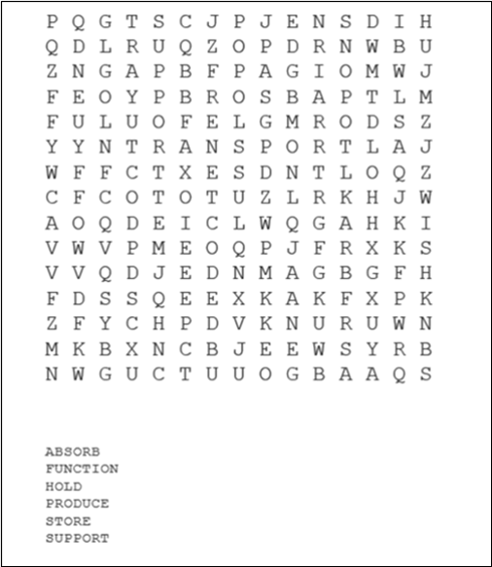

puzzle answer sheet
