☐ Listening √ Speaking ☐ Reading ☐ Grammar ☐ Writing

Topic: Travel

Instructor:  Alastor/Jess | Level:  Upper-intermediate | Students:  10 | Length:  30 Minutes

Materials:
- Realia (Luggage, Souvenir hat)
- Pictures of transportation(cruise ship, Hovercraft, hitchhike)
- 10 clean papers
- 5 Character cards
- Worksheets:
1. 5 copies of “My Friend is Coming” Brain Storming worksheets
2. 10 copies of “My Friend is Coming” travel planner worksheet
3. 1 copy of “Travel planner” worksheet for final plan
- Board
- Markers

Aims:
- Main aim: Ss will improve their speaking skills while they are planning travel Korea.
- Secondary aim: Ss will improve confidence to express their opinion by doing brainstorm and share ideas of travel plans in pairs/whole class.
- Personal aim: T will try to elicit more answers from Ss by asking questions in pre-task stage.
T will try to make Ss to correct errors by themselves(self-correction)

Language Skills:
- Reading: Read instructions and questions on discussion worksheet.
- Listening: Listening from other student’s answer about discussion questions.
- Speaking: Students will give opinions to others while they are doing discussion.
- Writing: Doing brainstorm of Travel.

Language Systems:
- Lexis: Luggage, Transportation, Souvenirs, Budget-holiday, Waterfront
- Function: Suggesting plan
- Discourse: Giving opinions for Travel plan and sharing ideas with classmates.
- Grammar: Future Tense(eg. We will visit~, we will eat~ etc)
- Phonology: Listening from other Ss and T. [eg. Wh sound from asking questions]

Assumptions:

- Ss have experience making travel plan.
- Ss already know traveler’s attractions in Korea
- Ss may already know most of vocabularies in discussion.

Anticipated Errors and Solutions:
- Ss might not finish discussion in pair
- T will give extra 1 or 2 minutes to finish.
- If the class finish earlier than expected
- T will give Ss SOS activity

References:

Movie clip: https://goo.gl/Uf6KhM
character carts: https://goo.gl/owc3u8

Pictures: Transportation
    - Cruise ship: https://goo.gl/HAqPB1
    - Airplane: https://goo.gl/jBo6Hq
    - Train: https://goo.gl/FdSaZa
    - Bus: https://goo.gl/JQxBLF

Pre-task
Materials:
Board and Markers
Time | Set Up | Student Activity | Teacher Talk
5mins | Whole  Clsss  In pair | Greetings  Ss will see short movie clip and draw Mind-map | Procedure:  Greetings  Hello everyone. How are you today?  Did you go somewhere in this summer holiday?  (Ss answers)  Do you know where I have been?  I have been to China and met my friends. One of them is my best friend and he made every detailed plan for me. I was very impressed.  Introduction of task  (write on the board “Travel”)  T: Today, we are going to make a plan to travel Korea. Let’s guess that your foreigner friend is visiting you next month. And we will all going to travel together. Each group has different friends.  How can you make a plan?  Do you know any traveler’s attraction in Korea?  What do you need for traveling Korea?  I will play a video and you can think about what you will see, eat and where to visit with your friend.  Here I will give you a piece of paper, please draw a mind map with your partner what is coming up in your mind when you hear a word “Travel”.  You have 5minutes  (T distribute mind-map worksheet)  CCQ:  - Are you working alone?  (in pairs)  - What are you going to do?  (draw a mind map of travel)

Task Preparation
Materials:5 character cards, board, marker, photos of transportation, realia( hat, luggage)
Time | Set Up | Student Activity | Teacher Talk
10 mins | Whole  Class | Ss will guess meaning of words and answer by eliciting from teacher. | Procedure:  Instruction  T: as I informed already, each group have different foreign friends are visiting Korea soon, now let’s think about travel plan.  Here is your friend’s detail. Do not share your friend’s detail with other group.  (Distribute friends detail to Ss)  Your plan will be depend on your friend’s detail.  Discuss with your partner important things for your foreign friend’s travel  You have 3 minutes.  Do not write.  CCQ:  - Are you working alone?  - Are you sharing your friend’s information with other group?  Before we make a detailed plan for traveling, I will introduce you some vocabularies.  Vocabulary  1.Souvenir  (write ‘Souvenir’ on board)  T: has anyone heard of this word? Can you tell me what it means?  (Ss answers)  Yes, this is something which you buy or keep reminding you of a holiday, place, or event.  This is what Jess bought from Vietnam as a souvenir.  CCQ:  - Where can I buy souvenir?  - What do you normally buy for souvenir?  2.Transportation  T will put photos of different types of transportations(bus, train, airplane, cruise ship)  T: do you know what are they?  (Ss anwers)  Yes, these are what we called transportation.  Transportation refers to any type of vehicle that you can travel in or carry goods in.  CCQ:  - What transportation do you usually take?  - What transportation you need to take to visit Jeju island  3.Waterfront  T: I will draw a picture on the board if you know this word, please say loud.  (T will draw pictogram of waterfront)  (If Ss say waterfront, T will explain)  Waterfront is a street or piece of land which is next to an area of water, for example a harbour or the sea.  CCQ:  - Can you find waterfront in Seoul?  - What can you do in the waterfront?  4.Budget holiday  (Ts will do role play)  A: let’s go to Europe for this summer holiday.  B: well I don’t have much money to go with you.  A: ok then, what is your budget? Jeju island is ok?  B: sorry I don’t have enough money.  A: hm…ok. Let’s go to Han liver.  B: thank you, I have enough money for that!  Ss will understand while they are seeing T’s role play.  CCQ:  - Who does have enough budgets for traveling Europe here?  - Who have to go budget holiday?  5.Luggage  T will show realia to Ss.  Do you know what is this called?  (Ss answers)  This is what we called luggage.  Luggage is bags that you are carrying when you travel.  Ok, Now we are going to next stage  CCQ:  - How many luggages do you carry for your holiday?  - Do you know how many luggages you can bring into the airplane?  OK then, Let’s make a detailed plan

Task Realization
Materials: 5 copies of “My Friend is coming” travel planner worksheets, board, marker, T’s note for taking errors of Ss
Time | Set Up | Student Activity | Teacher Talk
7 mins  10 mins | In pair  Whole class | Ss make a detailed plan for their friend.  Ss will make a whole class travel plan by doing discussion | Procedure:  1.Make a Plan!  Instruction:  (T distribute “My friend is coming” travel planner worksheet to Ss)  Ss will write their plan on travel planner for their friends. Ss will consider friend’s character when they make plan. Groups will not share their friend’s character card with other group.  Ss will have 7 minutes.  T: Now I will give you travel planner. You will work in pair to make a travel plan for your friend. Write your plan on worksheet. When you make a plan, please consider your friend’s character. You will not share friend’s character card with other group.  I will give you 7 minutes.  ICQ:  - Can you share your friend’s character card with other group?  - Do you have 5 minutes?  After 7minutes, T will stop Ss:  If they finish: move on to next stage  If they did not finish: T will give 1 or 2 more minutes  Ok, Now we will have whole class discussion.  2.Make a Plan!(whole class discussion)  Instruction:  (T will distribute 1 copy of Travel planner)  Ss will have group discussion. They will try to make their friend happy by putting their planned schedule.  Class captain will write whole class travel plan while they are discussing about plan.  T: Here is travel planner for whole class. As our whole class will travel together, now you will discuss with other groups to make a final class travel plan.  Every group has different friends’ characteristics. So, when you discuss with other groups, you need to try to make your friend happy.  (As your friends have different characteristic, every groups will have different plan)  You have 10 minutes to discuss to make a final plan.  While you are discuss, class captain will write final plan on worksheet  So, let’s do it!  ICQ:  - Do you work in pair?  - Are you traveling with your friend only?  Please share final plan in class.  Great!  Let’s move on to the next stage.

Post Task
Materials: Board and Markers.

Time | Set Up | Student Activity | Teacher Talk
3mins | Whole  Class | Share opinions about the activity | 1.Feedback  Did you enjoy today’s activity?  2.Language focus(error correction)  Error correction (T will correct Ss’ error referring teacher’s note taken during Task realization. T will write Ss’ error on board.  T will not correct directly and ask Ss to correct them(self-correction)  T: While you were discussing, I could find some errors.  (T will write errors on board)  What is wrong with this?  (Ss will answers and do self correcting)  T: I hope you have enjoyed and learnt from Travel discussion that we have done today  See you tomorrow!

SOS Activity
Materials:
Travel Planner worksheet
Time | Set Up | Student Activity | Teacher Talk
5min | individual  In pair | Ss make a detailed plan for family holiday individually  Ss will share their plan in pair | Instruction  Make plan for your family travel for 2nights 3days. Ss will make a detailed plan for travel location, accommodation, activities, time etc.  When they finish Ss will share the plan with partner.  T: Imagine that you are going to family travel for 2nights and 3days. Make a detailed plan. What do you need to do? You need to plan accommodation, activities, time and etc. you have 5 minutes and once you finish, please share it with your partner.  CCQ:  - Are you making plan alone?  - What are you doing when you finished making plan?

5 Characters Cards
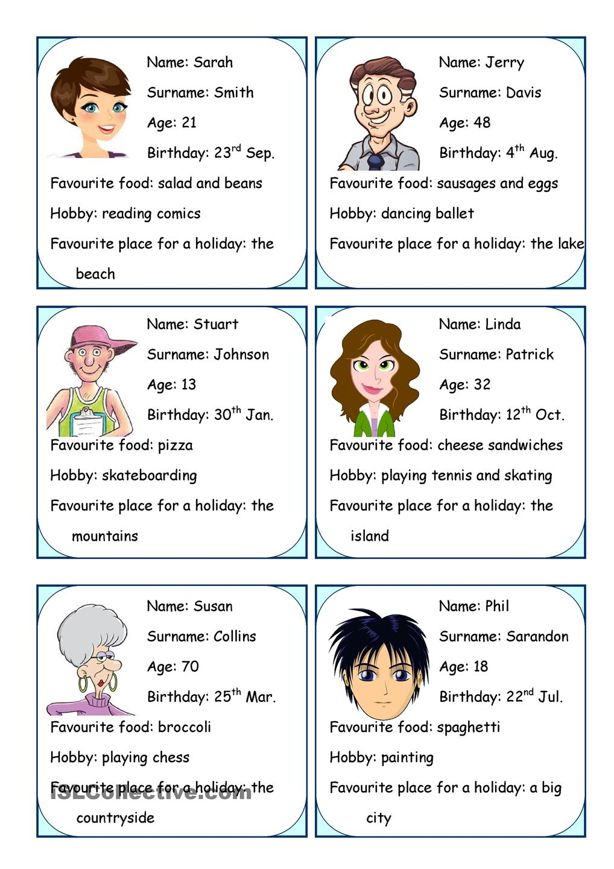

“My Friend is Coming” Brain Storming worksheets

- Brainstorming your ideas for travel

Pictures
Cruise Ship

Airplane

Bus

Airplan

Train

Realia (Hat)

Luggage

Luggage

