☐ Listening ☑ Speaking ☐ Reading ☐ Grammar ☐ Writing

Topic:
Should students wear uniforms in school?

Instructor:  Belle, Sophia | Level:  Intermediate | Students:  8 | Length:  30 Minutes

Materials:
- Board & markers
- School uniform picture
- 8 copies of the “Students should wear uniforms in school.” debate worksheets
- 8 copies of the clothes wordsearch worksheets
- 8 cards of Pros and Cons
- Realia (magnifier)

Aims:

Main aim- Students will encourage speaking fluency by “Students should wear uniforms in school.” debate task.

Secondary aim- Students will be confident by giving their opinions for debate.

Personal aim- Teacher wants to follow the Lesson Plan.

Language Skills:

Speaking- Debating each other about the topic

Listening- While students debate, they can listen each other carefully

Reading- When Ss read the worksheet.

Writing- Students write their idea about the topic in the debate worksheet.

Language Systems:

Phonology- agree, disagree ‘ee’ long [ i ] sound
- I don’t think so ‘think ‘ [ θ ] sound
Lexis- Debate words (eg. Pros and Cons, evidence…)
Grammar- I agree VS I disagree (explaining some common thoughts by simple present tense)
Function- Presenting the idea to express the opinion
Discourse- Debating

Assumptions:

1. Ss know the teacher’s style of teaching.

2. Ss know they should speak only English in the class.

3. Ss are confident with group work.

4. Ss already understand the structure of debate

Anticipated Errors and Solutions:

- If Ss speak their L1
– Encourage them to speak English

- If Ss need more time to finish the debate (Cut-off plan)
– Stop the debate and then choose the winner.

- If Ss finish their activity early (SOS plan)
– Give Ss the clothes wordsearch worksheet

References:

- Card for Pros and Cons : https://goo.gl/risaSW

- Clothes wordsearch worksheet (SOS) : www.bogglesworldesl.com

Pre-task
Materials:
- School uniform picture
Time | Set Up | Student Activity | Teacher Talk
2min | Whole Class | Greeting | Hello everyone. How are you today?  (Show the picture of School uniforms)  Have you ever worn the school uniforms?  When did you wear the school uniforms?  How do you think about wearing uniforms in school?  (Elicit from students)  (Let Ss talk about their experience.)  OK, Let’s move on to today’s keywords.

Task Preparation
Materials:
- Board & Markers
- Vocabulary Pictures
- Realia (magnifier)
Time | Set Up | Student Activity | Teacher Talk
6min | Whole Class | Vocabulary | T : Before we debate the today’s topic, let’s learn some new vocabulary.  1. Vocabulary  T : Repeat after me.  “pros” and “cons”  Show the picture of the words.  What do you think about this picture?  (Elicit from students)  (Let Ss talk about that)  “pros” means a good point like strengths.  “cons” means a bad point like weaknesses.  T : Repeat after me.  “evidence”  (T: Miming explanation).  T: Can you guess what we are doing? (Elicit)  “evidence” means… Finding a fact for your opinions and something that makes clear.  T : Repeat after me.  “arguments”  Show the picture of the word.  Ts show some actions about the arguments.  T1: I like this. It’s my style.  T2: I don’t agree with you.  T1: You never listen to me.  T2: I think you’re so selfish.  “arguments” means…It’s like a fighting to express your opinions each other.  T : Repeat after me.  “individuality”  Show the picture of the word.  T: What do you see in this picture? (Elicit)  (Give Feedback to Ss.)  “individuality” means…. Being oneself and Different from the others.

Task Realization
Materials:
- Worksheet 1 (Debate): “Students should wear uniforms in school.”
- 8 cards of Pros and Cons
Time | Set Up | Student Activity | Teacher Talk
2min  5min  4min  7min  1min | Whole Class  Group  Whole Class  (Pros & Cons) | 1. Grouping  2 Finding Supporting Evidence.  3. Debate  4. Rebuttals  5. Who is the Winner? | T: Now we’re talking about the topic.  What is the title?  (Ss: Students should wear uniforms in school.)  1. Making two groups  T: Now We’ll choose the cards about Pros and Cons.  (Ss pick the cards up)  I’ll divide you into two groups.  This is for Pros and that is for Cons.  Please move to the seat in Pros and Cons.  (Ss move to the seat in Pros and Cons.)  2. Finding supporting evidence  Instruction  It’s time to think about your supporting evidence about the topic.  (Distribute “Students should wear uniforms in school.” worksheet)  Find your 2 pieces of supporting evidence with your group.  You have 3 minutes.  Demonstration (Elicit)  (Write the debate format in the board.)  T: What are the pros and cons of this topic?  Let me know the one reason for each group.  (Let Ss talk about their opinions and write the 2 answers on the board.)  CCQ  How many pieces of evidence do you have to have?  (2)  How much time do you have? (3min)  (Ss find their supporting evidence for 3 min.)  3. Debate  Instruction  Now, We’ll start to debate. Give your supporting evidence about the topic one by one.  1. First affirmative speaker states their first argument.  2. First negative speaker states their firs argument.  3. Second affirmative speaker states their second argument.  4. Second negative speaker states their second argument.  Make sure one person can give a piece of evidence.  Please stand up and speak your argument.  CCQ  Can one person give two pieces of evidence? (No)  Will you sit down when you give your supporting evidence? (No)  (Ss debate.)  4. Rebuttals  Instruction  T: Now, It’s time for rebuttals.  First, I’ll give you a 3 minute break for each team to prepare their rebuttal speech.  After 3 minutes, Let’s do rebuttals.  1. Negative team states two rebuttals for the affirmative team’s two arguments.  2. Affirmative team states two rebuttals for the negative team’s two arguments.  Make sure one person can give one rebuttal.  Please stand up and speak your argument.  CCQ  How much time do you have to prepare your rebuttal speech? (3min)  Can one person give two pieces of evidence? (No)  (Ss have a 3 minute break for each team to prepare their rebuttal speech.)  (After 3 minutes, Ss state rebuttals each team)  T: Now, it’s time to choose the winner. I think ( ) group has a strong reason so ( ) team is a winner.

Post Task
Materials:
- Board & markers
Time | Set Up | Student Activity | Teacher Talk
3min | Whole Class | 1. Error Correction  2. Feedback | 1. Error Correction  (Write sentences on the board that Ss misspoke during debate. Facilitate peer correction.)  2. Feedback  T: Did you enjoy today’s activity?  (Listen to Ss feedback on the activity)

SOS Activity
Materials:
- Worksheet2 (SOS): Clothes wordsearch
Time | Set Up | Student Activity | Teacher Talk
5min | Individually | Clothes  wordsearch | Instructions  Now I’ll give you the clothes wordsearch worksheet. Find the words in the big box.  CCQ  Are you working together?  What are you supposed to do?  (Distribute clothes wordsearch worksheet and monitor discreetly)  (If Ss don’t finish it, let them do free homework.)
[ Vocabulary Materials ]

[ School uniform Picture ]

[ 8 cards of Pros and Cons ]
[ Worksheet 1 - Debate ]
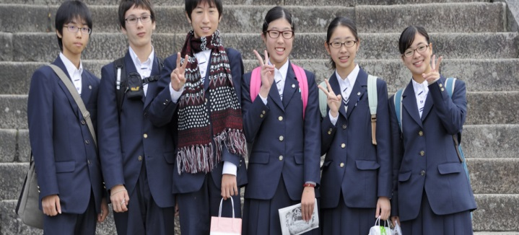
Students should wear uniforms in school.

Do you agree or disagree?

Affirmative team | Negative team
1. the speaker 1's 1st argument | 1. the speaker 1's 1st argument
2. the speaker 2's 2nd argument | 2. the speaker 2's 2nd argument
◎ Rebuttal 1 | ◎ Rebuttal 1
◎ Rebuttal 2 | ◎ Rebuttal 2
[ Worksheet2 - Clothing word search ]

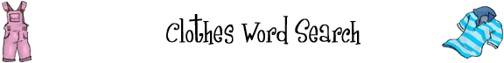
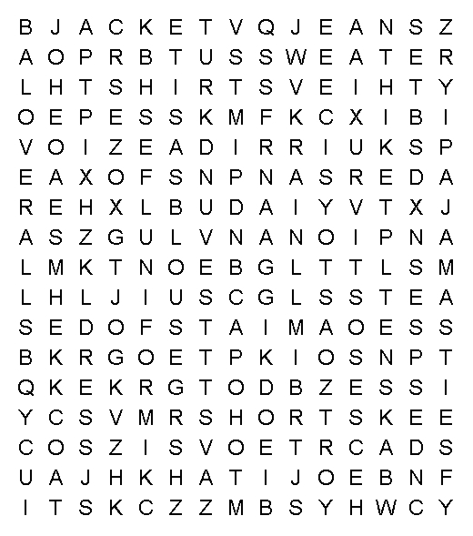 |  | 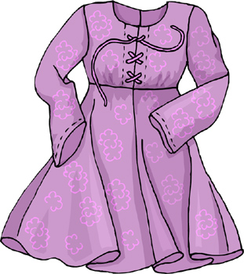
belt  bikini  blouse  boots  cap  coat  dress  gloves  hat  jacket | jeans  mittens  overalls  pajamas  pants  sandals  shirt  shoes  shorts | socks  suit  sunglasses  sweater  tie  T-shirt  uniform  vest  skirt

