☐ Listening ☐ Speaking ☐ Reading ☐ Grammar ☐ Writing

Topic: Camping

Instructor:  Jennifer | Level:  Intermediates | Students:  9 | Length:  30 Minutes

Materials:
- Worksheet
- 1. Present continuous timetable & substitution table.
- 2. Camping worksheet (Make a sentences)
- 3. Discussion-Camping worksheet.
- 4. Grammar crossword (sos worksheet)
- Realia- Mobile phone, Marshmallows
- Video- Camping (Describe the video)
- Board & Marker

Aims:
- Main aim - Student will learn ‘Present continuous’ form by make a sentences (worksheet 2) and the memory game.
- Secondary aim – Student will discussion their ideas about camping by disruption worksheet (worksheet 3).
- Personal aim – Want students understand ‘Present continuous’ form easily by camping video.

Language Skills:
Listening – Listen Students ideas.
Speaking – Students make sentences and speak when they play games.
Reading – Read the discussion worksheet.
Writing – Make the sentences and write on the work sheet2.

Language Systems:
Phonology – Contractions (I’m, She’s, He’s)
Lexis - Camping (set on the tent, play with hammock, eat marshmallows)
Grammar – Present continuous (He’s walking, She’s sitting, She’s eating)
Function - Describe what I am doing now, use ‘Present continuous’.
Discourse – Discussion about camping.

Assumptions:
1. Students have experienced about camping.
2. Students know ‘present simple’.
3. Students know a few words that they can read and write.

Anticipated Errors and Solutions:
- If Students have no experience with camping.
>Give a lot of background about camping.

2. If many Students don’t know ‘Present simple’.
>Explain briefly about ‘Present simple’.

3. If Students can’t understand discussion questions.
>Read together and give some examples about questions.

References:
Describe the video [FIRST FAMILY CAMPING EXPERIENCE!]
- https://sve.me/5L

Sos activity [Present continuous]
- https://sve.me/5M

Lead-In
Materials: Realia-Mobile phone, Marshmallows

Time | Set Up | Student Activity | Teacher Talk
2 mins | Whole class | 1.Greeting  2.Answering the questions. | (Prepare a campfire with teacher’s mobile phone)  Hello guys good afternoon.  Where do you think these situations are?  (Elicit Students’ thoughts)  Good!  (Act out some actions and ask them what teacher is doing? )  T: (Sitting on the chair)  What am I doing?  Ss: You are sitting.  T: (Acting out eating marshmallows)  What am I doing?  Ss: You are eating.  Ok! Today we are going to talk about ‘Present continuous’

Presentation
Materials: 1.Video - Describe the video
2.Timeline & Substitution table
3.Board & maker

Time | Set Up | Student Activity | Teacher Talk
8 mins | Whole class | - Describe the video  (play the video)  - Timeline  (Distribute the sheet)  (Give time to draw)  - Substitution table | (Prepare the camping video)  Instruction  I’m going to show you a clip. Watch the video and tell me what people are doing?  ICQs  1. What should you say? (What people are doing)  00:00  T: What are they doing?  Ss: They are setting up the tent.  05:20  T: What are they doing?  Ss: They are playing with hammock.  06:24  T: What is she doing?  Ss: She is holding some meat.  06:47  T: What is she doing?  Ss: She is cooking.  10:26  T: What are they doing?  Ss: They are eating popcorn.  Instruction  (Draw the timeline on the board)  Look at this timeline  Where is the present continuous?  (Draw the arrow)  The present continuous form is used to describe what I am doing now.  For example “He is walking”  Means right now, he is walking, as we speak. Draw the picture on your paper.  ICQs  1. What do you draw on the timeline? (He is walking)  2.When do use ‘present continuous’ form? (When I’m doing now.)  Instruction  Look at this table. The Present continuous form is Be verb+ing.  Add ‘ing’ to most verbs. When we make negative sentences add ‘not’ to the ‘Be verb’. When we make question sentences bring the ‘Be verb’ to the front.  ICQs  1. When you make negative sentences what do you add? (Add ‘not’)  2. When you make question sentences how do you make? (Bring the ‘Be verb’ to the front.)

Practice
Materials: 1.Camping worksheet

Time | Set Up | Student Activity | Teacher Talk
15 mins | Whole class  Individually  Whole class  Whole class | - Camping worksheet  (Distribute the worksheet)  (Make a sentence)  2. Memory game  (Playing game) | Instruction  Let’s make a full sentence.  Look at this picture what is happening at the camping? Use the ‘present continuous form.  ICQ  1. Which form do you use?  (present continuous)  Are you finished? Then, let’s answer the answer one by one.  (_Name_)go first.  (Answer the answer up to 8)  All right, guys. Good job.  Instruction  We are going to play memory game. All the students play games together. The first person starts speaking sentences with act about camping. For example “I am eating marshmallows.” Sentences and act what the first person has done After that the second person speaking and acting. Like “She is eating marshmallows.” “I’m sitting on the camping chair.” The next person remembers all sentences. It’s a game that people remember what they said.  ICQs  1. What type of sentences do you make? (Present continuous)  2. What do you make sentences about? (Camping)  3. Do you act when speak sentences? (Yes)  4. Do I have to speak everyone in front of me before I speak? (Yes)  Ok! Let’s do it!  Great job! Did you have fun?

Production
Materials: 1.Discussion-camping worksheet

Time | Set Up | Student Activity | Teacher Talk
5 mins | Whole class  Pairs  Whole class | 1. Discussion-Camping  (Distribute the sheet)  (Discussion with their partner)  2. Conclude lesson | Instruction  I’m going to give you another work.  Think about it when you go camping?  and discussion about camping. It’s  going to talk in pairs.  (Make pairs)  ICQs  1. Is it a pair work? (Yes)  2. Do you need to write on your paper? (No)  Ok. Let’s start with your partner and  share many ideas. But you don’t need  to write on your paper.  Did you have fun? What did you learn?  (Elicit what students learned today)  Great job! Have a nice weekend.

SOS Activity
Materials: 1. Grammar crossword worksheet

Time | Set Up | Student Activity | Teacher Talk
3 mins | Whole class  Pairs  Whole class | 1. Grammar crossword  (Distribute the sheet) | Instruction  It’s a crossword about ‘Present continuous’ Read and fill in the missing words. Work with your partner.  ICQs  1.Do you do it alone? (No, pairs)  Well done today!

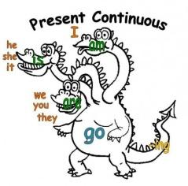
[work sheet1]
Present continuous
Draw the timeline.
“He is walking.”

Past Now Future
Affirmative
I | am | walking  cooking  eating popcorn.  setting up the tent  playing
He  She  It | is
You  They  We | are
Negative
I | Am not  =‘m not | walking  cooking  eating popcorn.  setting up the tent  playing
He  She  It | is not  =isn’t
You  They  We | are not  =aren’t
Question & Answer
Question |  |  | Answer
Am | I | walking  cooking  eating popcorn.  setting up the tent  playing | Yes, I am / No, I am not (I’m not)
Is | he  she  it |  | Yes, he is/ No, he is not (he isn’t)
Are | you  they  we |  | Yes, they are. / No, they are not ( they aren’t )
Camping [Worksheet 2]
Look at this picture and make a suitable sentence. Use ‘Present continuous’.
What is happening at the camping?
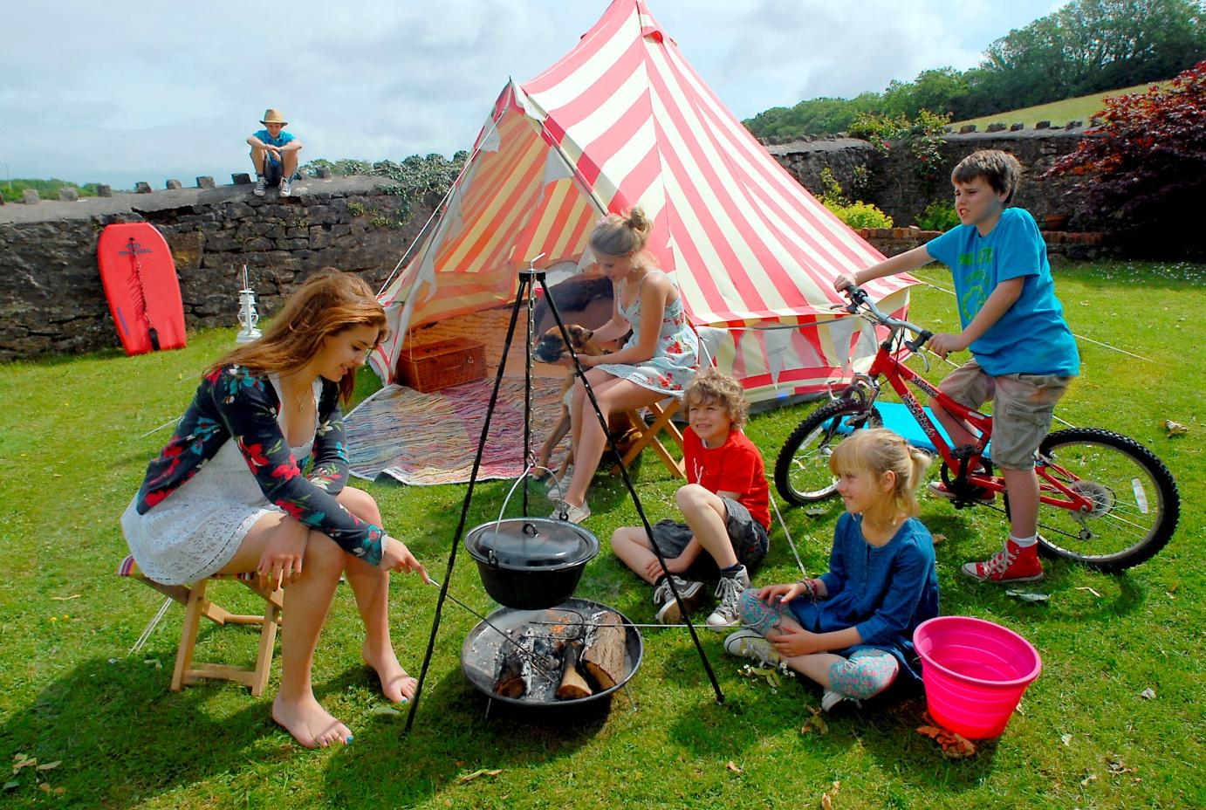
1. _______________________________. (The woman / hold / a stick)
2. __________________________. (The boy / ride / a bike)
3. ________________________? (children / sit / on the grass)
Yes, They _____.
4. ________________________________. (The man / sit / fence)
5. ________________________? (woman / pet / the cat / the dog)
No, She ______. She ________________.
6. _______________________________. (Blue board / lean / the fence)
7. _______________________________. (The tent / stand / behind / the people)
8. __________________________________________.
(The person / with the bike / wear / a blue T-shirt)
Camping (Answer) - Worksheet 2
Look at this picture and make a suitable sentence. Use ‘Present continuous’.
What is happening at the camping?
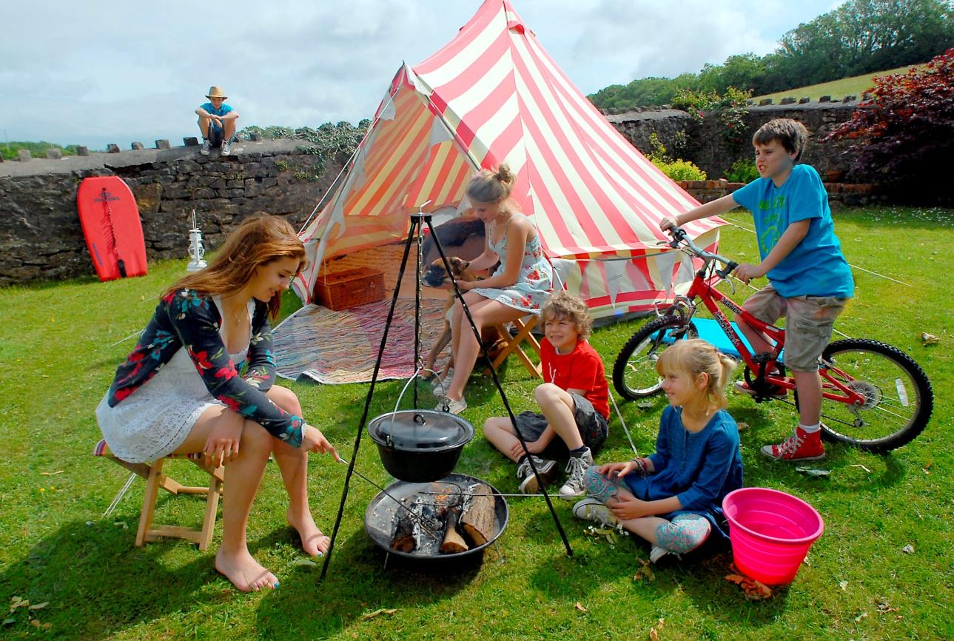
1. The woman is holding a stick. (The woman / hold / a stick)
2. The boy is riding a bike. (The boy / ride / a bike)
3. Are children sitting on the grass? (children / sit / on the grass)
Yes, They are.
4. The man is sitting on the fence. (The man / sit / fence)
5. Is the woman petting the cat? (woman / pet / the cat / the dog)
No, She isn’t. She is petting the dog.
6. Blue board isn’t leaning the fence. (Blue board / lean / the fence)
7. The tent is standing behind the people. (The tent / stand / behind / the people)
8. The person with the bike isn’t wearing a red T-shirt.
(The person / with the bike / wear / a red T-shirt)

Discussion-Camping [Worksheet 3]
- What is the best activity to do while camping?
- How many times have you gone camping?
- Where have you gone camping?
- What are the 4 most important things to bring when you go camping?
- Is camping with lots of amenities (solar panels, fans, stove, etc.)
- Where is the best place to go camping in your country?
- Tell a story about a camping trip. (It doesn’t have to be your story)
- What is the best thing about camping? How about the worst thing?
- What is the best food to bring on a camping trip?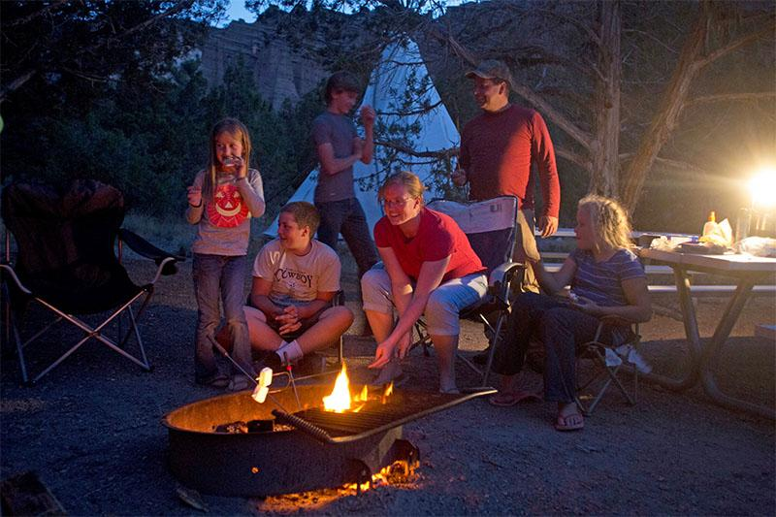
Sos activity - worksheet 4
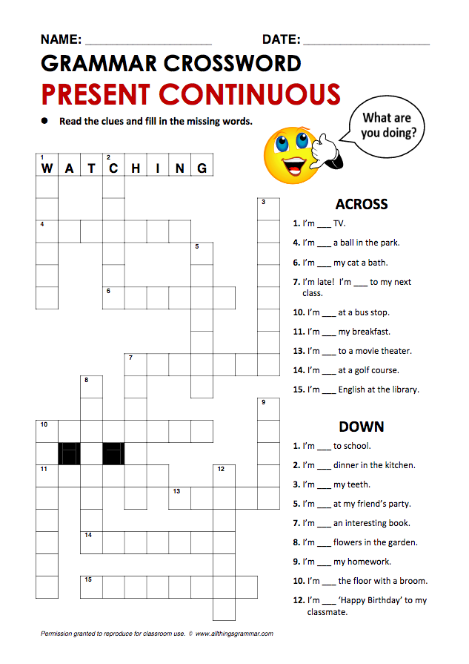
Sos activity - worksheet 4 [Answer]
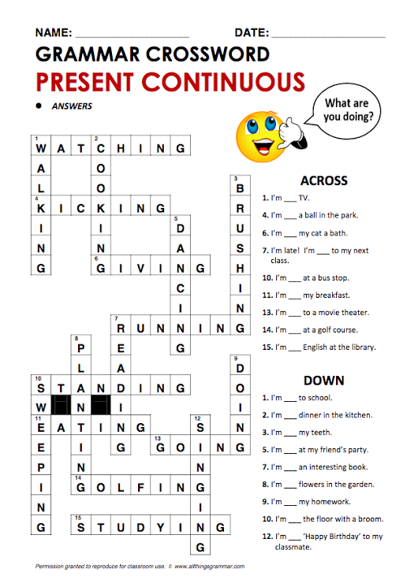

Realia-Mobile phone

Realia - Marshmallows

PPT - Present continuous
