☐ Listening ☐ Speaking ☐ Reading ☑ Grammar ☐ Writing

Topic:
I went to school.

Instructor:  Sophia | Level:  Intermediate | Students:  9 | Length:  30 Minutes

Materials:
- Board & markers
- Music Video
- Sticky tape
- 30 Flash Cards
- 9 copies of the worksheet 1 “The ugly duckling”
- 4 copies of the worksheet 2 “Board game” and 9 game pieces
- 3 copies of the worksheet 3 “What did you do last week?”
- 9 copies of the worksheet 4 “Simple past irregular verb crossword”

Aims:

Main aim- Students will practice the simple past irregular verb by “The ugly duckling” worksheet 1, “Board game” worksheet 2 and “What did you do last week? Worksheet 3

Secondary aim- Students will be confident about the simple past irregular verb by “The ugly duckling” worksheet 1, “Board game” worksheet 2 and “What did you do last week? Worksheet 3

Personal aim- Teacher wants to follow the Lesson Plan.

Language Skills:

Speaking- Doing board game
- Making the story by worksheet3 “What did you do last week?”

Listening- Music video
- While Ss share their story, they can listen each other carefully.

Reading- When Ss read the worksheet 1,2,3

Writing- Write their worksheet 3 “What did you do last week?”

Language Systems:

Phonology – Correcting the pronunciation during the class
Lexis- irregular verbs (eg. ate, brought…)
Grammar- Simple past
Function- Describing what they did last week
Discourse- Board game

Assumptions:

1. Ss know the teacher’s style of teaching.

2. Ss know they should speak only English in the class.

3. Ss are confident with pair and group work.

4. Ss know simple present and simple past (regular verbs).

Anticipated Errors and Solutions:
- If Ss speak their L1
– Encourage them to speak English

- If Ss need more time to finish their activity (Cut-off plan)
– Give them 30 seconds more and then stop the activity.

- If Ss finish their activity earlier than anticipated (SOS plan)
– Give Ss the simple past irregular verb crossword worksheet

References:

- Music Video : https://www.youtube.com/watch?v=AKaD2btS1A4
- Worksheet 4 Simple past irregular verb crossword (SOS) : https://goo.gl/niysfd

Lead-In
Materials:
- Board & markers
Time | Set Up | Student Activity | Teacher Talk
2min | Whole Class | Greeting  Review | 1. Greeting  Hello everyone, how are you today?  (Ss greet back)  What did you do last week?  (Elicit – Simple past tense)  2. Review  Yesterday we studied about the simple past regular verbs. For example, I watched TV last night.  (Write the timeline on the board.)  It happened in the past and finished action specific time. So it usually use with yesterday, before in the past.

Presentation
Materials:
- Music Video
- 30 Flash cards
- Sticky tape
Time | Set Up | Student Activity | Teacher Talk
2min  1min  5min | Whole Class  Whole Class | Show the music video  Recall  Reflect with Flash cards | ● Do (Listen to the song)  Instruction  Now, we’re going to watch the music video. When you watch it, don’t look at the subtitle and just listen to the song.  CCQ  1. What should we do when you watch?  (Don’t look at the subtitle and just listen to the song.)  2. Will you focus on the subtitle?  (No)  (Play the music video (0:53 ~ 2:10) and let Ss watch.)  ● Recall (about the song)  Did you enjoy the song?  What did you hear?  (Try eliciting more the simple past verbs from Ss.)  ● Reflect  Is this in the past or present? (Past)  Great!  Instruction  Now it’s fun time. I’ll say the simple present and past verbs and you should repeat after me. And then after I read sentence in the flash card, you should make own your sentence using the simple past verb. One flash card is for one person. So you can make your own sentence from each flash card by turns. You can change all things without the simple past verb.  Demonstration  Let’s do the demo.  (show the Flash card 1)  T: go- went / Ss : go – went  T: I went to school. (eg. Mimi, Please make the sentence) / Mimi: I went to church.  T: I made a cake. / Jiwon: I made some noodles.  T: Great!  CCQ  1. What do you supposed to repeat?  (The simple present and past verbs)  2. After Teacher read the flash card, What do you supposed to do? (Make the sentence)  (Show the flash cards to Ss.)  (T says the simple present and past verbs)  (Ss repeat that)  (T reads out the Flash cards)  (Ss make their own sentence by turns.)  (After Ss speech their sentences, T put the cards on the board.)
Practice
Materials:
- Board & markers
- Worksheet 1 : “The ugly duckling”
- Worksheet 2 : “Board game” and 9 game pieces
Time | Set Up | Student Activity | Teacher Talk
5min  7min | Whole Class  Whole Class  Pair  Whole Class  Pair | Leaning of Form  Doing worksheet1 “The ugly duckling”  Board Game | ● Conclude  Form  There are the simple past irregular verbs on the board. Their form is no rule. That’s why their form must be learned by heart.  1) Controlled practice  Instruction  Let’s do the “The ugly duckling” worksheet. Complete the paragraph by filling in the missing words with your partner. There are the simple present verbs in the big box. You should change the verbs to Past Tense! You have 3 minutes.  CCQ  1. How much time do you have? (3)  2. Do you do alone? (No)  (Distribute the “The ugly duckling” worksheet1 and monitor discreetly.)  Feedback  Do you need more time to do?  (If yes – give 30 seconds extra time  If no – check answers together)  Let’s check the answers.  Please read out each sentence one by one.  Here we go!  (Check the answers and correct them.)  2) Less controlled practice  Instruction  Now, we’re going to play the board game with your partner  (Distribute worksheet2 - Board game).  1. Put your game pieces on Start  2. Do “Rock-scissors-paper” and move your game piece following the “Rock-scissors-paper” picture.  3. When you move to some space, make the sentence with given verb.  4. But, there are simple present verb. So when you make the sentence, you should change the verb to Past Tense.  5. When you go to Finish, you are the winner.  6. You have 6 minutes.  CCQ  1. Who is the winner? (When someone go to Finish)  2. How much time do you have? (6min)  (T make pairs)  Let’s play the game!  (monitor discreetly)

Production
Materials:
- Worksheet 3 “What did you do last week?”
Time | Set Up | Student Activity | Teacher Talk
8min | Whole Class  Group  Whole Class | Making a story  Sharing their stories | 1. Free Practice  Instruction  Now, let’s make the story. The title is “What did you do last week?” So make the story with you group. Each day, you should make more than 3 sentences. You can see a lot of verbs in the board. So please use a lot of verbs. You have 5 minutes.  CCQ  1. What are you supposed to do? (Making a story)  2. How many sentences do you have to make each day? (more than 3)  3. How much time do you have? (5min)  (Dividing the group and distribute the “What did you do last week?” worksheet3 and monitor discreetly.)  Feedback  Have you all finished?  (If no – give 30 seconds extra time)  Let’s share each group’s stories.  Group 1, please share your group’s story.  (Go through all groups)  2. Wrap-up  Did you have fun today?  I hope you enjoyed today’s lesson.  See you tomorrow.

SOS Activity
Materials:
- Worksheet 4 Simple past irregular verb crossword
Time | Set Up | Student Activity | Teacher Talk
5min | Pair | Simple past irregular verb crossword | Instructions  Now I’ll give you the Simple past irregular verb crossword worksheet t with your partner. Find the words in the big box.  CCQ  Are you working alone?  What are you supposed to do?  (Distribute the Simple past irregular verb crossword worksheet and monitor discreetly)  (If Ss don’t finish it, let them do free homework.)
[ Flash Card ]

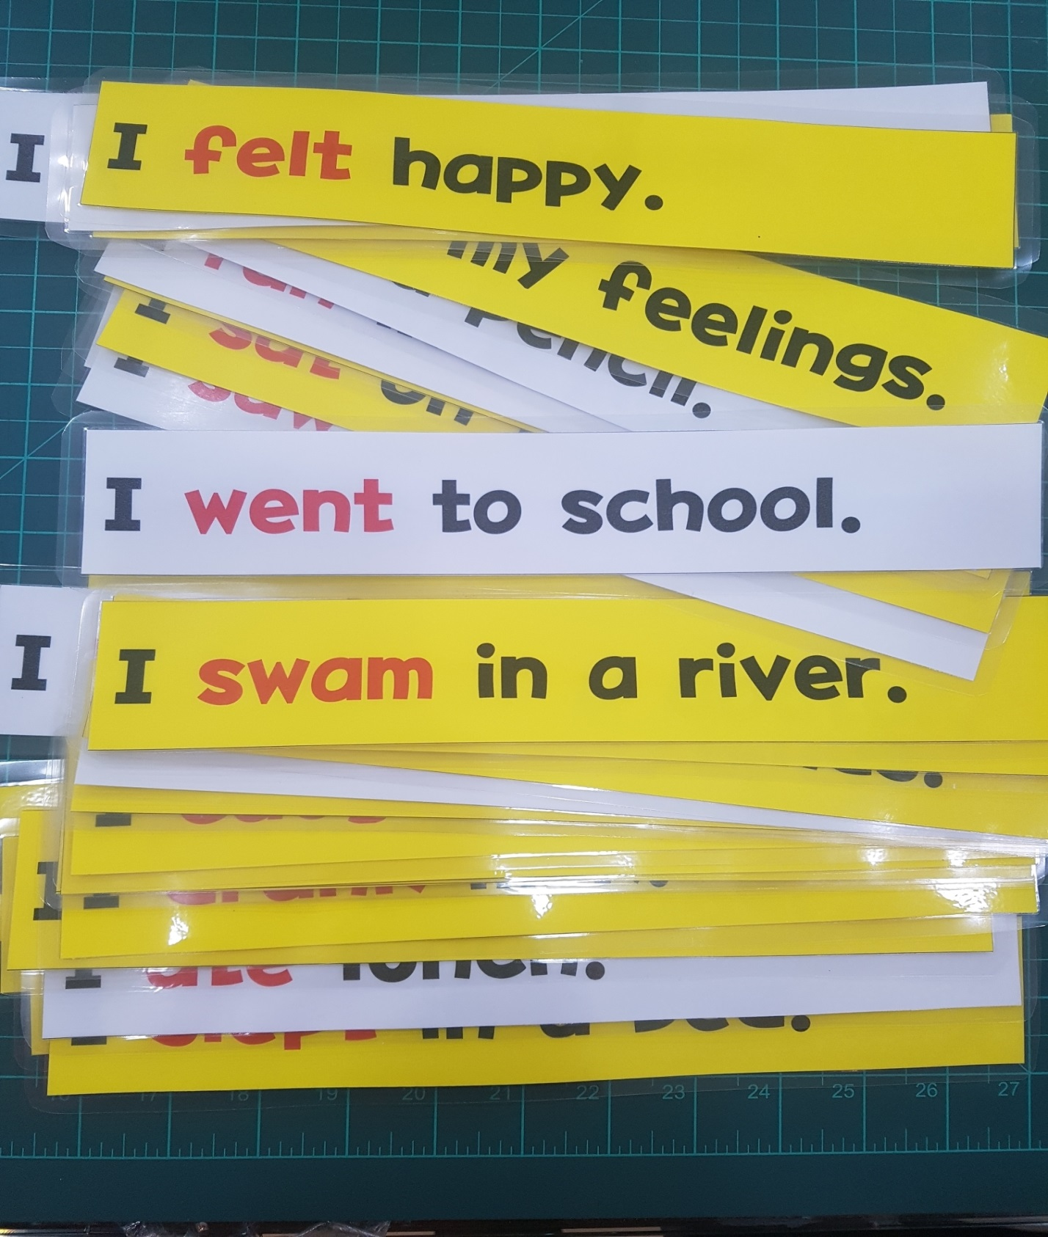
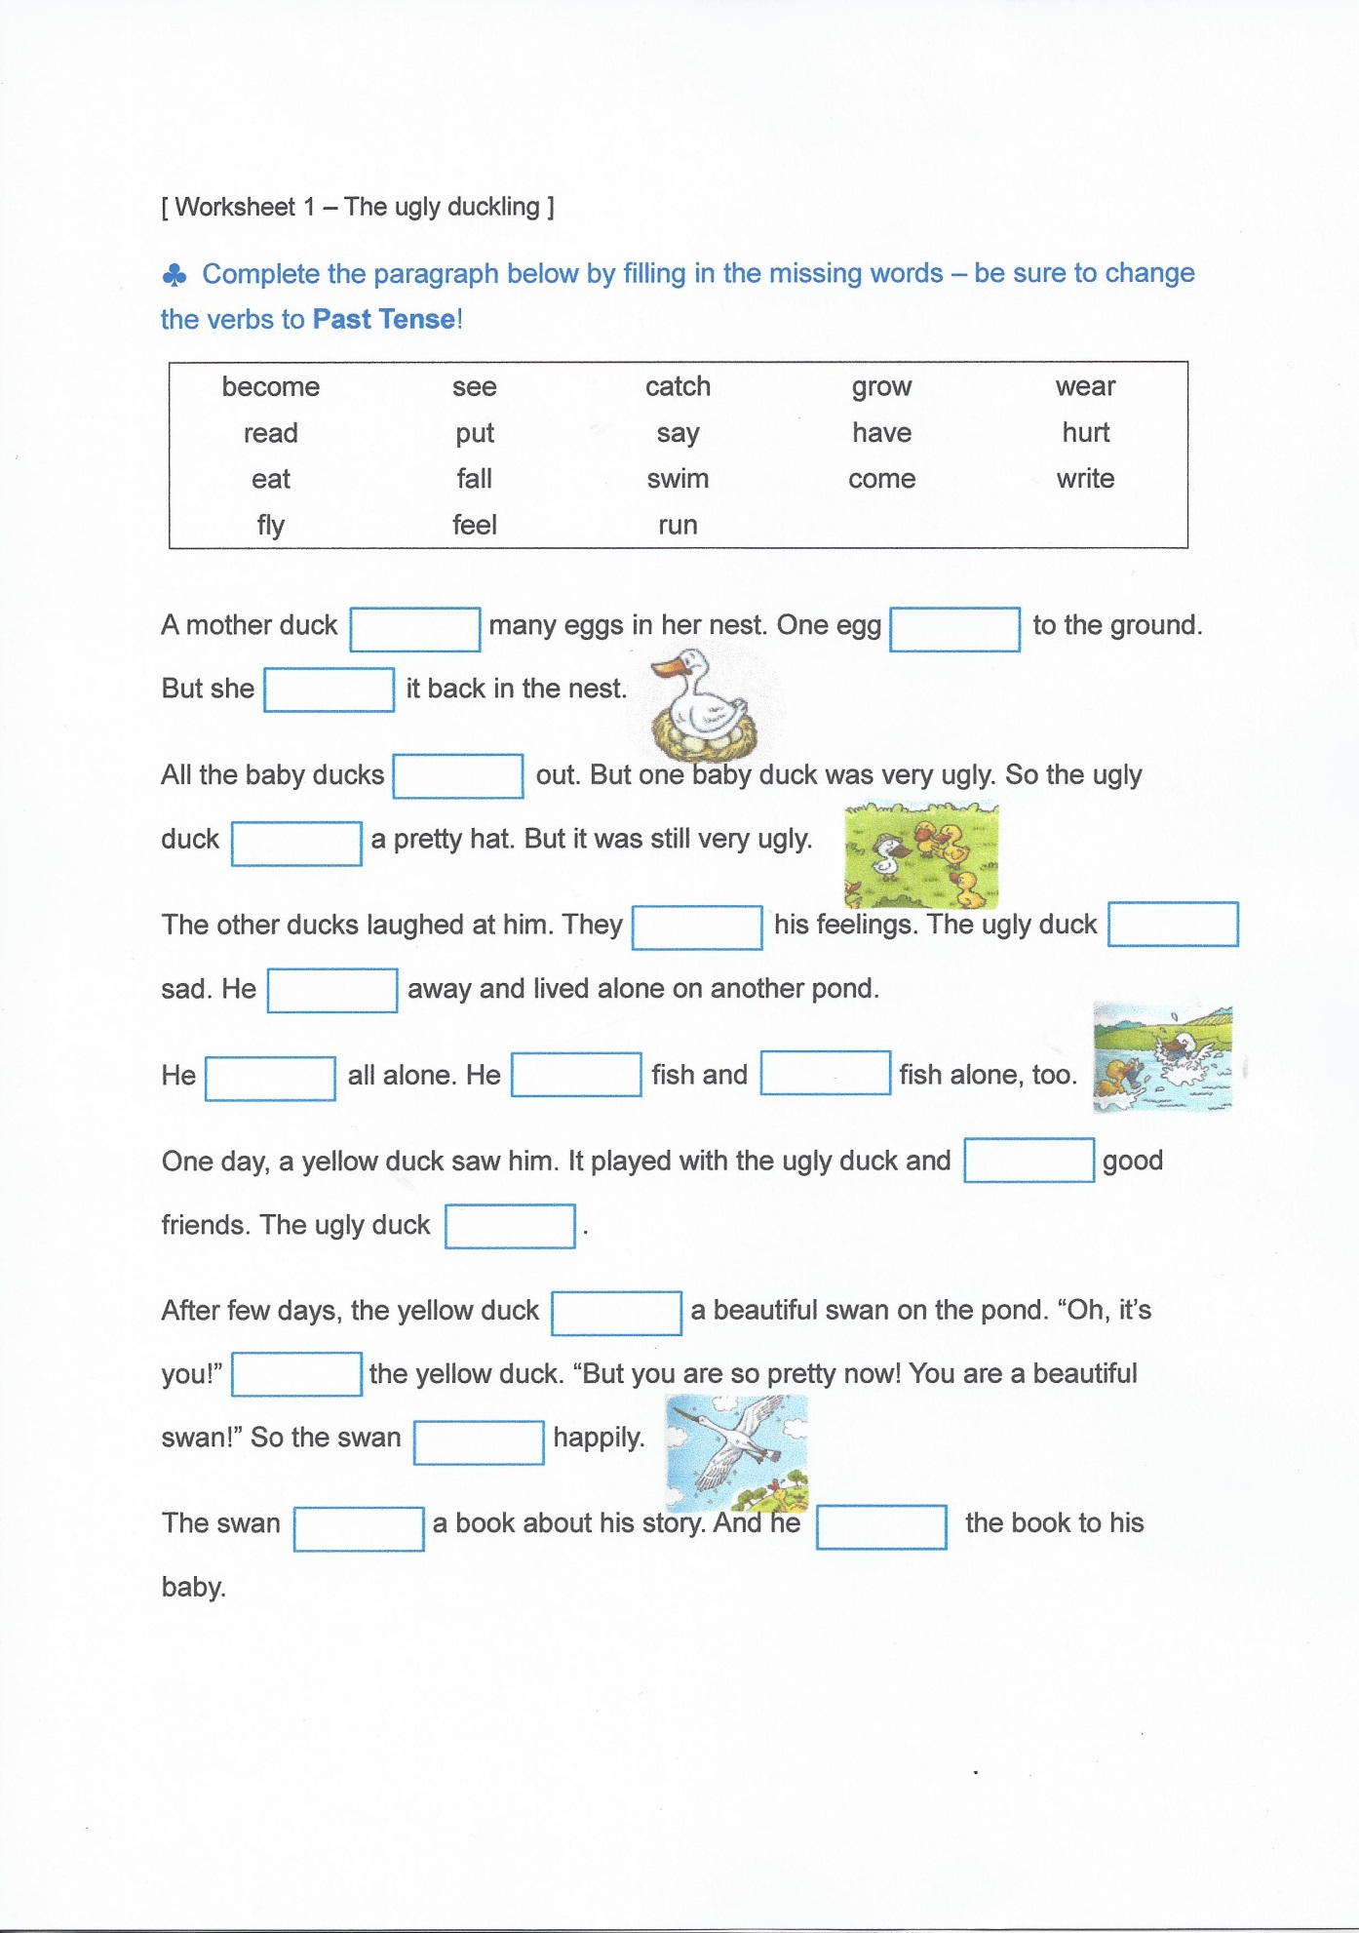
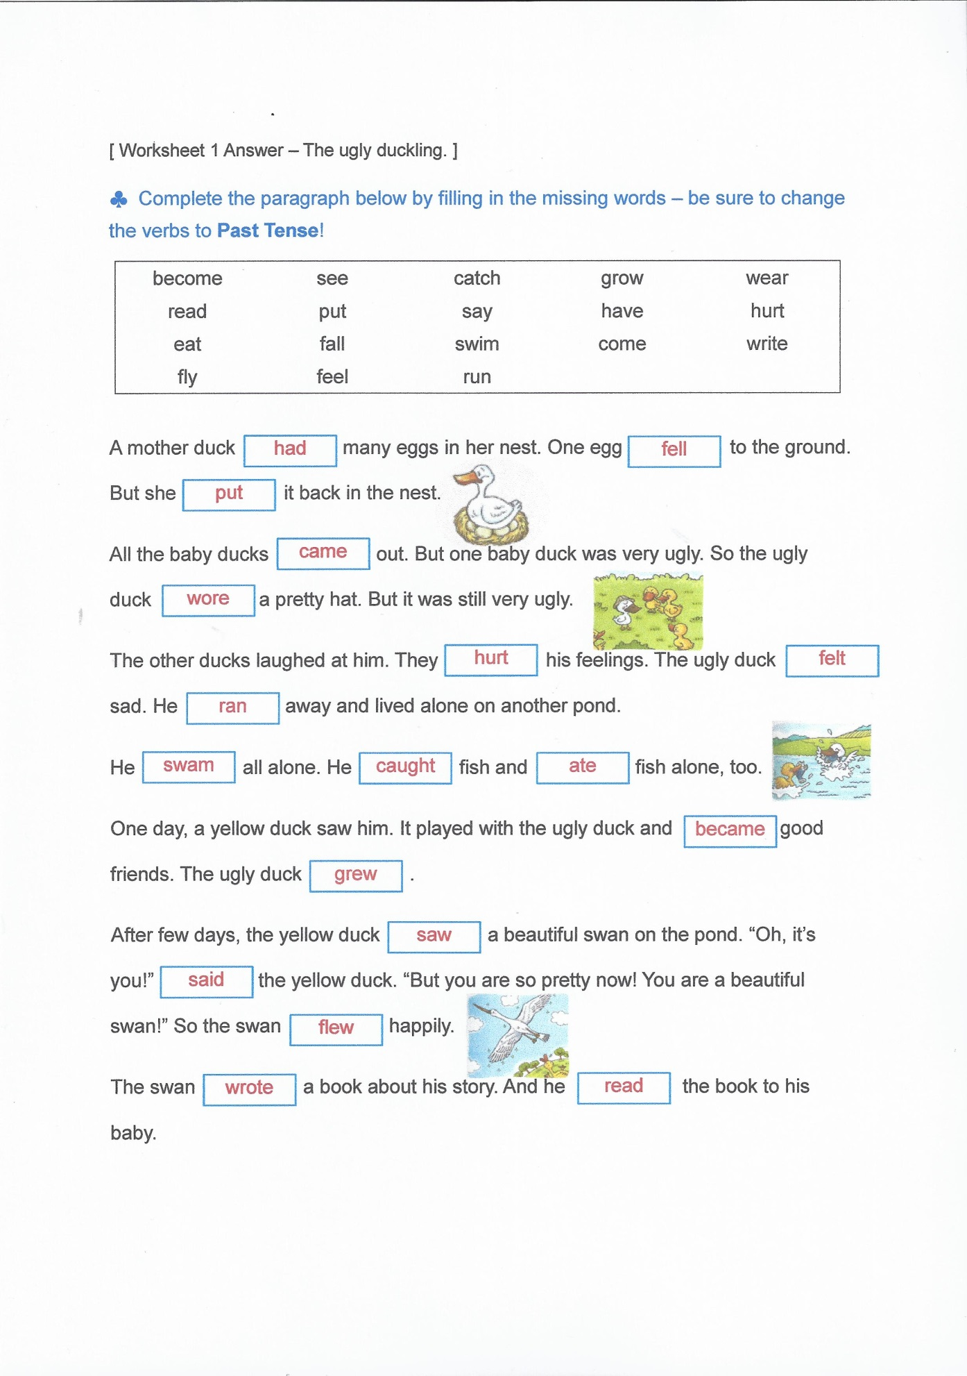
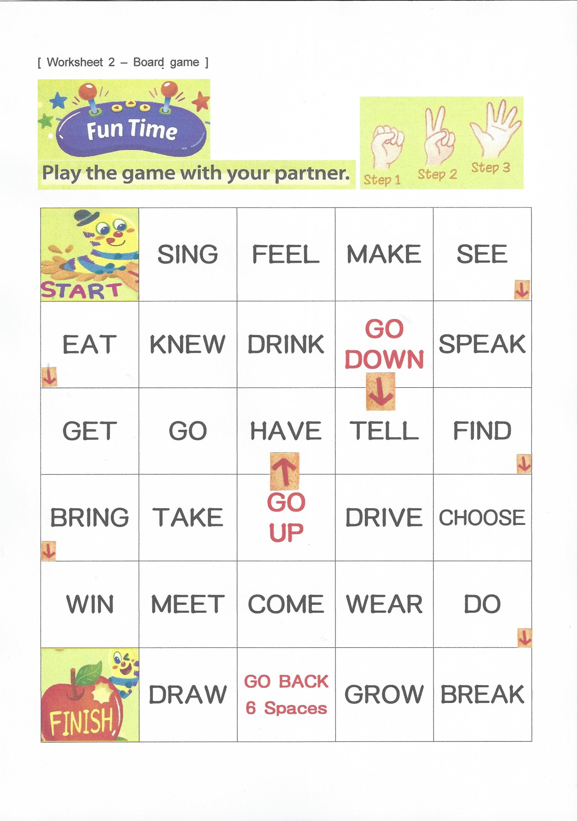
[ Worksheet 3 – What did you do last week? ]

What did you do last week?
Each day, you should make more than 3 sentences.

Monday
Tuesday
Wednesday
Thursday
Friday
Saturday
Sunday

[ Worksheet 4 SOS - Simple past Irregular verbs ]
