You like the tesol class, don’t you?
Grammar Lesson Plan

163th WK TESOL
Annie/Seonju Oh

☐ Listening ☐ Speaking ☐ Reading ◙ Grammar ☐ Writing

Topic: You like the TESOL class, don’t you?

Instructor:  Annie | Level:  Intermediate | Students:  9 | Length:  30 Minutes

Materials:

-“You like the TESOL class, don’t you?” work sheet 1,2
-“Question tag interview” video clip
-A part of “a little time” video clip
-“You like the TESOL class, don’t you?” substitution tables 1,2,3, and 4
-“You like the TESOL class, don’t you?” board games sets
(3 game-boards, 6 dices, 9 game-pieces)

-SOS: Sentence pieces

Aims

-Main aim: Students will use question tags more confidently by practicing speaking and repeating question-tag-sentences.

-Secondary aim: Students will know the rules of question tags by talking about the structure and changing the form of verb and subject.

-Personal aim: Teacher will improve grammar-explaining skills by preparing and do the lesson

Language Skills:

Speaking:
-Students can improve their intonation and pronunciation by drilling question-tag-sentences.
-Speaking while play the “You like the TESOL class, don’t you?” board game

Writing
-Writing interview questions using question tags on “You like the TESOL class, don’t you?” work sheet 2

Listening
-Listening to a part of a song and the interview in the presentation
-Listening to the teacher leading drilling
-Listening to the instruction of “You like the TESOL class, don’t t you?” board game.
-Listening to their teammates’ sentences while playing “You like the TESOL class, don’t you?” board game.

Reading
-Reading the sentences on “You like the TESOL class, don’t you?” works sheet1

Language Systems:

Phonology: contractions (don’t, aren’t, isn’t, I’m, you’re, she’s, he’s)
Lexis: language(pronoun, auxiliary, intonation, question tags)
Grammar: Question tags
Function: Asking and Confirming
Discourse interview(in presentation, in free production)

Assumptions:

-Students know the structure of statement and question sentences.
-Students have heard of question tag in songs and movies
-Students can make statement sentences with words given to them.

Anticipated Errors and Solutions:

-Some students might finish the “you like the TESOL class, don’t you” board game earlier > Ask them to interview each other using question tags like they watched the video in the beginning.

-Some students couldn’t finish their sentences in time in production stage.
> Let them interview each other as long as they have 2 or 3 sentences.

-Some students don’t understand the grammar point clearly
> let other students help them during the board game and if the students need more explanation, explain personally.

References:
Grammar
https://goo.gl/4Yo3xo
http://www.allthingsgrammar.com/

Vedio clip
https://goo.gl/iLHJHW

Pictures
https://goo.gl/CXE1an
https://goo.gl/j9CQGJ
https://goo.gl/ruhGvb

Lead-In
Materials:
Time | Set Up | Student Activity | Teacher Talk
1min | Whole class | Greeting together | Good afternoon,  How are you today?  It’s a nice day today, isn’t it?  But it’s cold outside, isn’t it?  So you want to stay here and study English grammar, don’t you?

Presentation
Materials:
-“Question tag interview” video clip
-A part of “a little time” video clip
-“You like the TESOL class, don’t you?” work sheet 1
Time | Set Up | Student Activity | Teacher Talk
9mins | Whole class | Watch the video  Answering the questions | Inductive grammar warm up  Okay, before we start the lesson, I want you to see this first  (Play “A little time” song video clip)  (Running time: 0’49”)  And one more,  (Play “Interview” video clip)  (Running time 0’52”)  Recall  (Eliciting)  What did you just watch?  What did you hear from the video?  Do the questions have some special parts? / Do you know the name of it?  (If students don’t know the name, question tags, ask what’s called this? Showing real tags)  So, we called the special part of the question question-tags.  Here are the sentences that you just heard.  (Distribute “You like the TESOL class, don’t you?” work sheet 1)  Look through them and try to find the rules.  Reflect  What did you find?  (Write down what students say)  (keep in mind the board plan)  (When students don’t say, ask them)  Where do you put the question tags?  What kind of words do you put from the original question?  How do you change the verb and the subject?  When do you use question tags?  When do you ask “You are late, aren’t you?”(↘)  Confirm what I believe is true.  When do you ask “You are late, aren’t you?”(↗)  Ask more information  Alright.  I think we are done with boring stuff.  Let’s do more boring stuff, shall we?

Practice
Materials:
“You like the TESOL class, don’t you?” substitution tables 1,2,3, and 4
“You like the TESOL class, don’t you?” board game sets
(3 game boars, 6 dices,9 game-pieces)
Time | Set Up | Student Activity | Teacher Talk
5mins | Whole class  8mins | Answer the CCQs  Drilling | Controlled practice  Drilling  See this very pretty chart that I made.  (Show the “you like the TESOL class, don’t you?” substitution table1)  Instruction  - I read this first and you repeat after me and later I will give a que than you make a sentence.  - The rule is the same color goes together, like yellow goes with yellow, green goes with green.  CCQs  - Who is going to say first? The teacher  - Then, what are you going to do? Repeat after you  - When I give you a que, what you going to do? Make a sentence.  Okay, here we go.  (Keep in mind: Error correction will be done immediately)  You are a teacher, aren’t you?  (students: repeating)  You are a student, aren’t you?  (students: repeating)  You are an artist, aren’t you?  (students: repeating)  A driver  A player  Now we are going to do green ones.  You weren’t a teacher, were you?  (students: repeating)  You weren’t a student, were you?  (students: repeating)  an artist  a driver  a player  And now, we are going to practice with the 3rd person she.  (Show the “You like the TESOL class, don’t you?” substitution table2)  Repeat after me please.  She isn’t late, is she?  (students: repeating)  She isn’t lazy, is she?  (students: repeating)  Smart  Happy  sad  Now we are doing greens.  Late  Lazy  Smart  Happy  Sad  Now, we are going to practice with general verbs.  (Show the “You like the TESOL class, don’t you?” substitution table3)  Make yellow sentences with my ques.  Like candies  Eat noodles  Make spicy food  Cook dinner  Now, make green sentences.  Like candies  Eat noodles  Make spicy food  Cook dinner  Now, we are going to practice with 3rd person, “he”  (Show the “You like the TESOL class, don’t you? Substitution table4)  Make yellow sentences with my ques.  In seoul  In New York  In jeju  In New Zealand  In buans  In Gangrung  Chain drilling  Okay, now we are going to do one by one from here.  (Point the first student in left-hand-side)  You say one sentence using the form on the monitor, and next, next.  (drilling one by one until the last student)  I think it’s enough practice, isn’t it?  Now, we are going to have some fun.  Less controlled practice  Board game  I will divide you as groups of three.  Three of you are one team, three of you are one, and three of you are one.  (Distribute the “ You like the TESOL class” board game sets)  (Show “the you like the TESOL class, don’t you?” board game instruction)  Instruction  -You start from the house, located in the top-left corner. (Put your game pieces there.)  -Roll two dices.  1st one present how many steps you move,  2nd one presents positive(o) or negative(x)  -You make a sentence with given words or a sentence and you must have a question tag at the end of the sentence.  -When you make a sentence, two others will decide you can pass or not.  (if you can’t pass, make a sentence again)  -When you step on a trick, follow the direction.  -If you get back home, you win.  Demonstration  -When you step on “happy,” you can make a sentence like “I am happy, aren’t I?” “You aren’t happy, are you?”  -When you step on “You love me,” you can make a sentence like “You love me don’t you?” Or “You don’t love me, do you?”  CCQs  -What must you have at the end of the sentence?  -What will you do when your team say you can’t pass?  We are all set. You have about 5minutes.  (monitoring and helping)  Time’s up. Well done everyone.  Feedback  Did you have fun?  Which one did you need more time to make a question tag?

Production
Materials: “You like the TESOL class, don’t you? work sheet 2
Time | Set Up | Student Activity | Teacher Talk
7mins | Individuals | Students write sentences  Students ask questions each other. | Alright.  Now, let’s move on to a writing.  (Distribute the “You like the TESOL class, don’t you? work sheet2)  Instruction  -Imagine you are about to interview your partner who you have known only for a month.  (Make pairs)  Two of you, two of you, two of you, and three of you together.  -Write 8 sentences  1. What you wonder about the person  2. What you know, but you are not sure.  -You have to have a question tag in each sentence  -You have 4minutes  CCQs  -What are you writing?  -What do you have to have in your questions?  Everyone seems to write some sentences.  So, ask your partner two or three questions.  Okay, time’s up  Feedback  How was it?  Did you have fun today?  What did we learn today?  Great  We are done.  Have a nice day.

SOS Activity
Materials: “You like the TESOL class, don’t you?” sentence-pieces sets
Time | Set Up | Student Activity | Teacher Talk
5mins | pairs | Complete the sentences matching the main sentence with question tags. | Since we have a little time left.  I’ll give you these pieces of paper.  Instruction  With your partner, complete the sentences matching the main sentences and the question tags.  CCQs  -What are you going to do?  -Who do you work with?  Feedback  -How was it?  -Did you have fun?  Great.  We are done today.  Have a nice day.

You like the TESOL class, don’t you? -work sheet 1

Your name is Louis, isn’t it? Yes, it is.
You live in Madrid, don’t you? Yes, I do.
You live in a house, don’t you? No, I don’t. I live in an apartment.
You are around thirty years old, aren’t you? Yes, I am.
You are from New Zealand, aren’t you? No, I’m not. I’m from Australia.
You are an English teacher, aren’t you? No, I’m not. I’m a librarian.
Your parents are librarians too, aren’t they? No, they’re not.
You work in a library, don’t you? No, I don’t.
You had a little fun, didn’t you?
I am telling you everything I know, aren’t I?

“You like the TESOL class, don’t you?”
Substitution tables
1.
You are | a teacher,  a student,  an artist, | aren’t you?
You weren’t |  | were you?
2.
She isn’t | late,  lazy,  smart, | is she?
She was |  | wasn’t she?
3.
You | like  eat  make | chocolate,  noodles,  spicy food, | don’t you?
You didn’t |  |  | did you?
4.
He lives | in Seoul,  in New York,  in Jeju,  in New Zealand, | doesn’t he?
He doesn’t live |  | does he?

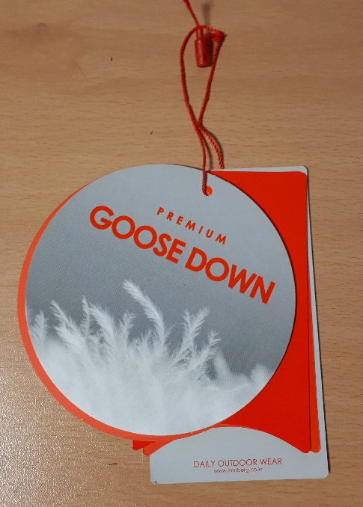

“You like the TESOL class, don’t you?” board game instruction
Board game instruction
1 | You start from the house, located in the top-left corner, And when you come back home, you win
2 | Roll two dices.  1st one presents how many steps you move,  2nd one presents positive(o) or negative(x) sentence.
3 | You make a sentence with given words or a sentence,  you must have a question tag at the end of the sentence.
4 | When you make a sentence,  two others will decide you can pass or not.  (if you can’t pass, make a sentence again)
5 | When you step on a trick, follow the direction.

“You like the TESOL class, don’t you?” worksheet 2
Imagine you are about to interview a person next you who you have known only for a month. (You might know a little about the person.)

* Write 8 sentences about
1. What you wonder about the person
2. What you know, but you are not sure.

1.
2.
3.
4,
5,
6.
7.
8.

“You like the TESOL class, don’t you?” SOS worksheet
(Students will get these sentences separated two parts, the main sentence and the question tags.
Students will match the question tags to the main sentences in pairs)

She isn’t coming, is she?
You don’t recognize me, do you?
I’m invited to your party, aren’t I?
I need to go with you, don’t I?
I don’t know you, do I?
You fixed the coffee machine, didn’t you?
She runs in marathons, doesn’t she?
You were at the park, weren’t you?
You excise everyday, don’t you?
You didn’t make it, did you?
You weren’t there yesterday, were you?
You are in the same group as me, aren’t you?
You aren’t visiting your grandparents, are you?
They didn’t talk about you, did they?
They sold their house already, didn’t they?
They were really happy together, weren’t they?
They live in an apartment, don’t they?
They don’t like to have a pet, do they?
They are traveling now, aren’t they?

“You like the TESOL class, don’t you?” game board
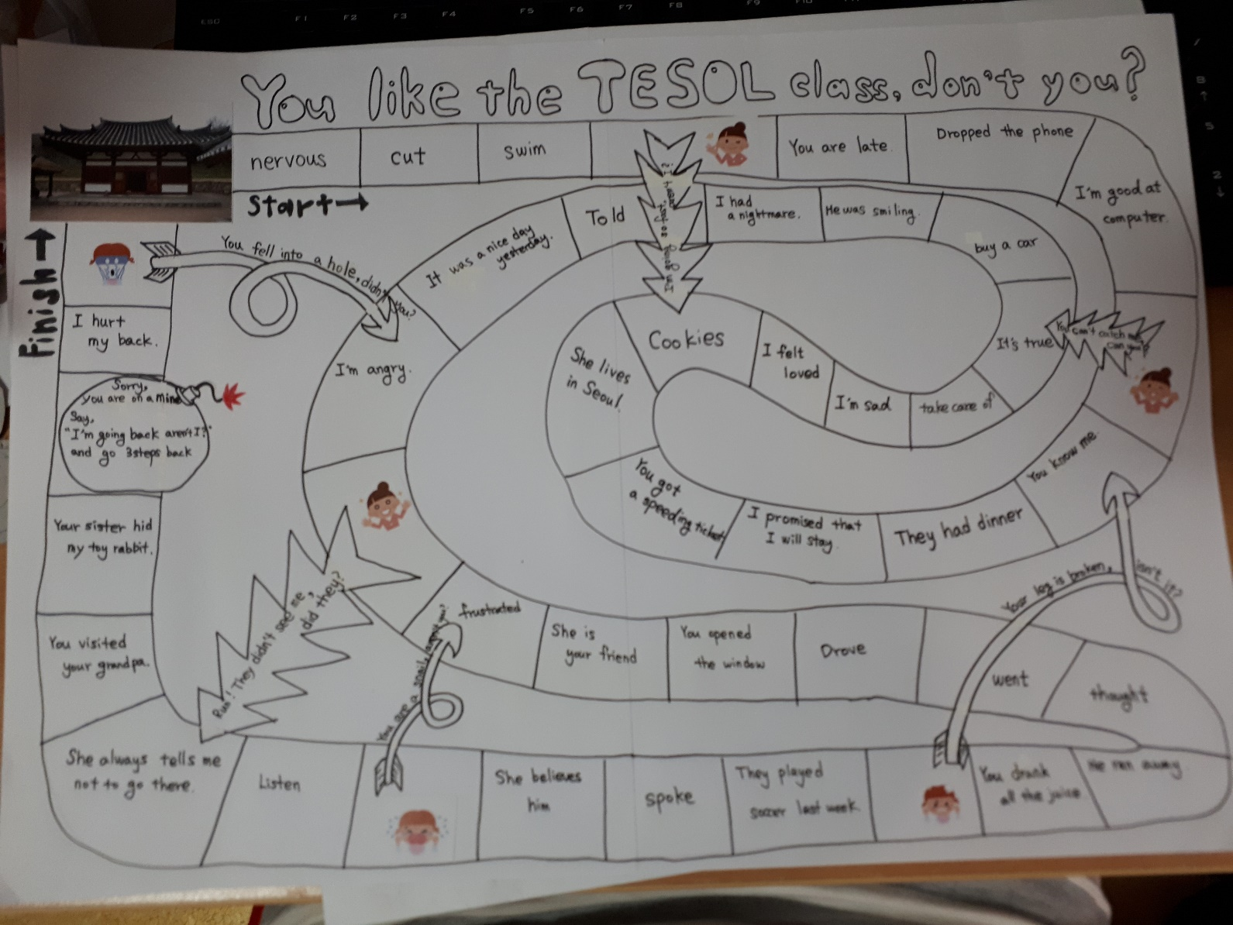
“You like the TESOL class, don’t you?” board plan
You like the TESOL class, don’t you?
1 Watch video  2. Grammar  3. Drilling  4. Board game  5. Writing  6. Feedback | Question tags  -location: end of the sentence  -structure: auxiliary verb(helping verb) + pronoun  ·matches the tense of the main verb · related directly from the noun  Exception) I am →aren’t I?  · positive→negative/negative→positive  -use: ask more information (intonation↗)  Confirm what I believe is true. (intonation↘)

