Grammar Lesson Plan (PPP)
☐ Listening ☐ Speaking ☐ Reading ☐ Grammar ☐ Writing
Topic: (Participle adjectives)

She is frightened because of a frightening snake

Instructor:  Belle | Level:  Intermediate | Students:  9 | Length:  30 Minutes

Materials:
- computer, internet, video clip(youtube)
- white board, marker – Realia (Picture)
- substitution table cards
- 9 copies of worksheet 1 (circle the right one)
- 9 copies of worksheet 2 (match sentences)
- 9 copies of worksheet 3 (If you are)
- 9 copies of worksheet 4 (discussion)
- 9 copies of SOS worksheet (word search)

Aims:

- Main : Students will learn about how to use participle adjectives
by practice their worksheets
- Secondary : Students will also improve the speaking and writing skills also
by doing their interview
- Personal : Students will enjoy studying grammar by teacher's encouragement

Language Skills:

- Reading : reading worksheets to answer questions
- Listening : listening to the video, teacher's explanation
- Speaking : speaking the sentences using participle adjectives
- Writing : writing some sentences on their worksheets

Language Systems:

- Phonology : contraction ; because of', 'she is', 'interested in'
- Lexis : frightened, frightening, embarrassed, embarrassing
- Grammar : present participle (~ing)/ past participle (~ed)
- Function : expressing emotion, describing what the situation is like
- Discourse : explain feelings, emotions, situations, things

Assumptions:

- Students already have known the adjectives
- Students are used to working individually and in groups
- Students can explain their feelings and things around them
- Students enjoy doing the worksheets

Anticipated Errors and Solutions:

- If students need more time to finish their activity
: Be flexible with the time, give students more time to finish their activity
- Students may have difficulty in their drilling
: Have students do themselves first and give some help
- If students finish their tasks earlier than anticipated
: Give students SOS activity to do with

References:

- warm up video : https://goo.gl/bhLzcw
- presentation : https://goo.gl/XGRLGq
- worksheet 1 : https://goo.gl/PSisc7
- worksheet 2 : https://goo.gl/UW2Mh1
- worksheet 3 : https://goo.gl/fCoZux
- worksheet 4 : https://goo.gl/fCoZux
- sos worksheet : https://goo.gl/OP2p2f

Lead-In
Materials: computer, youtube video
Time | Set Up | Student Activity | Teacher Talk
2 min | whole  class | Watch Video  watch on the board | Procedure :  (Greeting and Eliciting)  -Hello everyone. how are you ?  Guided warmer activity  Before we learn today's lesson, let's take a  look some video clip  (show SS video) 1min20sec  Recall  (Put on the Picture(realia) on the board)  (Write the two sentences of title)  -How was it ? what did you see in the video?  (Ss answer) (feedback)

Presentation
Materials: white board, marker, substitution table (cards)
Time | Set Up | Student Activity | Teacher Talk
5 min | whole  class | Listen and think  answer | Procedure :  Reflect  (Substitution table on the board)  (Question about the table)  How can you say when you see something scary?  (Let Ss answer)  How can you say about the scary things?  (Let Ss answer)  Can you see the difference between these  two sentences?  (feedback)  It looks almost the same  but there's a big difference between them  Can anyone explain? (Ss answer)  As you probably noticed,  One ends in ~ing, and the other ends in –ed  Conclude  (-ing adj. subject cause the feeling)  (-ed adj. subject receives the feeling)  (T's explain the form using the drawing)  Now repeat after me.  The snake is frightening (Ss repeat)  What’s the meaning? (Ss answer)  yes, it means the snake is scary  Snake caused the feeling  Repeat after me.  She is frightened (Ss repeat)  What’s the meaning? (Ss answer)  yes, it means she is scared  She receives the feeling  Drilling  (with other words ; boring, bored, surprising, surprised)

Practice
Materials:

9 copies of worksheet 1 (circle the right one)
9 copies of worksheet 2 (match sentences)
9 copies of worksheet 3 (If you are)

Time | Set Up | Student Activity | Teacher Talk
13 min | Individually  In pair  individually | Do activity  Do activity | Controlled Practice 1  worksheet 1 (circle the right one)  instructions  Now it's time to do the worksheet question1-10 individually  Circle the right word.  You have 3 minutes.  CCQ)  How much time do you have? (3 min)  What do you do? (Do the question)  Do you work with your partner? (No)  (Pass out the worksheet1/run the task)  (Feedback)  Do you need more time?(Ss answer)  (If yes - give 30 seconds  If no - check answers together)  Controlled Practice 1  worksheet 2 (match sentences)  instructions  We're going to do 'match sentences'  You can do it in pairs  You have 3 minutes  (help students make groups)  CCQ)  How much time do you have? (3minutes)  Are you going to work alone? (No)  (Pass out the worksheet2/run the task)  (Feedback)  Do you need more time?  How was it?  (If yes - give 30 seconds  If no - check answers together)  Less Controlled Practice  worksheet 3 (If you are)  Now we're going to do some different activity.  instructions  Write your answers for each pictures  using participle adjectives  Do it individually  After you finished, share it with the person next to you. You have 5 minutes.  CCQ)  What are you going to use to answer?  (participle adjectives)  How much time do you have? (5minutes)  (Pass out the worksheet3/run the task)  (Feedback)  Do you need more time?  How was it?  (If yes - give 30 seconds  If no - share together)

 | Production
Materials:
9 copies of worksheet 4 (Discussion)
 | Time |  | Set Up |  | Student Activity |  | Teacher Talk
 | 10 min |  | in pair |  | Do activity |  | Free practice  worksheet 4 (Discussion)  Now let's do our final activity today.  You're going to discuss with your partner  You have 10 minutes  (Help them make pairs)  CCQ)  What are you going to have? (Discussion)  Are you going to do it alone? (No)  (Pass out the worksheet 4 / run the task)  (Feedback)  Have you all finished?  Did you get any interesting information?  (share)  Wrap-up  Did you enjoy today's lesson?  I hope you enjoyed today's lesson.  Have a nice day everyone. Bye.
 | SOS Activity
Materials:
9 copies of worksheet (word search)
 | Time | Set Up |  | Student Activity |  | Teacher Talk
 |  | whole  class |  | Do their activity |  | Instruction)  We have more time do to another activity  You can find some words on your worksheet  Do it individually and share your answer  CCQ)  What are you going to do?(word search)  Do you work alone?(yes)  End
Woksheet1 (Circle the right one~ )

What is a participle?
A participle is a word formed from a verb which can be used as
an adjective.

PAST PARTICIPLES* (-ed) | PRESENT PARTICIPLES*(-ing)
Interested | Interesting
I am interested in this movie. | This movie is interesting.
You are interested in me. | You are an interesting person.

- I don’t understand chess. The rules are very confused / confusing.

- He was embarrassed / embarrassing when he arrived late for class.

3. There is a new movie playing at the theater. Are you interested / interesting?

- My little brother makes too much noise. He is annoyed / annoying.

- I like my new chair. It’s quite relaxed / relaxing.

6. Moving to a new home is hard work. It’s tired / tiring.

7. The sad news made me depressed / depressing.

8. Louise got a B+. She was satisfied / satisfying with her test results.

9. Our company isn’t making any money. It’s very worried / worrying.

10. Robert thinks that roller coasters are terrified / terrifying.

Worksheet2 (Match the sentences)

- ( ) I don’t think the children can sleep. A It’s drinking water.

- ( ) My mother is a working woman. B They are too excited.

- ( ) The soccer match was exciting. C Let’s do something fun.

- ( ) I’m so bored ! D This map is so confusing.

- ( ) We can never find the place. E Our team won.

- ( ) You can drink from the tap. F She’s always busy.

- ( ) I don’t like this movie. G You are boring.

- ( ) I want to do it again. H It’s too scared.

- ( ) You can’t make me laugh. I So I was relaxed.

- ( ) The warm bath was so nice. J It’s interesting
Worksheet3( If you are )
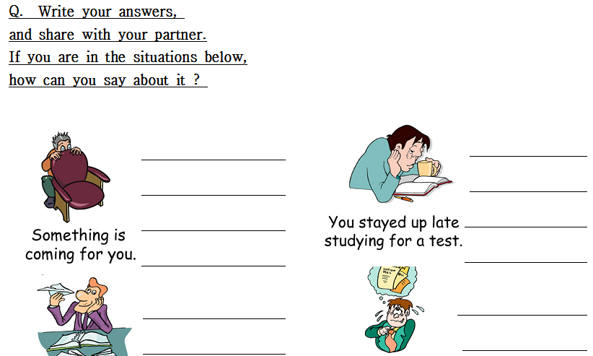
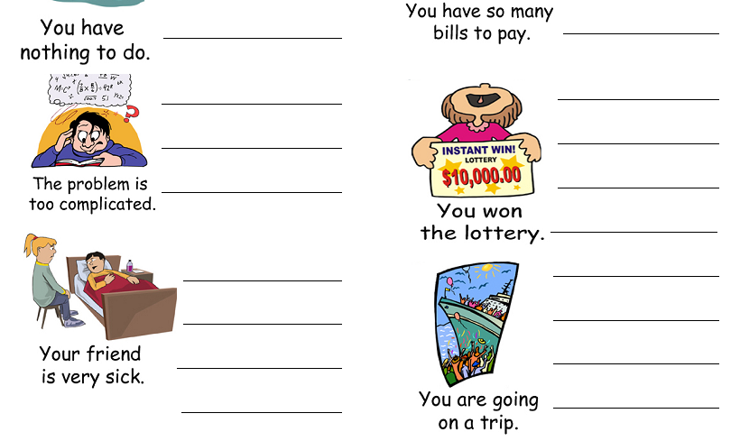

Worksheet4 (Discussion)

GRAMMAR DISCUSSION ‘ED’ and ‘-ING’

Student ‘A’
 Discuss the questions below with your partner.

1. What kinds of TV programs are you interested in?

2. When was the last time you were embarrassed?

- What makes you feel relaxed?

- Do you feel tired after class? Why, or why not?

- Were you satisfied with the test results of your last grammar test?

--------------------------------------------------------------------------
Student ‘B’
 Discuss the questions below with your partner.

- What kinds of TV programs do you think are boring?

- Talk about something you think is fascinating.

- Talk about some surprising news you heard or read about.

- Did you ever see something that was terrifying? What?

- What kinds of activities do you think are exciting?

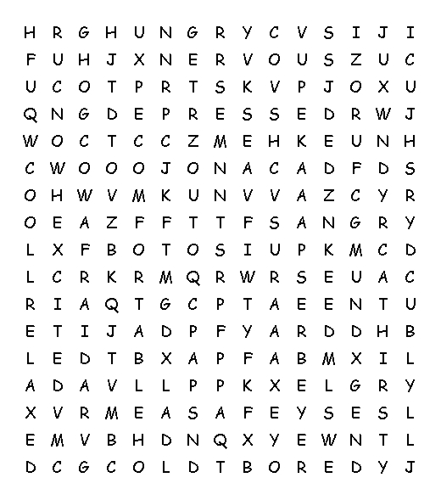 |  |  | Find the words below in the grid to the left.  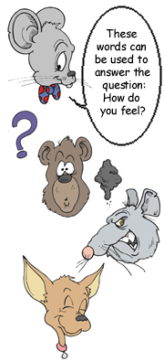
afraid  angry  bored  cold  comfortable  confused  cool | depressed  excited  happy  hot  hungry  nervous  relaxed | sad  safe  thirsty  tired  uncomfortable  warm

Realia

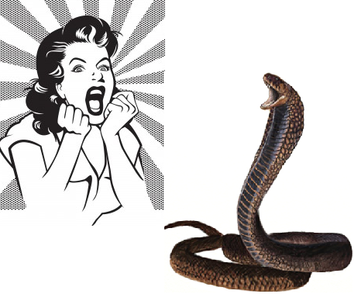

Worksheet 1 Answer

- Confusing
- Embarrassed
- Interested
- Annoying
- Relaxing
- Tiring
- Depressed
- Satisfied
- Worrying
- .Terrifying

Worksheet 2 Answer

- B
- F
- E
- C
- D
- A
- H
- J
- G
10. I

Worksheet 3,4 no answer
Sos activity Answer
