☐ Listening ☐ Speaking ☐ Reading ☐ Grammar ☐ Writing
Topic: When I was young…

Instructor:  Ji weon park | Level:  intermediate | Students:  9 | Length:  30 Minutes

Materials:

- Song <used to> (play time 00:45~01:40)
- 9 copies Worksheet 1: <Let’s guess> gap fill
- The word cards ( use, d, to, verb)
- PPT <The substitution table>
- 9 copies Worksheet 2: <When I was young…(1)> rewriting
- 9 copies Worksheet 3: <When I was young…(2)> brainstorming
- 9 copies Worksheet 4: <When I was young…(3)> life graph
- 9 copies SOS: <times of the year>

Aims:

1. Main aim: Students will learn ‘used to’
2. Secondary aim: Students will learn how to use ‘used to’ when they speak
3. Personal aim: Students will be share their stories and familiar with their partner.

Language Skills:

- Listening: To do gap fill by listening the song ‘used to’
- Speaking: To share their stories which they did in the past.
- Reading: To read questions on worksheets
- Writing: Taking a note brainstorming and freewriting about life graph.

Language Systems:

- Phonology: Using contractions (used to /usta/, ues to /usta/)
- Lexis: Everyday word (sports. Habits, routine, life graph)
- Grammar: Being familiar with ‘used to’
- Function: Describing my past habit, using ‘used to’
- Discourse: Speaking about past habit

Assumptions:

1. Students know present and past tenses.
2. Students have experienced writing ‘‘brainstorming’
3. Students know how to draw life graph.

Anticipated Errors and Solutions:

1. If students have confusing between past tense and ‘used to’ form.
> show them time line.
2. If students have hard time with brainstorming
> give them some topic words.

References:

‘Used to’ song - https://www.youtube.com/watch?v=yMDcRUSmRvk

Lead-In
Materials: N/A
Time | Set Up | Student Activity | Teacher Talk
2min | Whole class | Greeting | T: Hello, students.  How are you today?  Today, we’re going to talk about our past stories. Do you ready for share your stories? Then, let’s start the class.

Presentation
Materials:
Worksheet 1 <Let’s guess>
The word cards ( use, d, to, verb)
PPT <The substitution table>
Time | Set Up | Student Activity | Teacher Talk
5 mins | Whole class | Worksheet 1  And listening song  Grammar explanation  Repeat | (Distribute the worksheet 1 ‘Let’s guess’)  Instruction  T: I’m going to play the song, listen carefully and fill out the blank.  (Play the song ‘used to - Mutemath’  to 00:40 from 01:35)  T: How was the song? Did you get all the blank? Do you want repeat it one more?  (if they want repeat one more.)  Let’s check answer together. Shall we guess which topic we will learn today?  Instruction  T: Alright, today we’re going to learn about ‘used to’ form.  (Put the word card on the board)  T: before we start. Check the pronunciation first. How can you pronunciation ‘use to’ and ‘used to’?  S: used to, use to….  T: (show the pronunciation key) Both have same pronunciation. Repeat after me.  T: ‘used to’ is using for when you talking about past habits and past stages in life. ‘Used to’ expresses that an activity was a past habit that occurred at earlier stage of life, but is no longer performed in the present. Also, it can be used to describe past stages. Let’s see the timetable here.  (Draw the timeline.)  T: the action was happened in that period. But not anymore. It was stopped in the past.  Instruction  (Show the substitution table PPT)  T: Now let’s make sentences. ‘Used to’ is always followed by a base verb.  T: and how to change with negative and question?  Drill  ‘used to’  - I used to walk more often.  =Do I walk theseday? (No)  - I used to eat meat.  =I don’t eat meat any more. (Yes)  ‘didn’t use to’  - I didn’t used to study English.  = Now I study English. (Yes)  - I didn’t used to play video games.  = I don’t play video games. (No)  CCQ  -When do we use used to form? Explaining action in now? (No, for explaining in past habit)  -how to pronounce ‘use to’ and ‘used to’? (same)

Practice
Materials:
- Worksheet 2 <When I was young…(1)> -rewriting
- Worksheet 3 <When I was young…(2)> -brainstorming
Time | Set Up | Student Activity | Teacher Talk
18  Mins  (5mins)  (13  mins) | Individually  pairs | Rewriting  Worksheet  Brainstorming  worksheet | (Distribute the worksheet 2 ‘rewriting’)  T: now, Let’s practice which we learned. Look at the worksheet. There are two sentences. Using two sentences and rewrite it as a one sentence. I’ll give you 5mins.  T: done? Let’s check the answer.  CCQ  1. How many sentences have after rewriting? (one)  2. How many minutes do we have?  (after 5mins)  T: Let’s check the answer together.  (Distribute the worksheet 3 ‘brainstorming’)  T: next, we’re going to fun activity. Do as the pair.  Instruction  1. Make a pair  2. Brainstorming topics which is ‘when I was young..’ and ‘now…’  2. (show them demo)  A: What did you use to eat when you were young? What do you like to eat now?  B: When I was young, I used to eat pizza. Now I eat vegetable.  3. Give 5minutes for brainstorming  4. Ask partner about the brainstorming topics.  5. Give 8 minutes for activity.  ICQ  1. What is the first thing we should do? (brainstorming)  2. How many minutes do we have? (8mins)  (after finish the activity)  T: Let’s share the ideas.

Production
Materials:
- Worksheet 4 <When I was young…(3)> -life graph
Time | Set Up | Student Activity | Teacher Talk
5  mins | pairs | Draw life graph | (Distribute the worksheet 4 ‘life graph’)  T: we are going to draw life graph.  (show the demo how to draw life graph)  Instruction  1. Draw a picture graph about your life.  2. You were happy that age the line goes up and you were unhappy that age the line goes down.  3. Write your experiences by period.  4. Give 5 minutes.  5. Talk about your life with your partner.  T: Did you have fun?

SOS Activity
Materials:
SOS <times of the year>
Time | Set Up | Student Activity | Teacher Talk
 | Pairs | Cross word | (Distribute the SOS)  Instruction  Crosswords about ‘times of the year’  Read and find out the words. Work with as a pair.  ICQ  1.Do you do it alone? (No)

Worksheet 1:
Let’s guess!

I’m hardly moving on
The proof in is in the song
Remembering how
I (1) ____ __ feel alive
I (2) ____ __ want to
I (3) ____ __ be all right
I (4) ____ __ love you
I (5) ____ __ never feel like I do now
I (6) ____ __ never feel like I do now
I (7) ____ __ walk on air
I (8) ____ __ care
I had no fear of falling
I (9) ____ __ never feel like I do now

Let's guess what we learn today. Are we going to learn about...?
“ ____________ ”

The word cards:

use
d
to
verb
/juːstə/

PPT: The substitution table

1page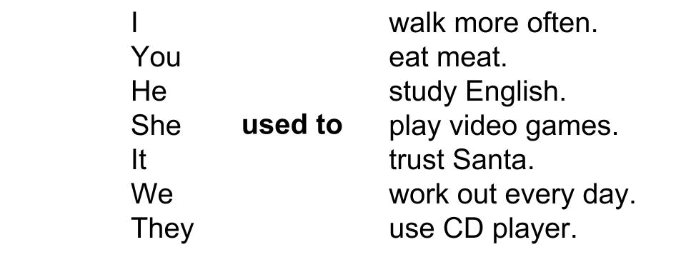
2page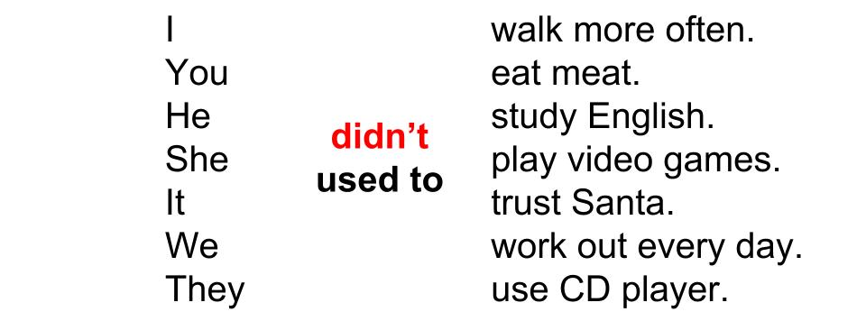
3page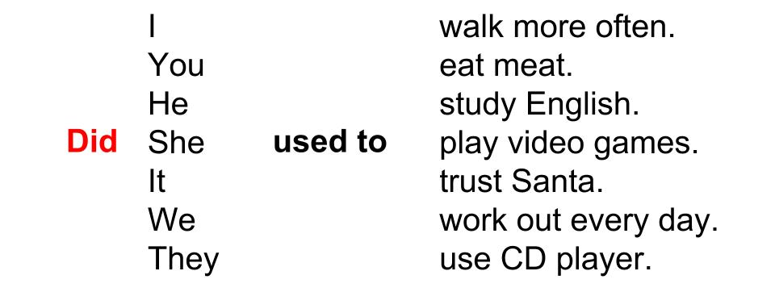

Worksheet 2:
When I was young…(1)
Rewrite the sentences below using “used to”
1. Last month, I rode my bicycle to school. Now, I don’t ride my bicycle to school.
I used to ride my bicycle to school.

2. Ten years ago, I studied Japanese. Now I don’t study Japanese.

3. Last year, my classmate didn’t study hard. Now, he studies hard.

4. When I was young, I was lazy. Now I’m not lazy.

5. When Sarah was younger, she was short. Now, Sarah is tall.

6. Ten years ago, I play soccer. Now I play baseball.

7. Ten years ago, my sister look like a cute rabbit. Now she look like wild rabbit.

8. When I was a child, I lived in Seoul. Now, I live in LA.

9. When you were a kid, my favorite food was pizza. Now, my favorite food is oatmeal.

10. 5 years ago, my friend had a cat. Now, she don’t have any pet.

Worksheet 3:
When I was young…(2)

Let’s brainstorming topics.

When I was young...
hobbies
Food

Sport
games

Ask your partner about your topic.
Question: When you was young. Did you use to play soccer ?
Answer: When I was young, I used to play soccer, but now watch on TV.
Or When I was young, I didn’t use to play soccer, but now play soccer.

Worksheet 4:
When I was young…(3)

Draw a picture graph. Talk about your life in those days.

Happy
ages | 5 | 8 | 15 | 18 | 20 | 25 | 30 | 35 | 40
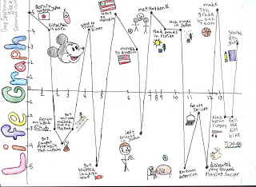
Unhappy

E.g. When I was 10 years old, I used to play tennis. I didn’t use to play badminton. Because, …… (following sentences)
SOS:
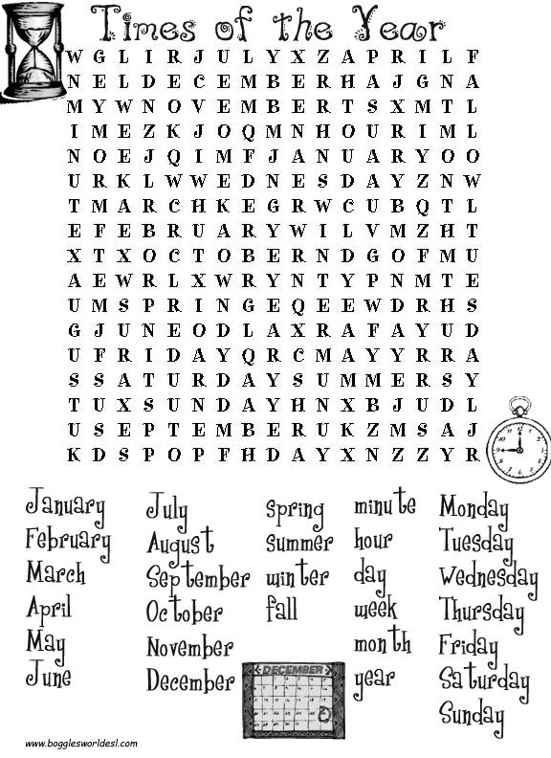

Worksheet 1: Answer
Let’s guess!

I’m hardly moving on
The proof in is in the song
Remembering how
I (1) used to feel alive
I (2) used to want to
I (3) used to be all right
I (4) used to love you
I (5) used to never feel like I do now
I (6) used to never feel like I do now
I (7) used to walk on air
I (8) used to care
I had no fear of falling
I (9) used to never feel like I do now

Let's guess what we learn today. Are we going to learn about...?
used to

Worksheet 2: Answer
When I was young…(1)
Rewrite the sentences below using “used to”
1. Last month, I rode my bicycle to school. Now, I don’t ride my bicycle to school.
I used to ride my bicycle to school.

2. Ten years ago, I studied Japanese. Now I don’t study Japanese.
I used to study Japanese.

3. Last year, my classmate didn’t study hard. Now, he studies hard.
He didn’t use to study hard.

4. When I was young, I was lazy. Now I’m not lazy.
I used to be lazy.

5. When Sarah was younger, she was short. Now, Sarah is tall.
Sarah used to be short.

6. Ten years ago, I play soccer. Now I play baseball.
I used to play soccer.

7. Ten years ago, my sister look like a cute rabbit. Now she look like wild rabbit.
I used to look like a cute rabbit.

8. When I was a child, I lived in Seoul. Now, I live in LA.
I used to live in Seoul.

9. When you were a kid, my favorite food was pizza. Now, my favorite food is oatmeal.
I used to play with action figure.

10. 5 years ago, my friend had a cat. Now, she don’t have any pet.
She used to have a cat.

SOS: Answer
