Pre-Activity

Take a tour of London by listening to this tour guide and do the exercises to practice your listening skills. Preparation Do this exercise before you listen. Draw a line to match the pictures with the words below.
Do this exercise before you listen. Draw line to match the pictures with the words below.
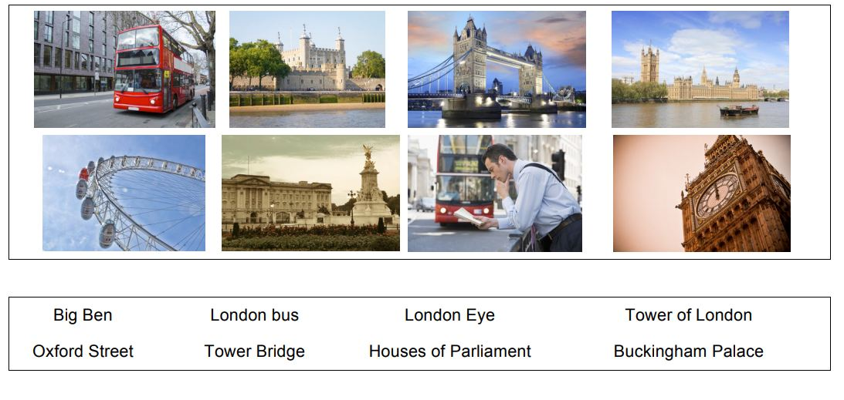

CCQ[Following questions]
Have you ever been to any of these places?
Where did you go? How was it?
Have you ever experienced bus tour abroad then?
Let’s talk about the weather of London.
What is the origin of afternoon tea?

Main activity

Check your understanding: Ordering
Do this exercise while you listen. Write a number(1-8) to put these places in order that the tour bus will visit them.
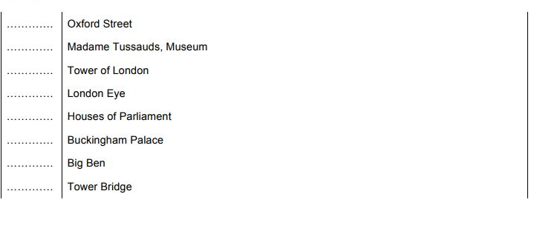

2. Check your understanding: Multiple choices.
Circle the best word to complete these sentences.

Post Activity

Debates
- Have you ever experienced unexpected rain while you travel? If you were the tour guide, what would you do?
- Does the tour guide have to refund the money to the travellers?
- Have you ever experienced bus tour in other countries? What are the advantages and disadvantages of it?

SOS activity
Role-Play
Work in a pair as a tour guide and a guest.

- Choose a city which you want to introduce.
- One is a tour guide and the other is a guest.
- Introduce at least 3 attractions of the city.
- Assume that it suddenly rains during the tour.
- Demonstrate the role-play to other students.

