☐ Listening ☐ Speaking ☐ Reading ☐ Grammar ☐ Writing

Topic: Disaster

Instructor:  Alastor & Jiwon | Level:  intermediate | Students:  8 | Length:  30 Minutes

Materials:
- 7 pictures ‘disaster’
- Vocabulary presentation file
- board
- marker
- globe(paper)
- News article
- worksheet:
- 1.vocabulary gap fill worksheet
- 2.Question worksheet
- 3.write your opinion essay worksheet
- 4. crossword worksheet for SOS

Aims:

Main aim- Students will improve their reading skill by reading a news article & answering question worksheet.
Secondary aim- Ss will learn new vocabulary in the preparation stage.
Personal aim- T will elicit more answers by asking CCQs.

Language Skills:

Listening- Ss will listen T’s explanation of vocabulary and CCQs.
Speaking- Ss will discuss after reading article(discussion worksheet)
Reading- reading a news article
Writing- Ss will write an essay on writing worksheet in post-activity stage

Language Systems:

Phonology - “-ed”, contraction “as of”, “out of”, “expect to” etc
Lexis - province, magnitude, properties, destroy, tremor, sustain, restore
Grammar - past tense(article), second conditional(writing essay)
Function - giving information, giving suggestion(essay write)
Discourse- new article, Ss discussion

Assumptions:
- Ss already know there was earthquake in Pohang
- Ss are confidently express their opinion in class
- Through the media, Ss gained knowledge of disasters worldwide.

Anticipated Errors and Solutions:
- Ss are not accustomed to disasters that rarely happen in Korea.
> Give more specific examples of disasters.
- Ss can have difficulty when they are looking for answer(gap fill, T/F)
> T will give hint where they can find answers.
- Ss might not finish post activity in class.
> let them write essay as a homework.

References:
News article - https://goo.gl/agAXro
Globe development - www.progonos.com/furuti

Lead-In
Materials: Board, Marker
Time | Set Up | Student Activity | Teacher Talk
1 | whole class | greetings | Procedure:  Greeting:  Good morning everyone!  how are you today?  (Ss greetings)  we are going to start today’s lesson.

Pre-Activity
Materials:
- 7 kinds of pictures ‘disaster’
- Sellotape
- monitor
- computer
- Paper Globe
- Red sticker
- Korea map(cut by province)
- 8copies of Vocabulary gap fill worksheet
Time | Set Up | Student Activity | Teacher Talk
10min | Whole  class |  | Procedure:  Guiding Questions:  - what natural disaster do you know?  -> Ss answers(earthquake, mountain  fire, flood, drought. etc)  (T will attach pictures what Ss answer)  - do you know what country is common with each disaster?  (T will write country under picture according to Ss answer)  T: Ok, these are natural disasters. have you ever experienced? I recently felt earthquake when there was earthquake in Pohang. anyone felt earthquake on that day?  before we go to the next stage, we will learn some of new vocabularies.  Vocabulary  (T will display PPT on the monitor after eliciting, explain every vocabulary)  1. Province  (T will prepare Korean map cut by province and will attach them on the board one by one)  T: what is this?  (Ss answer Gyeonggi Do and T will put another map(province) and will ask to Ss same question again until complete korean map is made.)  T: OK. So, each of this is, we call it ‘province’  CCQ:  - Korea is combination of what?  (province)  2. Magnitude  (T will show Globe to Students)  T: what is this? I will show you strenth of each magnitute.  magnitute 1(T will shake the globe and table gently)  .  Magnitute 9(T will shake the globe and table strongly)  T: so, magnitute means strength of earthquake.  CCQ:  - which is storonger M1 or M5?(Magnitute 5)  3. Tremor(photo)  (T will show Ss photo on monitor)  T: what can you tell when you see this picture.  (Ss answer synonym - shake, quake)  T: Yes, similar meaning of shake, quake is “Tremor”. you can say tremor with little shaking.  CCQ:  - is tremor big shake?  4. Properties(acting)  (T will acting. T1 will sitting in the chair and reading a book. T2 will put red sticker on everywhere)  T1: what are you doing? these are my property!  T2: Ok. property means something belong to someone. this classroom is belongs to me but now it is Jiwon’s.  CCQ:  - Is this book belongs to me?(yes)  - what is your property?(Ss will show their property to classroom)  5. Destroy (paper globe - realia)  (T will show paper globe)  T: Let’s see what i am doing.  (T will destroy paper globe)  T: what am I doing?  (Ss will answer - breaking etc)  T: yes, if you break or something is broken, we can use the word destroy  CCQ:  - Can I use destroy instead of break?(yes)  6. Restore(paper globe - realia)  (T will reassemble destroyed paper globe)  T: Can you tell me what i am doing?  (Ss will answer - reassemble, rebuilding, making again etc)  yes, you are right and we can also say restore.  CCQ:  - what is the synonym of reassemble, rebuilding?  7. Sustain  (T will show antonym on monitor)  T: can you tell me what is opposite words of “uncontinuos”?  (Ss will answer - maintain, continue, restain, carry on, keep up etc.)  T: today’s word is sustain and it has same meaning with maintain & continue.  (T will distribute vacabulary worksheet)  T: this is vocabulary worksheet. please fill the gap before we go to next stage.  T:Great! now let’s read!

Main Activity
Materials: 8 copies of worksheet 2 ‘Pohang earthquke damage’
Time | Set Up | Student Activity | Teacher Talk
3min  5min  6mins | individual  in pair  whole class & pair | Ss will do skimming  Ss will read and answer the literal questions.  Ss will check the answers together. | Procedure:  (T will distribute news article)  T: let’s read news article first! just do skim-read. I will give you 2 minutes. let’s go!  (after skimming)  CCQs:  - Will you memorise every detail?  T: Ok, what is the main story?  (Ss will answer earthquaqe)  (T will distribute question worksheet)  T: now I will give you worksheet with questions. Let’s read the article carefully, and fill the qap and answer True or False questions. once you finish you will check the answer with your partner. I will give you 5minutes.  (after Ss read the article and check the anwer with partner)  T: good. let’s check the answer together.  (T will check the answer with whole class)  Ok, now we will talk about next questions.  we will discuss in pair, let’s discuss quesitons on worksheet.  (give them 5mins)  T: Ok, that’s enough. Is there any interesting title? Let’s go to the next step.

Post Activity
Materials: 8copies of ‘write your opinion about’ essay worksheet
Time | Set Up | Student Activity | Teacher Talk
5 | whole class | Ss write an essay | Procedure:  (T will distribute essay worksheet)  T: now we are going to write an essay. shall we read the topic together?  (T & Ss will read the topic together)  T:as we have two topics, you can choose one  of them and write an essay. try to use  vocabularies what we leart today as many as  possible. working alone.  Wrap up:  T: Good. if you do not finish, you will do your  essay for homework.  what did we learn today?  (Ss answer: Disaster)  Ok, I hope you to do more reading after this  class as it will improve your english a lot.  see you next week!

SOS Activity
Materials: SOS sheet
Time | Set Up | Student Activity | Teacher Talk
Left time | Individually | Match the occupation  on SOS | Procedure:  Distribute the ‘crossword worksheet’  T: Read the each sentence below and complete the wordcross.

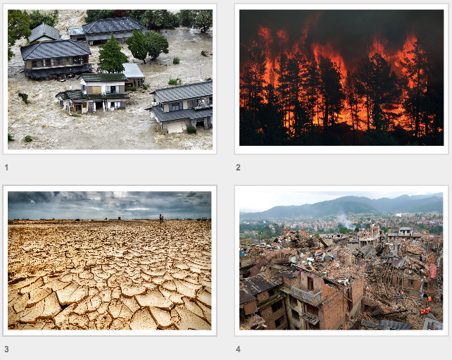
Pictures: The Pictures of disaster.

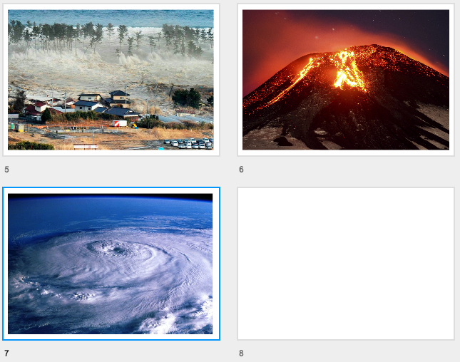

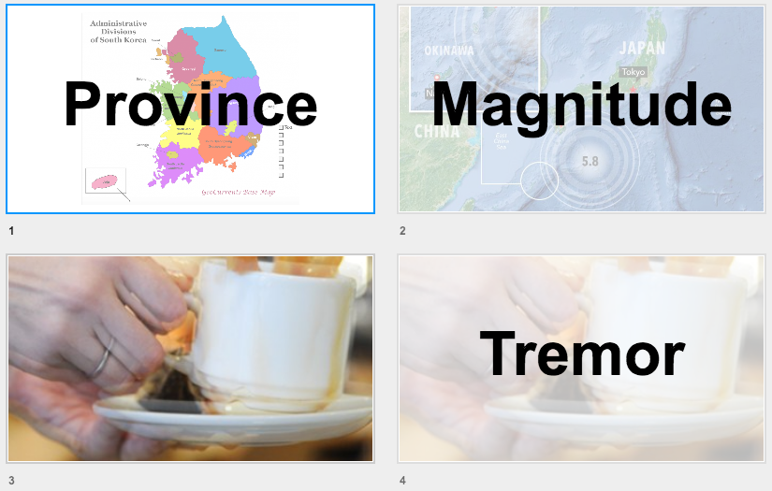
Vocabulary: ppt.
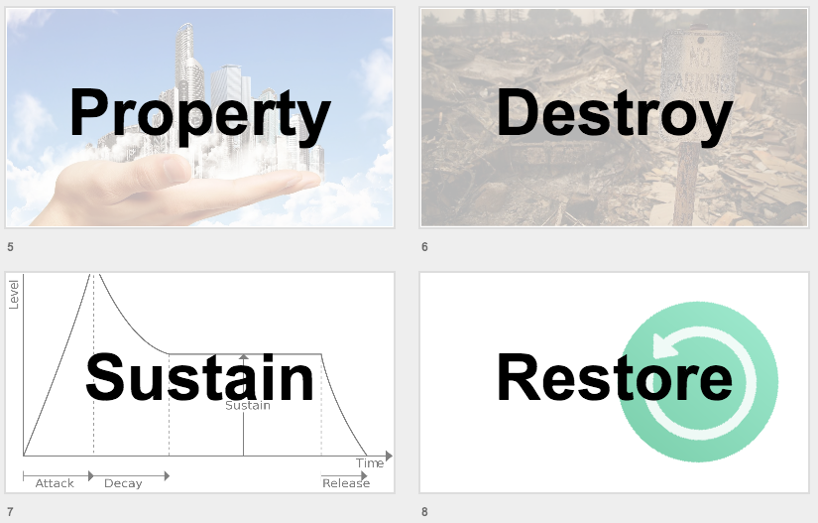

1.Vocabulary Worksheet
Pohang quake damage.

- a large section of a country which has its own administration.
[ The show will tour the _______s after it closes in London. ]

- strength of earthquake.
[ A _______ of 5.4 earthquake broke out in Pohang. ]

- a small earthquake.
[ It was just an earth _______. ]

- all the things that belong to them or something that belongs to them.
[ Richard could easily destroy her personal _______ to punish her for walking out on him.]
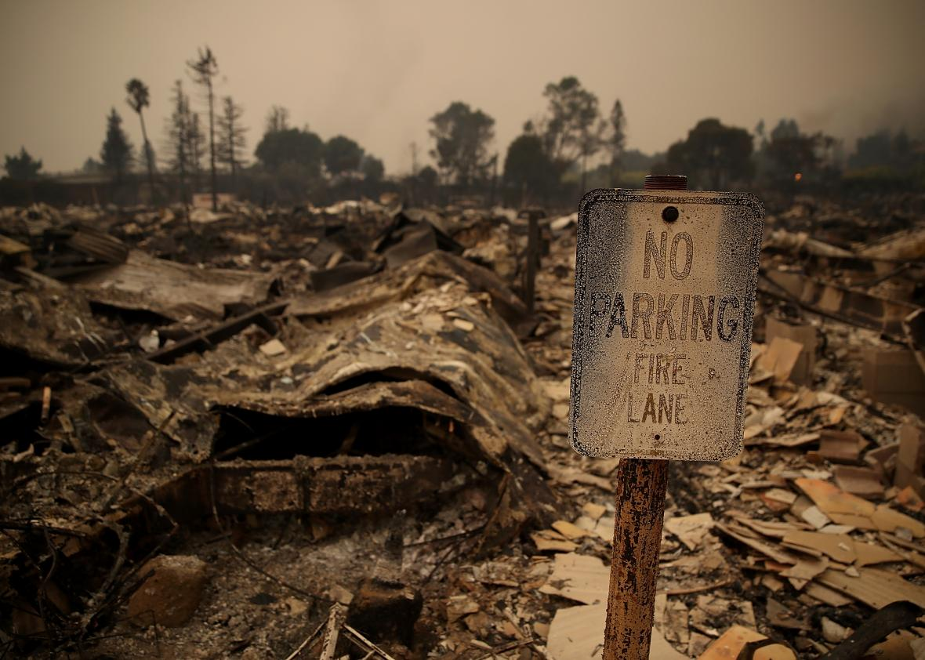

- To _______ something means to cause so much damage to it that it is
completely ruined or does not exist any more.
[ That's a sure recipe for _______ing the economy and creating chaos. ]

- To _______ a situation or practice means to cause it to exist again.
[ The police are trying to _______ public order. ]

- If you _______ something, you continue it or maintain it for a period of time.
[ Our business will _______ its growth trend for next year ]

1.Vocabulary worksheet with answers:
Pohang quake damage.

- province
- a large section of a country which has its own administration.
[ The army has recently been brought in to restore order. ]
- magnitude
- strength of earthquake.
[ A magnitude of 5.4 earthquake broke out in Pohang. ]
- tremor
- a small earthquake.
[ It was just an earth tremor. ]
- property
- all the things that belong to them or something that belongs to them.
[ Richard could easily destroy her personal property to punish her for walking out on him.]
- destroy
- To destroy something means to cause so much damage to it that it is
completely ruined or does not exist any more.
[ That's a sure recipe for destroying the economy and creating chaos. ]
- restore
- To restore a situation or practice means to cause it to exist again.
[ The police are trying to restore public order. ]
- sustain
- If you sustain something, you continue it or maintain it for a period of time.
[ Our business will sustain its growth trend for next year ]

News article:
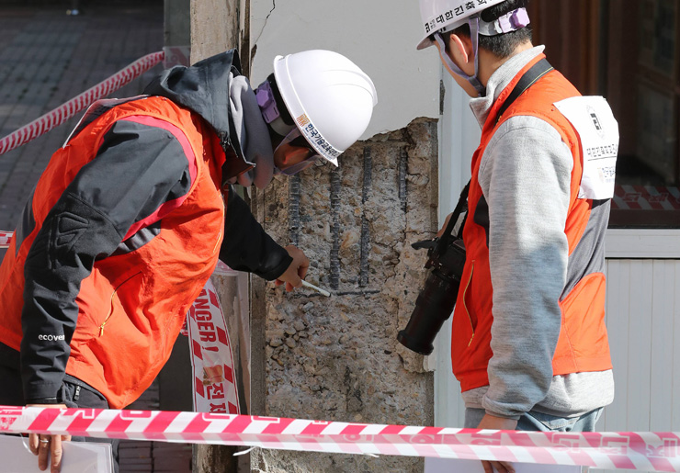
Pohang quake damage.(1)
Architectural Institute of Korea experts check Heungae Elementary School in Pohang, North Gyeongsang Province, Nov. 18, after the 5.4-level earthquake there. / Yonhap
Some 2,000 houses have been damaged by a series of earthquakes as strong as 5.4 magnitude that hit the southeastern city of Pohang last week, the Ministry of Interior and Safety said Sunday.
According to the ministry's National Disaster and Safety Control Center, 2,165 private properties have been reported to have been affected as of 5 a.m. Sunday by the earthquakes, of which 1,988 are private houses.
The most frequent damage was done to roofs, with 1,789 cases being filed. The number of houses almost destroyed stood at 52, while those seriously damaged was 157. Ninety shops and 77 factories have been damaged.
The country's second strongest tremor and a series of aftershocks that hit the port city starting Wednesday have left 498 public properties destroyed.
A total of 227 schools, including 107 in Pohang, 44 in Ulsan and 26 in Daegu, sustained cracks in their walls. Of the 227 schools, 110 were elementary schools, followed by 54 middle schools and 52 high schools.

Other damaged buildings include 79 public offices and parks, 23 port facilities and seven roads.
In the wider area, 11 bridges -- six out of 182 in Pohang -- sustained minor damage.
"It remains to be seen how big the aftershocks will be, but as of now, we expect to suffer no major disruption to traffic," a Pohang city official said.
The Korea Expressway Corp. said five bridges on the Pohang-Daegu highway sustained damage, such as chunks of concrete falling off the bridge bearings and shear keys being bent.
"They are minor problems and have no impact on traffic. We will complete the restoration shortly," the company said.
So far 82 people have been treated for injuries at hospitals. Of them, 15 are hospitalized.
A total of 1,124 people have been displaced and are living in 11 temporary shelters.
Nearly 20,000 people have been mobilized for restoration works, and more than 80 percent of the 2,663 damaged properties have been restored, the center said.
2. Question Worksheet:
Pohang quake damage.(2)
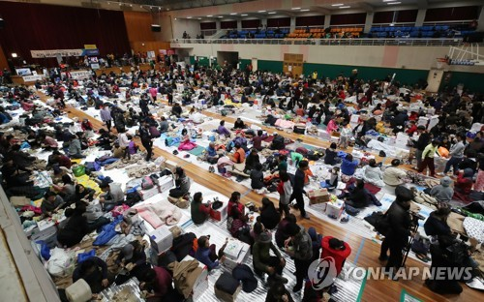
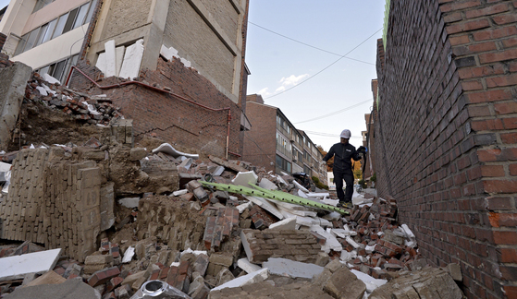
- Literal
1. Fill out the colum.
Where | When | What kinds of disaster was happened | Magnitude | How many people  were seriously injured

True or False
2. The big aftershocks came up and it caused damage on many properties.
3. Many other properties has been damaged but schools were not damaged.

-Interpretive
1. What happened after the earthquake?
2. why so many of buildings were destroyed?

- Appiled
1. Create new title for this article.
Title: _________________________________________________

2. What do you think is one of the most dangerous disasters?
2. Question Worksheet with answer:
Pohang quake damage.(2)
- Literal
1. Fill out the colum.
Where | When | What kinds of disaster was happened | Magnitude | How many people  were seriously injured
pohang | last week | earthquake | 5.4 level | 15

True or False
2. The big aftershocks came up and it caused damage on many properties.
3. Many other properties has been damaged but schools were not damaged.

-Interpretive
1. What happened after the earthquake?
2. why so many of buildings were destroyed?

- Appiled
1. What would you do if there is an earthquake ?
2. Create new title for this article.
Title: _________________________________________________

Worksheet 3:
Write your opinion about...

Choose one of the two questions and write down your opinion.
1. If you had the power to stop a natural disaster that has
happened in the past, which would you choose? Why?

2. Are you prepared for a disaster? What can you do to prepare for a disaster?

Title: ____________________________________

___________________________________________________________________
___________________________________________________________________
___________________________________________________________________
___________________________________________________________________
___________________________________________________________________
___________________________________________________________________
___________________________________________________________________
___________________________________________________________________
___________________________________________________________________
___________________________________________________________________
___________________________________________________________________
___________________________________________________________________
___________________________________________________________________
___________________________________________________________________

Realia:
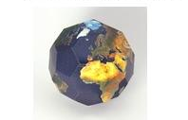
- grove development
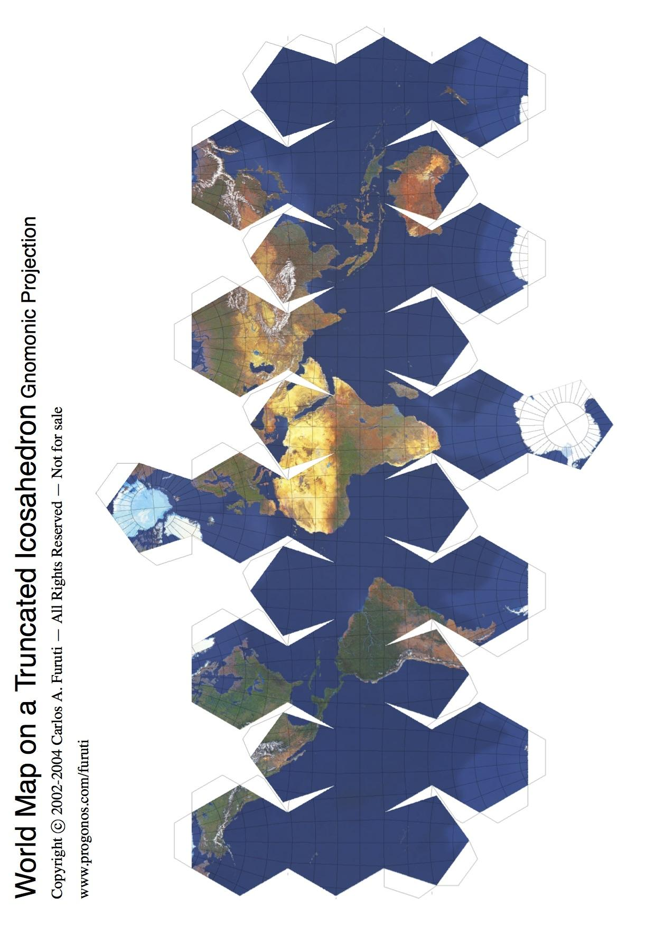
- Authority
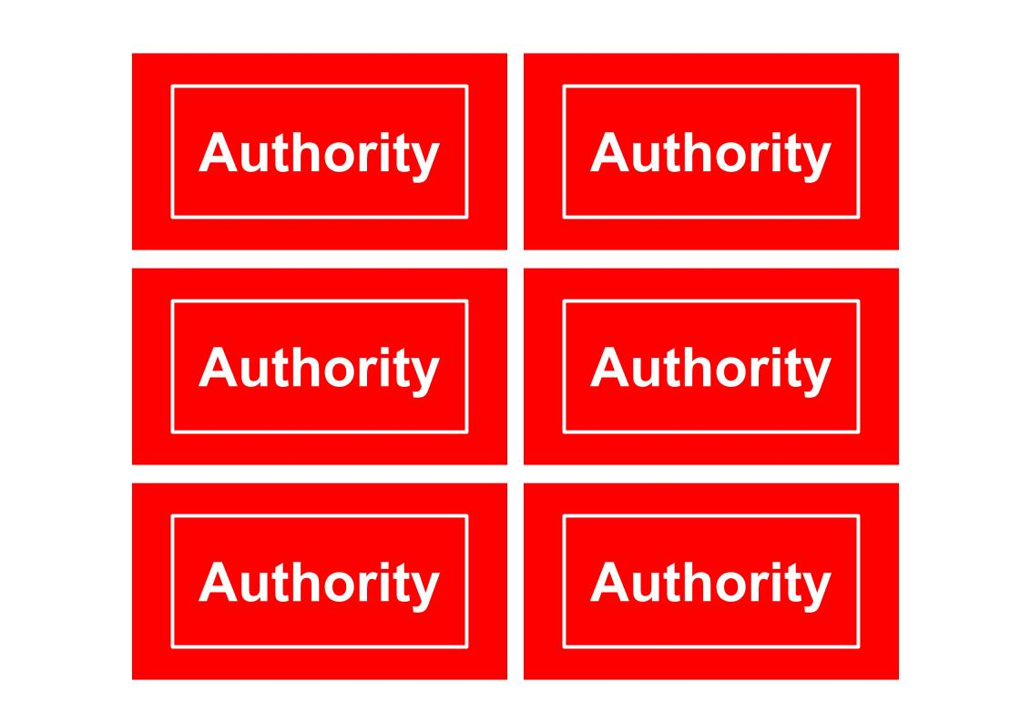

SOS: Crosswords
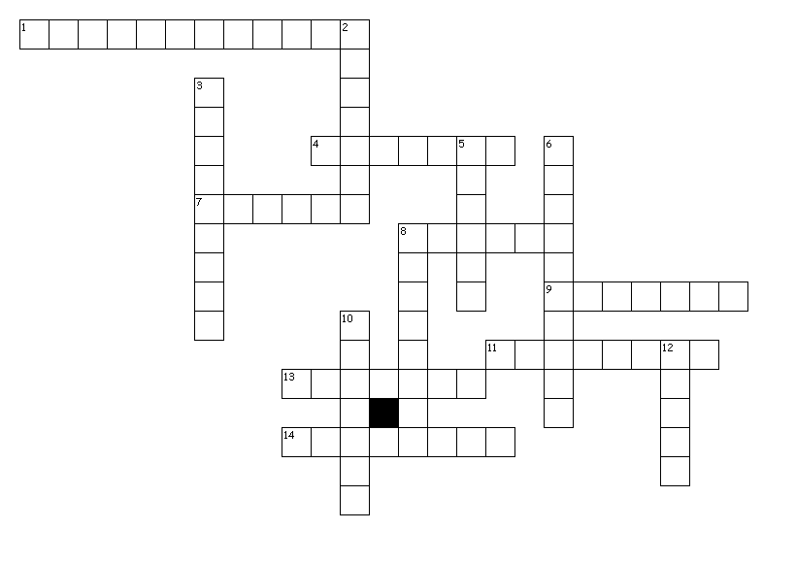
Pohang quake damage.
Across
1. If someone is ____, they are sent or admitted to hospital.
4. are owned or controlled by an individual person or a commercial company, rather than by the state or an official organization.
7. is damage done to a person's or an animal's body.
8. to break it, spoil it physically, or stop it from working properly.
9. a small building or covered place which is made to protect people from bad weather or danger.
11. a large section of a country which has its own administration.
13. If you ____ something, you continue it or maintain it for a period of time.
14. all the things that belong to them or something that belongs to them.
Down
2. to cause so much damage to it that it is completely ruined or does not exist any more.
3. If you talk about the ____ of something, you are talking about its great size, scale, or importance.
5. a small earthquake.
6. smaller earthquakes which occur after a large earthquake.
8. If one thing ____ another, it forces the other thing out of its place, position, or role, and then occupies that place, position, or role itself.
10. to cause it to exist again.
12. are thick solid pieces of it.
SOS: Answer
Pohang quake damage.
Across
1. hospitalized
4. private
7. injury
8. damage
9. shelter
11. province
13. sustain
14. property
Down
2. destroy
3. magnitude
5. tremor
6. aftershock
8. displace
10. restore
12. chunk

