☐ Listening ☐ Speaking ☐ Reading ☐ Grammar ☐ Writing

Topic: Bezos Seizes Title Of World’ s Richest Person After Amazon Soars

Instructor:  Jess  Karen | Level:  Upper Intermediate | Students:  8 | Length:  30 Minutes

Materials:

- Board & Marker
- PPT ( To explain meaning of vocabularies)
- Projector
- (Vocabulary) Pictures
a. vaulting
b. surge
c. Bloomberg
d. Juggernaut
e. Estimates(picture)
f. Eclipsed
g. Intraday

- Video Clip

(Worksheets)
- Handout
- Worksheet 1: Vocabulary
- Worksheet 2: Comprehension
- Worksheet 3: Interview
- Worksheet 4: Cross words : SOS

Aims:

Main aim: Ss improve reading skills by skimming the reading text and answering comprehension questions.

Secondary aim: Ss will improve speaking and listening ability by sharing ideas by discussing topic.

Personal aim: T will try to elicit more answers from Ss by asking questions in pre-task stage

Language Skills:

Listening - Teacher’s explanation of word meanings and others opinions of topic

Speaking – Students will give opinions to others while they are doing discussion

Reading - reading the article by handout
g s
Writing - answering comprehension worksheet

Language Systems:

Phonology - Speaking and listening from Teacher and students using

Lexis - Vocabulary used from article
(ex: vaulting, surge, Bloomberg, Juggernaut, Estimates, Eclipsed, Intraday )
Grammar - Making complete sentence using…
(ex: I agree or disagree…..)
Function - Assuming and guessing..
Discourse - Have conversation with a partner

Assumptions:

1.  Students might not be familiar with Bezos.
●
2. Students know how to skim and scan the article.
●
3.. Students may not know some vocabularies in article.

Anticipated Errors and Solutions:

- The times is not enough to write the sentences
> the sentences that is incomplete can be said to be just plain speaking

- Students might understand meanings of vocabularies during the class.
>T will put the words flashcards with key meanings on the board

- Students may take longer than expected to complete task.
> T will give more time to think and encourage Ss to finish the task.
> give examples

References:
Article: goo.gl/ZCDufn
Video: goo.gl/yHaPg6

Vocabluary pictures
Intraday- goo.gl/yj8wk1
Estimate-goo.gl/vZ8kFo
Surge-goo.gl/EBVszs
Juggernaut- goo.gl/RO4GN9
Eclipsed- goo.gl/EdReks
Vault- goo.gl/hpuJ9B

Lead-In
Materials: n/a

Time | Set Up | Student Activity | Teacher Talk
1min | Whole class | Greetings | Greetings  T: Hello everyone!  How was your weekdays? Anything interesting?  Have you seen this person?  (Ss answers)  I will show video and you can guess who it is!  (Tshows video of Bezos)

Presentation
Materials:
- Board & marker
- Projector

(Vocabulary) Pictures
- a. vaulting
- b. surge
- c. Bloomberg
- d. Juggernaut
- e. Estimates(picture)
- f. Eclipsed
- g. Intraday

- Video Clip
- Worksheet 1: Vocabulary
Time | Set Up | Student Activity | Teacher Talk
1mins  5mins  3mins | Whole class | Student Activity  Watching video  Learn new vocabularies  Do matching right word worksheets | Teacher Talk  Introduction of task  (write on the board “Rich”)  T: Do you know who was on the screen?  (Ss answered)  Bezos is the Amazon's chief and the richest person in 2017!  T : Today we are going to read Bezos’s article who is the richest person in the world.  Before we start to read, let’s learn some vocabularies in today’s article first!  Vocabularies  (T shows 6 pictures and explan meaning of new vocabularies.After T explains meaning of vocabularies and putting meaning flashcards on the board and gives matching the words worksheets to students for understanding firmly.  #1 Surge  T: What can we see in this picture?  (Ss answered)  We can see the big waves are coming! .  Surge means a sudden, strong increase or burst  Teacher gives an example sentence  =The gates opened and the crowd surged forward.  #2 Vault  T: Can you see the athelte jump over high?  Vault means Rising or reaching very high.  #3 Juggernaut  T: Do you recognize that character on the screen? His name is Juggernaut from the X-men movie!  Juggernaut means a massive force, movement, or object that crushes.  #4 Estimate  T: What is he thinking?  There are many things to estimate in everyday life such as cost, times, skills.  Estimate is to judge approximately of value, worth, or significance  =She estimates the cost of a college education for children.  #5 Eclipse  T: Can you explain that picture?  Eclips means Blocking and covering  #6 Intraday  T: The chart showing intraday numbers.  Money of day trading .  Intraday is another way of saying  "within the day".  How many vocabularies did we see?  (Ss answered)  T Points out vocabularies again  T : Here is your mathing the word meanings worksheet. Find the right pitures to right meanings as drawing line!  You have 3mins.  CCQ:  1. How many vocabularies did we learned?  (six)  2. What do we have to find?  (Right meaning )  3. How much time do we have?  (4mins)  After Ss finish worksheet each students give their answers in turns.  Well done!  Let’s move on to the next activity

Practice
Materials:

- Handout : Reading Activity
- Worksheet 2: Comprehension

Time | Set Up | Student Activity | Teacher Talk
8mins | Whole class | Read the article from Handout | Instruction  This time we are going to read an article.  Please get one and pass  (Distribute Handout to Ss.)  Read this article carefully.  You can underline and highlight it.  You have 3 minutes.  CCQ:  How many minutes are you given?  (Ss response 3mins)  (Let Ss read it.)  Do you need more time to read?  (If Ss say Yes, give them 1 min  If Ss say No, proceed to next activity)  Alright, who is “Jess Bezos”?  (Ss response “Amazon founder”)  Yes, he is a founder of Amazon which is the world's largest online shopping retailer.  Let’s check if you understood about this article.  (Distribute worksheet 2 to Ss.)  Please read and answer the questions with your partner.  You have 3mins.  ICQs:  Do you work alone? (No)  How much time are you given?(3mins)  Do you need more time?  (If Ss say Yes, give them 1 min  If Ss say No, proceed to next activity)  Let’s check the answer all together.  1. Who seized the title of World’s richest person?  (b. Jeff Bezos)  2. Who has been the World’s richest person since 2013?  (a. Bill Gates)  3. How did Bezos rank as a richest person in the world the past four years?  (b. at No.2.)  4. When did wealth of Bezos eclipsed that of Gates?  (b. July 27)  5. Why do you think Jeff Bezos donate $4.6 billion of Microsoft Stock?  (Ss share their idea of this question.)  6. If you were a Jess Bezos, would you donate $4.6 billion of Microsoft Stock? Why?  (Ss share their idea of this question.)

Production
Materials:
- Worksheet 3: Interview
- Business cards

Time | Set Up | Student Activity | Teacher Talk
10mins | Whole class  Individual  Pair  Whole class | Write down the worksheet and have interview with their partner  Share what they learned today | Instruction  Before we have an interview each other, let’s write your own business card.  (Distribute the worksheet 3: interview and business cards to Ss.)  You need to have contraction with somebody for your business  Please invent and fill up your Business card.  You have 2mins.  ICQs:  Can you invent your information?  (Ss response “Yes”)  How much time are you given?  (Ss response “2mins”)  (Ss invent and write their information on their business card.)  Alright! While you have interview with your partner, please write down your partner’s information on your worksheet.  This is how you do with your partner  Demonstration  Karen: Hi Jess, what’s your occupation?  Jess: I am Head of idol entertainment.  How about you?  Karen: I am head of nail salon. What is the strength of your company?  Jess: our company is good in investment and never failed it.  Karen: wow, that’s awesome! My nail salon has connection with many VIP customers. What is your purpose to have contract with me?  Jess: my purpose is to build up another company in front of Billboard company. Would you like to have contraction with my company?  If you done having interview with your partner, change to another partner and continue the activity.  You have 8mins  ICQs:  What do you write down while you have an interview with your partner?  (Ss response “Their information”)  How much time are you given?  (Ss response “8mins”)  Discussion  That’s enough!  Who do you want to have contract with?  And can you tell me why?  How about the the others?  Conclusion  Well done everyone!  What did we learn for today?  (Ss response what they learned today)  I hope you enjoyed it today.  Have a nice day guys!

SOS Activity
Materials:
- Worksheet 4 : Cross words

Time | Set Up | Student Activity | Teacher Talk
3mins | Whole class |  | Instruction  Here is a search word puzzle. Those questions are what we learned from vocabulary. Work with your partner. I will give you 2 minutes.”  ICQs  “How much time do you have?  “Are you answering it your partner?”  Monitoring  Assist students if they need any help. Give a time warning “1 minute left”

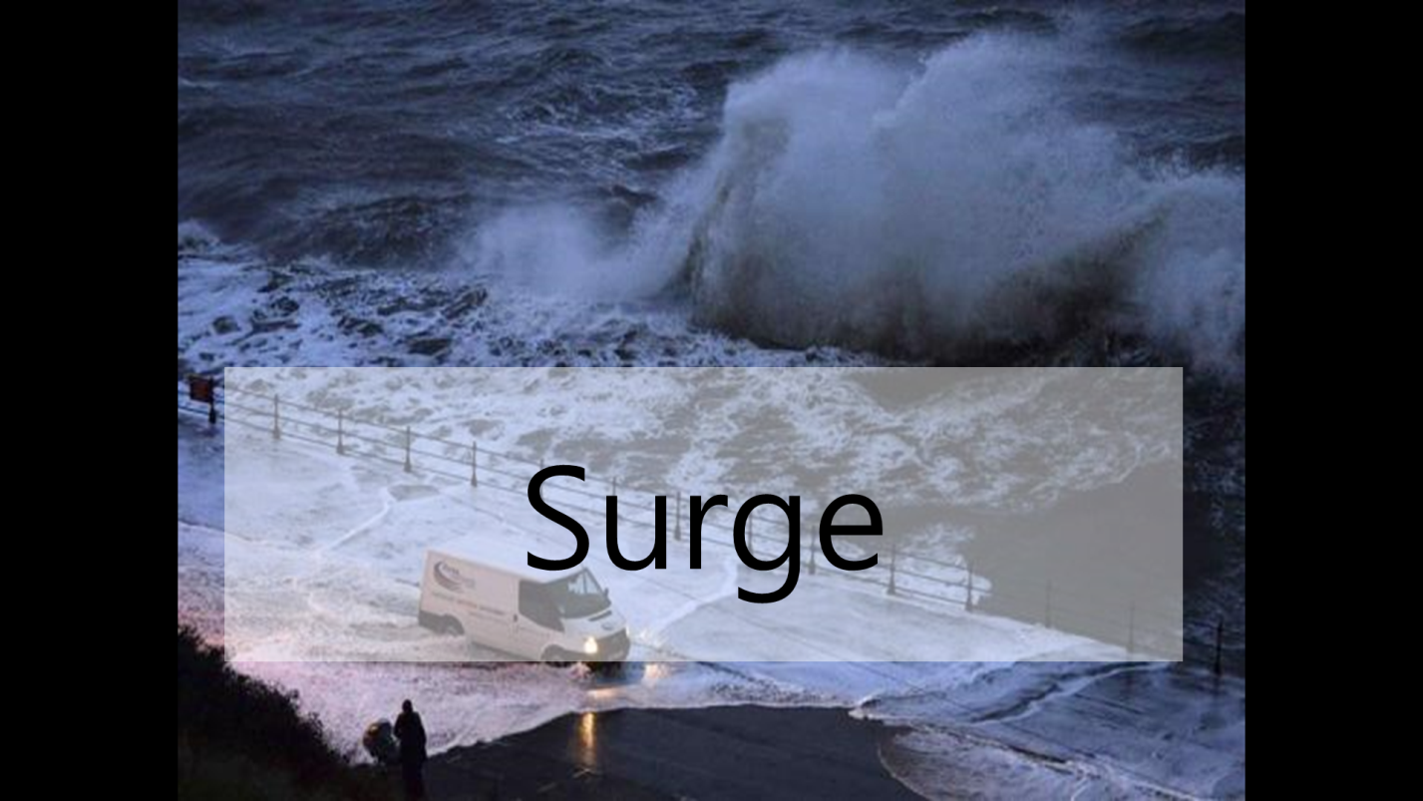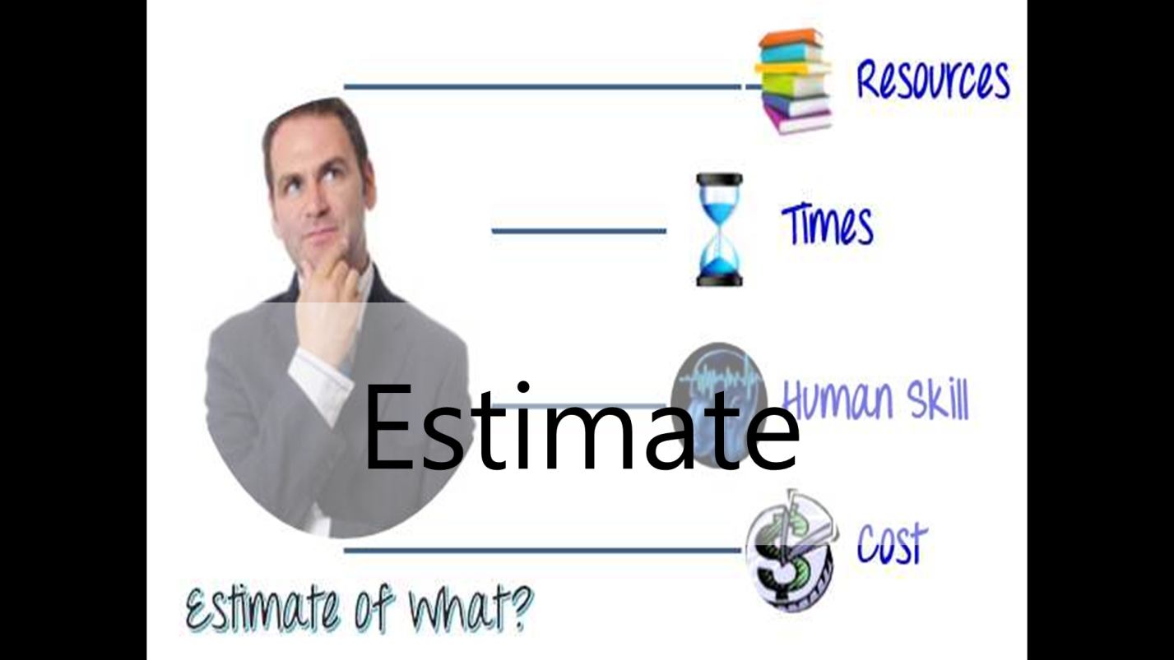

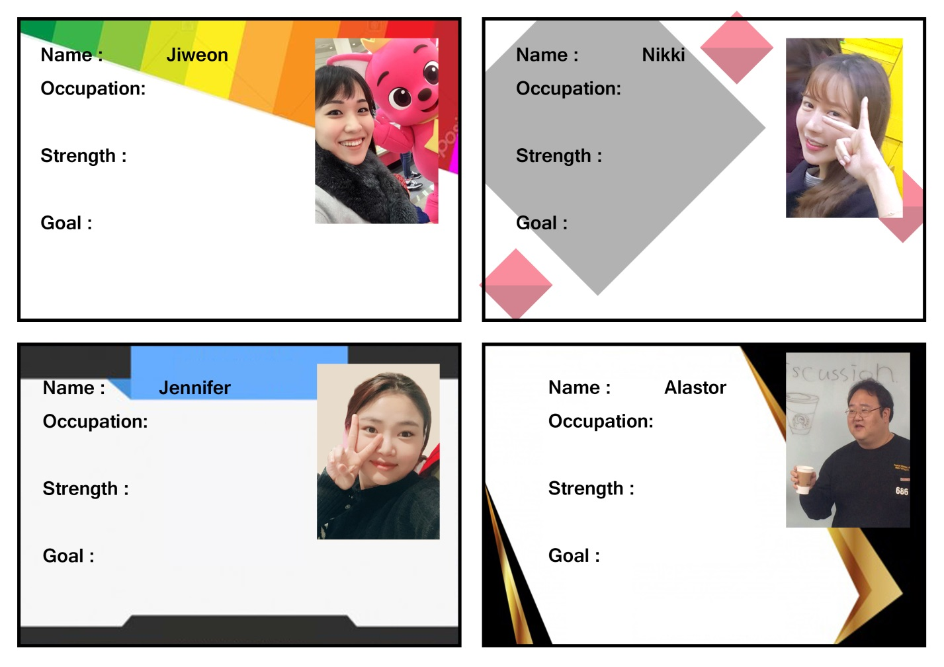
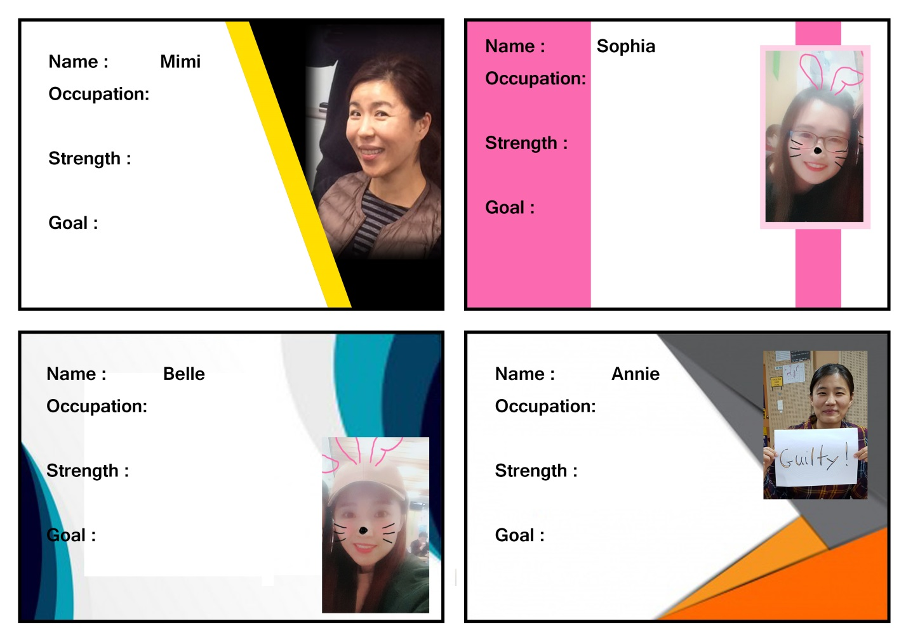
Business card
