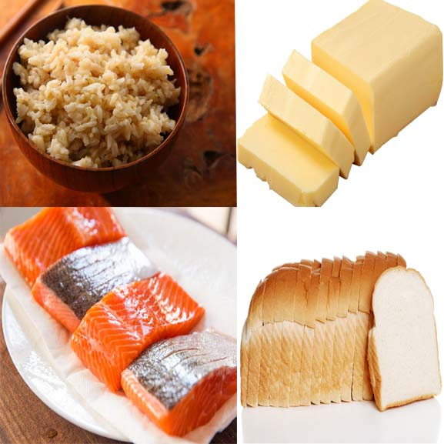
Worksheet 1(Main activity)

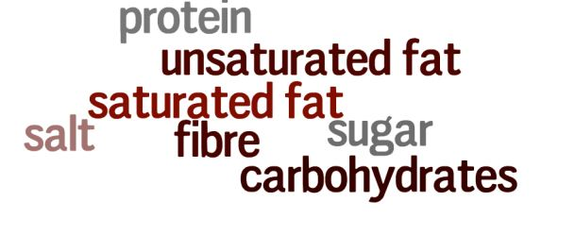

Use the words above to finish the sentences below:

a. White bread, white rice and potatoes are high in ________________
b. Butter and cheese are high in _______________
c. Oily fish, for example salmon, is high in _______________
d. Brown rice and wholegrain bread are high in _______________

Worksheet2(Main activity)

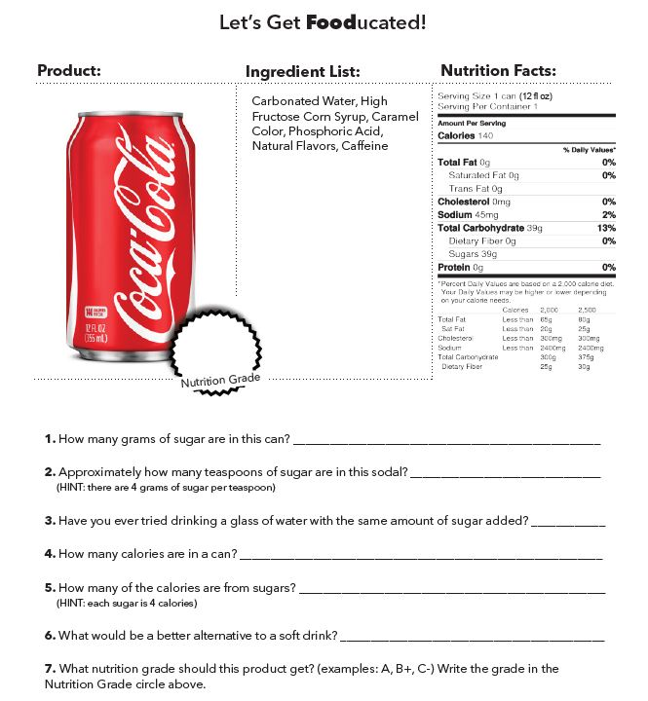

Worksheet3(Post Activity)

Discuss with your partner about given topic. Use the keyword below to explain the questions. (5min)
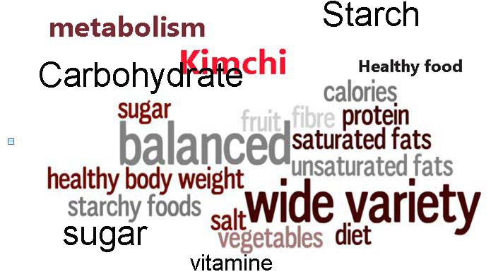

-To be healthy, what kind of food will you eat? Make your diet for tomorrow lunch. Explain it with the vocabulary above (at least 3).

