Listening Speaking Reading Grammar Writing
Topic:
It’s Raining!!
Instructor:  Jenny | Students Competency Level and Student ages  Elementary,8-9 years old | Number of Students:  5 | Lesson Length:  50 Min
Materials:(List the Names of all materials used in the lesson. Materials must be shown at the end of this document)
It's Raining YouTube Video
Color Crayons
Paper Board
Brush, Spray
Cloud Pictures
Umbrella
Rain Coat
Rain Boots
Toothpick
Large Size Vinyl Bag
Rope
Water Bottle Sprayer
Lesson Objectives(What do you want the students to know (new skill or knowledge that you want them to gain)?andWhat do you want them to be able to do?
Students will understand and be able to know how rain comes by watching YouTube about rain and teacher’s explanation.
Students will experience the rain; the sound of the rain, the feeling of walking in the rain, the feeling of touching the rain, and play with classmates in the rain.

Aims:(What students will be able to achieve by participating in the activities of the lesson. (Ss’ gain or get by doing…)
Students get comfortable and interested in lesson by watching YouTube on how rain comes to us.
Students will learn the words related to rain by watching YouTube again, writing the words on the worksheet and reading the words out loud.
Students will improve listening, writing and speaking skills by talking about rain and sharing friends’ stories.
Students will draw and paint the neighborhood; apartment, trees, stores, playground, parking lot on the paper board.
Students will spray on the paper to describe the rain. (color will be added in the water to see the rain clearly)
Students will wear rain coats and rain boots, and hold umbrellas.
Students will walk in the rain with umbrella and listen to the rain to know the feeling of rainy day.

Language Skills :(Lists what activities language skills students will be using by participating in the activities of the lesson.)
- Reading: (Where did reading occur in the lesson?)
YouTube, worksheet
- Listening :( Where did listening occur in the lesson?)
Watching YouTube
- Speaking: (Where did speaking occur in the lesson?)
Sharing stories with friends
- Writing: (Where did writing occur in the lesson?)
worksheet
Assumptions :( What students must already be able to do and what concepts must already be mastered before the lesson in order to achieve the aims of the lesson.)
Students will enjoy and have fun
Students will understand how rain is made, and know the words related to rain
Students will hear the sound and touch of the rain, and walk in the rain
Students will
Anticipated Errors and Solutions :(What things might go wrong in the lesson and what the solution will be. An SOS activity should also be included)
The computer does not work; teacher will prepare the materials to show how rain is made.
Students get wet and slip, teacher must watch them not to get hurt.
Activity takes too long; the other activity may be shortened
Students might be shy, teacher give encouragement
References:
https://youtu.be/liIPIGdWkcA, https://youtu.be/TWb4KlM2vts

Lead-Inor Pre-Task Part (Warm-Up Part to activate and create interest in the lesson.)
Materials: (List the Names of all materials used in the Lead-Inor Pre-Task Partof the lesson. Materials must be shown at the end of this document)
It’s Raining YouTube Video

Time: | Classroom Set Up: | Student Activity and Goals: | Teacher Procedure &Instructions:
1 min  3 min  3 min | Whole Class  Whole  class  Whole  class | Greet teacher  Students watch YouTube clip and become interested  Students watch YouTube and become familiar with rain  Ss repeat the words as T reads and write  The words on Ss’ worksheet | Greet student  T plays It’s Raining YouTube Video and writes the words related rain on the board while YouTube video is playing.  T introduces rain and words related to rain. T encourages Students to find out and read out loud  T encourages Students to write words on Ss’ worksheet correctly write the words on the worksheet. Example :Rain, cloud, sun, water, wet, raindrop, water puddle

Pre-Activity or Task Familiarization Part (Presentation PartforPresenting the language structure to be covered in the lesson. Prepares students for the communication activity.)
Materials: (List the Names of all materials used in the Pre-Activity or Task Familiarization Part of the lesson. Materials must be shown at the end of this document)
Color Crayons
Paper Board
Water Bottle Sprayer
Time: | Classroom Set Up: | Student Activity and Goals: | Teacher Procedure &Instructions:
3min  7min  5 min  5 min | Whole class  Whole  Class  Whole  Class  Whole  Class | Ss see and listen to T  Students draw and paint neighborhood on the paper board  Students share the stories of rain  Students spray on the paper and talk about rain on house | T draws house on board. T talks about looking at rain from inside house. T hands out paper and colors to Ss  T help Students to draw and paint their own house  T encourages Students to share their picture with the class talk about their stories  T sprays water on T house and hands spray bottle to Ss T helps Students express the feeling of rain on the paper

Main Activity or Task Realization Part(Practice to Production PartTeacher lead practice of the language presented and move to communication based more student centered activity)
Materials: (List the Names of all materials used in the Main Activity or Task Realization Partof the lesson. Materials must be shown at the end of this document)
Umbrella
Rain Coat
Rain Boots
Toothpick
Large Size Vinyl bag
Rope

Time: | Classroom Set Up: | Student Activity and Goals: | Teacher Procedure &Instructions:
4 min  2 min  15 min | Whole  class  Whole  class  Whole  class  Whole  class | Ss observe teacher and become interested  Students wear rain coat, rain boots  Ss wear raincoats and rain boots, and hold umbrellas  When water comes out of the little holes, children can enjoy rain under the water bag.  Ss respond to T and enjoy the rain. Students start experiencing the rain  ; touch, hear, walk | T shows vinyl bag and asks Ss to help put water in bag. Suspends bag with water from ceiling  T gives raincoats and rain boots to Ss and T helps them to wear rain coat, rain boots. T hands out umbrellas  T tells Ss to stand under bag with water and T uses toothpick to make holes to make water come out  T asks Students how Students feel when Students touch and hear the rain and walk in the rain

Post Activity or Post Task Part (Wrap-Up Part to Close the Lesson on a high note to and consolidate language learned in a communication based activity new situation.)
Materials: (List the Names of all materials used in the Post Activity or Post Task Part of the lesson. Materials must be shown at the end of this document)

Time: | Classroom Set Up: | Student Activity and Goals: | Teacher Procedure Instructions:
5 min  3 min | Whole  class  Whole  class | Students talk about how the rain comes and how it feels like to be in the rain  Students say goodbye | T writes down the words on the board and remind Students  Congratulate and thank Students for active participation

Toothpicks
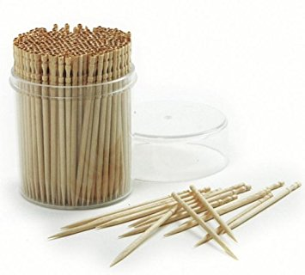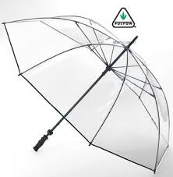

Umbrella
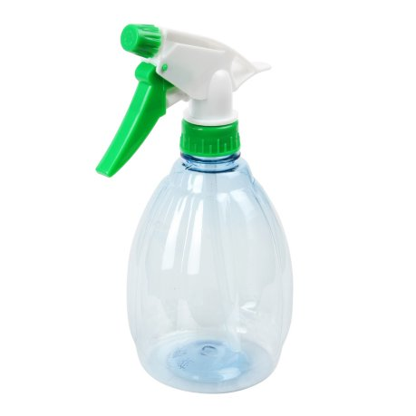
Spray Bottle and

Cloud
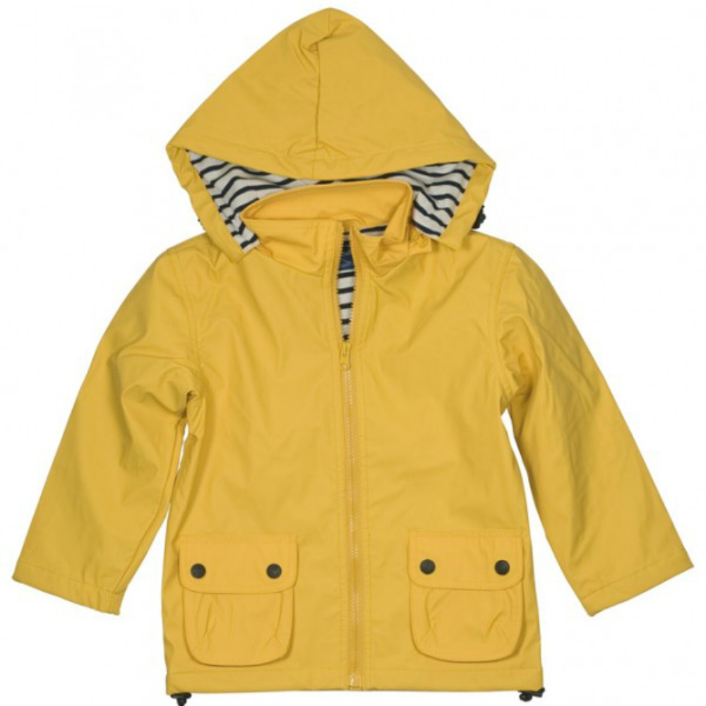
Raincoat
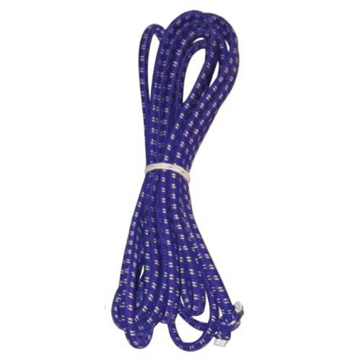
Rope
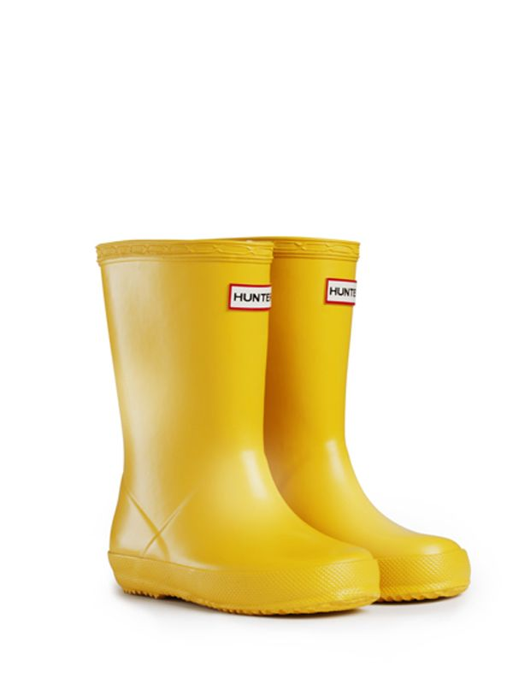
Rain Boots

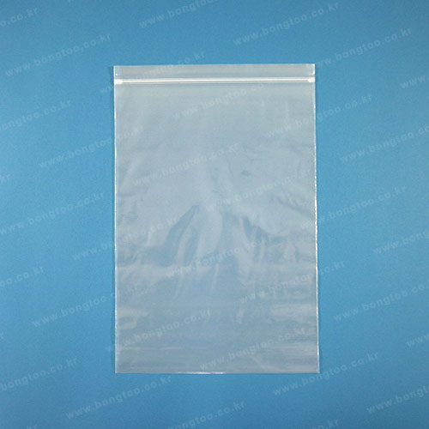

Large Size Vinyl Bag

