☐ Listening ☐ Speaking ☐ Reading ☐ Grammar ☐ Writing

Topic: Present continuous

Instructor:  Jin Ryu | Level:  Beginner | Students:  6 | Length:  30minutes

Materials:
1. audio clip & player
2. flash cards
3. board & markers
4. 6copies of practice worksheet
5. PPT slides #1 to #5

Aims:

- Students will know the form of the present continuous
- Students will practice the present continuous by answering concept checking questions, completing the worksheets and the activity
- Students will improve speaking and listening ability by playing the activity and sharing answers with partners

Language Skills:

- Reading : reading worksheets to answer the questions
- Listening : listening the video clip, teacher’s explanation, and each other’s ideas
- Speaking : sharing answers and ideas, practicing activity, and answering teacher’s questions
- Writing : answering on worksheet

Language Systems:

- Grammar : Present continuous
- Functions : describing motions, actions, and happenings
- Lexis : new vocabularies
- Discourse : post activity

Assumptions:

- Students already know teacher’s style of teaching and the pace of the course
- Students already studied the simple present
- Students like to work or play games in pairs
- Students already know the meaning of the words (focus on understanding and practicing present continuous)

Anticipated Errors and Solutions:

-Some students have difficulty to understand or use present continuous
; stay around when they complete the worksheet.
-Some students feel shy to act out for the post activity
; let other students play first, so that they can feel we are doing something fun
-Extra time left
; prepare for SOS activity

References:

https://www.youtube.com/watch?v=tVuVrVr4dvI

https://en.islcollective.com/resources/printables/worksheets_doc_docx/what_are_these_people_doing/present-continuous-present/11421

https://www.pinterest.com/pin/3659243419874321/

https://www.slideshare.net/TomsSullivan1/present-continuous-info-gap-1

Lead-In
Materials: n/a

Time | Set Up | Student Activity | Teacher Talk
3min | Whole class |  | Procedure  Greeting  Hello everyone, how are you?  Review  Do you remember the simple present tense we studied last week? Give me some examples of simple present.  (Write down several sentences on the board)  -I go to school (to go)  -you read a book (to read)  -He/she walks on the street (to walk)  -We talk to each other (to talk)  -They do exercise (to do)  Good!  Today, we are going to study something new!

Pre-Activity
Materials: video clip, player, white board & markers, ppt slides #1 to 4

Time | Set Up | Student Activity | Teacher Talk
10min | Whole class |  | Procedure  Before we get started, we will watch a short video. Try to catch or remember some sentences from the video if you can.  (CCQ)  What do you have to do?  (play the video)  (Eliciting)  Anybody remember any sentences or expressions from the video?  (Listen to students’ answers and write them down on the board. If no one remembers anything, play the video one more time and ask them to write down some sentences that they can hear on a piece of paper)  Instructions  Let them read the sentences out loud and ask if they can see any patterns commonly going on all of the sentences.  Show the ppt slides about the form and use of Present Continuous tense (page 1 to 3) and give extra explanations or examples if needed.

Main Activity
Materials: PPT slide #5, 6 copies of worksheet – Fill in the blanks

Time | Set Up | Student Activity | Teacher Talk
5min  5min | Whole class  Whole class  Individually  & in pairs  Whole class | Students answer  Write answers &  Compare with partners | Procedure  Now we know how to form Present continuous and when to use it.  Instructions  Let’s do some exercise together.  I am going to show you a picture, and you try to describe people’s action by using the present continuous. For example,  (put the picture on)  CCQ  What is Cindy doing?  What is baby Ben doing?  Great job!  Instructions  I am going to hand out a worksheet for you.  (Distribute the fill in the blanks worksheet)  Look at the picture on the top. There are many people doing something.  Each question is talking about different person. Find the name from the picture, and write down the right answers in each blank.  Demonstration  Let’s do the number 1 together.  Can you find Dmitri from the picture?  What is he doing?  (wait for students’ answer)  Right, he is talking on the phone. So, you write down ‘is talking’ in the blank.  I can give you around 5minutes. When you are finished, you can compare answers with your partners  CCQ  What are you supposed to do?  For how long?  (monitor)  Good. Start!  Time is up. Let’s check the answers together.

Post Activity
Materials: flashcards

Time | Set Up | Student Activity | Teacher Talk
7min | Whole class  In pairs | Student play the game | Procedure  1.Free Production  Instructions  We are going to play a game now.  How many played Heads-up before?  Two students become one team. One person (A) holds the card up against his/her forehead. Her/his partner (B) stands in front of her/him and act out whatever it says on the card. B asks “what am I doing?” while he/she is acting. Then A should guess what is written on the card by using the present continuous. If the card says ‘run’, B acts it out and say “what am I doing?”, and A guesses the card says ‘run’ but her/his answer should be ‘you are running’.  Each team will have 1 minute and the team who get right answers the most wins!  CCQ  How many people play in a team?  Can the person who is acting out talk?  Do you have time limit?  (play game)  Good job! See you tomorrow!

SOS Activity
Materials: 6 copies of worksheet - matching

Time | Set Up | Student Activity | Teacher Talk
5min | Individually |  | Procedure  Look at the pictures on the left and match with the sentences on the right.  Demonstration  Look at the first picture. What is the boy doing? Find the right answer from the sentences and write #1.

Look at the picture. Write sentences about people in the picture. Use to be –ing or not to be –ing.
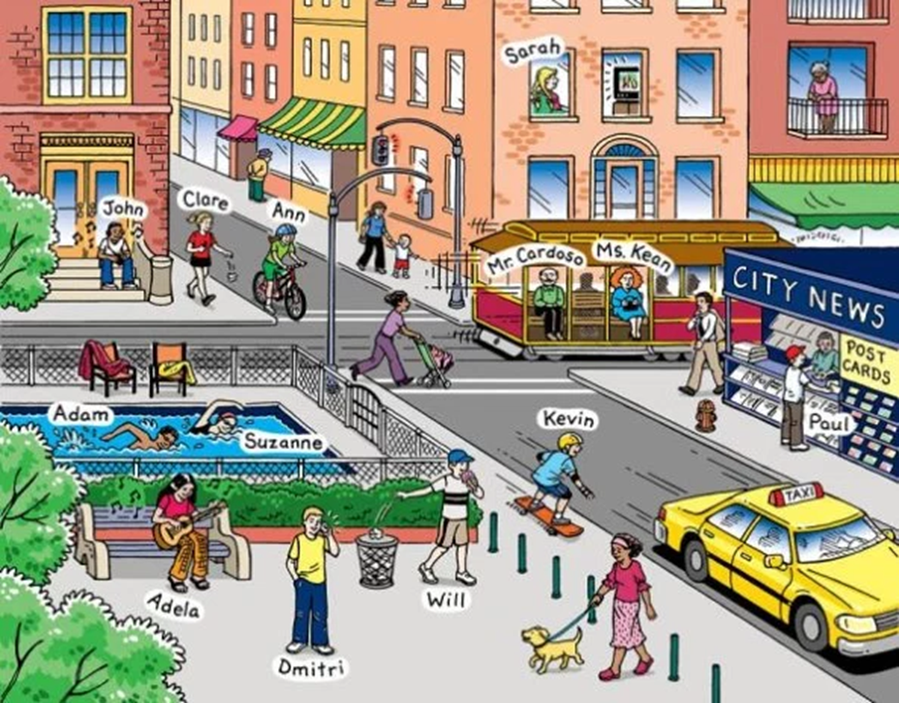

- Dmitri ____________________ on the phone. (talk) is talking

- Mr. Cardoso ___________________on the streetcar.(dance) is not dancing He is sitting on the streetcar.

- You (Sarah) ___________________ TV. (watch)

- Adam & Suzanne ____________________ in the pool. (swim)

- Kevin ____________________ a song. (sing)

- I (Ann) _________________ a book. (read)

- Adela __________________ guitar. (play)

- Kevin _________________on a skateboard. (ride)

- Paul ___________________ a radio. (listen to)

- John ___________________ on the street. (sing)
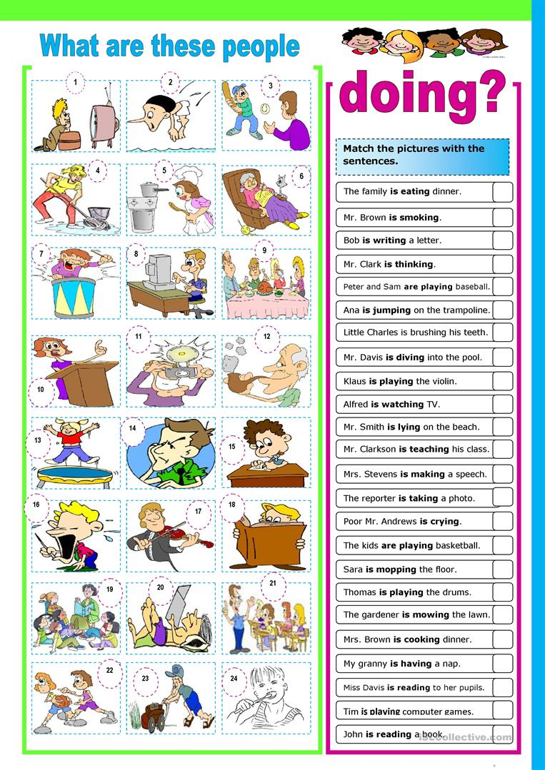
Answer sheet
