☐ Listening ☐ Speaking ☐ Reading ☐ Grammar ☐ Writing

Topic: What's your problem?

Instructor:  Todd | Level:  Pre-intermediate | Students:  4 | Length:  40 minutes

Materials:

- 'Problem' work sheets (4 copies)
- Blown-up 'each problem' sheets
- 3 eliciting pictures
- White board and markers
- Extra work sheet (4 copies)
- Presents

Aims:

- To practice giving advice and suggestions using should and shouldn't through team competition (Grammar)
- Students will work cooperatively in a group by making sentence that is unique to each student. (Communication)
- Students will try to win the game as team players (Group Dynamics)

Language Skills:

- Reading : Problem sheets
- Speaking : Discussion about problems, Active participation for the game
- Writing : Making sentences for each case
- Listening : Teacher's elicitation, Listening to other people's ideas

Language Systems:

- Discourse : Guessing what the problems are
- Function : Practice from various situations
- Grammar : Should and Shouldn't

Assumptions:

- Most students can understand every sentence on the problem sheet.
- Each student may have a strong will to win the game. (Winner team gets the present)

Anticipated Errors and Solutions:

- If some groups take longer to complete their task than expected.
→ give them more time.
- Some students may not be active in the discussion.
→ encourage S by asking his/her opinions of her own experiences.

References:

http://www.onestopenglish.com/community/lesson-share/winning-lessons/speaking/speaking-whats-your-problem/145170.article

Pre-Activity
Materials: 3 Sample pictures, White board and markers
Time | Set Up | Student Activity | Teacher Talk
10 min | Whole Class | Listen and see the pictures and guess what they are.  Try to give answers | Hello, everyone? How are you today?  Do you like to advise to others?  Two of you are already teachers now and the rest of you could be future teachers after this course. Also three of you are mothers. Probably you had many chances to give an advice to your students or babies in Korean.  What English word do you think would be the most necessary when you give an advice to others? Got it! SHOULD!  So, Today. I'd like to give you a chance to practice giving advice and suggestions using 'should and shouldn't'.  (Take out 3 Sample pictures and show each one to students step by step.)  (Watching the first picture)  What do you think the news announcer says?  That's right. She is reporting about 'noise problem from upstairs'  If you have trouble hearing this kind of noise problem, you might go to your neighbor upstairs and advise something.  Now, please tell me what to say using should or shouldn't  (Some students maybe give you answers, and you write these on the board.)  Good for you!  (There are 2 more pictures. You repeat the same process as I did above.)  Look at the second picture! What do you see? He is bald. He is losing his hair. Poor guy... What suggestion do you want to give him?......  (You write the answers that students give on the board)  What seems to be described in the third picture? Maybe she wants to eat more. I think she fails to go on a diet or something. What kind of advice do you want to give her?.....  (You write the answers that students give on the board)

Main Activity
Materials: 'Problem' work sheets, Blown-up 'each problem' sheets (for game), White board and markers
Time | Set Up | Student Activity | Teacher Talk
10 min  10~17  min | Pairs  Whole  Class | Discuss the problems each other, and write the three pieces of proper advice on the paper  Participate the game actively | (Distribute the 'problem' work sheet to each student)  1. To think about the advice and suggestions about the problems written on the sheet 'using should or shouldn't'  Let's make pairs. I gave you a sheet of paper. As you can see, a lot of problems that we can meet in everyday life are written on the paper. Maybe you would like to give various advice based on your own experiences.  Share your ideas with partner. And write down 3 suggestions below each problem. I'll give you 10 minutes.  (Monitor discreetly. Answer students if they ask questions. Give time warning: 30 seconds left. Be flexible with time. Give 1 more minute if they need it.)  CCQ)  Do your babies act well?  Recently, do you have any problems like these?  Is there any expressions you don't understand?  2. Let's have a game  Are you finished? Well-done. I made an interesting game with your answers. First, Team A ! Come to the front, and sit down. I will stand behind the Team A having Blown-up each problem sheet. And Team B presents the three pieces of advice you have already written and more if possible. Then Team A, guess what the problem is. If your team catches the answer, you will get 1 point. Got it? Good~~  Team B must have Team A understand your suggestions, and Team B try to answer what the problem is.  (After finishing answering the problem, each team exchanges its role.)

Post Activity
Materials: White board and markers, Presents
Time | Set Up | Student Activity | Teacher Talk
3 min | Whole Class | Wait for the results and get the presents | You all did a wonderful job. Team A got 8 points. Team B got 7 point. So, Team A won the game. But actually this game looks a little strange. I think if we had 8 members, this could be more fun and give more competing spirits.  Here's presents for you. I will give all of you the presents. You deserve it.  Thank you!

SOS Activity
Materials: Extra work sheets, A present
Time | Set Up | Student Activity | Teacher Talk
 | Whole Class | Make sentences, present them loudly and make Tim know what the problems are | We still have extra time. I will give more assignment. Do the same thing. But I will organize a little different game. Anyway, make some sentences first.  Now, teacher, Tim come to the front and he will answer the question. I think this is going to be a real competition.  (Everyone advises Tim about the problem written on extra work sheet. Tim tries to answer what the problems are. Winning team will definitely be the one that leads for Tim to say as many correct answers as possible.)  Thank you! Tim you also did a good job. Here's your present.

(Eliciting pictures)

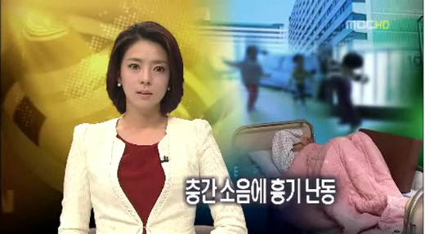

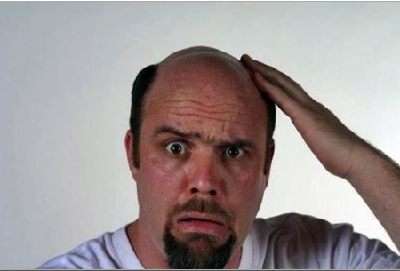

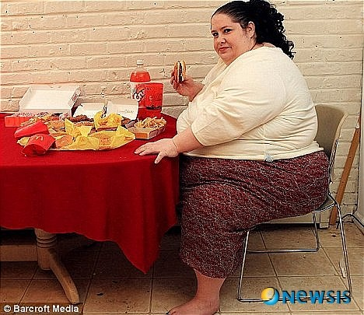

('Problem' work sheets)

(TEAM A)

I failed my last English exam.
------------------------------------------------------------------------------------------------------------

------------------------------------------------------------------------------------------------------------

------------------------------------------------------------------------------------------------------------

------------------------------------------------------------------------------------------------------------
I have a cold.
------------------------------------------------------------------------------------------------------------

------------------------------------------------------------------------------------------------------------

------------------------------------------------------------------------------------------------------------

------------------------------------------------------------------------------------------------------------
I am always late for class.
------------------------------------------------------------------------------------------------------------

------------------------------------------------------------------------------------------------------------

------------------------------------------------------------------------------------------------------------

------------------------------------------------------------------------------------------------------------
I have a flight tomorrow but is afraid of flying.
------------------------------------------------------------------------------------------------------------

------------------------------------------------------------------------------------------------------------

------------------------------------------------------------------------------------------------------------

------------------------------------------------------------------------------------------------------------
I have lost his/her keys.
------------------------------------------------------------------------------------------------------------

------------------------------------------------------------------------------------------------------------

------------------------------------------------------------------------------------------------------------

------------------------------------------------------------------------------------------------------------
I have a toothache.
------------------------------------------------------------------------------------------------------------

------------------------------------------------------------------------------------------------------------

------------------------------------------------------------------------------------------------------------

------------------------------------------------------------------------------------------------------------
I have bad breath.
------------------------------------------------------------------------------------------------------------

------------------------------------------------------------------------------------------------------------

------------------------------------------------------------------------------------------------------------

------------------------------------------------------------------------------------------------------------
I have lost his/her voice.
------------------------------------------------------------------------------------------------------------

------------------------------------------------------------------------------------------------------------

------------------------------------------------------------------------------------------------------------

------------------------------------------------------------------------------------------------------------
My computer has crashed and I have lost my homework.
------------------------------------------------------------------------------------------------------------

------------------------------------------------------------------------------------------------------------

------------------------------------------------------------------------------------------------------------

------------------------------------------------------------------------------------------------------------
I have head lice.
------------------------------------------------------------------------------------------------------------

------------------------------------------------------------------------------------------------------------

------------------------------------------------------------------------------------------------------------

------------------------------------------------------------------------------------------------------------

(TEAM B)

I didn’t get any sleep last night.
------------------------------------------------------------------------------------------------------------

------------------------------------------------------------------------------------------------------------

------------------------------------------------------------------------------------------------------------

------------------------------------------------------------------------------------------------------------
I am afraid of the dark.
------------------------------------------------------------------------------------------------------------

------------------------------------------------------------------------------------------------------------

------------------------------------------------------------------------------------------------------------

------------------------------------------------------------------------------------------------------------
I am homesick.
------------------------------------------------------------------------------------------------------------

------------------------------------------------------------------------------------------------------------

------------------------------------------------------------------------------------------------------------

------------------------------------------------------------------------------------------------------------
My luggage was lost at the airport.
------------------------------------------------------------------------------------------------------------

------------------------------------------------------------------------------------------------------------

------------------------------------------------------------------------------------------------------------

------------------------------------------------------------------------------------------------------------
I forgot to wish his/her mother Happy Birthday.
------------------------------------------------------------------------------------------------------------

------------------------------------------------------------------------------------------------------------

------------------------------------------------------------------------------------------------------------

------------------------------------------------------------------------------------------------------------
I got stood up by a date.
------------------------------------------------------------------------------------------------------------

------------------------------------------------------------------------------------------------------------

------------------------------------------------------------------------------------------------------------

------------------------------------------------------------------------------------------------------------
I got fired from his/her job.
------------------------------------------------------------------------------------------------------------

------------------------------------------------------------------------------------------------------------

------------------------------------------------------------------------------------------------------------

------------------------------------------------------------------------------------------------------------
I have a black eye.
------------------------------------------------------------------------------------------------------------

------------------------------------------------------------------------------------------------------------

------------------------------------------------------------------------------------------------------------

------------------------------------------------------------------------------------------------------------
My purse was just stolen.
------------------------------------------------------------------------------------------------------------

------------------------------------------------------------------------------------------------------------

------------------------------------------------------------------------------------------------------------

------------------------------------------------------------------------------------------------------------
I have been arrested for stealing a chocolate bar.
------------------------------------------------------------------------------------------------------------

------------------------------------------------------------------------------------------------------------

------------------------------------------------------------------------------------------------------------

------------------------------------------------------------------------------------------------------------

(Blown-up 'each problem' sheets)
I failed my last English exam

I have a cold

I am always late for class

I have a flight tomorrow but is afraid of flying

I have lost my keys

I have a toothache

I have bad breath

I have lost my voice

My computer has crashed and I have lost my homework

I have head lice

I didn’t get any sleep last night

I am afraid of the dark

I am homesick

My luggage was lost at the airport

I forgot to wish my mother Happy Birthday

I got stood up by a date

I got fired from my job

I have a black eye

My purse was just stolen

I have been arrested for stealing a chocolate bar

(Extra Work Paper)

(Team A)
I cut my hand on broken glass

I sprained my ankle

My arms are numb

This shoulder is stiff

My neck hurts so much that I can't turn my head

(Team B)
My neck is stiff

I got burned with boiling water

I've got frostbite

I have a blister

I slipped on the stairs

