Worksheet① Main activity
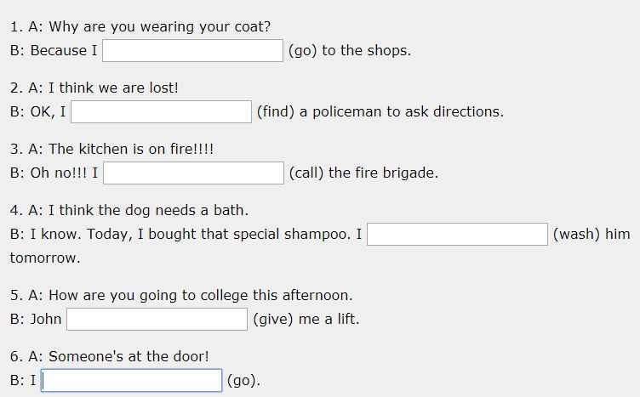

Worksheet ② Post Activity
Will or Be going to
① A: We don't have any bread.
B: I know. I ____ get some from the shop.
② A: We don't have any bread.
B: Really? I ____ get some from the shop then.
③ A: Why do you need to borrow my suitcase?
B: I ____ visit my mother in Scotland next month.
④ A: I am really cold.
B: I ____ turn the heating on.
⑤ A: What are your plans after you leave university?
B: I ____ work in hospital in Africa. I leave on the 28th.
⑥ (The phone rings)
A: I ____ get it!
⑦ A: Are you ready to order?
B: I can't decide... Okay, I ____ have the steak, please.
⑧ A: Why are you carrying a hammer?
B: I ____ put up some pictures.
⑩ A: Where are you going on holiday?
B: I don't know yet, maybe ___ to India.
We ___ get married next year.
⑪ Have you heard? Jean is pregnant – she ___ have a baby.
⑫ A: This exercise looks really hard.
B: I ___ help you.
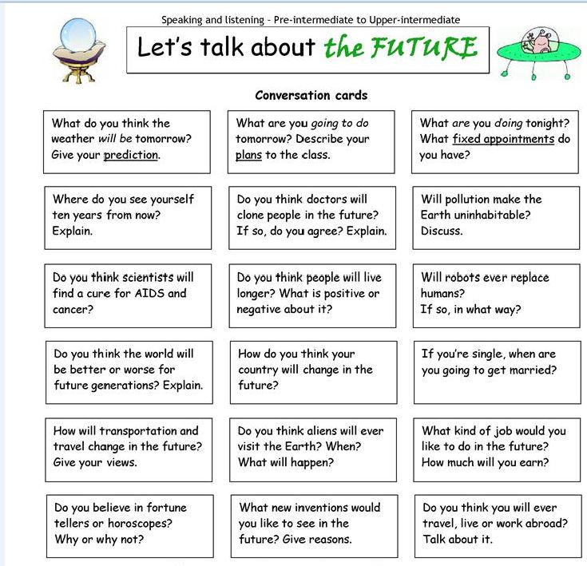
Worksheet ② SOS Activity

