- Reading Material
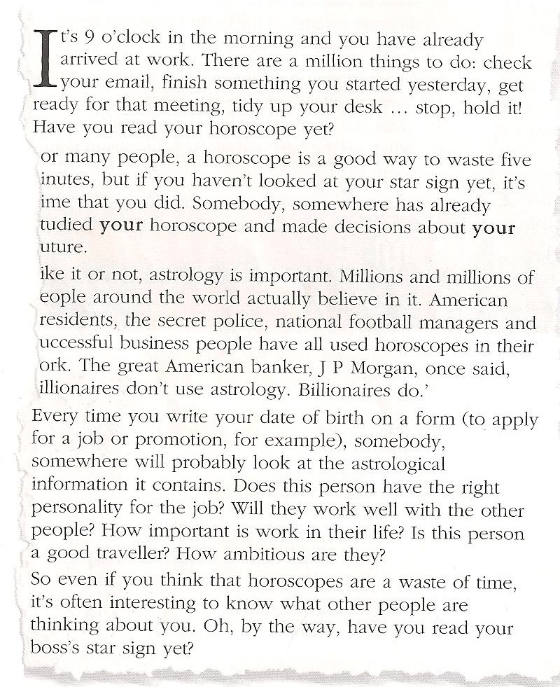

It’s 9 o’clock in the morning and you have already arrived at work. There are a million things to do: check your email, finish something you started yesterday, get ready for that meeting, tidy up your desk ... stop, hold it! Have you read your horoscope yet?
For many people, a horoscope is a good way to waste five minutes but if you haven’t looked at your star sign yet, it’s time that you did. Somebody somewhere has already studied your horoscope and made decisions about your future.
Like it or not, astrology is important. Millions and millions of people around the World actually believe in it. American presidents, the secret police, national football managers and successful business people have all used horoscopes in their work. The great American banker, J P Morgan, once said, ‘Millionaires don’t use astrology. Billionaires do.’
Every time you write your date of birth on a form (to apply for a job or promotion, for example), somebody, somewhere will probably look at the astrological information it contains. Does this person have the right personality for the job? Will they work well with the other people? How important is work in their life? Is this person a good traveller? How ambitious are they?
So even if you think that horoscopes are a waste of time, it’s often interesting to know what other people are thinking about you. Oh, by the way, have you read your boss’s star sign yet?
* Kerr, P (2005) Straightforward Pre-Intermediate Student's Book: Macmillan

②Work sheet

Read the magazine article and choose the best title.

1 )Horoscopes are a waste of time
2) Why you should read your horoscope
3) Astrology and the secret police

Read the article again. Complete the sentences with words from the text.
Some people think that horoscopes are a ________________ of time.
Many different kinds of people _____________ in astrology.
People sometimes make _________ about your future after studying your horoscope.
People can get your astrological information when you fill in form with _________for a job.
The great American banker, J P Morgan, once said, ‘Millionaires don’t use __________. Billionaires do.’

Characteristics of each star sign
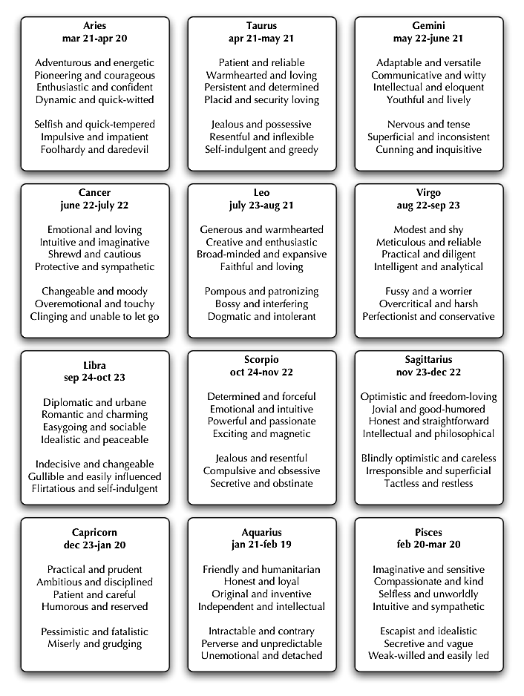
③Discussion

1. What is your star sign?
2. Does given characteristics of your star sign are mostly right?
3. Is it possible to predict future events by horoscope?
4. Is horoscope important for you?
5. If not, do you believe any type of astrology?

Horoscope of December 12nd

ARIES
March 21 to April 20
Love has a powerful core of determination and, with Mars patrolling the passion zone of your chart, a partnership that seemed to be cooling can get back to its best. If you start the day single, a Libra who is your opposite in looks and lifestyle could be The One. Work-wise, there’s more to achieve.

TAURUS
April 21 to May 21
Even if you feel the opposite has been true lately, you have the power to say what happens next in a love match. If you’re ready for a totally new relationship it will be with someone you first notice in a work context. Pluto, planet of the unexpected, links sudden financial gains with a relative you have not yet met.

GEMINI
May 22 to June 21
New ambitions take shape in your mind and one that surprises you also has the greatest chance of success. Interesting developments in your love life should give you extra motivation to switch to a healthy way of eating. A debt of gratitude is repaid in an imaginative way that the whole family can enjoy together.

CANCER
June 22 to July 22
You’re ready to add something new to your life, whether a study course or learning the tango. The extra energy you get from Mars helps you get through must-do jobs and free-up the time you need. Today you realize love will always be a learning process and that is what makes it special.

LEO
July 23 to August 23
Pluto, planet of change, gets busy in your career zone and some sudden arrivals and rather mysterious departures give you the chance to show what you can do. You meet someone special just as your favorite song is playing. If you’re in a relationship, celebrate what keeps you close and caring.

VIRGO
August 24 to September 22
Jupiter and Mars are side by side in your communication chart and conversations flow so easily. It’s also time to take a talent for writing or music seriously. Love can get sidelined by the day-to-day business of life but put that right with the plans you make together tonight. A Spanish name is significant.

LIBRA
September 23 to October 23
You’re the zodiac’s most popular person as the moon travels across your personality sector and reconnects you with long-lost friends. Love-wise, you will not settle for a vague “maybe’’ from a partner, but if you’re free to begin a new relationship it starts when you go to an event mostly to please a friend.

SCORPIO
October 24 to November 22
Braveheart planet Mars gives you a deeper level of self-belief and though you have a lot to contribute to the success of a group, you can shine as a solo act. When it comes to love Venus will match you with someone who believes in a full-on partnership. A glamorous blonde friend will bring luck.

SAGITTARIUS
November 23 to December 21
Work-master Saturn gives you the stamina to keep going with a project until it’s a success. If you’re single choose quiet sincerity over flashy style. Long-term partners learn more about each other. Cash that comes too easily can go even faster so do set a spending limit and stick with it.

CAPRICORN
December 22 to January 20
Something you’ve been hoping for all year can now move into the success zone.
Your love profile is more mysterious as Venus dives deeper into the hidden part of your chart and you can attract new love, or intrigue an established partner, with just one enigmatic smile. You won’t always understand the family.

AQUARIUS
January 21 to February 18
At work, being serious may not be your usual role but it gets the right results. You have a different approach to love and rating kindness as highly as passion helps you make good choices. The family will listen to you today so talk about what matters.
The moon sets up a link between travel and holiday prizes.

