Listening Speaking Reading Grammar Writing
Topic: Shapes
Instructor:  Sally | Students Competency Level/Ages Elementary 8-9 years old, | Number of Students:  12 | Lesson Length:  50 min
Materials: ( List the Names of all materials used in the lesson. Materials must be shown at the end of this document)
-Shape Flash Cards:
Circle
Triangle
Rectangle
Square
Heart
Star
Oval
Diamond
-Days Of The Week Flash Cards:
Sunday, Monday, Tuesday, Wednesday, Thursday, Friday

- Color Zoo Story Book
-Worksheets:
Shapes and Counting
What Can You Make…
-Crackers
-Cheese
-Ham
-Egg
-Pickle
-tomato
-Sauce
-Mp3 Player
-Shape Song
-Shape Song Lyrics
-Bingo Board
-Bingo box

Lesson Objectives: (What do you want the students to know (new skill or knowledge that you want them to gain)? and What do you want them to be able to do?
-Ss will be able to identify circle, triangle, rectangle, square, heart, star, oval, and diamond by solving a problem on a worksheet.
-Ss will be able to describe circle, triangle, rectangle, and square by drawing and motions in front of the class.

Aims: (What students will be able to achieve by participating in the activities of the lesson. (Ss gain or get by doing…)
-Ss get interested in lesson by singing a song about shape..
-Ss will improve listening skills by storytelling about color zoo
-Ss will improve writing skills by doing a worksheet.
-Ss will improve speaking skills by showing and telling about a shape in front of the class.

Language Skills: (Lists what activities language skills students will be using by participating in the activities of the lesson.)
- Reading:
Reading a storybook
- Listening:
Listening to the song, to the teacher and to other students
- Speaking:
Sharing their favorite shape
- Writing:
Doing a worksheet
Assumptions: (What students must already be able to do and what concepts must already be mastered before the lesson in order to achieve the aims of the lesson.)
-Ss will enjoy and have fun by making a canapé.
-Ss will easily learn shapes by playing a game.
-Ss will learn shapes by making a canapé.
Anticipated Errors and Solutions: (What things might go wrong in the lesson and what the solution will be. An SOS activity should also be included)
-If Ss have a difficulty to make a canape, T can help Ss.
-If Ss are ashamed to play a game, T encourages them to play a game.
-If Mp3 Player doesn’t work, T uses computer.
References:
Shapes song- https://youtu.be/vLeQJL-28K0

Lead-In or Pre-Task Part (Warm-Up Part to activate and create interest in the lesson.)
Materials: (List the Names of all materials used in the Lead-In or Pre-Task Part of the lesson. Materials must be shown at the end of this document)
- Shape Flash Cards:
Circle
Triangle
Rectangle
Square
Heart
Star
Oval
Diamond
-Days of the week Flash Card
Sunday, Monday, Tuesday, Wednesday, Thursday, Friday
-Color Zoo Story Book
-Shape song
-Shape song Lyrics
-MP3 Player
-Cracker

Lead-In or Pre-task Part (Warm-Up Part to activate and create interest in the lesson.)
Time: | Classroom Set Up: | Student Activity and Goals: | Teacher Procedure &Instructions:
1min  3min  3min  4min  2min  3min | Whole  W  W  W  Pairs  W | Greet teacher  Ss tell what day it is.  Ss guess the shape and say it.  Ss listen to the story  and become interested  Ss share ideas with partner  Ss sing a song with teacher | Greet students  T shows days of week flash cards, says names and asks Ss to repeat.  T shows a cracker and explains the shapes.  T reads a story about ‘Color Zoo’  T puts Ss in pairs, T asks Ss to share ‘what’s your favorite shape with their partner on the left. Ask Ss to share their partners shape with the class  T shows the motion of song first, then helps Ss learn the song, and sing a long together.

Pre-Activity or Task Familiarization Part (Presentation Part for Presenting the language structure to be covered in the lesson. Prepares students for the communication activity.)
Materials:
-Bingo Board
-Bingo box
-Shape Flash cards
Circle
Triangle
Rectangle
Square
Heart
Star
Oval
Diamond
Time: | Classroom Set Up: | Student Activity and Goals: | Teacher Procedure &Instructions:
2min  4min  5min | Whole class  Two teams  S | Ss listen and become interested  Ss get the bingo board.  Ss write down shapes on the bingo board.  When Ss cross out three words in a row, Ss call out “Bingo”  Ss do a worksheet about Shape. | T introduces the bingo game and hands out the bingo board to Ss.  T asks Ss to write down shapes on a bingo board  T shows a box .Ss take turn and pick up the one shape.  Ss circle the shape. Bingo will end when Ss get the bingo  T hands out the worksheet and asks Ss to solve the problem.

Main Activity or Task Realization Part (Presentation Part for Presenting the language structure to be covered in the lesson. Prepares students for the communication activity.)
Materials: (List the Names of all materials used in the Pre-Activity or Task Familiarization Part of the lesson. Materials must be shown at the end of this document)
-Cracker
-Cheese
-Ham
-Egg
-Pickle
-tomato
-Sauce
Time: | Classroom Set Up: | Student Activity and Goals: | Teacher Procedure &Instructions:
4min  5min  3min | Whole class  S  S | Ss say that shape  Ss make canapé with T  Ss make different canapé. | T introduces ingredients and asks what shape that is.  Cracker-square  Ham-triangle  Cheese-rectangle  Egg-star  Pickle-circle  T shows how to make canapé.  Put the ham on the cracker  Put the cheese on the ham  Put the egg on the cheese  Put the pickle on the egg  Put some sauce on pickle.  Put the tomato on the sauce.  T asks Ss to make another canapé with different shape ingredient.

Post Activity or Post Task Part (Wrap-Up Part to Close the Lesson on a high note to and consolidate language learned in a communication based activity new situation.)
Materials: (List the Names of all materials used in the Post Activity or Post Task Part of the lesson. Materials must be shown at the end of this document)
-Shape Flash Cards:
Circle
Triangle
Rectangle
Square
Heart
Star
Oval
Diamond
-Mp3 player
-shapes song
Time: | Classroom Set Up: | Student Activity and Goals: | Teacher Procedure Instructions:
9min  3min | W  S  W | Ss review the shapes  Ss come to the front and say  Ss sing the shape song  Ss say goodbye | T reviews the shape and their character  T asks Ss to come to the front and draw and tell their favorite shape.  This is a circle. It has no side and no corner. It is round  This is a square. It has 4 sides, and 4 corners.  This is a triangle. It has 3 sides and 3 corners.  T sings the song with Ss.  T thanks for participation and ask if Ss enjoyed an activity

Shapes song Lyrics
"We are shapes you can see us everywhere
I'm a square I'm square
You can see me everywhere
I have four sides
I'm a square I'm square
I'm circle I'm circle
I go round & round & round
I have only one side
I'm circle round & round
I'm triangle triangle
I'm pointy little shape
I have three sides
I'm triangle triangle
We are shapes you can see us everywhere
I'm rectangle rectangle
Like a really long square
I have a four sides
I'm a rectangle rectangle
I'm a star I'm star
In the sky so far
I have five pointy arms
I'm star I'm star
I am a heart i am a heart
I'm so curvy I'm so smart
I'm a really lovely shape
I'm a heart I'm a heart
I'm a diamond I'm a diamond
You can see me on a ring
I'm so shiny I'm so bright
I'm a diamond I'm a diamond
We are shapes you can see us everywhere."

Flash Cards
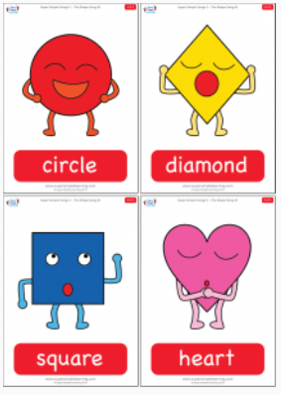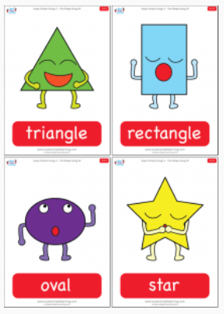

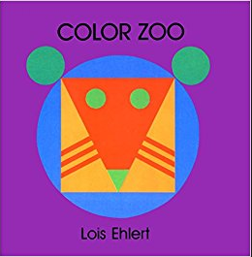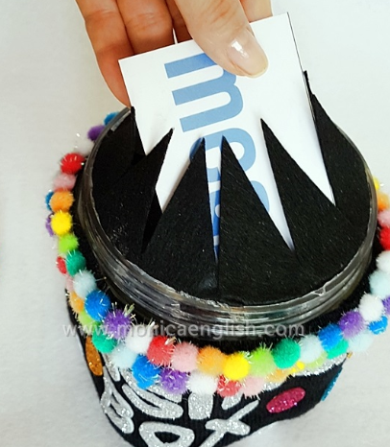
Storybook Bingo box
