Listening Speaking Reading Grammar Writing
Topic:
How Are You Feeling Today?
Instructor:  Jenny | Students Competency Level and Student ages  : Elementary 8-9 yrs. old | Number of Students:  5 | Lesson Length:  50 Min
Materials:(List the Names of all materials used in the lesson. Materials must be shown at the end of this document)
Pictures of Facial Expression
Happy
Sad
Angry
Scared
Surprised
Silly
Emotions Hokey Pokey Song
Emotions Hokey Pokey Song Lyrics
Feeling and Tracing Worksheet
Computer

Lesson Objectives (What do you want the students to know (new skill or knowledge that you want them to gain)? and What do you want them to be able to do?
Students will learn how we express our feelings such as: happy, sad, angry, scared, surprised, silly by singing, dancing and writing on a worksheet.
Aims:(What students will be able to achieve by participating in the activities of the lesson. (Ss gain or get by doing…)
Ss will understand feelings by looking at the pictures of feelings that teacher shows to class.
Ss get comfortable and interested in lesson by listening to the song.
Ss will be able to learn a song by dancing to the song and following the lyrics.
Ss will learn how to write feelings such as happy, sad, angry, scared, surprised, silly by completing the worksheet.
Ss will understand how to express feelings by playing a game and acting
Ss will understand feelings better by reviewing the words of feelings and sing the song together.

Language Skills:(Lists what activities language skills students will be using by participating in the activities of the lesson.)
- Reading: (Where did reading occur in the lesson?)
Pictures of feelings
- Listening:(Where did listening occur in the lesson?)
Listening to the song
- Speaking: (Where did speaking occur in the lesson?)
By repeating after T and singing the song
- Writing: (Where did writing occur in the lesson?)
Worksheet
Assumptions:(What students must already be able to do and what concepts must already be mastered before the lesson in order to achieve the aims of the lesson.)
Ss will enjoy and have fun.
Ss will learn feelings.
Ss will know how to express their feelings on their faces.

Anticipated Errors and Solutions:(What things might go wrong in the lesson and what the solution will be. An SOS activity should also be included)
Ss might get too excited during the activity.

References:
https://youtu.be/ZHS7vCdBeus

Lead-In or Pre-Task Part (Warm-Up Part to activate and create interest in the lesson.)
Materials: (List the Names of all materials used in the Lead-In or Pre-Task Part of the lesson. Materials must be shown at the end of this document)
Emotions Hokey Pokey Song
Emotions Hokey Pokey Song Lyrics
Computer

Time: | Classroom Set Up: | Student Activity and Goals: | Teacher Procedure &Instructions:
1 min  2 min  3 min | Whole class  Whole class  Whole class | Greet Teacher  Look at T and learn expressions of feelings  Ss listen to the song and become interested and familiar with the song | Greet Students  T shows the pictures of feelings and let Ss repeat after T.  T plays the song about emotions twice

Pre-Activity or Task Familiarization Part (Presentation Part for Presenting the language structure to be covered in the lesson. Prepares students for the communication activity.)
Materials: (List the Names of all materials used in the Pre-Activity or Task Familiarization Part of the lesson. Materials must be shown at the end of this document)
Emotions Hokey Pokey Song
Emotions Hokey Pokey Song Lyrics
Computer
Pictures of Facial Expression
Happy
Sad
Angry
Scared
Surprised
Silly
Emotions Hokey Pokey Song
Emotions Hokey Pokey Song Lyrics
Computer
Feeling and Tracing Worksheet
Time: | Classroom Set Up: | Student Activity and Goals: | Teacher Procedure &Instructions:
10 min  10 min  5  min | Whole class  Whole clas  Whole class  s | Ss follow the dance and sing along  Ss listen to teacher and learn the words and repeat  Ss write down the words of feelings on the worksheets and read out loud. | T plays song and T sings and shows how to dance to the song. Then sings with Ss  T introduces the words related to feelings by showing pictures. T encourages Ss to read out loud  T hands out worksheet and encourages Ss to read out loud and write words on Ss’ worksheet correctly Example : happy, sad, angry, scared, surprised, silly

Main Activity or Task Realization Part (Practice to Production Part Teacher lead practice of the language presented and move to communication based more student centered activity)
Materials: (List the Names of all materials used in the Main Activity or Task Realization Part of the lesson. Materials must be shown at the end of this document)
Pictures of Facial Expression
Happy
Sad
Angry
Scared
Surprised
Silly

Time: | Classroom Set Up: | Student Activity and Goals: | Teacher Procedure &Instructions:
3 min  2 min  10min | Teams  Teams  Teams | Ss observe teacher and get in teams  Ss follow T’s instruction to play the game  Ss watch and cheer for their teams. The first S of each team starts playing. Ss take turns | Put students in teams  Teacher puts pictures on the table placed in front of the class and explains how to play the game.  Teacher tells students to play the game.

Post Activity or Post Task Part (Wrap-Up Part to Close the Lesson on a high note to and consolidate language learned in a communication based activity new situation.)
Materials: (List the Names of all materials used in the Post Activity or Post Task Part of the lesson. Materials must be shown at the end of this document)
Pictures of Facial Expression
Happy
Sad
Angry
Scared
Surprised
Silly
Emotions Hokey Pokey Song
Emotions Hokey Pokey Song Lyrics
Computer

Time: | Classroom Set Up: | Student Activity and Goals: | Teacher Procedure Instructions:
1 min  3 min | Whole class  Whole class | Ss repeat after T and review words related feelings  Ss sing and dance  Ss say good bye | T reviews the words of feelings by using picture  T encourages Ss to stand up, sing and dance to the song learned in the beginning of the class.  Congratulate and thank Ss for active participation.

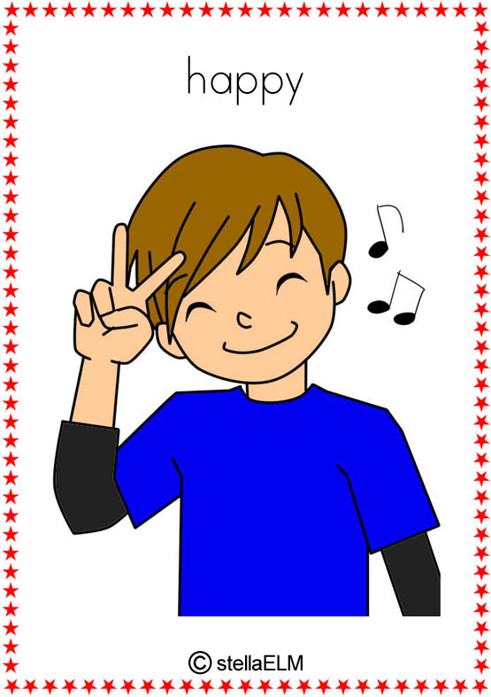
Happy

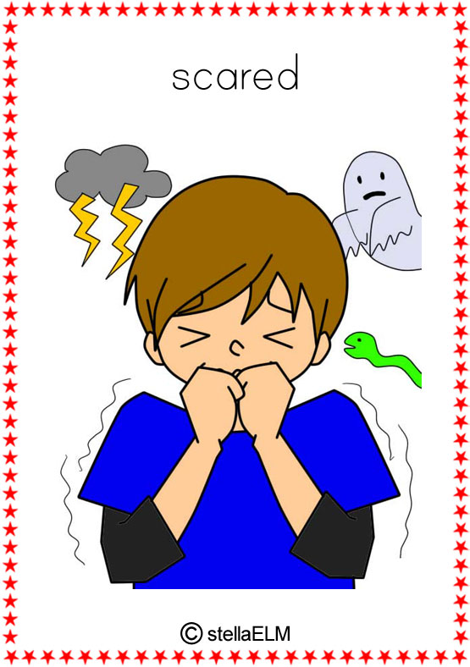
Scared

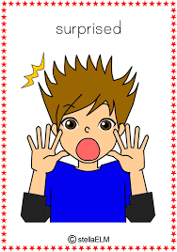
Surprised

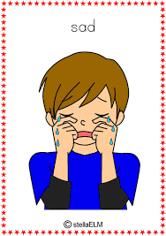
Sad

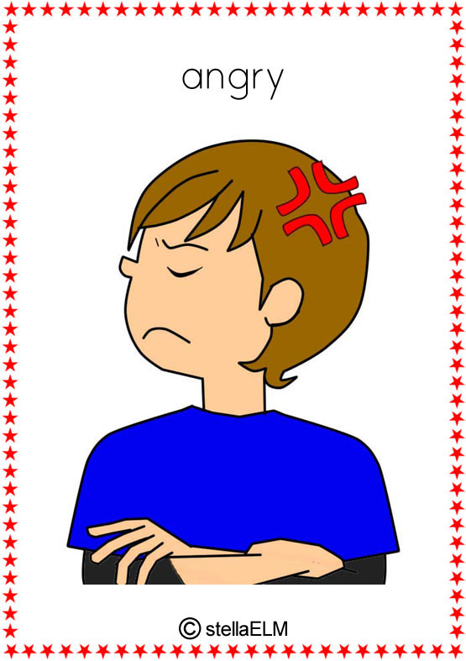
Angry

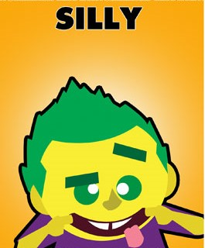
Silly

