‘Stephanie’s Likes and Dislikes’ Transcript

I would like to tell you, a little bit about some things I like, and then a little bit about some things I don't like.

first of all, I really enjoy exercising. Some of my favorite types of exercises are swimming, especially in rivers in the country and in big oceans because I like to jump over the waves. I also really enjoy dancing. I like dancing to American music because that's what I know best and I also, like Salsa and Merengue, which are more Latin types of music. I also like to walk in the woods and to explore. I like to walk through forests, and I like to hear rivers.

I enjoy meeting new people too. I like to find out about different ways of life, what different people think, where they're from, and how they live. Probably one of my favorite things are animals. I really love dogs, and cats, and horses. when I was little I always tried to talk my mom in letting me have more animals, but usually she wouldn't. So I think now that I'm going to have my own house, I'll try to get lots of animals. Some things that I don't really like are rude people. Sometimes people are not very nice to strangers, and that makes me feel bad. I also don't really like driving. I tend to get pretty bored in the car. and it seems like it just takes a long time to get there. One final thing I don't really like is waiting. Sometimes I'm not a very patient person, and I just like to hurry things up.

Word Worksheet I

- Fill out the Blanks, using the words in the box below.

Dislike(verb) Favorite(adj) Enjoy(verb) Bored(adj)

Most people _______ going to the dentist, so they brush their teeth well.

- My ________ ice-cream at BR 31 is Mint Chocolate Chip.

- I usually get ________ when I listen to a politician’s speech.

- I _______ dancing in the Kitchen because it helps me cooking better.

- Make a sentence with a given word. You can make each sentence using the words in the box below.

exercising, swimming, dancing, animals, music, hiking, climbing, food, pizza, watching TV, lecture, spider, history, diet, reading a book

- Dislike -

- Favorite -

- Enjoy -

- Bored -

Pictures for pre-activity

 | swimming
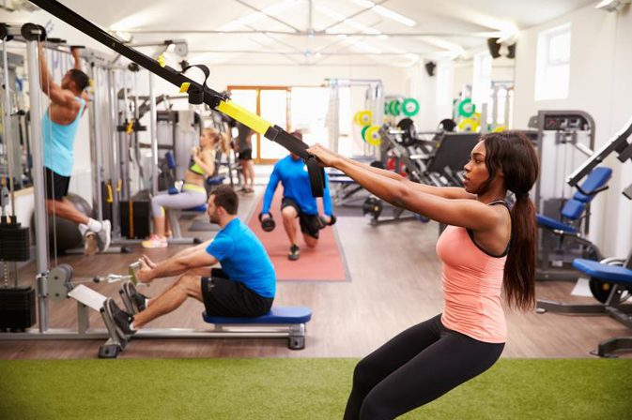 | exercising
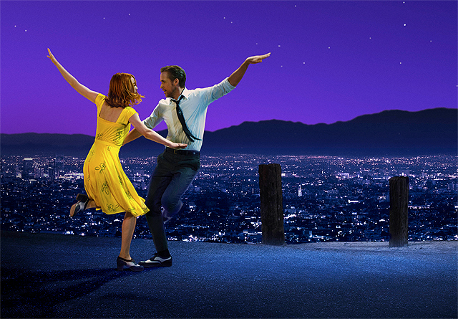 | dancing
 | driving
 | waiting
 | meeting new people

Listening Worksheet II

- Find the facts. Check T(True) or F(False).

- Stephanie dislikes exercising. (T/F)
- Stephanie likes dancing. (T/F)
- She likes driving. (T/F)
- She gets bored when she meets new people. (T/F)
- Especially, she enjoys K-pop music. (T/F)

2. Pick Yes or No and Explain Why you pick the answer.

- Did Stephanie’s mother let her have more animals? Yes/No
- Does she like to meet old people? Yes/No
- Is she good at waiting? Yes/No

3. Why is Stephanie going to have her own house?
(please, answer in a sentence)

4. What makes her feeling bad?
(please, answer in a sentence)

