☐ Listening ☐ Speaking ☐ Reading ☐ Grammar ☐ Writing

Topic: How was your weekend?

Instructor:  Soo yeon lee | Level:  False beginner | Students:  10students | Length:  50 minutes

Materials:
Listening CD & CD player (Track 23,25)
White board & board markers
Listening worksheets (10copies each)
Writing worksheets (10copies each)
Vocabulary worksheets (10copies each)
Key expressions worksheets (10 copies each)
Picture
Text book

Aims:
To learn vocabulary and expression of describing relationships by completing an key expressions matching worksheet
To practice speaking by discussing with partner
To predict about what is in the picture
To understand questions from listening
To practice listening to real-life speech of people with various accents.
To encourage students to make their own sentences

Language Skills:
Reading : worksheet, text book
Listening : listen to dialog and teacher’s instructions.
Speaking : discussing among students, repeat and speak dialogs
Writing : details (dictation), write to fill in the blank, information about partners

Language Systems:
Lexis : new vocabulary used in describing answer the ‘How was your weekend?’ question.
Function : questions and answers about what the person did on weekend.
Discourse : dialog, discussing among students

Assumptions:

Students already know
-students know how the class is set up and run
-teacher’s learning style
-finished word’s pronunciation
-all students are elementary school’s students.

Anticipated Errors and Solutions:

Students may not be able to follow the dialogs easily
-repeat listening the dialogs and read clearly with all students
Students may not be able to know the words in dialogs
- say them about the word’s meaning
If students finish their worksheet earlier than expected
-makes them figure out the main idea of topic and ask them what they think
Students may not be able to do a role play
-give them example of doing role play

References:
Text book : Listening starter 1 , Anne Taylor and Linda Kilpatrick-Lee ,
Unit 9 ‘How was your weekend?’ p69 ~ 73

Lead-In
Materials: picture about the word ‘weekend’

Time | Set Up | Student Activity | Teacher Talk
3 | Whole class | (students are sitting on the desk) answering the teacher’s question.  Answering about the teacher’s questions. | Greeting  Hi, everyone. How are you?  I’m glad to meet you again.  It’s too cold outside. Isn’t it?  Ok. Let’s start!  Eliciting  (prepare the picture about the word ‘weekend’)  I bring a picture, guys. Please attention to me.  (show a picture about the word  ‘weekend’ and ask question about the picture.)  What words in this picture?  What did you do on weekend?  Ok. Today we will learn how can we talk and answer to those sentences in English.

Pre-Activity
Materials: vocabulary worksheet, white board & board marker.

Time | Set Up | Student Activity | Teacher Talk
7 | Whole class  Individually  Whole class | Repeating and speaking  5 key vocabularies with following what the teacher says.  Doing the multiple choice worksheet.  Check the answer of each word. | Procedure  Key Vocabulary  (teacher writes 5 key vocabularies on the board)  T : repeat after me  “terrific”  “terrific” means…  (teacher explains the definition of each word)  Now, we are going to do a multiple choice activity.  Instruction  Solve the multiple choice questions about the 5 key words. You have 2miniutes.  Demonstration  Here is an example. You should choose the one that best fits the sentence.  CCQ  How much time do you have?  Are you working alone?  (distribute the worksheet and monitor discreetly)  Let’s check the answers together.  Explain the meaning of words if some  students do not still understand that.  Ok. Now, let’s start listening for the main idea.

Main Activity
Materials: textbook, CD & CD player (track 23,25),listening worksheet, key expressions worksheet

Time | Set Up | Student Activity | Teacher Talk
6  3  10 | Whole class  Individually  individually | Listening to the main sentences and taking notes.  Doing matching activity.  Check the answers  Listen the conversation.  Doing multiple choice  and fill in the blanks.  Check the answer | Listening for the main idea  Instruction  Open to page 69. And listen to the main sentences. (track 23)  And check the key words in that sentences. Students take notes.  CCQ  Can you take notes?  What do you find the key words in the main idea?  Do you want to listen again?  -yes : have them listen one more time.  -no : have them see the main sentences’ script.  Check the student’s writing.  Key expressions  (prepare key expression worksheet)  Instruction  Match the sentence on the left to the sentence on the right. Draw a line to match. You have 2 minutes.  CCQ  Are you working alone?  What are you supposed to do?  How much time do you have?  (Distribute the worksheet to students)  Let’s check the answers together.  And repeat after me. Speak louder.  Listening for details (dialog)  (prepare CD track 25)  Instruction  Now listen to the conversation and do a multiple choice activity and fill in the blanks on the worksheet. Work individually.  CCQ  Are you working alone?  For how long?  Listen track 25 twice to do 2 activities.  (distribute the worksheet)  (monitor actively)  Now, let’s check the answers.  -if students don’t answer incorrectly, teacher can help them directly.

Post Activity
Materials: writing worksheet

Time | Set Up | Student Activity | Teacher Talk
13 | pairs | Do a pair activity.  volunteering | Instruction  Let students do a pair activity. In pairs, students ask the question which the chart has to each other. And fill in the blank. You have 15 minutes.  Demonstration  ask each other about the questions. For example,  -lisa, how was last weekend?  CCQ  Who do you work with?  How much time do you have?  (distribute the worksheet)  (monitor actively)  Now, any volunteer who read a  friend’s answer about the which questions?  Good job today. See you guys tomorrow!

SOS Activity
Materials: ‘fill in the blank’ worksheet

Time | Set Up | Student Activity | Teacher Talk
8 | individually | Do a ‘fill in the blank’ activitiy  Check the answer | We will do a ‘fill in the blank’ activity.  Instruction  Give students a dialog which has blank.  Fill in the blank with alphabets of view  You have 8 minutes.  (distribute the worksheet)  Now, check the answer.

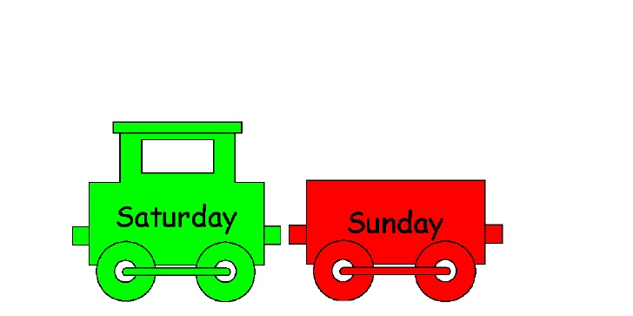
- picture about the word ‘weekend’

- Vocabulary worksheet

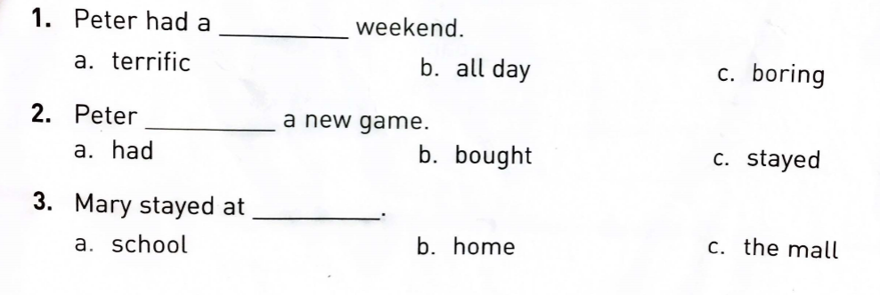

- key expressions worksheet

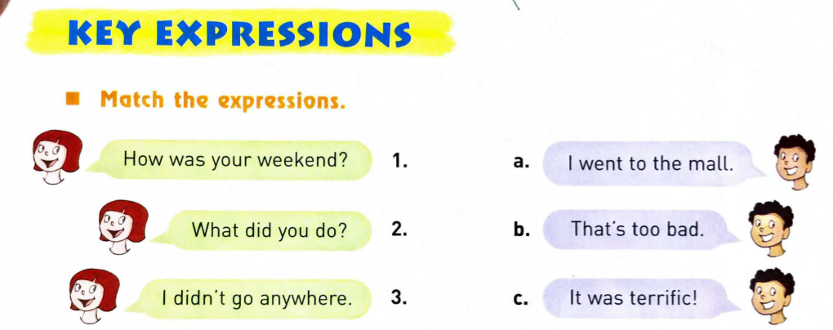

- listening worksheet

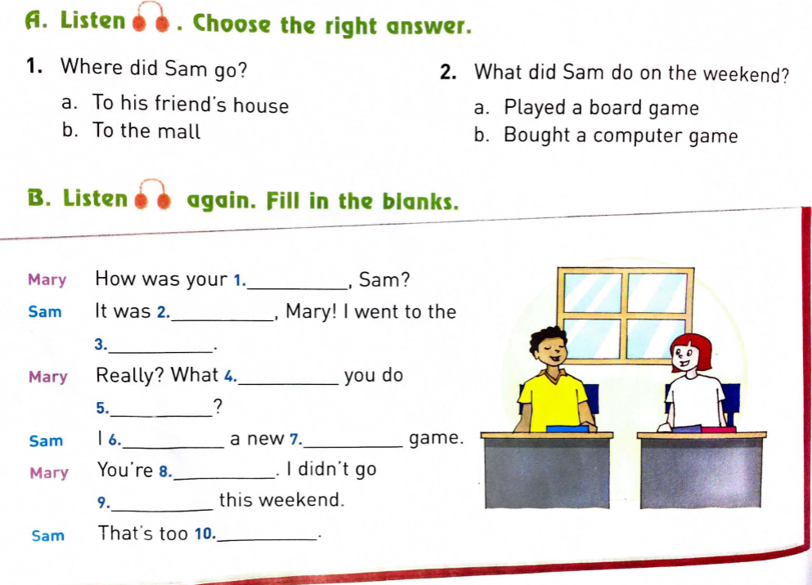

- writing worksheet

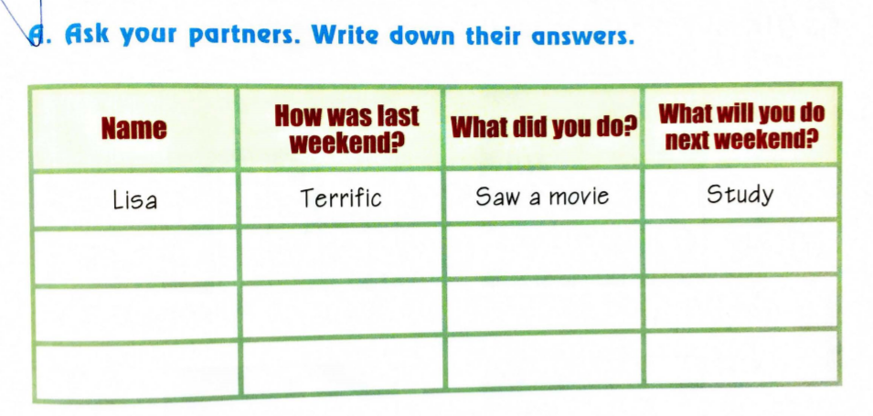

- sos activity’s worksheet ( writing worksheet)

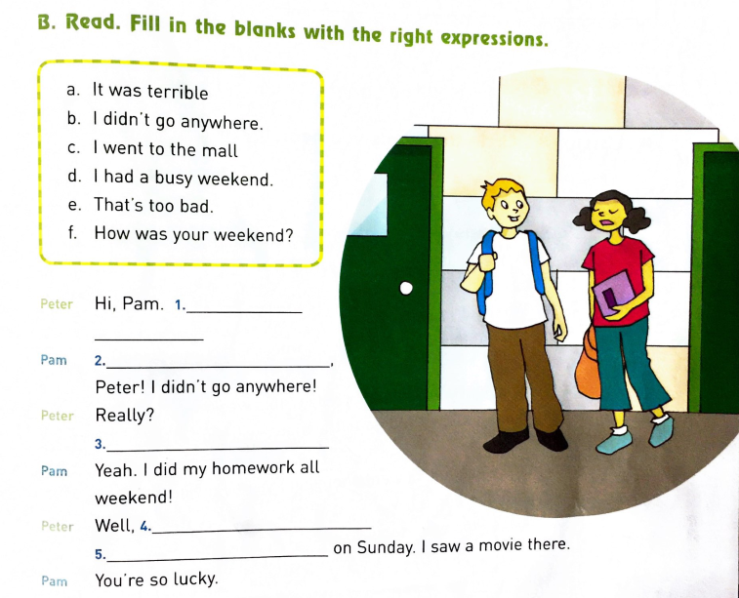

Dialog script

