☐ Listening ☐ Speaking ☐ Reading ☐ Grammar ☐ Writing

Topic: Relative clause

Instructor:  Nancy | Level:  intermediate | Students:  9 | Length:  30 mins.

Materials:
Family pictures
9 copies of the practice worksheets
Computer, whiteboard, board markers

Aims:
Students will predict the meaning of the relative clause by listening to the teacher introducing family members.
Students will know the form of the relative clause by teacher’s explanation and substitution table.
Students will practice the relative clause by answering concept check questions and completing the worksheets.
Students will practice speaking and listening ability by sharing ideas in a group and introducing classmates.

Language Skills:
Listening: listening to the teacher’s introduction, instructions, explanation and classmates’ ideas.
Speaking: drilling, practice activities and sharing ideas
Reading: reading worksheets to answer questions
Writing: worksheet answers

Language Systems:
Phonology: drilling
Grammar: use of relative clause
Function: introducing people

Assumptions:
Students have already learned several tenses.
Students are teenager.

Anticipated Errors and Solutions:
Students may have difficulty in understanding the meaning →
Teacher provides more examples
Students may have hard time when doing worksheets→
Teacher provides clear instructions and gives them more chances to practice.
If students finish their tasks earlier than anticipated→
Give students more time on final activity.

References:
https://www.google.co.kr/search?q=people+names&dcr=0&source=lnms&tbm=isch&sa=X&ved=0ahUKEwjQmuXVlJbZAhVEhrwKHcQvD6EQ_AUICigB&biw=1366&bih=574#imgrc=vGXsmmb9qMmfyM:

Lead-In
Materials:

Time | Set Up | Student Activity | Teacher Talk
2mins | Whole  class | Free talk | Hello everyone, how are you today?  (Students greet back)  Review  Last week, we talked about family tree. How many people are there in your family?  Who are they?  What do they do?  Contextualization  Today, I’m going to introduce my family to you. Would you like to know them? Ok, let’s watch.

Presentation
Materials:
Family pictures computer whiteboard marker

Time | Set Up | Student Activity | Teacher Talk
3mins  2mins  3mins | Whole  class | Family introduction | Procedure:  1.Presentation  (Show picture1) What can you see in the picture? One of them is my father. Can you tell me which one? Now listen to me and you’ll know the answer. The man who wears a white shirt is my father. Now tell me which one is my father. That right.  (repeat this with all the pictures)  2.Recall  Now look at the first picture. Can you use the sentence I used to tell me which one is my father? (Make students recall the sentences, if the students feel difficult, the teacher helps. Then the teacher writes the sentences on the board.)  3.conclude  Meaning  Great! We have just learned relative clause. Let’s talk about the meaning. Look at the first picture and first sentence. If I say “The man is my father.” Do you know which one? (No) So we use relative clauses to make clear which person we are talking about.  For example, “The man who stole my wallet has been arrested”. It means the man has been arrested. Which one? The one stole my wallet.  CCQ  Did the man steal my wallet?(Y)  Was he arrested?(Y)  Form  Look at these sentences. Can you tell me what the form is? Good. Here “who” is a relative pronoun for people. We use relative pronouns to introduce relative clauses, which tell us more about people. So for the first sentence, which is the relative clause?  Drilling  The man woman girl boy who Is tall is my dad.  wears a dress lives here.  Is shouting dances well.  sings well is my son.  (Show students the substitution table)  Ok. Listen to what I say and don’t repeat.  CCQ  What do you do?  Now listen and repeat.  CCQ  What do you do?  Now I will pick some students to repeat individually.

Practice
Materials:
worksheet

Time | Set Up | Student Activity | Teacher Talk
5mins  5mins  5mins | Whole  class  individually  Whole  class  Whole  class  Pair  Whole  class  Whole  class  Pair  Whole  class | Controlled practice 1-  Combine the sentences  Controlled practice 2-  Information gap  Less controlled practice-  Define them! | Instruction  Do the worksheet questions number 1-5. Combine the sentences individually. You have 2 minutes.  CCQ  What do you do?  How much time do you have?  Do you do it alone?  (Pass out the worksheet and run task)  Feedback  Do you need more time?  (If yes-give 30 seconds extra doing time  If no-check answers together)  Instructions  (Pass out the worksheet)  You have the same picture with different information. Please ask each other to complete the sentences in pairs. Don’t show your picture to each other. You have 3 minutes.  CCQ  Do you work alone?  Can you show your picture to your partner?  What do you do?  (run task)  Feedback  Would you like to have more time?  (If yes-give 30 seconds extra doing time  If no-check answers together)  Instructions  Here are some occupations. What do they do? Please tell me by completing the sentences. Work in pairs. You have 3 minutes.  CCQ  Do you work in pairs?  How much time do you have?  (run task)  Feedback  Would you like to have more time?  (If yes-give 30 seconds extra doing time  If no-check answers together)

Production
Materials:

Time | Set Up | Student Activity | Teacher Talk
5mins | Whole  class  Pair  Whole  class | Introduce your classmates.  Wrap up | Instruction  Now, let introduce our classmates. Please introduce at least 3 students. Let’s work in pairs and you have 3 minutes.  Demonstration  For example, you can say “The woman who teaches Japanese well is Soyeon.”  CCQ  What do you do?  How much time do you have?  (Monitor discreetly)  Now let’s share each pair’s ideas. Pair 1, please share your sentences.  (Go through all the pairs)  Did you have fun today?  I hope you enjoyed today’s lesson.

Worksheet
Combine the sentences.
1. The pretty girl works in this office. She is my girlfriend.
_____________________________________________________
2. The people are very nice. I work with them.
_____________________________________________________
3. The boy broke the window. He ran away.
_____________________________________________________
4. A police man stopped our car. He wasn’t very friendly.
_____________________________________________________
5. A woman opened the window. She was wearing a yellow dress.
______________________________________________________

Complete the sentences by asking your partner.
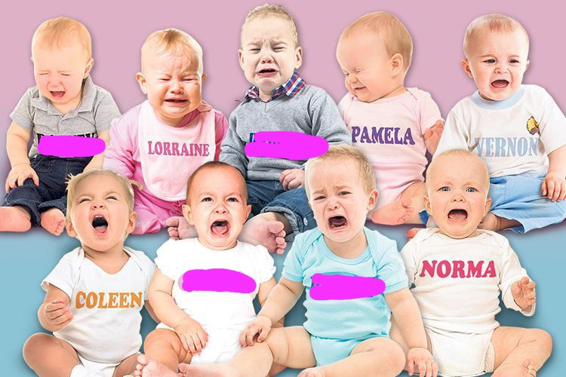
1. The baby _______________________________________ is Cilla.
2. The baby _______________________________________ is Warwich.
3. The baby _______________________________________ is Rodney.
4. The baby _______________________________________ is Dermot.

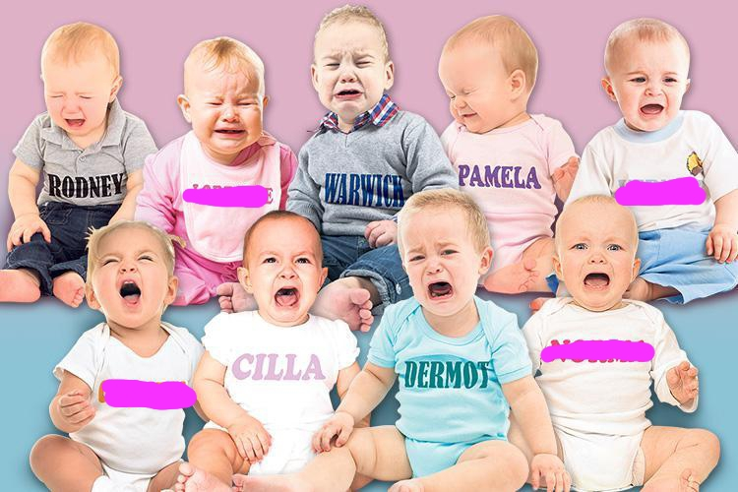
1. The baby _______________________________________ is Lorraine.
2. The baby _______________________________________ is Norma.
3. The baby _______________________________________ is Vernon.
4. The baby _______________________________________ is Coleen.

Complete the sentences.
1. A musician is a person who __________________________________.
2. A patient is a person _______________________________________.
3. A liar ____________________________________________________.
4. A photographer ____________________________________________.
5. A genius _________________________________________________.

