☐ Listening ☐ Speaking ☐ Reading ✓Grammar ☐ Writing

Topic: Simple present “Can~”

Instructor:  Warren (Han Sin) Kim | Level:  High Beginner | Students:  5 students | Length:  36 minutes

Materials:
A desktop computer to access into YouTube.
A desktop computer to access viewing images.
White board, board markers and an eraser.
Video clips from YouTube.
A phonogram cards or copy of key vocabulary lists.

Aims:
To improve use of grammar skills for students.
To improve speaking skills for students
To improve listening skills for students
To improve student’s comprehension skills.
To be able to explain and discuss about the topics they’ve learned.
Students are able to work cooperatively in a group or pairs by sharing their ideas and thoughts.

Language Skills:
Reading: reading worksheets to answer questions
Listening: listening teacher’s instructions, explanation, and classmates’ ideas
Speaking: by answering questions after listening & by having a discussion about it.
Writing: by answering worksheets.

Language Systems:
Discourse: listening to the lyrics(song).
Function: Having a group or pair discussion & share ideas with teacher.
Grammar: Make a full sentence when writing down the ideas and information.
Lexis: new key vocabularies.
Phonology: drilling.

Assumptions:
- Students are confident with pair and group work.
- Students already know the teacher’s style of teaching and pace of lecture.
- Students are aware to speak only English in the class.

Anticipated Errors and Solutions:
- It takes time than what T expected and give students more time if needed.

- If students finish their work earlier than expected time, give students SOS activities.

- Students may have difficulties in understanding the materials, give students more examples and explanation.

- Students may have difficulty in understanding the meaning. Then teacher provides more examples.

References:
https://www.youtube.com/watch?v=i_FXF5tR74U
http://www.esl-lounge.com/student/grammar-guides/grammar-beginner.php
https://www.merriam-webster.com
https://www.popsongprofessor.com/blog/2017/2/24/what-does-something-just-like-this-by-coldplay-and-the-chainsmokers-mean
https://www.quora.com/What-is-the-meaning-of-Coldplays-song-Something-Just-Like-This
https://en.islcollective.com/resources/printables/worksheets_doc_docx/can__cant_abilities/can-ability-can/72458
https://en.islcollective.com/resources/printables/worksheets_doc_docx/can_-_cant/ability-can-cant/19277
http://christianrock123.blogspot.kr/2012/06/superheroes.html

Lead-In
Materials:
A desktop computer to access viewing images

Time | Set Up | Student Activity | Teacher Talk
2 Min | Whole class | Students are expected and prepared to listen.  Look at the picture.  Guess and answer to questions | Greeting  Good morning everyone?  How are you today?  How was your weekend go?  Eliciting  Have a look at the picture here.  What do you all see here?  What do you all think when you look at this picture?  Think about the when you were just a kid. What do you wanted to be?  Etc…

Pre-Activity
Materials:
A desktop computer to access viewing images

Time | Set Up | Student Activity | Teacher Talk
2 Min | Whole class | Students are expected and prepared to listen and respond. | Contextualization  Does anyone here like pop music? Do you know any of American bands?  (listen to responses)  Have you ever heard about the American male band “The Chainsmokers?  So, we will listen to their song.

Main Activity
Materials:
A desktop computer to access into YouTube.

Time | Set Up | Student Activity | Teacher Talk
5 Min  1 Min  3 Min  5 Min  5 Min  2 Min  2 Min | Whole class  Whole class  Whole class  Group  Whole class  Whole class  Whole class | Students are at full attention to teacher and they are ready to listen to music.  Students are ready to answer.  Listen to teacher and to answer questions what they heard and how they think. Students are at full attention to think while listening to teacher.  Students are discussing their thoughts and ideas with them.  Students are sharing their ideas from the video that they’ve just watched.  Students are at full attention to teacher. And reply through answering questions.  Students are at full attention to teacher.  Students are at full attention to teacher. | Guided Warmer Activity  You don’t have to focus on the video, try to listen and focus on the repeated lyrics. You can right down the repeated lyrics if you want to. Also please figure out what the situation is from the video clip including a lyric.  CCQ’S  What should you do when you all watch the video?  Hand out the lyrics to students right after the song.  Procedure:  Recall.  - Did you all enjoy the song? What is the title of the song?  - The song is The Chainsmokers’s “Something Just Like This”.  Elicit first then have students discuss about it.  - As you listened, to elicit it. This boy was a hero and he could do anything he wanted when he was just a boy. But then he became an adult and realize that he isn’t hero anymore, and he figured out that the gods are not real. The things are not perfect in the real life.  - He is also looking or find for someone like him or maybe with someone who has a same social status like him now. Or he’s looking for an ordinary love. And want to have a good enough relationship.  Now, I want you to tell me what situation do you think the singer is at? What feeling do you think he has?  - What is lyrics telling people?  Have discussion with your partner.  (The answer 1: The song shows he wants to be something more without realizing that he is good enough. Also, it shows the strength of true love and a woman’s heart which will always love him no matter how less he is.)  (The answer 2: Yet he believes he is not enough. He ignores her and compares himself with the Superman. Again he fails to be him. Yet her love for him doesn't change. She knows what he is and is completely happy with him and says: I want Something just like this).  Key sentences  - Where’d you wanna go? (with this relationship?) (He realizes the truth and wakes up from the dream or What kind of relationship do you wanna have?).  - Just something I can turn to  (Literally it means, lean to. Sth + I can believe or trust.)  Reflect  (If there’s not enough time skip it)  Great!! So now did you notice the repeated lyrics? (Have students reply through answering question.)  Yes, I can, I want, and etc. They are all repeated words from that lyrics. Good Job.  Then do you remember any lyrics starting with “I can, I want, or I am not?  Then can you tell me why do you all think they were using ‘can~’ phrase/form?  (to elicit students to think about the meaning of can and cannot.)  Conclude  Meaning:  Oh well, I’m sure that you all learned many things from the song.  Guess what?! You all just learned “Can and cannot form.  Can and cannot expresses the idea that It can be used to express ability or opportunity, to request or offer permission, and to show possibility or impossibility.  When we learn a simple present tense.  1.To express habits, general truths, repeated actions or unchanging situations, emotions and wishes: ...  2.To give instructions or directions: ...  3.To express fixed arrangements, present or future: ...  4.To express future time, after some conjunctions: after, when, before, as soon as and until.  The use of simple present.  The simple present is a verb tense with two main uses. We use the simple present tense when an action is happening right now, or when it happens regularly (or unceasingly, which is why it's sometimes called present indefinite).

Post Activity
Materials:
A worksheet. (Forming the simple present tense)

Time | Set Up | Student Activity | Teacher Talk
1 Min  2 Min | Individually | Students are ready to drill and learn simple present tense.  Students are filling the worksheet. | Here, I’m going to hand you out this form right here says “Forming the simple present tense: to play”.  Let me show you an example.  Have students work individually.  I want you to pick any topic for that and try to right down a sentence for at least two to three column.  This is it for today. Did you all enjoy my class? (Ask students some feedbacks for my lesson today).

SOS Activity
Materials:

Can and cannot Abilities Worksheets.

Time | Set Up | Student Activity | Teacher Talk
1 Min  5 Min | Group | Students are ready to drill and learn can and cannot abilities.  Students will fill in the blanks. | If there’s not enough time left, then skip the Reflect and do the worksheet for the SOS Activity.  Let me show you an example.  Have students work in a group.  After their work is done or if there’s not enough time left.  Have them to do it for a homework for the following lessen.

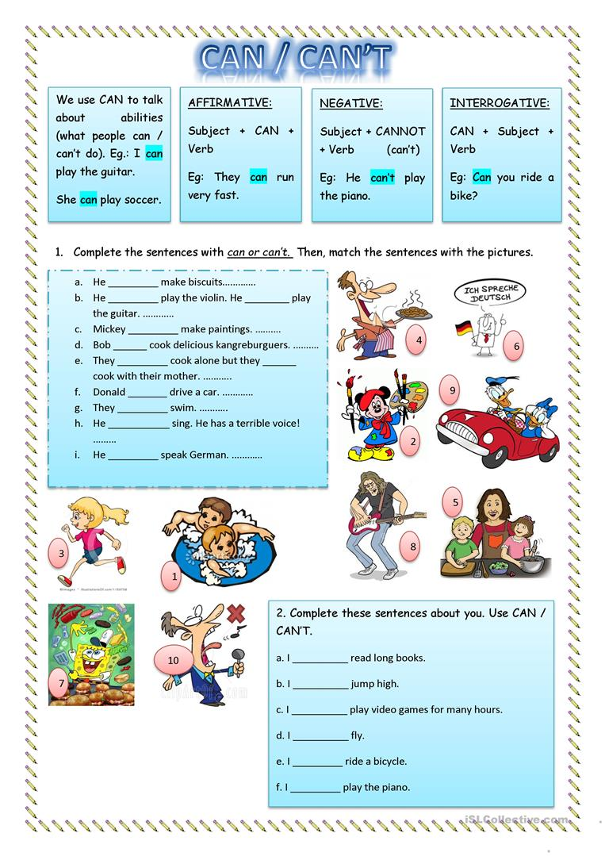
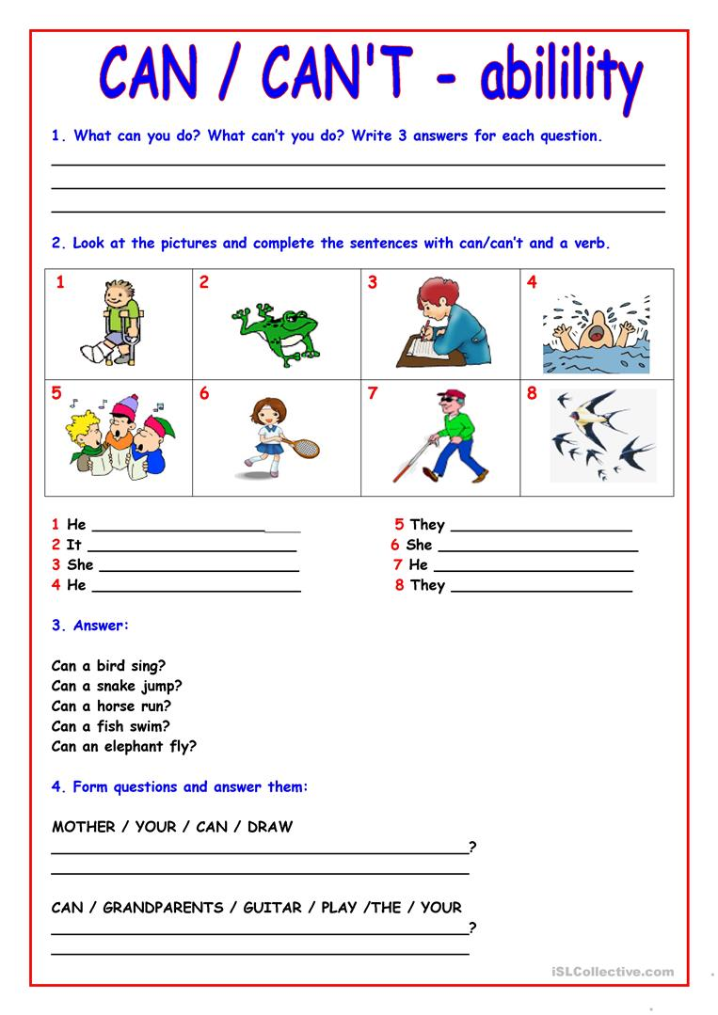

Forming the simple present tense: to play
Affirmative | Interrogative | Negative
I can play tennis | Can I play tennis? | I cannot play tennis
You can play baseball | Can you play baseball? | You cannot play baseball
He can play basketball | Can he play basketball? | He cannot play basketball
She can play hockey | Can she play hockey? | She cannot play hockey
It can play music | Can it play music? | It cannot play music
We can play violin | Can we play violin? | We cannot play violin
They can play soccer | Can they play soccer? | They cannot play basketball

