☐ Listening ☐ Speaking ☐ Reading ☐ Grammar ☐ Writing

Topic: At The Party!

Instructor:  Kim Yeonkyung | Level:  Pre-intermediate | Students:  4 students | Length:  40 minutes

Materials:
- 4 different Self-introduction cards
- Practice Worksheets (4 copies)
- White board and board marker
- vocabulary worksheet for Teacher

Aims:
- Students will practice how to communicate with each others when they share the information.
- Students will be able to practice speaking and listening by sharing information
- Students will practice reading skill by reading self-introduction card

Language Skills:
- Listening : teacher talk, classmates talk, sharing information with classmates
- Reading : self-introduction card, vocabulary worksheet
- Speaking : communicate with classmates
- Writing : write down practice worksheet

Language Systems:
- Lexis : vocabulary
- Function : ask and answer the questions
- Discourse : communicate with classmates assuming they are at the party

Assumptions:
- Students are aware of what the party is.
- Students will enjoy the activity
- Students are able to ask questions each other in a correct way
- Students are able to write down what classmates say

Anticipated Errors and Solutions:

- It takes time than expected
- Give them more time, not exceeding 5 minutes

- Students may have difficulties in understanding the patterns and use it
- Give them more examples and explanation

- Students may not actively participate in the group discussions
- Monitor from the beginning and encourage them to participate

References:
http://www.pinasacademy.com/material_kids/self-introduction.html

Pre-Task
Materials: Whiteboard and Board marker, self-introduction cards
Time | Set Up | Teacher Talk
7m | Whole Class | Greeting  T : Have you guys ever been to party before with unfamiliar people? Or are you planning to go for party in the future?  (Some students may say yes and some say no)  T : What did you ask or what you want to ask to the people who you do not know?  (Write down what students say)  T : Today, we will open a small party with strangers.  Introduction of Task  T : At the party with strangers, we ask questions to get to know each other. I will pass up the self-introduction cards of yourselves. So during the exercise time, you will become the person written on the card.  (Write on the board “PARTY”)  T : So, after the exercise starts, let’s assume that we all met first time at the party! Here are the cards.  (Pass up the cards written all different information)

Task-Preparation
Materials: self-introduction cards
Time | Set Up | Teacher Talk
 | Whole Class | Instructions  T : Before we read the passage, we will learn the new vocabulary first. Please write down the meaning on the cards or somewhere if there is the words that you do not know.  (Pass up the vocabulary worksheet and elicit the meaning of vocabulary by giving them sentence. After they get the meaning, write the definition on the board. Make sure every students understand the meaning. If not, explain again)  T : So far you all understand the meaning of vocabulary, let’s move on to the next step! It is time to read the cards. You have 3 minutes to read it. If you do not know any words from the cards, please let me know. And do not show the cards to the others.  CCQ  - How much time do you have?  - Can you show your cards to the others?  T : Alright, times up. Let’s go party now!  (If some students need more time, give them extra time)

Task-Realization
Materials: self-introduction cards, Practice worksheet
Time | Set Up | Teacher Talk
 | Whole Class | Instructions  T : Ok, before we start party, I will pass up a worksheet. You can ask the others whatever you want to ask but ask questions based on the paper. The form of the cards are all same, only the details are different. After you ask, write the answers of others on the paper. You have to ask at least 10 questions per person and do not need to work in a pair. If you get more than ten answers, write at the back of the worksheet. You have 15 minutes. Let’s start.  Demonstration  T : If the age is written as “27 years old” in the card, you may answer you are 27 years old when people ask your age.  CCQ  - How much time you have?  - Can you discuss in a pair?  - How many questions you have to ask?  T : 5 minutes left.  T : Alright. Times up.  (If students need more time, give them 3-5 minutes)  <Instructions continue>  T : Okay, good. Now, let’s find out who could not enjoy the party today. Tell me who is a teacher?  (Ask students around 10-15 questions based on the cards.)  T : It seems everyone has enjoyed the party today!

Post Activity
Materials:
Time | Set Up | Teacher Talk
 | Whole Class | <Error correction and Feedback>  T : I hope today’s activity helped you to know about new version of your classmates. Did you have any difficulties?  (Have students analyse their difficulties or errors made during the class and discuss about them. Try to correct as a whole class. Note the difficulties of students. )  T : You all did a good job. Bye!

Practice Worksheet
1.

2.

3.

4.

5.

6.

7.

8.

9.

10.

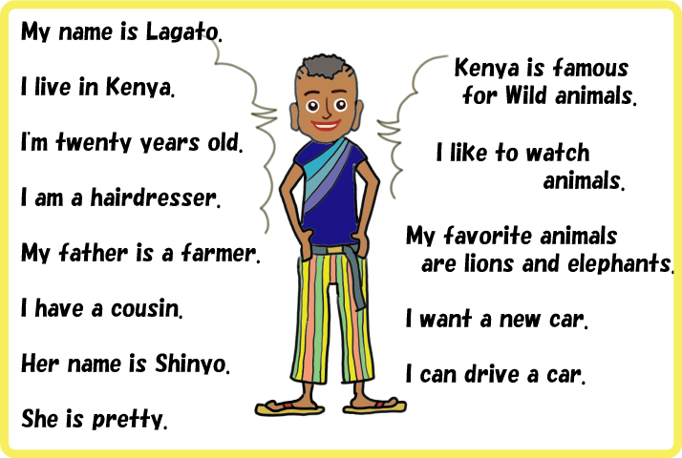
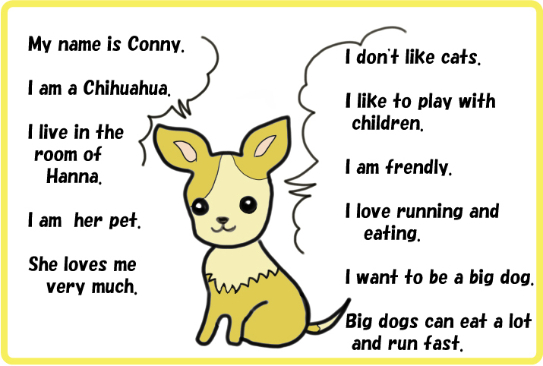

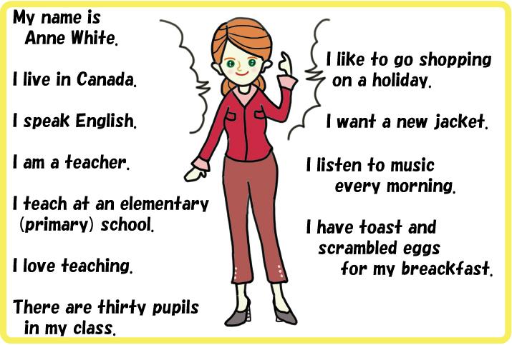
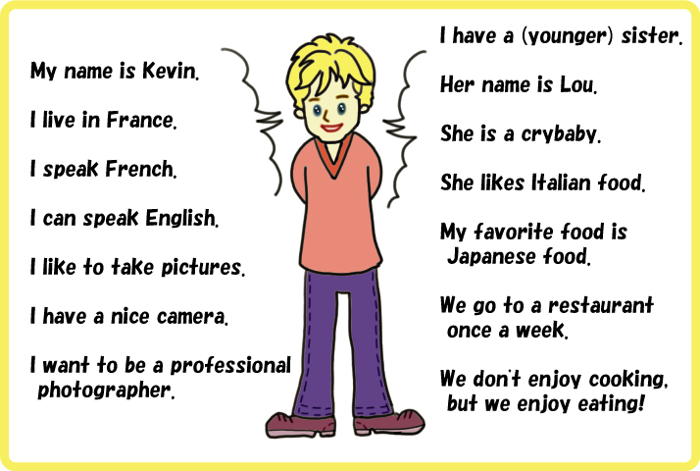

Vocabulary Worksheet for Teacher

- Hairdresser ; a person who cuts and styles hair as an occupation.
- She went to the hairdresser's for a shampoo and set.

- Cousin ; a child of one's uncle or aunt.
- I have two cousins because my aunt gave birth of twins

- Wild ; (of an animal or plant) living or growing in the natural environment;
- These herbs grow wild in the area.

- Friendly ; kind and pleasant.
- they were friendly to me, so I felt comfortable.

- Pupils ; a person who is taught by another, especially a school child or student in relation to a teacher.
- they are former pupils of the school

- Photographer ; a person who takes photographs, especially as a job.
- We hired a photographer for our wedding.

