Nutrition Specialists Talk About Small Diet Changes

that Make a Big Difference

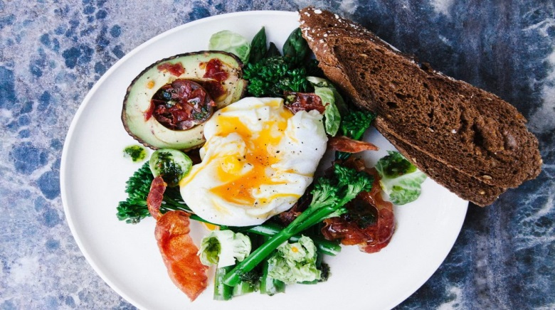
No pain — no gain, right?
Wrong.
There is a reason why crash diets seldom work. Very few people are capable of making a dramatic lifestyle change overnight and then sticking to it. For the rest of us, it’s small but meaningful changes that can make all the difference.
It is proven that consistent changes in dietary pattern bring long-term health benefits — no matter how tiny the change is.
Because — and we won’t get tired of saying this —
Little things that can add up to make a big difference.
Last week, we asked our favorite nutrition and healthy living experts: “If you could only give someone ONE small diet tip that can lead to big changes, what would it be?”
Here is what they said.
Kayleigh Christina Clark, health & nutrition coach, kayleighchristina.com:
Eat a breakfast full of protein, greens, fiber, and fats! (not talking about running out of the house with a granola bar).
This is so much easier than you think! It can be as simple as a smoothie — my favorite Mint Chocolate Chip Smoothie, Double Dark Chocolate Smoothie, Chocolate Chia Seed Pudding, or whipping up some eggs, spinach, avocado, and optional chicken sausage. All of these breakfasts can be made the night before and then kept in the fridge until you leave for work in the morning, so there is no excuse for “I didn’t have enough time”.
Having a breakfast filled with protein, fats, and fiber will keep you energized, full for longer, balances your hunger hormones, and leads you to make better decisions throughout the day!

Rachael Hartley, RD, private practice dietitian and blogger at The Joy of Eating:
Eat foods you love, including those you might think are “bad.” Cutting out foods just makes you want them more, and while you might be able to go without for a short period, when you inevitably eat the “bad” food, you’ll end up eating a lot more than you would have. Allow yourself to savor foods that you love!
Katie, healthy eating & fitness blogger, Gettin’ My Healthy On:
Make it homemade. It’s a small lifestyle change that can make a big difference, simply because you have more control over what you’re eating. You don’t have to be an amazing chef to make tasty, nutritious meals either. (One of my favorite easy meals to throw together is burrito bowls.)
By simply reducing the number of times you go out to eat within a week or month, it can be significantly easier to reach your health goals. Plus, it can be fun to experiment with fresh ingredients, and you might even discover you enjoy cooking!

