☐ Listening ☐ Speaking ☐ Reading √ Grammar ☐ Writing

Topic: Have you been to ________ in Korea? (Present Perfect)

Instructor:  Jean Yoo | Level:  Pre-Intermediate | Students:  8 | Length:  30min

Materials:

-Worksheet
-Whiteboard
-Note
-Substitution table
-Pictures

Aims:
-Students will learn basic structure of present perfect tense and notice the different between past simple tense.
-Students will practice the present perfect tense by asking questions by completing the table by ticking the box in the worksheet.
-Students will practice speaking activity by asking questions and answering that can practice any grammar or language.
-The learners can create questions by making questions and ask each other the questions.
-Students can learn present perfect by asking or telling a story starting with “I have been to”

Language Skills:
Listening: listening to Teacher and SS’s conversation and hearing of drill.
Reading: reading the questions of interviewee’s answer in the worksheet.
Speaking: talking about SS experience visiting places in Korea.
Writing: make questions about present perfect sentence. Also writing the answer on the board.

Language Systems:
-Phonology: drilling
-Grammar: use of present perfect tense
-Function: through the picture, asking question of ‘have been to’ based on your experience

Assumptions:
- Students have living and travel experience in Korea
- Students know past tense
- Students already know of present simple tense.

Anticipated Errors and Solutions:
- Students may not be able to follow present perfect tense
- Review from Present simple tense and present perfect tense’s grammar structure again

- XX

- If time is short
- Cut post-activity short and only ask 1-2 students to share their experience of visiting a country.
- If students finish their task earlier than anticipated,
Do SOS activity to practice their interview as if it is actually done.

References:

https://www.pinterest.co.kr/pin/632826185114381018/
https://www.pinterest.co.kr/pin/554857616570971539/
https://www.pinterest.co.kr/pin/632826185114379928/
http://www.esl-lounge.com/student/grammar-guides/grammar-pre-intermediate-3.php#present perfect structure

Lead-In/Pre-task
Materials: Whiteboard, marker

Time | Set Up | Student Activity | Teacher Talk
2min | Whole class |  | Hello everyone. How are you?  Review  Do you guys remember what we learned about past simple tense last class? For example,  (Write on the board)  “I went to Paris in 1997.” we use past simple tense because we are talking about a specified time in the past, 1997  So moving further, I would like to study another function of present perfect tense today.

Pre-Activity/Present/Task Preparation
Materials: Whiteboard, Substitution table

Time | Set Up | Student Activity | Teacher Talk
5min | Whole class | Looking at the board and listen to the teachers’ guide also taking a note | (Write on the board)  I went to Paris in 1997.  I have been to Paris two times. (add)  In the second sentence, we are just saying "at some time in my life" without being specific as to exactly when we have been to Paris - so we use the present perfect.  The present perfect used in this way means "at some time in the past".  Good to draw if you can on the board.  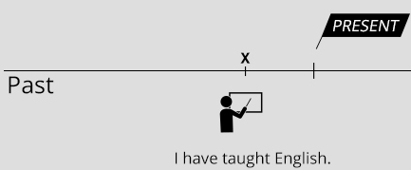  Change into I have been to Paris two times.  I would like to give you more examples on this and practice.  Draw a substitution table as below on the board.  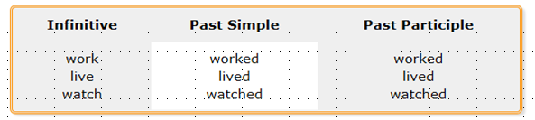  - I have worked  - He has lived  - They have watched  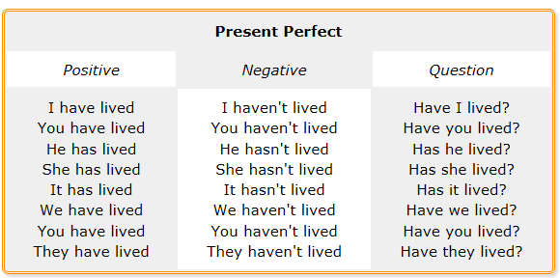  For irregular verb, which base form changes, I will give you the most commonly used verbs for your reference.  Present Perfect tense is used to talk about our experiences up to the present.

Main Activity/Practice/Task Realization
Materials: Whiteboard, Worksheet, Pictures

Time | Set Up | Student Activity | Teacher Talk
10min  8min | Whole class  Whole class | Drilling  Have interview with classmate  Speak and tell about what you have interviewed | (Give out Korea worksheet 1 to students)  Please see worksheet, you will see map of the Korea and famous city of it.  You will ask your partner or group member by asking “Have you been to ______?”  Then, you will be marking using a chart after hearing Yes or No answer. Also when you hear the answer from your partner, you will be writing the answer on the next sheet of worksheet I gave you.  You will be presenting other person’s answer afterwards  You will have 10min for it.  CCQ  - What were you supposed to do?  - What are you supposed to ask your partner?  While SS having an interview, teacher draws the following chart on the board.  I would like each of you to tell me one of each person’s answer to complete the chart.

Post Activity/Production/Post Task
Materials: Worksheet

Time | Set Up | Student Activity | Teacher Talk
10min | Whole class | Make questions your own  Interview with those question | [Instruction]  Now, let’s make our own question with ‘Have  been to’ starting a sentence. You may use  different places of picture to help the idea of  places.  You need to make 3 questions per person to  ask. You have 5min to create.  Those who have finished, ask each other and  Write down the answer on the sheet.  Please you guys can come up and write each  of the best answer you like on board.  Thank you everyone for your cooperation and I hope you practice a lot in your daily life you learned today.  Goodbye!

SOS Activity (in case you finish more quickly than you thought)
Materials: Worksheet

Time | Set Up | Student Activity | Teacher Talk
5min | Individual | Ask other SS with “Have you ever” questions | I would like to practice “Have you ever?”  Question. This is very commonly used present  perfect tense that is used to talk about our  Experiences up to the present.  (Pass out worksheet)  Please see the picture described and fill in  the blank with past participle in it.  You have 5mins to fill in.  Every one of you will read it with two lines of  each.

