☐ Listening ☐ Speaking ■ Reading ☐ Grammar ☐ Writing

Topic: Cinderella

Instructor:  Hyun Ji Son | Level:  Intermediate | Students:  12 | Length:  35 Minutes

Materials:
- White board and markers
- Reading passage (13 copies)
- Worksheet#1, #2, #3, #4 (13 copies each)
- SOS worksheet (13 copies)
- Computer file (for vocabulary)

Aims:
- Main aim: Students will be able to improve their reading skill by reading a fairly tale ‘Cinderella’
- Secondary aim: Students will develop their reading skill to recognize the main idea of the reading by drilling handouts
- Personal aim: I want students to develop their imagination by creating their own short story

Language Skills:
- Reading: Ss will read reading passage
- Listening: Ss will listen the instructor and other students
- Speaking: Ss will present their own story
- Writing: Ss will practice their writing by accomplishing handouts

Language Systems:
- Phonology: [-θ], [-ər], [ə], [ʌ]
- Lexis: new vocabularies
- Grammar: the simple present tense, the simple past, and the future tense
- Function: giving information
- Discourse: student’s own experience
Assumptions:
Student already know
- how the class is organized and operated
- the most of words in the reading passage
- today will be learned reading

Anticipated Errors and Solutions:
If the students finish their work faster than I expected,
- Give them SOS activity
If the students are too scary to present in front of the class,
- I will allow them to remain their seat and present
If the students are hesitated for talking with partner
- I will encourage them to talk each other

References:
- Reading passage: www.en.islcollective.com
- SOS activity: www.dltk-teach.com
- Worksheets: www.dltk-teach.com
- Definition: www.google.com
- Visual aim: www.googleimage.com

Lead-In
Materials: None
Time | Set Up | Teacher Talk
1min | Whole  class | Good after noon everyone, how are you today?  What was your favorite Disney character when you were little?  Why did you like it?  Wow, I used to like them too

Pre-Activity
Materials: Board and makers, computer file, worksheet#1
Time | Set Up | Teacher Talk
7 min | Whole class | Procedure:  Spark interest  (show the image)  What do you see?  Who are they?  Who is princess in the picture?  Pre-teach vocabulary  Before we get into today’s reading, we should learn several vocabularies that will help us to understand the reading passage  (Distribute the worksheet #1)  Try to fill the gaps in your own, you have 5 minutes  after 5 minutes, we will check the answers all together  ICQ  Are you working alone?  What are you doing?  Let’s start it  (after 3 minutes)  who needs more time?  (if someone finished the worksheet, give SOS activity)  (after 2 minutes)  Let’s see what do we have  (check the answers with computer file)  Ok, #1? Any volunteer?  #2? 3? ….  Any question or concern?  Great job  Introduce topic  Guiding questions:  Who was your favorite Disney princess when you were little?  Why did you like it so much?  Model  (Write on the board “Cinderella”)  Today’s we are going to read a fairy tale story, Cinderella

Main Activity
Materials: Reading passage, worksheet #2, #3, #4, pencil (something Ss like to draw with)
Time | Set Up | Teacher Talk
7min  6min  10 min | Whole class | - Reading for the main idea  (Distribute the reading passage)  Read the passage that I just gave to you.  Read it alone and you have 4 minutes  ICQ  What do you do?  For how long?  O K -  While you are reading it, ask me if you have any question.  I will walk around  Is there any question, concern about the reading?  (after 4 minutes, distribute the worksheet#2)  I’ll give you 2 minutes, read the sentences and decide based on the reading passage. Circle either T or F  ICQ  What do you do?  For how long?  What does T stand for?  What does F stand for?  (after 2 minutes)  Ok- let’s do it together,  #1.. T or F? #2, T or F?  .  - Reading for detail  Literal + Interpretive questions  (distribute the worksheet #3)  answers the questions on the worksheet that you were just given  discuss with your partner. You have 5 minutes  ICQ:  Are you working alone?  What are we doing?  (encourage students to talk each other)  who needs more time?  (if someone has done with worksheet, give SOS activity)  (5minutes later)  Ok, let’s talk about it  who would like to answer #1?  #2…#3….  Good job  - Production  (distribute the worksheet #4)  Instructions:  Draw and write a few sentences inspired by the Cinderella fairy tale  “Imagine you are going to a royal ball  What are you going to wear?  Who are you doing to see?”  First, draw in the box and then write a corresponding story  Work alone and you will present to the class  Don’t forget write your name at the bottom of the page  You have 6 minutes  (Show my final product to students)  Here is my drawing and story-  ICQ  Are you working alone?  Are you going to present your story to the class?  (walk around the classroom, and see drawings and writings)  (after 4 minutes)  Remember that be prepared to present your own story  who needs more time?  (If someone finished their worksheet, give SOS activity)  (After 2 minutes)  Ok! who wants to tell us your story?  Show us your drawing  (Take the first come. If not, turn clockwise)  (Liston carefully what students are telling, write down incorrect and correct sentences)

Post Activity
Materials: while board, board marker
Time | Set Up | Teacher Talk
5 min | Whole class | Error correction  (Write on the board two incorrect and correct sentences that student made)  Look, they are four sentences that I would like to mention  1._______  2.________  3.________  4.________  what do you think?  Any suggestion or concern?  Feed back + conclusion  We accomplished a lot today, great job  Is there any question?  Ok, have a good day

SOS Activity
Materials: Word search puzzles (13 copies), pencil
Time | Set Up | Teacher Talk
5 | Individually | (Hand out the word search puzzles work sheets)  Instruction:  As you look for the hidden words from the Cinderella story, remember that they can be horizontal, vertical, and frontward or backward  Do it alone and you have 5 minutes to do it  ICQ:  How much time do you have?  Are you working alone?

Worksheet #1
Filling the gap

Read the short definitions below. Fill the gaps using the words below.
Use each list word once only

- _________ a formal dance party. Social dance forms a large part of the evening

- _________ a large building or group of buildings against attack with think walls, battlements towers, and in many cases a moat

- _________ a horse-drawn carriage

- _________ a small imaginary being of human form that has magical powers

- _________ a stick or rod thought to have magic properties

- _________a light slip-on shoe made of glass, especially one used for dancing

- ________a woman who presents a child at baptism and promises to take responsibility

- _______ a woman who is married to one’s father after the divorce of one’s parents or the death of one’s mother

glass slipper wand fairy coach

castle godmother ball step-mother

worksheet #2
Are theses sentences true or false? Circle the correct answer

- According to the paragraph 1, Cinderella shear her work with their family. T___F

- According to the paragraph 2, A Fairy Godmother bought a beautiful dress and a coach at a shopping mall for Cinderella. T___F

- According to the paragraph 3, Cinderella supposed to leave the place at 11:00 pm and gave her glass slipper to the prince. T___F

- According to the paragraph 4, the prince bought the new glass slipper for Cinderella. T___F

- According to the last paragraph, many guests were invited the wedding party and all had a lot of fun. T___F

Worksheet #3
Answers the questions

- What people called Cinderella’s two stepsisters?

- What Cinderella has to do everyday and all day at the house?

- The Fairy Godmother told Cinderella that she must come back before______?

- What happened to Cinderella’s mother?

- Why did the Fairy Godmother make a couch for Cinderella?

- Why Cinderella did not realize the time until the clock strikes twelve?

Reading passage

Cinderella

Cinderella lives with her step-mother and two bad and ugly step-sisters. She has to work all day while her step-sisters do nothing but play and try on new dresses and shoes.
There is a ball at the prince’s castle tonight and Cinderella’s step-sisters are ready to do go it. Cinderella is very sad. She is not allowed go the the ball

Suddenly a Fairy Godmother comes to the house. “Do not worry, Cinderella”, - she says. She waves her magic wand. In a moment a very beautiful dress appears and there is a coach with two horses ready to take her to the ball. “But remember,- says the Fairy Godmother.- You must come back before midnight”.

Cinderella is in the castle. There are many nice-looking young ladies but she is the prettiest of all. The price dances with Cinderella all the time, but nobody knows the name of the beauty. When the clock strikes twelve, Cinderella runs away without saying goodbye. She leaves a beautiful little glass slipper on the stairs in a hurry.

The prince and his men travel through the kingdom looking for the beautiful lady from the ball. They come to Cinderella’s house. Cinderella’s sisters are ready to try on the little slipper. But their feet are too big. The step-mother is furious. Then Cinderella puts on the slipper. It is just right. “Now I know,- the prince says.- you are my beautiful dancer. I want you to be my wife!”

There was a big wedding party at the palace. Cinderella and prince were very happy. They had so many guests! There were the king, the queen and the fairy. They all danced and had a lot of fun. The price and Cinderella lived long and happily ever after.

Worksheet # 4 Main activity
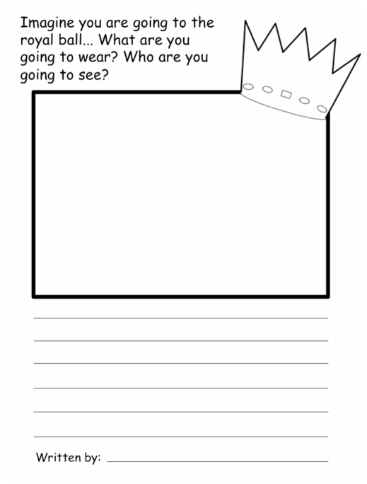

SOS activity 