Listening Speaking Reading Grammar Writing
Topic: Jobs AI will replace.

Instructor:  Eddie Moon | Level:  Intermediate | Students:  12 students | Length:  30 Minutes

Materials:
- Computer, TV, white board, board markers, image files
- Reading material – Internet news article
- Worksheet #1 – Match-up worksheet
- Worksheet #2 – True or false worksheet
- Worksheet #3 – Literal and interpretive questions worksheet
- Work sheet #4 – Applied question and writing worksheet
- SOS Worksheet – Crossword puzzle

Aims:
- Main aim: Ss will practice the skimming and scanning reading skill by reading the news article.
- Secondary aim: Ss will learn how to organize and present own opinion to the class by writing a worksheet #4.
- Personal aim: I want to help Ss to get the meaning of new words from context.

Language Skills:
- Reading: reading the article, worksheets
- Listening: listening to teacher’s instructions, classmates’ comments
- Speaking: drill new vocabulary words, presenting own opinion to the class
- Writing: worksheet answers, write down own opinion about the topic

Language Systems:
- Phonology: /r/, /l/, /z/
- Lexis: AI, bot, essence, replace, secure, probability, automation, computerization
- Grammar: past tense, present tense, future tense, conditional tense.
- Function: present the own opinion in a sentence.
- Discourse: conversation and discussion with partner.

Assumptions:
- Students have heard of some IT words from the news.
- Students know most of vocabularies in the worksheet.
- Students know what the news articles are.
- Students know some of the jobs and its duties.

Anticipated Errors and Solutions:
- Students may not have an interest in the topic.
-> Draw their attention to the latest news that related to the topic.
- Students may not know the exact meaning of the IT vocabularies.
-> Give students some example to understand the words properly.

References:
- Reading material (Internet news article)
https://blog.hubspot.com/marketing/jobs-artificial-intelligence-will-replace
- English dictionary
Https://www.dictionary.com
- Match-up worksheet
https://worksheets.theteacherscorner.net/make-your-own/match-up/
- Crossword puzzle
https://worksheets.theteacherscorner.net/make-your-own/crossword/

Lead-In
Materials: None
Time | Set up | Student Activity | Teacher Talk
1 min | Whole  class | Answering the teacher’s questions | Good morning, everyone! How are you doing today?  Good!

Pre-Activity
Materials: computer, TV, image files, worksheet #1, board, board markers
Time | Set up | Student Activity | Teacher Talk
2 min  3 min  3 min | Whole class  Pairs  Whole class | Students answer to teacher’s questions  Students work on worksheet #1  Students check the answers and repeat after teacher | Procedure:  1. Prediction  I will show you some pictures that related to today’s topic.  (Show picture on TV)  Elicit  What’s the first thing that comes to your mind?  (Give Ss time to think and answer)  Yes, today’s topic is “Jobs AI will replace.”  (Board the topic and drilling.)  Model  “Jobs AI will replace.”  (Hand out worksheet #1)  Before we get started, let’s solve the worksheet #1. Write the letter of the correct match. Work with your partner and you have 3 minutes.  ICQ  What do you do now?  Do you work in pairs?  How much time do you have?  You may begin now.  Monitor  (Monitor discreetly, answer if any questions arise)  (Give time warning)  30 seconds left. Time’s up.  Check answers and drill the words  Let’s check the answers together.  What’s the answer for question #1? Right. Everyone repeat after me, “Artificial intelligence”. Again? Good job.  And #2? …  Everyone did a good job!  Guiding question  Do you think some jobs will be replaced by AI or robot?  (Allow Ss to answer)

Main Activity
Materials: reading material, worksheet #2, #3, #4, white board, board markers
Time | Set up | Student Activity | Teacher Talk
5 min  2 min  1 min  3 min  1 min  4 min  3 min | Individual  Pairs  Whole class  Pairs  Whole class  Pairs  Pairs | Students read the reading material alone  Students work on worksheet #2  Students check the answers  Students work on worksheet #3  Students check the answers  Students work on worksheet #4  Students present it to the class | 1. Reading for the main idea  Instruction  Here’s the article from the internet and read alone for 5 minutes.  ICQ  What do you do now?  Do you read alone?  How much time do you have?  You can start now.  Monitor  (Monitor discreetly, answer if any questions arise)  (Give time warning)  30 seconds left. Time’s up.  Do you guys need more time?  (Allow 1 more minute if necessary.)  CCQ  Can AI process the work faster than human?  Will some jobs be replaced by AI or robot?  Instructions  Here’s the worksheet #2 and read these sentences and circle true or false.  (Hand out worksheet #2)  Work with your partner and you have 2 minute.  ICQ  What do you do now?  Do you read alone?  How much time do you have?  You can start now.  Monitor  (Monitor discreetly, answer if any questions arise)  (Give time warning)  30 seconds left. Time’s up.  Check answers  Let’s check the answers together.  Is #1 true or false? Right.  And #2 ...  2. Reading for the details  Instructions  Here’s the worksheet #3.  (Hand out worksheet #3)  Work with your partner and you have 3 minute.  ICQ  What do you do now?  Do you read alone?  How much time do you have?  You can start now.  Monitor  (Monitor discreetly, answer if any questions arise)  (Give time warning)  30 seconds left. Time’s up.  Check answers  Let’s check the answers together.  What’s the answer for #1? Right.  And #2 ...  3. Free production  Instructions  Here’s the worksheet #4.  (Hand out worksheet #4)  Think about jobs will be replaced by AI or robot in the future and ones will be safe.  Demonstration  Here’s the example.  (Board the answer format.)  I think Air traffic controller will be replaced by AI or robot because robot can work all day without getting tired.  I think teachers will be safe because human interaction plays a vital role in the education.  Now, write down the jobs in the blanks and present it to the class after. Work with your partner and you have 4 minute.  ICQ  What do you do now?  Do you read alone?  How much time do you have?  You can start now.  Monitor  (Monitor discreetly, answer if any questions arise)  (Give time warning)  30 seconds left. Time’s up.  Present to the class  Ok, team A. Please, tell us what job will be replaced by AI and what will be safe.  (Students present their ideas to the class)  Excellent!  Thank you!

Post Activity
Materials: white board, board maker
Time | Set up | Student Activity | Teacher Talk
2 min | Whole class | Students listen to the teacher | 1. Feedback and conclusion  (Error correction if necessary)  (Write the grammatical or pronunciation errors on the board and drill.)  Feedback  Did you guys have fun today?  You all did a great job today and let’s keep today’s article in mind when we choose our future job. See you next class!

SOS Activity
Materials: SOS worksheet
Time | Set up | Student Activity | Teacher Talk
5 min | Pairs | Students solve the crossword puzzle | 1. Solving the crossword puzzle  Instruction  Ok, now I will hand out another worksheet and you will solve the crossword puzzle in pairs. I will give you 5 minutes.  ICQ  What do you do now?  Are you working in pairs?  How much time do you have?  You can start now.

- Images

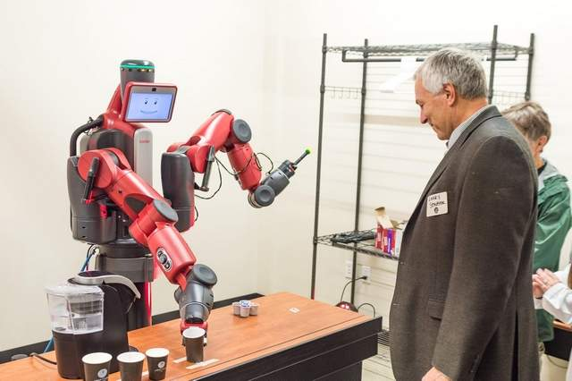

“Jobs AI will replace”
"AI can analyze sales calls far faster than any sales manager could -- in fact, it would take 9 years of nonstop sales call analysis for a human being to compete, and that’s if they didn’t take vacation or sleep. And AI is already being used to develop marketers’ content strategies and email marketing playbooks -- it’s only a matter of time before it plays a bigger role in the process. HubSpot co-founder Dharmesh Shah has a more positive outlook on the future of AI - in fact, he thinks bots and AI will make us better at our jobs and more secure in our careers, not the other way around. The truth probably lies halfway between these camps -- in many cases, AI will serve to make our jobs easier and will make us more effective and data-driven. But the fact remains that some jobs will be replaced by machines -- it’s the essence of any industrial or technological revolution. The good news is; some jobs won’t be strictly replaced -- they just might be adjusted to account for new technologies’ “careers.” Based on the landmark 2013 study that inspired “Will Robots Take My Job?” we’ve rounded up some of the marketing and sales roles most likely to be replaced by robots, bots, and AI in the next few years. This study analyzes the likely probability that a job will be replaced by automation and computerization -- based primarily on the level of routine a job has and the specialized training and social intelligence required to complete it. It’s not an exhaustive list, but it gives you an idea of what your life could look like in a few years."
"Most Likely to Be Replaced
Telemarketers
Likelihood: 99%
Why: You probably already receive robo-calls on behalf of various products and services, and career growth in the telemarketing space is expected to decline by 3% by the year 2024. This is largely in part because of the requirements to be successful: Unlike other sales roles, telemarketers don't require a high level of social, or emotional, intelligence to be successful. Think about it -- are you likely to purchase from a telemarketer? Conversion rates for direct telephone sales are typically less than 10%, making this role a ripe opportunity to be automated."
"Most Likely to Be Safe (For Now)
Writers
Likelihood: 3.8%
Why Not: Writers have to ideate, create, and produce original written material. AIs can do some of this with title suggestions, writing prompts, and automated social media messages, but blog posts, books, movies, and plays will likely be written by humans for the foreseeable future.
- Worksheet #1
Write the letter of the correct match.
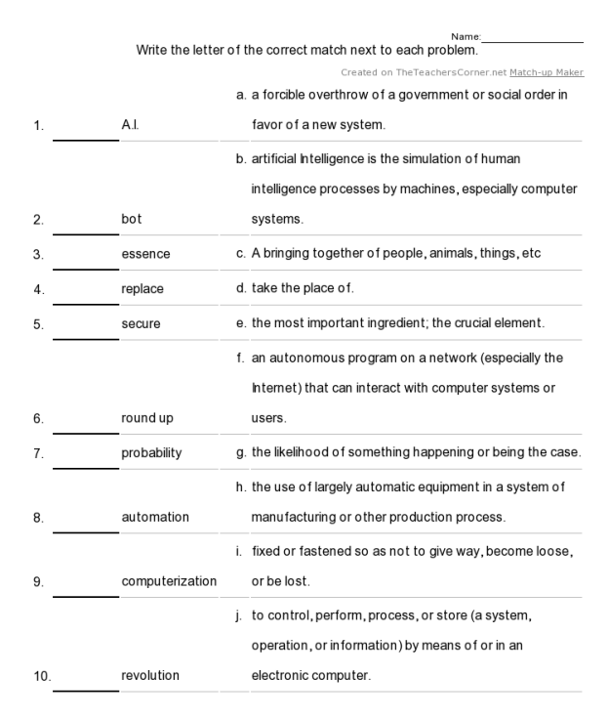

- Worksheet #2
Read sentences below and circle true or false.
1. True / False – AI can analyze sales calls.
2. True / False – AI is already being used in many areas.
3. True / False – It’s only a matter of time that AI will play the bigger role.
4. True / False – Some jobs will be replaced by AI or robot.
5. True / False – Some jobs won’t be strictly replaced by AI or robot.

- Worksheet #3
Please, write or underline the answer in the article.
1. Who can analyze sales calls faster? Human or AI?
2. How is AI already being used?
3. How does Mr. Dharmesh Shah view the future of AI?
4. Will all jobs be replaced by AI or bots?
5. This study analyzes the probability that a job will be replaced by automation and computerization based on what?
6. Unlike other sales roles, what does not require for telemarketers to be successful?
7. What kind of writing can AI do?
8. Why most likely will some writings be written by humans?

- Worksheet #4
Fill in the blank with your partner and present it to the class.

I think _________ will be replaced by AI or robot because ______________________.

I think _________ will be safe because _______________________.

- SOS Worksheet
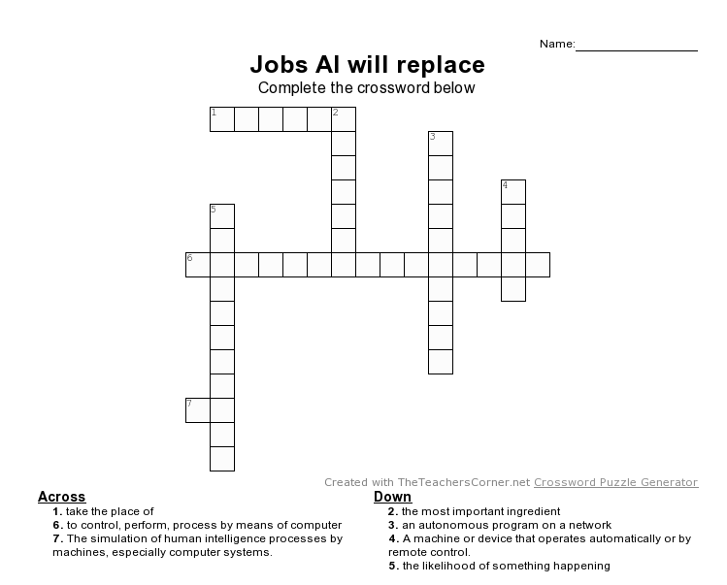

- SOS worksheet Answer key
