Listening Speaking Reading Grammar Writing
Topic: Ordering Food at a Restaurant

Instructor:  Sunny Kim, | Level:  Intermediate | Students:  12 students | Length:  35 Minutes

Materials:
- White board, markers
- Realia (Tteok-bokki restaurant menu, Chinese restaurant menu)
- Worksheet #1 – Vocabulary fill the blank (12 copies)
- Worksheet #2 – Conversation “Ordering Food at a Restaurant” (12 copies)
- Worksheet #3(1) – Restaurant menus (12 copies)
- Worksheet #3(2) – Restaurant’s specials of day menus (12 copies)
- Worksheet #3(3) – Restaurant Role-play Waiter Sheet (12 copies)
- Worksheet #3(4) – Restaurant Role-play Customer Sheet (12 copies)
- Worksheet #4 – Restaurant Crossword Puzzle for SOS activity (12 copies)

Aims:
- Main aim: Students will be able to improve their speaking skills by drilling, practicing a role paly activity
- Secondary aim: Students will be able to order food in a restaurant by practicing a role paly activity
- Personal aim: I want to give my instructions short and simple to increase opportunities for STT

Language Skills:
- Reading: Ss will read conversation “Ordering Food at a Restaurant”
- Listening: Ss will listen to a new vocabulary, drilling, following instructions, a dialog in role play
- Speaking: Ss will speak a dialog during a role play
- Writing: Ss will write down changing the underlined word ,role play

Language Systems:
- Phonology: / θ/
- Lexis: New vocabulary
- Grammar: Using auxiliary verb “Would” ex) Would you like~? /I would like
- Function: Giving information
- Discourse: Conversation

Assumptions: Students already know
- How the class is organized and operated (3 at each table)
- Four language skills and five language systems
- Students know most of words in the conversation
- Students have experience to go a restaurant

Anticipated Errors and Solutions:
- If students have difficulties in understanding new vocabulary or conversation
-> give them further examples.
- If students have trouble with drilling practice
-> read the conversation more slowly.
- If students finish their activity early(SOS Plan)
-> give work sheet #4 (Restaurant Crossword) to students who finish their activity early.

References:
- Conversation & Role play
-> https://bogglesworldesl.com/survival_travel_english/restaurants.htm
- New vocabulary
-> http://www.dictionary.com

Lead-In
Materials: Realia((Tteok-bokki restaurant menu, Chinese restaurant menu)
White board and maker
Time | Set up | Student Activity | Teacher Talk
1min | Whole  class | Answering the teacher’s questions | Procedure:  1.Greeting students  Good morning, everyone! How are you doing today?  (Using realia: show two menus)  What are these?  This is a tteok-bokki restaurant menu and this is a Chinese restaurant menu.  When you go to the restaurant  What do you do first?  2. Introduce Topic  Model  (write the topic Going to Restaurants: Ordering Food)  Today we are going to learn “Ordering Food at a Restaurant”

Pre-Activity
Materials: White board, markers, Worksheet 1#
Time | Set up | Student Activity | Teacher Talk
3 min  2 min | Pairs  Whole  class | Students complete  worksheet #1  Students check answers | 1.New Vocabulary  Instruction  We are going to learn new vocabulary before the conversation. First, read the sentence and then fill in the blanks with the correct word from the list at the top. Now I will hand out a worksheet  (Hand out worksheet #1)  Demonstration  Now look at the worksheet. Let’s solve #1 together. People who work in a restaurant: The person who serves your food is a 000000.  What word will be filled in the blank?  Work together with your partner. I will give you 3 minutes to finish.  ICQ  What do you do now?  Are you working in pairs?  How much time do you have?  Let’s start!  Monitoring  (Quietly walk around the classroom. Check to see if the students are on track. Answer to questions)  Give time warning: 1 minute:  30seconds left.  (Be flexible with time. Give 1 more minute if they need it)  Time’s up!  Check Answers  Let’s check the answer together.  CCQ  *When do you have brunch?  * What do you have for your brunch?

Main Activity
Materials: Worksheet 2#, Worksheet 3(1)#, Worksheet 3(2)#, Worksheet 3(3)#,
Worksheet 3(4)#
Time | Set up | Student Activity | Teacher Talk
3 min  3min  4 min  10 min  5 min | Whole class  Group  Group  Group  Group | Listen to the teacher; read and repeat  Students repeat worksheet #2 as they change roles.  Students change the underlined words or phrases in worksheet #2 as they change roles.  Students have the role play by changing roles.  The students present their group's role play | 1. Conversation Drilling  (Controlled Practice)  Instruction  (hand out worksheet #2)  This is a conversation with three people at the restaurant.  Look at the worksheet#2, first just listen.  (Teacher reads)  Now repeat aftert me  (Teacher reads line by line, Ss repeat drill the conversation)  Now, practice with a group.  Change the role and repeat it.  Once as the waiter and once as customers.  Demonstration  Who wants to read it as customers and a waiter?  Are there any volunteers?  (Before you start, demonstrate with student volunteers).  Work together with your group. I will give you 3 minutes to finish.  ICQ  What do you do now?  Are you working in groups?  How much time do you have?  Let’s start!  Give time warning:  30 seconds left.  Time’s up!  2. Change the words or phrases  (Less Controlled Practice)  Instruction  Work with the same group. Change the underlined words or phrases.  Demonstration  (Reading the conversation and changing the underlined words)  Welcome to Sunny. Here are your menus. Today’s special is Kimchi bokkeum bap.  Just like that change the role and repeat it.  I will give you 4 minutes to finish  ICQ  What do you do now?  Are you working in groups?  How much time do you have?  Let’s start!  Monitoring  (Quietly walk around the classroom. Check to see if the students are on track. Answer to questions)  Give time warning:  30 seconds left.  Time’s up!  3. Role Play(Free Practice)  Instruction  Now, we are going to do a real practice. Everyone take worksheet3.  Each person should receive two menus, two special menus, a customer sheet, and a waiter sheet.  (hand out worksheet #3(1), worksheet #3(2), worksheet #3(3), And worksheet #3(4))  Show me each sheet. The menus, the special menus, the customer sheet. And the waiter sheet.  (Students show each sheet to the teacher)  Demonstration  If I am a waiter, I will give the menu to the customers when they come.  And I will say today’s special menu.  Welcome to ABOMINOSE PIZZA. Here are your menus. Today’s special is Mexican pizza…  Change the role and repeat it.  I will give you 10 minutes to finish  ICQ  What do you do now?  Are you working in groups?  How much time do you have?  Let’s start!  Monitoring  (Quietly walk around the classroom. Check to see if the students are on track. Answer to questions)  Give time warning:  30 seconds left.  Time’s up!  4. Each group presentation  Instruction  Now, each group is going to present a role play.  No you can say the same restaurant.  (Take note of any noticeable errors Ss make with the new expressions learned today.)

Post Activity
Materials: White board, makers
Time | Set up | Student Activity | Teacher Talk
2 min  1 min  1 min | Whole  class  Whole class  Whole class | Students listen  Students listen and answer to the teacher’s questions  Students will mentions about today’s activity | 1. Error Correction  (Write sentences on the board that Ss misspoke during the role play activity. Facilitate peer correction.)  2. Conclusion  (Conclude the lesson checking the new vocabulary and understanding of the topic. Then practice answers and questions about ordering menu.)  “You guys did a great job today.  Please try to remember the conversation and new vocabulary we learned today”  3. Feed back  “How was the class? What do you feel of the new topic? When you go to the restaurant, Can you use the conversation you've learned?”  Thank you all for you participation and have a beautiful day.

SOS Activity
Materials: Worksheet#4(Restaurant Crossword Puzzle)
Time | Set up | Student Activity | Teacher Talk
5 min  2 min | Individual  Whole class | Students complete the restaurant crossword puzzle using today’s newly learned vocabularies in sentences.  Students check answers | 1. Restaurant Crossword Puzzle  Instruction  Now, we are going to complete the crossword puzzle using the words we learned today. So Check the worksheet#1. If there are words you don't know, You could ask and I'll give you some hints.  I will give you 10 minutes to finish  (Hand out worksheet#4)  ICQ  What words will go in the puzzle?  Are you working in groups?  How much time do you have?  Let’s start!  Monitoring  (Quietly walk around the classroom. Check to see if the students are on track. Answer to questions)  Give time warning:  30 seconds left.  Time’s up!  Check answer  Each student will go around and read each sentence with the vocab out loud.
- Worksheet #1
Fill in the blanks with words from the box:

appetizer  brunch  dessert | chef  cook  dishwasher | lunch  salad | tip  waiter

People Who Work in a Restaurant:
The person who serves your food is called a ________________. The person who cooks your food is called a _________________ if it is a cheap restaurant or a ____________________ if it is an expensive restaurant. A ___________________ is somebody who washes dishes. If the food and service is good, people usually leave a __________________.

Meals and the Time of Day:
Most people eat breakfast after they wake up. Around noon people have their midday meal, or _____________________. And dinner is the meal that people eat in the evening. However, sometimes, especially on Sunday, people like to sleep in, so instead of having breakfast, they eat a meal between breakfast and lunch called ______________________.

Parts of a Meal:
At lunch or dinner sometimes people order a snack before the meal called an
________________________. A __________________ or a soup
is often served alongside the main meal. After dinner, people sometimes treat themselves to ___________________.

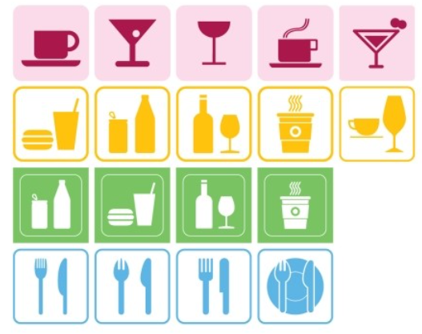
- Worksheet #2
Conversation:
Ordering Food at a Restaurant
Waiter: Welcome to Antico’s. Here are your menus. Today’s special is grilled salmon. I’ll be back to take your order in a minute.
. . .
Waiter: Are you ready to order?
Customer 1: I’d like the seafood spaghetti.
Waiter: And you?
Customer 2: I’ll have a hamburger and fries.
Waiter: Would you like anything to drink?
Customer 1: I’ll have a coke, please.
Waiter: And for you?
Customer 2: Just water, please.
Waiter: OK. So that’s one seafood spaghetti, one hamburger and fries, one coke, and one water. I’ll take your menus.
. . .
Waiter: Here is your food. Enjoy your meal.
. . .
Waiter: How was everything?
Customers 2: Delicious, thanks.
Waiter: Would you like anything for dessert?
Customer 1: No, just the bill please.

- Worksheet #3(1)
Restaurant menus A
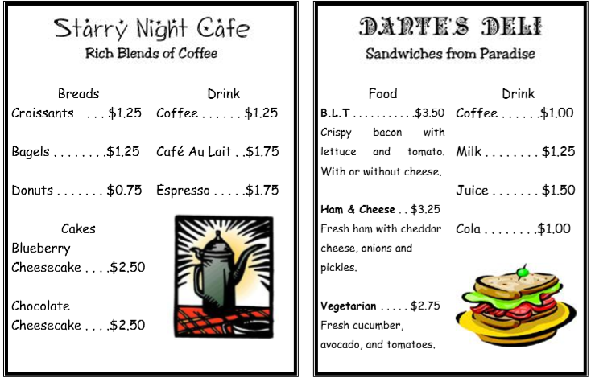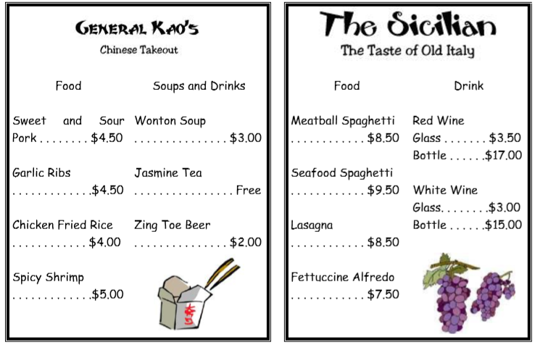
- Worksheet #3(1)
Restaurant menus B
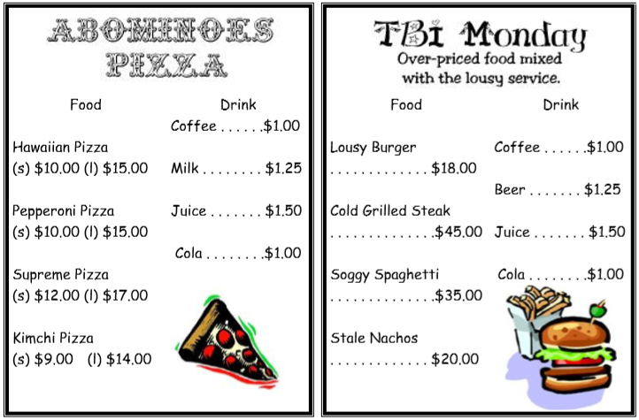
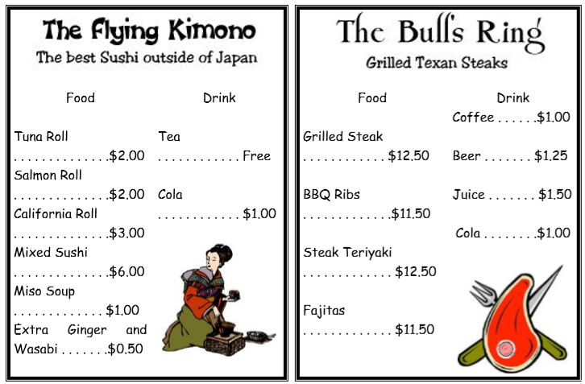
- Worksheet #3(2)
Restaurant’s specials of day menus
Special: Pumpkin pie and whip cream.
Price: $2:00
Special: Spring rolls
Price: $4.50
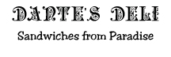 | Special: Smoked salmon and cream cheese on a bagel.  Price: $4.50
Special:
Four cheese ravioli.
Price: $7.50
Special:
Eel rolls
Price: $2.50
Special: Mexican pizza made with chili peppers, avocado, and hot pepperoni.
Price: (s) $11:00 (l)$16:00
Special:
Roast chicken with potatoes.
Price: $12.50
Special:
Hot chicken wings.
Price: 12 wings for $5.00.

- Worksheet #3(3)
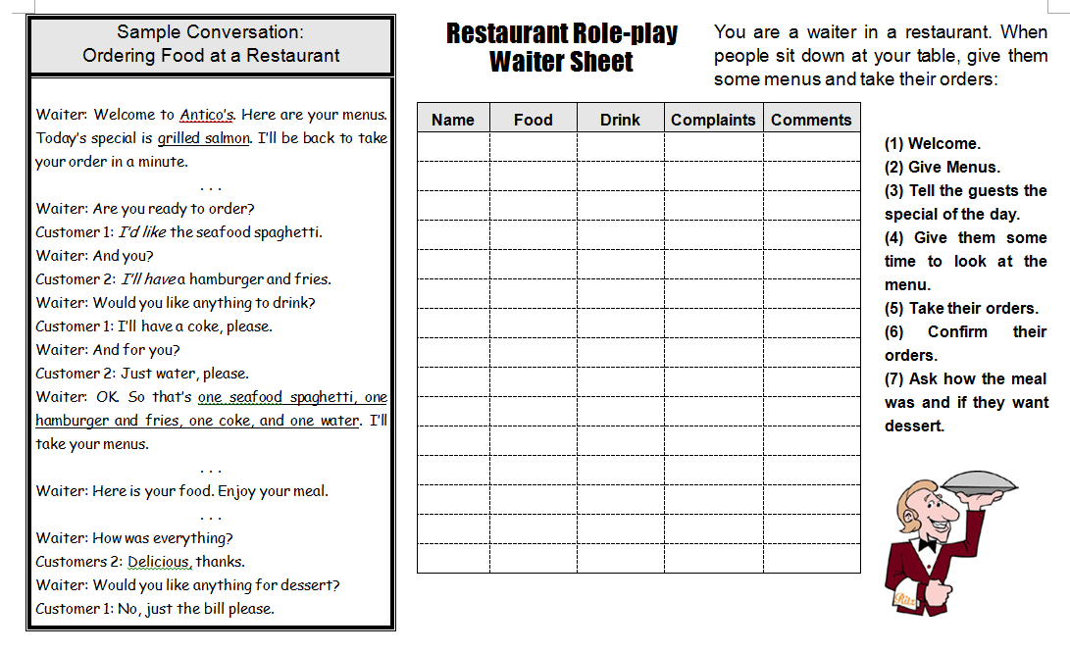

- Worksheet #3(4)
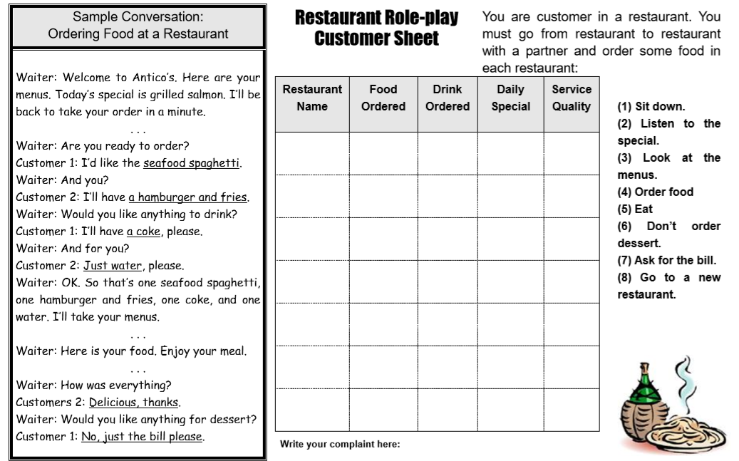

- Worksheet #4
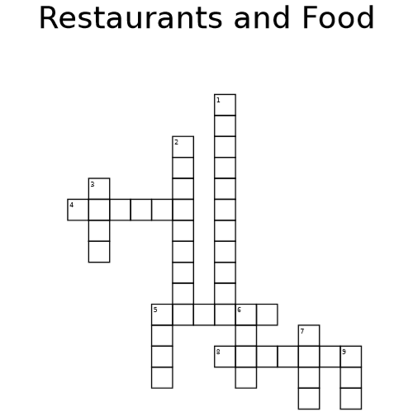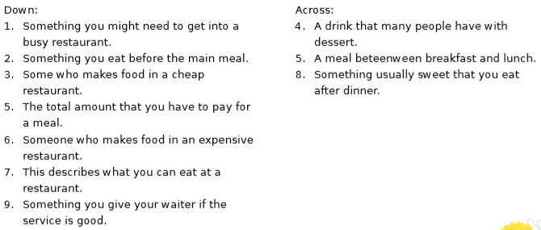

- Worksheet #1 Solution

1. waiter
2. cook
3. chef
4. dishwasher
5. tip
6. lunch
7. brunch
8. appetizer
9. salad
10. dessert

- Worksheet #4 Solution
