□Listening □Speaking □Reading ☑ Grammar □Writing
Topic: Talking about past habits(Used to/Didn’t use to)

Instructor:  Sunny Kim  Lauren Kim | Level:  Intermediate (Adult) | Students:  12 students | Length:  40 Minutes

Materials:
- White board and markers
- Realia(2 photos of Stefan)/Structure Table PPT 1&2
- Worksheet #1 – Used To/didn’t use to(Talking about past habits), (12copies)
- Worksheet #2 – How did we use to live? (12 copies)
- Worksheet #3 –When you were a child for SOS activity (12 copies )

Aims:
- Main aim: Students will learn new grammar “used to” and “didn’t use to” by drilling the target languages and filling the gaps.
- Secondary aim: Students will improve their writing, listening and speaking skills by listening and repeated speaking practice in pairs and whole class.
- Personal aim: I want my students to be more confident and active by improving their grammar communicatively.

Language Skills,
- Reading: Students will read questions from the worksheet.
- Listening: Students will practice their skills by listening other students/teachers.
- Speaking: Students will present their answers/opinions and practice pair activity in front of the class.
- Writing: Students will write their short essay about “How did we use to live?”

Language Systems,
- Phonology: Drilling
- Grammar: Use of “Used to” & “Didn’t use to”
(“I used to…, I didn’t use to…)
- Function: Describing past habits
- Discourse: Short essay

Assumptions,
Students Already know
- How the class is organized (there will be 12 students in a circled shape)
- Today they will learn the first “Used to(Affirmative & Negative)” out of three different usages (Be used to, Used to ~ ing)
- Their past habits

Anticipated Errors and Solutions:
- For less advanced students
-> Give them more language to get them started by giving more demonstration.
- For more advanced students
-> Have them demonstrate for themselves in front of the class.
- If the preparation and presentation time are too long or short for students
-> Vary the time according to the situation.

References:
- The meaning of Used to:
https://www.macmillandictionary.com/dictionary/british/used-to_1
- Worksheet#1
https://www.englishwsheets.com/used_to.html
- Worksheet #2
http://www.eslbase.com/downloads/pdf/used-to.pdf
- Worksheet #3
https://en.islcollective.com/resources/printables/worksheets_doc_docx/used_to_review_for_trinity_college_grade_7/used-to-preintermediate/7873

Lead-In
Materials: None
Time | Set up | Student Activity | Teacher Talk
1 min | Whole  Class | Answering the teacher’s questions | Good morning, everyone! How are you doing today?  As some of you guys might know, I used to work out 5 times a week but I only work out once a week. How about you? Do you have any past habit?

Presentation
Materials: Realia & Structure Table(PPT1&2), white board, board marker
Time | Set up | Student Activity | Teacher Talk
2min  2min  7min  2min | Whole  Class  Pairs  Whole Class  Pairs | Answer to the teacher  Students discussion  Answering the teacher’s question  Read the changeable words together  Answer to the teacher  Answer to the teacher  Students repeat after a teacher  Some pairs demonstrate for the class.  Students practice their sentence | Procedure:  1.Eliciting from pictures (Showing 2 different photos of Stefan to the class)  What do you think what did he do in the past and what does he do now? Can anyone explain?  (Listen to their answers)  Instruction  Yes. He used to be a hockey player in the past but now he is a TESOL teacher.  CCQ  - Is he still a hockey player?(No)  - What does he do now? (Teacher)  Great! Now talk with your partner about your past habit. I will give you two minutes.  ICQ  - What do you do?  - Are you working with your partner?  - How much time do you have?  Good. Start.  2. Introduce Grammar(Target language)  (Write the word Used to on the board)  Today’s grammar is used to.  What is used to? Any volunteer to answer it?  (Listen to their answers)  Right! Used to is the past habit.  Form  Stefan(S) used to(Affirmative) be(I) a hockey player(N)  CCQ  - What verb form come after used to? (Infinitive)  - Was he a hockey player in the past?(Yes)  (Write on board after listening to their answers)  Subject + Affirmative + Infinitive + Noun  When we talk about things that happened in the past but don’t happen anymore we use used to.  CCQ  - The form used to can change?(No)  Yes. In statements, the form used to does not change.  - Can we use the verb be before used to?(No)  Yes. We do not use the verb be before it. It always refers to past time.  (Show structure table PPT1 )  As you can see the table, we can also change the subject, infinitive and noun.  Let’s read together.  From the subject, Stefan, I,You,She/He,We/They…  Then What is the negative form? Can anyone know?  Yes, the negative form is didn’t use to.  (Show structure table PPT 2)  Stefan(S) didn’t use to(Negative) be(I) an English teacher(N)  Then what does it mean?  Right, the negative form “didn’t use to” uses to talk about things which in the past were not the part of your routine but now they are.  CCQ  - Was he an English teacher in the past?(No)  Right, it means he was not an English teacher but now he is.  Drilling  Everyone repeat after me!  Stefan used to be a hockey player  Stefan didn’t use to be an English teacher  Great! This time practice with your partner. You can simply change the subject, infinitive and noun or make a sentence using both used to/didn’t use to.  Any pairs want to demonstrate for everyone?  Good job! Now I will give you 2 minutes to practice with your partner.  ICQ  - What do you do?  - Are you working in pairs?  - How much time do you have?  Good. Start.  Monitor  (Walk around classroom. Help if any pair has a question)  1min left  Times up. Let’s move on.

Practice
Materials: Board & markers, Worksheet #1
Time | Set up | Student Activity | Teacher Talk
3min  1min  2min  5min | Individually  Whole  Class  Whole  Class  Pairs | Worksheet#1  (Talking about past habits)  One student demonstrates  Solve together  Demonstration  Change the box/answer to the opposite way | Procedure  1. Controlled Practice  Instruction  (Distribute the worksheet#1)  Instruction  Can anyone demonstrate first question?  Awesome! Everyone, please fill in the box with the matching phrase on the below the worksheet. I will give you 3minutes to finish. Work alone.  ICQ  What do you do?  Are you working in pairs?  How much time do you have?  Great, start!  Monitor  (Walk around classroom. Help if any student has a question)  1 minute left  Time’s up. Do you need more time?  (Be flexible with time)  Let’s solve together.  From left to the right, #1 is Cousin Peter didn’t use to climb mountains….  Good job! Well done everyone!  2. Less- Controlled Practice  Instruction  Now you can change the answer to the opposite way according to the image  Can anyone show demonstration for the class?  (Students demonstrate)  Fantastic! Now practice it with your partner. I will give you 5minutes to finish and practice.  ICQ  What do you do?  Are you working in pairs?  How much time do you have?  Great, Start!  Monitor  (See if all students are active and answer if students have a question)  (Giving time warning)  1min left  Time’s up. Well done, everyone!

Production
Materials: White board and marker,worksheet#2
Time | Set up |  | Student Activity |  | Teacher Talk
3min  7min  2min | Individually  Groups  Groups |  | One student read the paper  One student gives an example  Writing their short essay about 3 inventions and share with a group  Present three inventions |  | Procedure  3. Short Essay (Free Practice)  Instruction  (Distribute worksheet#2)  Ok. We have practiced many phrases using used to/didn’t use to. Then how did we use to live?  Any volunteer to read the paper?  Any volunteer gives another example for the class?  Good. I will divide into 3 groups. These three are group A, group B and group C.  Each group writes down 3 inventions that changed world.  Don’t forget to include today’s grammar “used to/didn’t use to” to your writing. Make it simple. Maybe 1 or 2 sentences each invention.  And Be ready to present to other groups after you are done. I will give you 7 minutes. Good luck!  ICQ  What do you do?  What do you include?  Are you working in groups?  How much time do you have?  Great, Start!  Monitor  (Walk around classroom. See if all students are active.)  1min left  Time’s up. Any group to present first?  Fantastic! Well done, Everyone!
Post Task
Materials: White board and marker
Time |  | Set up |  | Student Activity |  | Teacher Talk
1min  1min  1min |  | Whole  Class  Whole  Class  Whole  Class |  | Students listen  Students listen and answer to the teacher’s questions  Students will talk about today’s activities |  | 1.Error Correction  (Correct any mistakes from the activity)  2. Conclusion  (Conclude the lesson with a review of the new grammar.)  3.Feedback  (Share the students' ideas)  How was the class? What do you feel of the new grammar?  Great work today everyone! As you can see, “used to/didn’t use to” are really helpful but they are also not very complicated so I strongly encourage you to begin using it in your daily English!  Thank you all for you participation and have a nice day.

SOS Activity
Materials: (12copies) When you were a child
Time | Set up | Student Activity | Teacher Talk
7 min  3min | Individually  Whole  Class | Students complete the text  Present the three volunteers | 1. When you were a child  Instruction  Now we are going to complete the text with the correct form of USED TO and write about things you did when you were a child.  Don’t forget to include today’s grammar “used to/didn’t use to” to your writing.  (Distribute worksheet#3)  I will give you 7 min. Good luck! Work alone.  ICQ  What do you do?  Are you working in groups?  How much time do you have?  Great, Start!  Monitor  (Walk around classroom. See if all students are active.)  1min left  Time’s up.  Who will make the presentation first?

Eliciting<PPT-1>
In the past
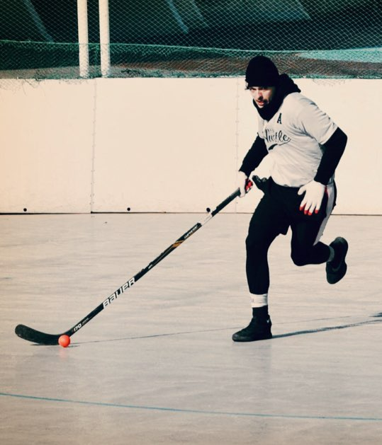Now
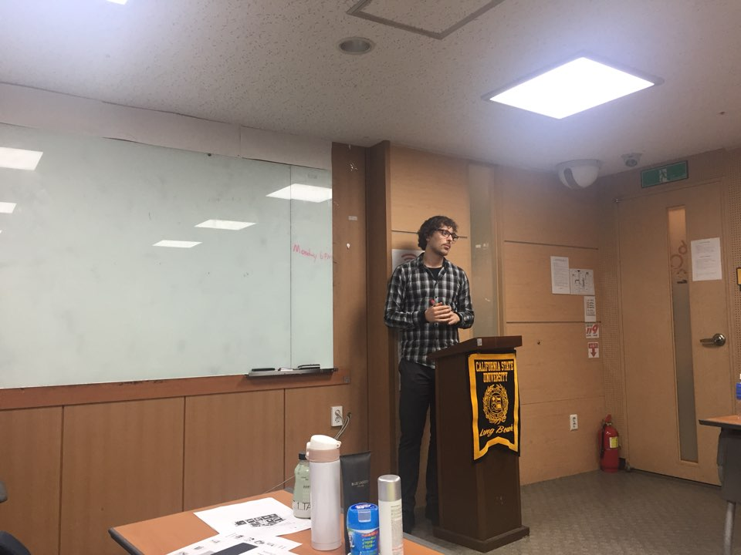

< Structure Table in PPT>

1. Stefan used to be a hockey player
Subject | Used to (Affirmative) | Infinitive | Noun
Stefan  I  YOU  She/He  We/They | used to | Be | (a)hockey (a)player(s), (a)musician(s),  (a)dancer(s),  (a)artist(s)

2. Stefan didn't use to be an English teacher
Subject | didn’t use to(Negative) | Infinitive | Noun
Stefan  I  YOU  She/He  We/They | didn’t  use to | be | an English (a)teacher(s), (a)musician(s),  (a)dancer(s),  (a)Artist(s)

- Worksheet #1
Used to/didn’t use to
(Talking About Past Habits) Answer Key

Hello. We are Mr. and Mrs. Goody. We are looking at our family album and talking about good old days. Look at the pictures and complete the sentence. Write what our relatives used to or didn’t use to do.

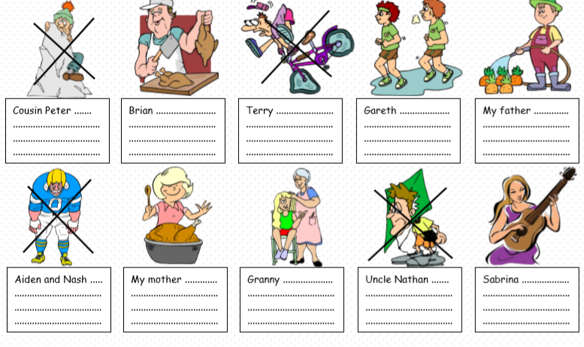
①ride a bicycle well ②climb mountains ③play the guitar
④grow vegetables ⑤sell meat ⑥run every morning
⑦play American football ⑧comb hair
⑨cook delicious food ⑩fly kite

- Worksheet #2
How did we use to live?
Write down 3 inventions that change the world
Explain what life was like before each invention and how life is different with it.
Example:
The Car
->People used to travel on horses. But now we have cars.
->People didn’t use to have cars. But now they have them.

1.

2.

3

Worksheet #3 (SOS)

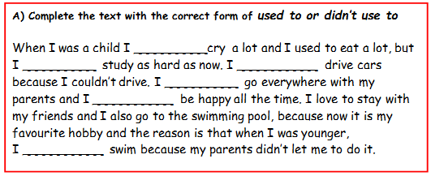
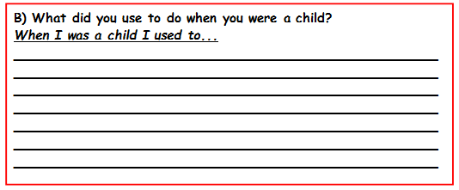
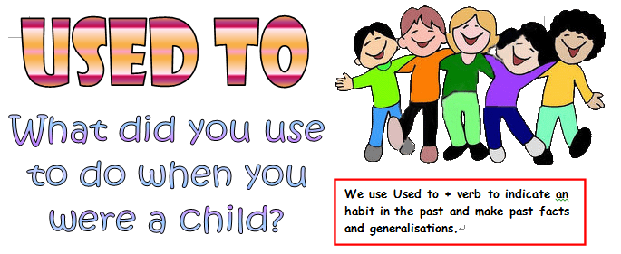

Worksheet #1 (Solution)

1. didn’t use to climb mountains
2. use to sell meat
3. didn’t use to ride a bicycle well
4. use to run every morning
5. use to grow vegetables
6. didn’t use to play American football
7. use to cook delicious food
8. use to comb hair
9. didn’t use to fly kite
10. use to play the guitar

Worksheet#3(Solution)

- used to
- didn’t use to
- didn’t use to
- used to
- used to
- didn’t use to

