Listening Speaking Reading Grammar Writing
Topic: Bamboo

Instructor:  Sonia | Level:  Intermediate | Students:  12 students | Length:  30 Minutes

Materials:
- white board, markers
- Reading material – text
- Worksheet #1 – choose True or False
- Worksheet #2 – find the correct answers
- Worksheet #3 – discussion
- SOS Worksheet – fill in the crossword

Aims:
- Main aim: Students will practice reading skill by reading the text.
- Secondary aim: Students will learn vocabulary of garden by completing the worksheet.
- Personal aim: I want to give clear and simple instructions.

Language Skills:
- Reading: reading the text, worksheets
- Listening: listening to teacher’s instructions, classmates’ presentation.
- Speaking: presenting own opinion to the class
- Writing: worksheet answers, write down own opinion about the topic

Language Systems:
- Phonology: /r/, /l/
- Lexis: new vocabulary in the worksheet #1 (Colourful, Gardener, Professional, Bridge, Furniture, Bamboo, Plants, Botanist)
- Grammar: present tense
- Function: give statement
- Discourse: conversation and discussion with partner

Assumptions:
- How the class is organized and operated.
- Students know most of vocabularies in the worksheet.
- Students know they should speak only English in the class.
- Students know that they learn about reading.

Anticipated Errors and Solutions:
- If some students speak too quietly
→ encourage them to take risks and walk further away from them so they can speak louder.
- Students may not have an interest in the given topic.
-> Draw their attention by making mind-map.

References:
- Reading material
http://www.onestopenglish.com/skills/reading/topic-based-lesson-plans/reading-lesson-plans-bamboo/146279.article
- English dictionary
Https://www.dictionary.com

Lead-In
Materials: None
Time | Set up | Student Activity | Teacher Talk
1 min | Whole  class | Answering the teacher’s questions | Good morning, everyone! How are you feeling today?  Good! Today we are going to learn about reading as you all know. The topic will be “Bamboo”

Pre-Activity
Materials: worksheet #1, board, board markers
Time | Set up | Student Activity | Teacher Talk
5 min  3 min  1 min | Whole class  Individually  Whole class | Students answer to teacher’s questions  Students work on worksheet #1  Students check the answers | Procedure:  1. Make a mind-map  Let’s think about the garden.  (Write the word ‘Garden’ on the middle of the board)  What can be found in a garden?  (plants, flowers, trees…)  What kinds of flowers are there? (rose, cherry blossom…)  What do you think about the trees? (green, tall…)  What kinds of job related to garden? (gardener, florist…)  (Make a mind-map on the board what students said)  Have you ever visited to garden? How was it? Were there a lot of plants?  Ok, Great! Now, we’re going to read about a man and his garden.  Before we read the text, let’s learn some new vocabulary.  (Hand out worksheet #1)  Look at this worksheet. You should fill in the blanks with below words. Work alone and I’ll give you 3 minutes.  ICQ  What do you do now?  Are you working in pairs?  How much time do you have?  Let’s start!  Monitoring  (Monitor discreetly. Answer to questions.)  Give time warning:  30 seconds left.  Time’s up!  3. Check Answers  Let’s check the answers together. What’s the answer for question #1? Right. And #2?…  Everyone did a good job!  Ok. Now, let’s start reading our text “Bamboo”

Main Activity
Materials: reading material, worksheet #2, worksheet #3, worksheet #4
Time | Set up | Student Activity | Teacher Talk
4 min  1 min  5 min  1 min  5 min  3 min | Pairs  Whole class  individually  Whole class  Pairs  Pairs | Students read the reading material and work on worksheet #2  Students check the answers  Students work on worksheet #3  Students check the answers  Students work on worksheet #4  Students present it to the class | 1. Skimming for the main idea  Instruction  (Hand out the text and worksheet #2)  Here’s the text about a man and his garden. Skim the text and circle true or false as you read on worksheet #2. Work with your partner and you have 4 minutes.  ICQ  What do you do now?  Do you read alone?  How much time do you have?  Ok. Go ahead.  Monitoring  (Monitor discreetly, answer if any questions arise)  (Give time warning)  30 seconds left.  Time’s up.  Check answers  Let’s check the answers together.  Is #1 true or false? Right.  And #2 ...  2. Scanning for the details  Instructions  Here’s the worksheet #3.  (Hand out worksheet #3)  Read the worksheet. This time, scan the text and find the answers to the questions. Work alone and you have 5 minutes.  ICQ  What do you do now?  Do you read pairs?  How much time do you have?  Let’s start.  Monitoring  (Monitor discreetly, answer if any questions arise)  (Give time warning)  30 seconds left.  Time’s up.  Check answers  Let’s check the answers together.  What’s the answer for #1? Right.  And #2 ...  3. Production  Instructions  Here’s the worksheet #4.  (Hand out worksheet #4)  I have questions to yours. Do you think bamboo is the most important plants in the world? If you disagree, which plant is the most important in the world? Think about this question and write down your opinion and give one or two reasons. After that, you should present it to the class. Work with your partner and I’ll give you 5 minutes.  ICQ  What do you do now?  Do you read alone?  How much time do you have?  You can start now.  Monitoring  (Monitor discreetly, answer if any questions arise)  (Give time warning)  30 seconds left. Time’s up.  Present to the class  Ok, let’s present to the first team. One of you should present about your opinion please.  (Students present their ideas to the class)  Thank you everyone!

Post Activity
Materials: None
Time | Set up | Student Activity | Teacher Talk
1 min | Whole class | Students listens and answers to the teacher | 1.Feedback  Did you have fun today?  Did you learn something about garden?  I hope this class gave you a chance to think about many plants.  Good job! Thank you all for your participation and have a great day.

SOS Activity
Materials: SOS Worksheet
Time | Set up | Student Activity | Teacher Talk
5 min | pairs | Play word search game | 1. Matching the crossword  Instruction  Now you can fill in the crossword by taking a hint below. You will do with your partner. I will give you 5 minutes.  (Hand out SOS worksheet )  ICQ  What do you do now?  Are you working in pairs?  How much time do you have?  Let’s start!  Monitoring  (Monitor discreetly. Answer to questions.)  Give time warning:  30 seconds left.  Time’s up!  Check answers  Let’s check the answers together.  What’s the answer for across #4? Right.  And across #6? ...  Ok. The word you can’t find is your homework. You all did a good job today!

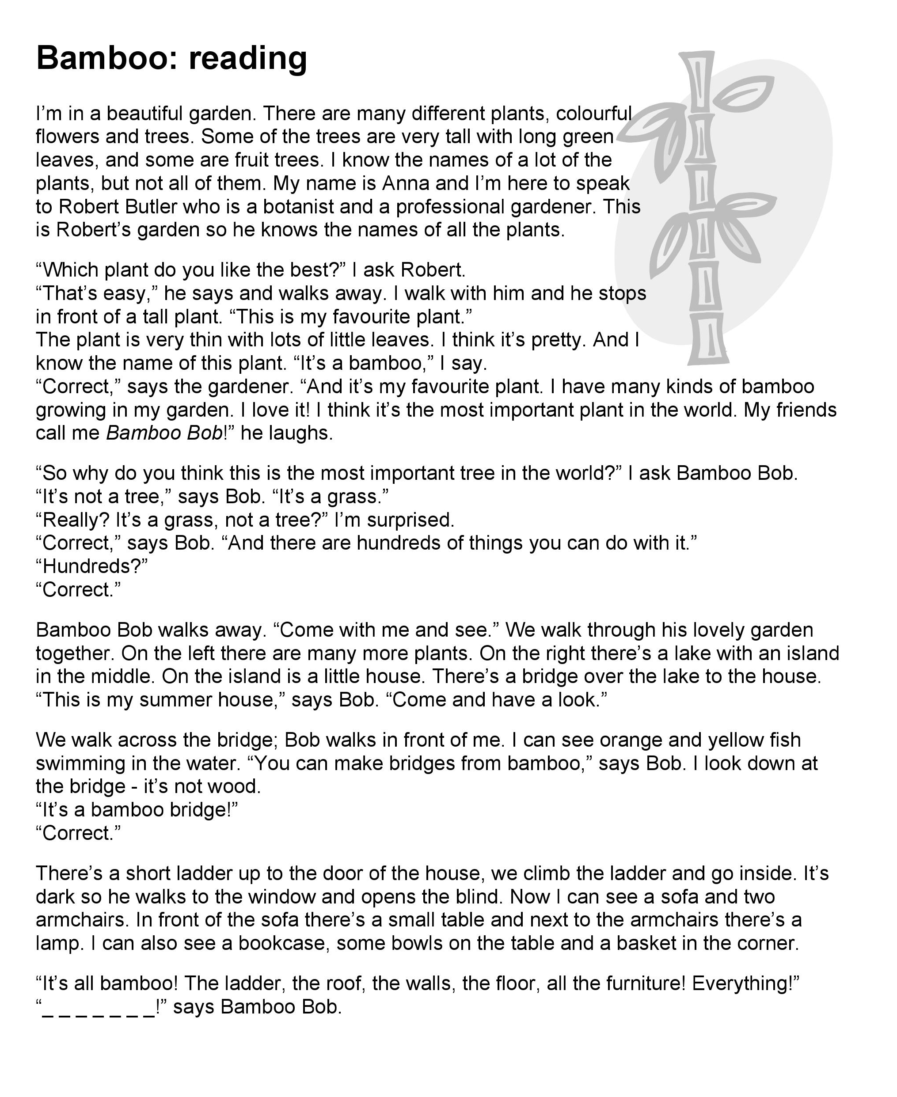

- Worksheet #1
Place each word in the box below, into its correct sentence.

- A is a scientist who studies plants.

- His grandfather was a gardener who grew cut flowers for the London theatres.

- Pandas can eat about 200,000 leaves a day.

- The stream flows under the .

- All the is crafted from natural materials.

- The gardener is clipping the .

- November is the best season to enjoy the leaves.

- The is planting some flowers.

Colourful Gardener Professional Bridge
Furniture Bamboo Plants Botanist

- Worksheet #2
Skimming the text and choose True or False.

1. True / False – Robert Butler who is a botanist and a professional gardener.

2. True / False – Robert Butler doesn't know the names of all the plants.

3. True / False – There are hundreds of things you can do with bamboo.

4. True / False – ‘Bamboo bob’ is Anna's nickname.

5. True / False – All the furniture is all made of bamboo.

- Worksheet #3
Scanning the text and choose the right answer
1. Who is Robert Butler?
a. a botanist
b. a scientist
c. a doctor
2. What is Robert’s favorite plants?
a. tomato
b. bamboo
c. pine tree
3. Why Robert think bamboo is the most important plants in the world?
a. It’s the most beautiful plants in the world.
b. There are hundreds of things you can do with bamboo.
c. Pandas eat bamboo every day.
4. Who call Robert to ‘Bamboo Bob?’
a. Robert’s father
b. Robert’s friends
c. Robert’s mother
5. What is not furniture made of bamboo?
a. sofa
b. armchair
c. refrigerator

- Worksheet #4
Work with your partner and present it to the class

Do you think bamboo is the most important plant in the world?
If you disagree, which plant is the most important in the world?

- I agree that bamboo is the most important plant in the world because

- I disagree that bamboo is the most important plants in the world.
I think is the most important plants because

- SOS Worksheet
across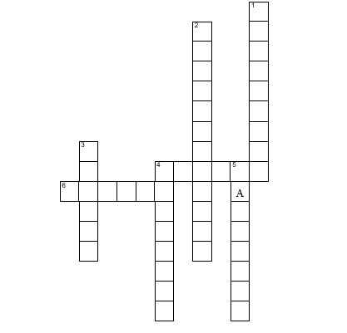
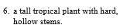
Down
