-Make your own soft drink.
Worksheet#4
- Create your own soft drink. Think about taste, color and logo…etc.

Name of drink:
Ingredient:
Taste:

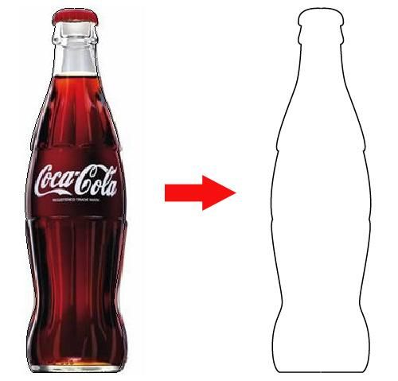
Cola nuts
Secret ingredients
Coca leaves
Sugar

