■ Listening ☐ Speaking ☐ Reading ☐ Grammar ☐ Writing

Topic: The Truth About Lying

Instructor:  Hyon Chu Yoon | Level:  Intermediate (Adult) | Students:  7 students | Length:  35 Minutes

Materials: • The pictures of four situations
- White board and board markers
- Vocabulary worksheet (7copies)
- Before listening worksheet- Phrases match (7copies)
- Discussion paper (3copies)
- Audio tape & Audio
- Crossword puzzle worksheet(7copies)

Aims: • Main aim: Students will improve their listening skills of listening for the main idea of an audio recording.
- Secondary aim: Students will practice speaking by having discussion.
- Personal aim: I hope the students express their own variety ideas more freely in English.

Language Skills:
Listening: Students will listen to the recorded article
Speaking: Students will talk and share about whether “People should always tell the truth.”
Reading: Students will read phases from the article and match them to each other.
Writing: Students will write the correct phrases from the article.

Language Systems:

Phonology: /r/, /＾/.
Lexis: New vocabularies in the article. (offensive, complimentary, sticky, innocent, approval, etc.)
Grammar: To-Infinitive.
Function: Discussion.
Discourse: Social topic.

Assumptions: Students already know
- How the class is organized and operated (2 or 3 students at each table)
- In many cases, lying is bad.
- The teacher’s style of teaching and pace of the course.

Anticipated Errors and Solutions:
- Students may not be able to follow the passage.
- I will let them listen to the audio again until they get the gist to the content.
- If certain students dominates a chance to speak.
- I will ask them to give other students a chance to speak
- If presenters find it scary to present their group idea in front of the class.
- I will allow them to stand up and present from their group area.

References:
- Exploring English 6 by Tim Harris & Allan Row, Chapter 8 “Lying”.

Lead-In
Materials: None.
Time | Set Up | Student Activity | Teacher Talk
1min | Whole class | Answering teacher’s questions. | Hello, everyone! How are you today? Have you ever felt it is difficult for you to be truthful before? When did you feel so?

Pre-Activity
Materials:
White board, board markers, visual aid, worksheet #1.
Time | Set Up | Student Activity | Teacher Talk
4min  4min  1min | Whole class  Pairs  Whole class | Discussing about the probable topic of today’s class.  Students complete.  Worksheet #1  Students check answers | Procedure  - Prediction  Elicit  (Show the students visual aid.)  Please look at the screen. There are four situations in the  Picture. They have one thing in common. It is related to today’s topic. Figure out the probable topic with your partner. Now I will give you 3mintues to share your thoughts.  (After 3minutes..)  Time’s up! One person form the team must write down the topic on the board.  (After writing down, the teacher reads them one by one)  Most of you had something like the topic.  Model  (Write the topic “The Truth About Lying.” on the board.)  Today’s topic is “The Truth About Lying.”  - New Vocabulary  Instruction  We are going to learn new vocabularies before we listen to the content. First, read the definitions of words with the blanks and then fill in the banks with the correct words from the list below. Now I will hand out worksheet.  (Hand out worksheet #1)  Demonstration  Now look at your copy. Let’s solve #1 together. Number 1.. Right! Ok!  Work together with your partners. I will give you 4 minutes to finish.  ICQ  What do you fill with in the blank?  Are you working alone?  How much time do you have?  Let’s start!  Monitoring  (Quietly walk around the classroom. Check to see if the students are on the track. Answer to questions.)  (Give time warnings: You have 1 minute/30 seconds left.)  Time’s up  Check Answers  Let’s check the answers together.

Main Activity
Materials:
Worksheet #2 (7copies), Listening audio tape, Audio, discussion paper(3 copies)
Time | Set Up | Student Activity | Teacher Talk
7min  4 min  3min  5min | Individual/Pairs  Individual  Group | Students complete worksheet #2.  Students listen to the article and check for their answers.  Students check answers.  Student in groups talk about the discussion topic  Students prepare the speech | Procedure  - Listening for the Main Idea  Instruction  “ I will give you another worksheet before listening. You will be able to have an overview of the article. So you will match the phrases individually for 4 minutes.  (Hand out worksheet #2)  ICQ  Are you working in pairs right now?  Will you match the phrases?  How much time do you have?  You may start now.  Monitoring  (Quietly walk around the classroom.) Check to see if the students are on the track. Answer to questions)  (Give time warnings: You have 1 minute left.)  Time’s up  Now you may share your answers with your partner. Write down the agreed phrases on your own paper. I will give you 3 minute.  You have 1mineute/30 seconds left.  (After after 1min /30seconds)  Time’s up. You did a great job. Were you able to have a glimpse of the content? Let’s listen to article.  Check if your answers were correct.  (Play audio recording. Let students check their answers and then check answers as a class).  - Listening for details  Instruction  Listen carefully and find out the correct answer listening to the whole content. Work on your own.  ICQ  Are you working individually?  Will you correct your answers while you’re listening?  (Play audio again)  Check answer  (Check your answers on your own)  Check answers with teacher.  - Free Production  Instruction  Now, we will have discussion in three groups. Each group will discuss “Should people always tell the truth?” I will hand out discussion paper. Each group needs a writer and a reporter to present your opinions. I will give you 5minutes to discuss.  ICQ  Are you working in groups?  What do you need to discuss?  Do you need a writer and a reporter to present?  Let’s begin!  Monitoring  Monitor discreetly. Answer students if they ask questions.  (Give time warnings: You have 1minute/30 seconds left.)  Time’s up!

Post Activity
Materials: Discussion paper (3copies)
Time | Set Up | Student Activity | Teacher Talk
- Feedback
“It is time to listen to each group’s reporter about their discussions. Please stand up and report your opinions. Speak loudly and clearly. Other students have to pay attention to the reporter.”

- Error correction
Pick out the grammatical and pronunciation errors the students made, and correct them.

- Conclude lesson
(Conclude today’s lesson by checking newly learned vocabulary and their understanding of the topic.)
“You did a great job today! Try to remember what we learned today and thank you for participation in class and have a good day.”

SOS Activity
Materials: Crossword puzzle worksheet(7copies)
Time | Set Up | Student Activity | Teacher Talk
5min  1min | Individual  Whole class | Students complete the crossword puzzle using today’s newly-learned vocabularies in sentences.  Students check answers | - Crossword Puzzle  Instruction  Now, We are going to complete the crossword puzzle using the words we learned today. So, Read the definition on the bottom and write down the word on the puzzle. Work individually please. You will have 5 minutes to do so.  (Hand out crossword puzzle worksheet)  ICQ  What words will go in the puzzle?  Are you working in a group?  How much time will you have?  You may start now.  Monitoring  (Quietly walk around the classroom. Check to see if the students are on track. Answer to questions.)  (After 3 minutes,,)  You have 2 minutes left.  (After 2 Minutes)  Time’s up. You did a great job.  Check answer  Each Student will go around and read each sentence with vocabulary out loud.

Listening script

The truth about lying

We all like to think of ourselves as honest people who try to tell the truth. But we have to admit that there are times when almost everyone lies. For example, we often tell “white lies” when it would be considered rude or offensive to “tell it like it is.” Telling a lie may or may not be a terrible thing, depending on the situation. Here are four of the most common types of lies:

- Lying to protect someone’s feelings. You want to avoid saying what you really think because it might hurt another person’s feelings, so you say something complimentary, a white lie that will make the person feel good.

- Lying to protect yourself. You want to get out of an uncomfortable or “sticky” situation, so you say something to make people think you’re innocent. Criminals always deny responsibility in order to get away with something.

- Lying to impress others. You want to be popular, gain approval, or sound important, so you say something that will make people think well of you.

- Lying to make a polite excuse. You want to avoid doing something that you find unpleasant, so you make up a polite excuse that will satisfy the other person.

When it comes to lying, the best advice for people with good intentions may be to follow the Golden Rule: “Do unto others as you would have them do unto you.”
Pre- Activity_ Visual aid
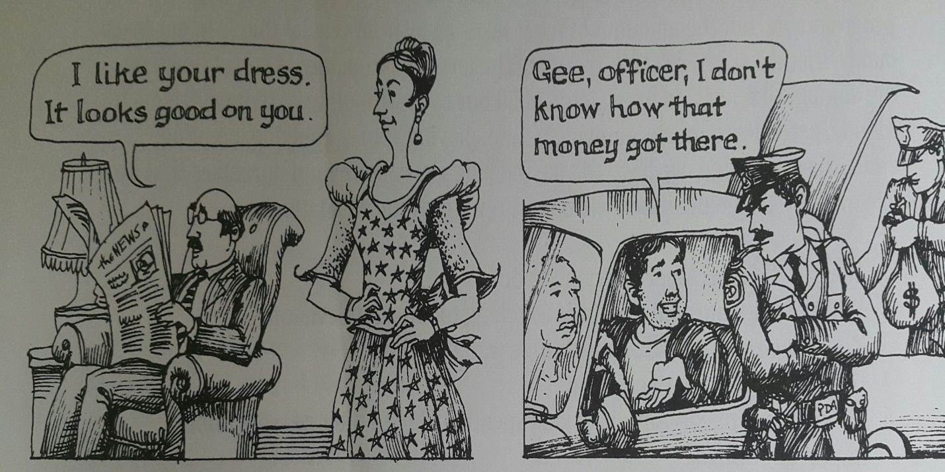

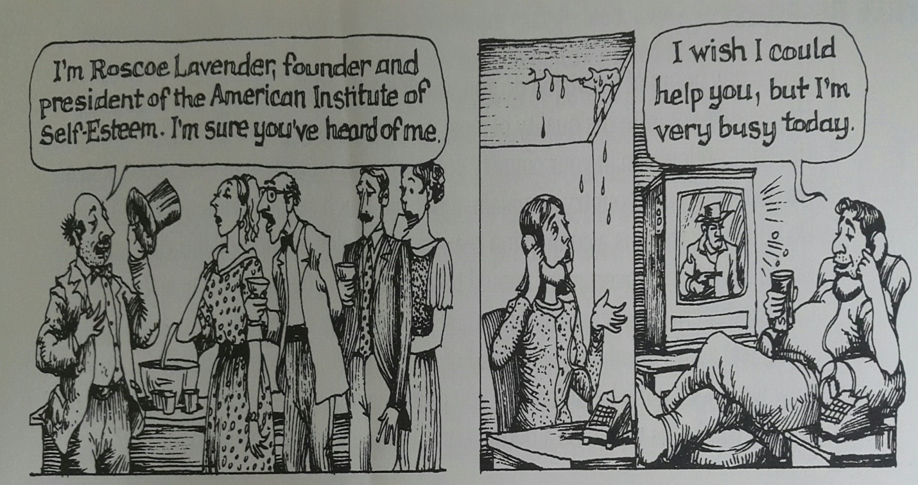
Pre-Activity_ New vocabulary (worksheet #1)

Answer Key
Word bank

- Rude b. complimentary c. truth d. offensive e. sticky f. honest
g. innocent h. responsibility i. approval j. uncomfortable

- * Fill in the blanks with the words from the “word bank” to match the definition.

- ( ) – A fact has been verified.
- ( ) – Not disposed to cheat or defraud.
- ( ) – Socially incorrect in behavior.
- ( ) – Violating or tending to violate or offend against.
- ( ) – Conveying or resembling a compliment.
- ( ) – Conducive to feeling mental discomfort.
- ( ) – Hard to deal with especially causing pain or embarrassment.
- ( ) – Free form evil or guilt.

Main Activity- Phrase Match (worksheet #2)

*Write the letter of the right answer on the blank from the box below.

- ______ Because it might hurt another person feelings.
- ______ A white lie that will make the person feel good.
- ______ You say something to make people think you’re innocent.
- ______ Criminals always deny responsibility.
- ______ You may say something that will make people think well of you.
- ______ You make up a polite excuse that will satisfy the other person.

- You say something complimentary.
- You want t to avoid saying what you really think.
- To get away with something.
- To be popular, gain approval, or sound important.
- To get out of an uncomfortable or sticky
- To avoid doing something that you find unpleasant.

Post – Activity_ Discussion Paper

*Topic: People should always tell the truth.

*Opinion:

*Reason:

1.

2.

3.

SOS-Activity_Crossword Puzzle.
Name:
- Complete the crossword below.

Across
1. A true statement.
3. Free from evil.
4. The social force that binds you to the courses of action demanded by that force.
9. The formal act approving.
10. Meet the requirements or expectations of

Down
2. Not disposed to cheat or defraud.
5. Hard to deal with.
6. Socially incorrect in behavior.
7. Violating or tending to violate or offend against.
8. The general state of thing.

