■ Listening ☐ Speaking ☐ Reading ☐ Grammar ☐ Writing

Topic: My House

Instructor:  SONG AERI (Ellen) | Level:  Low Intermediate | Students:  10 | Length:  34 Minutes

Materials:
-White board, board marker
-Computer for audio file
-Picture of two different houses
-Listening work sheets with blanks(10)#1
-Listening for details(10)#2
- White papers for drawing(20)
-SOS work sheets(10)

Aims:
-Main aim : Students can improve their listening skill by listening to a familiar subject
-Second aim: Students are going to learn new vocabularies by completing worksheets related to houses
-Personal aim : I want my students to be able to describe their houses

Language Skills:
Listening: : Ss will listen to the audio file and partner`s speaking
Speaking: Ss will describe each other`s drawing and have a discussion
Reading: Ss will read worksheets with blanks #1
Writing: Ss will write a worksheet about the details of their own house.

Language Systems:

Lexis: : Idioms used in describing a house
Function: presenting for a house
Grammar : present tense

Assumptions:
Students already know
- How the class is set up (There will be 2 students in pairs at each table)
- Their language abilities are similar
- They know well about basic vocabularies of house.

Anticipated Errors and Solutions:
- If they can`t understand audio file :
Give them one or two chances to hear it
- If they feel nervous or shy for presenting :
Let them present after other`s presentation
References
Listening file : https://youtu.be/RA-CT7BKuQE
Picture
Oxford dictionary
Lead-In
Materials: None
Time | Set Up | Activity Teacher Talk | Student
3Min | Whole class | Hello everyone, how are you today?  Is there anyone who had an interesting event at home? How was it? | Answering teacher`s question

Pre-Activity
Materials: Board, Board marker, picture of houses and apartments

Time | Set Up | Teacher Talk |  | Student Activity
3Min | Whole class  Pairs | - Brain Storming  (showing picture of two kinds of houses)  Guiding questions  -Which kind of house do you live in?  -what can you see in the picture?  Instruction  -Discuss about the differences of houses in the picture with your partner  -I will give you 3 minutes  ICQ  Are you working alone?  How much time do you have?  What are you doing?  Great! Go ahead.  (Monitoring discreetly and answer students ‘question)  - Introduce topic  As I board, today`s topic is “My house”  3. Pre-teach Vocabulary  Instruction  Before we start, we are going to learn some new vocabulary. (Hand out worksheet #1). Work with a partner and fill in the blanks. I will give you 3 minutes.  ICQ  Are you working alone?  How much time do you have?  What are you doing?  Time’s up!  (Check answers as a class).  Ok good. Now we are going to listen to an audio file about houses. | Discuss about the picture with partner

Main Activity
Materials:
Audio file from computer, Listening work sheets with blanks(10)#1, New vocabularies worksheets#2

Time | Set Up | Teacher Talk | Student Activity
18Min | Whole class  Individually  Whole class  Pairs | - Listening for Main Idea  Instructions  (Give out worksheet with blanks)  We are going listen to audio file about houses.  During listening, try to fill in the blanks.  I will play the audio file twice  Work alone and I will give you 5minutes.  ICQ  Are you working in groups?  How much time do you have?  How many times will I play the audio?  Ok good let`s listen to audio file and fill in the blanks(play audio file)  Monitoring  In front of the class check computer`s condition and volume  Instructions  (After listening)  Did you fill in the blanks?  Who didn`t finish it?  (If many students didn`t finish play the audio file one more time)  Ok let`s listen one more time  Time is up, let`s check your answers.  - Listening for Details  Instruction  (Hand out worksheet #2)  Now I am going to read sentences describing places of house.  Listen carefully and check True or False while I read the sentences.  Don`t discuss with your partner and work alone.  (Read and check answer)  Did you finish checking? Then let`s check your answer.  Everybody did a good job!  3. Production  Instruction  We will do another activity.  I am going to give you blank papers.  Describe your house to each other and draw the picture of partner`s house.  After drawing, show your partner the picture and discuss it.  Work in pairs.  I will give you 5 minutes.  ICQ  Are you working in alone?  How much time do you have?  Ok good  Monitoring  Walk around and check if any student needs help  Answer the student`s question  Inform the time limit  “Two minutes left”  “Time is up”  Now explain about partner`s house to this class one by one. Ok everyone did a great job!!! | Listen and write  Answer the question and  Correcting  Guessing and  Answer the question  Present their house and draw pictures of partner`s house  Draw and  Present partner`s house

Post Activity
Materials: White papers
Time | Set Up | Teacher Talk | Student Activity
8Min | Whole class  Pairs  Whole class | 1. Feedback  (Ask Students if they enjoyed the activity and if they learned something new).  - Error correcting  Did you check your answers without difficulties?  Ok good, is there anyone who has a question?  (Correct any errors that the students had and answer all questions).  - Conclusion  Did you learn new vocabulary today?  What did you learn?  Good job! I hope you have enjoyed and learned something new. Have a nice day and see you tomorrow~! | Draw and write of their own dream house  Check answers  Ask a question

SOS Activity
Materials: SOS worksheet
Time | Set Up | Teacher Talk | Student Activity
2Min | Pairs | Instruction  In this activity you have to make right sentences with the words in a box.  Work alone and don`t discuss with other students. | Make right sentences

WORKSHEET #1
My House

I live in a
My house is
My house has two
My house has a
My house has a
My house has a big
My house has a lot of
My house has a
My house doesn`t have a
My house has a
My house has a big
My house has a

What other places are in my house???
Talk about it with your partner.

Word Bank

Roof Garage Window
Fence Wall Bedroom
Kitchen Living room Bathroom
Closet Basement Floor
Backyard Garden

Listening script
I live in a house
My house is small
My house has two bedrooms
My house has a kitchen
My house has a Livingroom
My house has a big bathroom
My house has a lot of closets
My house has a basement
My house doesn`t have a second floor
My house has a garage
My house has a big backyard
My house has a vegetable garden

Two type of houses
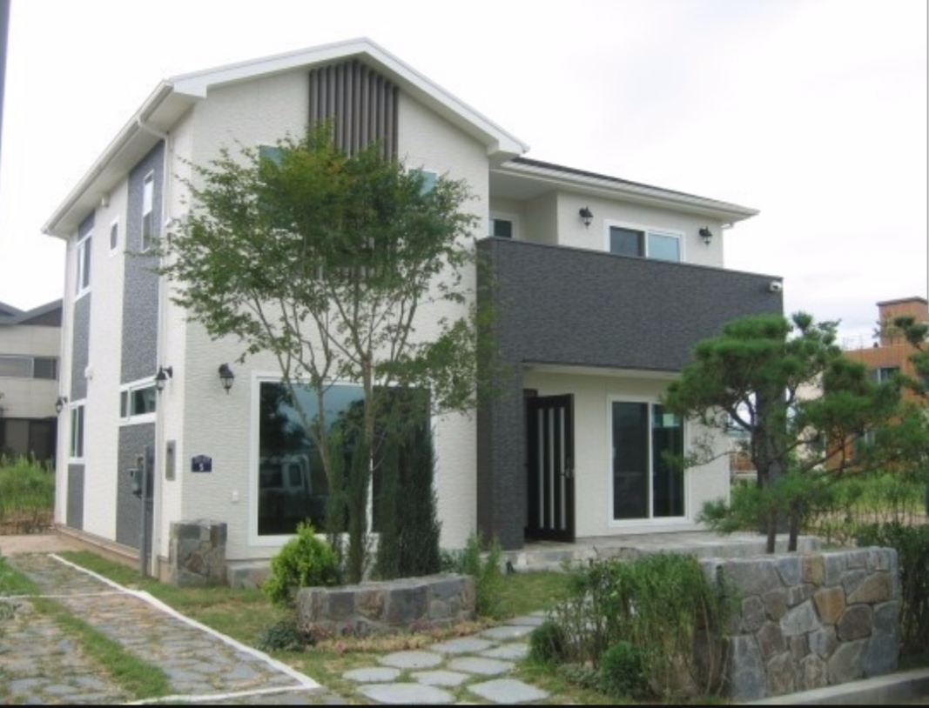

Explaining work sheet for new vocabularies

Roof: A building is the covering on top of it that protects the people and things inside from the weather
Garage: A building in which you keep a car. A garage is often built next to or as part of a house. Window
Fence: A barrier between two areas of land made of wood or wire supported by posts. Wall
Bedroom: A room used for sleeping in Kitchen
Living room: A room where people sit and relax
Bathroom: A room in a house that contains a bath or shower, a washbasin, and sometimes a toilet.
Closet: A piece of furniture with doors at the front and shelves inside, which is used for storing things.
Basement: A building is a floor built partly or completely below ground
Floor: A part of it that you walk on.
Backyard: An area of land at the back of a house.
Garden: a piece of land next to a house, with flowers, vegetables, other plants, and often grass.
Listening for details (True or false): Teacher talk
Garage is a building is the covering on top of it that protects the people and things inside from the weather (T/F)
Kitchen is a building in which you keep a car. Kitchen is often built next to or as part of a house. (T/F)
Fence is a barrier between two areas of land made of wood or wire supported by posts. (T/F)
Living room is a room where people sit and relax. (T/F)
Floor is a room is a place that contains a bath or shower, a washbasin, and sometimes a toilet. (T/F)
Closet is a piece of furniture with doors at the front and shelves inside, which is used for storing things. (T/F)
Bedroom is a floor built partly or completely below ground. (T/F)
Basement is an area of land at the back of a house. (T/F)
Garden is a piece of land next to a house, with flowers, vegetables, other plants, and often grass. (T/F)

SOS work sheet

I house in a live
→

My two has house bedrooms
→

big house bathroom My a has
→

My doesn`t house a floor have second
→

A My big house backyard has
→

