☐ Listening ☐ Speaking ☐ Reading ■ Grammar ☐ Writing

Topic: Harder, Better, Faster, Stronger

Instructor:  Angela  Hana | Level:  Upper Beginner | Students:  5 | Length:  45 Minutes

Materials: Audio file “Daft Punk - Harder, Better, Faster, Stronger”
Worksheet #1-3 (5 copies each of them)
Board
A4 paper
Monitor
Substitution table (PPT)

Aims:
Main Aim: Students will understand of comparative forms by making their own sentences.
Secondary Aim: Students will practice comparative forms by listening song and pictures given.
Personal Aim: I want to let students construct at least 4 sentences using adjectives given.

Language Skills:
Speaking: Drilling, practice activities
Listening: Listening to music
Reading: Reading worksheet to answer questions
Writing: Worksheet answers

Language Systems:
Grammar: Comparative adjective
Function: Compare two adjectives
Discourse: Making sentences, Drawing, Comparison

Assumptions:
Students already know
- How the class is organized and operated.
- Which partner they belong to
- How to use adjective

Anticipated Errors and Solutions:
If students need help finding out the meaning of word
- I will let them use a dictionary.
If students may have a hard time drilling
- I will give the students more chances to practice.
If students need more time to finish their activity
- Be flexible with the time as giving students more time to finish their activity and cut off the time of post activity.

References:
https://www.youtube.com/results?search_query=daft+punk+harder+better+faster+stronger
https://books.google.co.kr/books?id=aG3Ija7N2WQC&pg=PR6&lpg=PR6&dq=grammar+lesson+plan&source=bl&ots=3Oo8StHawE&sig=hI-HWUEG2eupXyq1cjEFboT2q8Y&hl=ko&sa=X&ved=0ahUKEwivsqal5K3bAhWEkJQKHe8YCs84MhDoAQglMAA#v=onepage&q=grammar%20lesson%20plan&f=false

Lead-In
Materials: none
Time | Set Up | Activity
5min | Whole class | Hi, everyone. How are you today?  A: Wow, Hana. You have very long hair. I’m very jealous of you.  H: Angela, you have short hair. But it’s good for you.  A: By the way, I feel like go to club today.\  H: Wow, good. Oh, I heard nowadays, short hair is hot trend in club. So you will be hot girl today.

Pre-Activity
Materials: Board, Music file ‘Harder, Better, Faster, Stronger’, Substitution table(PPT), Monitor
Time | Set Up | Activity
4min  5min  2min  7min | Whole class  Pairs  Whole class  Whole class | 1.DO  Have you ever been to club? I know very exciting song. It makes you cheer up.  When you listen to music, some forms of word are repeated. So listen carefully and try to catch what it is. Let’s listen.  ICQ  What are you especially listening for?  (Turn on the music)  2. Recall  How was the song? Did you enjoy? The lyrics are very simple. Do you remember what it is? Can you tell me some words which you remember?  (Let students answer the question and board it)  The title is “Harder, Better, Faster, Stronger”  Today we will learn about this type of grammar point.  (show Slide 1)  Look at this photo. This horse is fast. This one is also fast. Which one is faster?  (Student answer)  Right. Horse#8 is faster than the others. Please repeat after me.  (show Slide 2)  Look at this photo. They have a strength contest. Red man is strong. Both of them are strong. But who is stronger?  (student answer)  Right. Blue man is stronger than red man. Please repeat after me.  (student repeat)  3. Reflect  (Board the sentences)  “Horse #8 is faster than others”, “Blue man is stronger than red man.”  Can you notice something similar in them?  (Students answer)  4. Conclude  It has ‘-er’ at the back of the adjective. And also it has ‘than’ behind the adjective.  That is comparatives form. We can use comparatives to compare 2 nouns.  It is normally formed by adding ‘-er’ to the adjective and placing ‘than’ behind the adjective.  Repeat after me. “A is faster than B” ,“ A is stronger than B”  (student repeat the sentences)  But, how about this one?  (Board “beautiful”)  Do we have to say “beatifuller”? No. Adjectives with three or more syllables form the comparative by putting ‘more’ in front of the adjective. So we have to say “more beautiful”.  What else?  (students answer)  (Show students substitution table_Slide 3)  Listen to what I say and repeat after me.  (Teacher read the sentence and then students repeat.)  Now you will make sentence in turns.  (Students make sentences using substitution table)  CCQ  When we use this form?  What is comparative form of “slow”, “high”

Main Activity
Materials: Board, Worksheet #1-2,(5 copies), A4 paper(5 copies)
Time | Set Up | Activity
7min  4min  6min | Pairs  Whole class  Whole class | Controlled practice  (Hand out worksheet#1 )  Please complete the worksheet given. You will have to fill in the blanks with the correct comparative adjectives.  (Demonstrate)  I will give you 5 minutes. Work with you partner.  ICQ  Are you working with partner?  How much time do you have?  (Check answer together)  Less-controlled practice  I will give you another worksheet. You can see the chart  Make one sentence with comparative adjective using the information given.  (Hand out worksheet#2 and demonstrate)  I will give you 2min.  When you finish, please read aloud your sentence.  ICQ  Are you working alone?  How much time do you have?  (Monitoring)  Times up. Let’s start. Who want to go first?  (Student read their sentence in turns and let the others repeat it together)  Free practice  What we are going to do is making your own flash card adjusting comparative adjective. But you don’t have to make a sentence just draw it.  (Hand out A4 paper and show them example picture)  I will give you 2 minutes.  ICQ  Are you working alone?  How much time do you have?  Did you finish? Now your partner will make a sentence using the flash card and present it.  (Teacher demonstrate)  Now, let’s start from Kate.  (students present)

Post Activity
Materials: none
Time | Set Up | Activity
1min  1min  1min | Whole class  Whole class  Whole class | Error correction  When the adjective end in “-y’ it changed in ‘-ier’. For example, lucky – luckier, easy-easier.  Feedback  What did we learn today?  Do you remember what it is?  And when do we use the grammar point?  Conclusion  Everyone did great job today.  Let’s take a break.

SOS Activity
Materials: SOS activity worksheet#3 (5copies)
Time | Set Up | Activity
7min | Individual | Now, what we are going to do is construct a sentence for each of the adjectives given. You must use comparative adjective.  Work alone and I will give you 5 minutes.  (Hand out SOS activity worksheet)  ICQ  Are you working alone?  How much time do you have?  (Monitoring and see if there is a person who didn’t understand teacher’s instruction)  Did you finish?  (Check answer together)

Worksheet #1

Fill in the blanks with the correct comparative.

 | Adjectives | Comparatives
1 | Firm
2 | Light
3 | Long
4 | Dangerous
5 | Cheap
6 | Comfortable
7 | Big

Complete the sentences using adjectives which is presented

1. You’re ( older than ) me. → OLD

2. The text was pretty easy - ( easier than ) I expected. → EASY

3. A Plane is ( faster then ) a bus. → FAST

4. Stephan looks ( ( younger than ) he really is. → YOUNG

5. Mary is ( more beautiful ) than lily → BEAUTIFUL

Worksheet #2

 | Jake | Peter | Jane | Sara
Height | 180cm | 175cm | 155cm | 172cm
Weight | 77kg | 90kg | 44kg | 60kg
Age | 32 | 26 | 38 | 30

Worksheet 3
Construct a sentence for each of the adjectives given. You must use either comparative or superlative adjective.

- small (box/ bag)
Sentence: _______________________________________________________________________________________________________________

- light (book/ bag)
Sentence: _______________________________________________________________________________________________________________

- long (rope/ hair)
Sentence: _______________________________________________________________________________________________________________

- dangerous (activity/ game)
Sentence:
___________________________________________________________________________________________

- Make your own sentence.
___________________________________________________________________________________________

PPT file

Slide 1

Slide 2
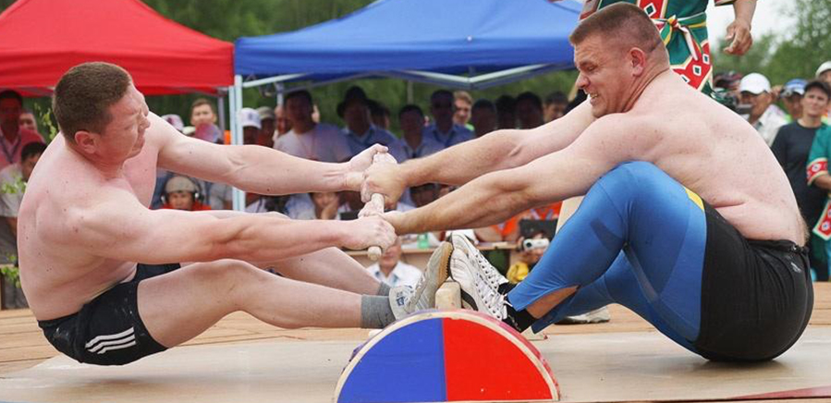

Slide 4
