☐ Listening ☐ Speaking ■Reading ☐ Grammar ☐ Writing
Topic: A Positive Lifestyle Is Good For Your Health

Instructor:  Yoon Hyun Chu  (Julie) | Level:  Intermediate | Students:  5 | Length:  35

Materials:
- White board, markers
- Worksheet #1 for pre-teaching vocabulary
- Worksheet #2 for finding main idea
- Worksheet #3 for finding details
- Worksheet #4 for free production
- SOS activity worksheet

Aims:
- Main aim: Ss will develop intensive reading skill by answering questions to find the main
- Secondary aim: Ss will be able to talk about how to improve their health
- Personal aim: I want my students to think about a good way to improve their health.

Language Skills:

- Reading: Matching worksheet, reading text to find main idea, detailed information.
- Listening: Pair discussion to answer the question, listening to teacher’s instructions
- Speaking: Answering the guiding question and interview in free production
- Writing: Answering worksheets

Language Systems:
- Phonology: Pronunciation of new vocabulary words
- Lexis: The meanings of new words
- Grammar: Making Questions and answers
- Function: Interviewing with their partners
- Discourse: Reading an article

Assumptions:
- Students know what skimming and scanning are
- Students have some information about health

Anticipated Errors and Solutions:
- If students need more time to finish their activities
- Be flexible with the time and give them more time to finish their activity.
- If students finish their worksheets or a task earlier than scheduled
- Give them SOS activity sheet (If not used in the class, give it to students as homework)

References:
Exploring English 6 by Tim Harris & Allan Rowe

Lead-In
Materials: None
Time | Set Up | Student Activity | Teacher Talk
1min | Whole class | Answering the teacher’s questions | Good morning, everyone! How are you today? Are you a positive person? Raise a your Hand, anybody if you like a positive person! Ok! Yes, most people like a positive person.

Pre-Activity
Materials: Board, markers, worksheet #1
Time | Set Up | Student Activity | Teacher Talk
2min  2min  3min  1min | Pairs  Whole class  Individually  Whole class | Talking about the guiding questions with the partner.  Answering the teacher’s questions.  Working on the worksheet #1  Checking the answers together | - Prediction  How can the positive lifestyle or the attitude benefit us?  Talk about this with your partner. You have 2minutes.  ICQ  Are you working alone?  What are you going to do?  How much time do you have?  Time’s up! Ok! Good!  Now we will talk about this in whole class.  How can the positive lifestyle benefit you? Take turns to tell the answer around.  Can you guess today’s topic?  Good! Today’s topic is “A Positive Lifestyle Is Good For Your Health!”  (Write the topic on the board)  - Pre-teaching Vocabulary  Before we read the text, let’s learn some new vocabulary. Let me give you worksheet #1.  Instruction  You will preview words by answering the questions by yourself. I’ll give you 3 minutes for this activity.  Demonstration  Here is an example. Read the first definition together. What’s the answer for number 1? Right, “aggravate”. Like this, write the word according to its definition. For the second, find the similar words to the underlined words. Did you get it?  ICQ  Are you working alone?  What are you going to do?  How much time do you have?  (Monitoring discreetly)  Time’s up!  Ok! Let’s check the answers together. What did you get for number 2?...  You did a good job! Repeat after me.

Main Activity
Materials: Worksheet #2, #3, #4

Time | Set Up | Student Activity | Teacher Talk
3min  2min  1min  3min  1min  5min  5min | Individually  Individually  Whole class  Individually  Whole class  Pair work  Pair work | Read the text for main idea  Working on the worksheet #2  Checking the answers  Working on the worksheet #3  Checking the answers.  Working on the worksheet #4.  Presenting their ideas and listening to what other classmates are saying. | - Skimming for the main idea  It’s time to read today’s text. I’ll give you worksheet. This time, you will read the text to find the main idea. You have 3minutes to skim the text. Read the text alone.  ICQ  Are you working alone?  How much time do you have?  What will you do?  (Monitoring)  Ok, time’s up!  Find the answers on the worksheet #2. Work alone and you have 2minutes.  ICQ  Are you working alone or with your partner?  How much time do you have?  Let’s check the answers. What’s the answer for number 1?  - Scanning for details  This time, scan the text and find the answers to the questions on the worksheet #3. You will do this alone. I’ll give you 3minutes for this.  ICQ  Are you working alone?  How much time do you have?  (Monitor discreetly and give students help if they have difficulty finding the answers)  Are you done?  (If students need more time, give them 30 seconds more)  Let’s check the answers together.  - Free Production  Now let’s do fun activity. We’ll talk about what you’d like to recommend to stay healthy. Please pass these worksheets around.  Did everyone get a worksheet? Good!  You are going to talk about what you would like to recommend to stay healthy using the interview sheet. You will work with your partner. You have 5minutes.  Demonstration  Here is an example.  (Model the activity with one student)  ICQ  Are you working alone or with your partner?  What are you doing with your partner?  How many minutes do you have?  Have you all finished?  (If some students need more time, give them two more minutes )  It’s time to present your partner’s recommending activity for you. Which pair wants to start first?  (Go through all pairs)  Everyone did a great job!

Post Activity
Materials: White board and makers.
Time | Set Up | Student Activity | Teacher Talk
2min  1min  1min | Whole class  Whole class  Whole class | Trying to self-correct their errors  Answering the teacher’s questions.  . | - Error Correction  Before wrapping up today’s lesson, we’ll review some errors. (Board sentences with errors and ask students to try to self-correct first, and then let them know the correct sentences)  - Feedback  Did you have fun today?  What did you learn today?  Was it helpful to think about a positive lifestyle?  (Share students’ ideas and wrap up the class)  - Wrap-up  You guys did great job today. I’m so proud of you. Please review the words you learn today. I hope you can be healthier and keep well.  Have a good day!!

SOS Activity
Materials: Worksheet #4
Time | Set Up | Student Activity | Teacher Talk
3min | Whole class | Working on the extra activity. (When finished the task earlier than scheduled.) | You finished the activity early. So I will hand out this worksheet. You will review the reading text with this worksheet.  (If not used in the class)  Everyone, this is an organizer. You should finish it at home. Choose the correct words by reviewing the text.
Reading Text

A positive lifestyle is good for your health

When most of us get sick we go to a doctor, get a prescription, and take a drug. With certain types of health problems, drugs can achieve beneficial results. However, there are many chronic illnesses that don’t respond well to pills. Common ailments such as insomnia, backaches, and depression are stress-related, and they are directly affected by the patient’s state of mind. To provide the most effective therapy for these conditions, it is necessary to address the psychological needs of the patient as part of the treatment. For this reason, a growing number of doctors are examining the connection between healing and spirituality. They are discovering that love, laughter, positive thoughts, and faith are good for one’s health.

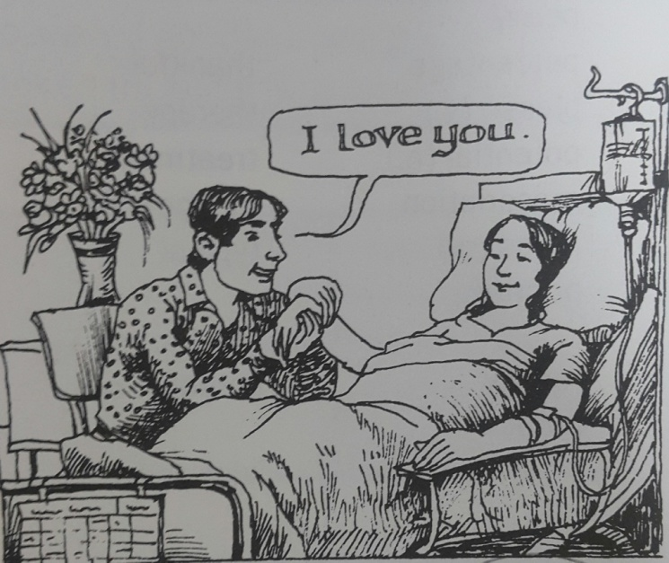  Love is the most powerful stimulant to the immune system. Love boosts our spirits and motivates us to get well. The truth is, love can heal. | 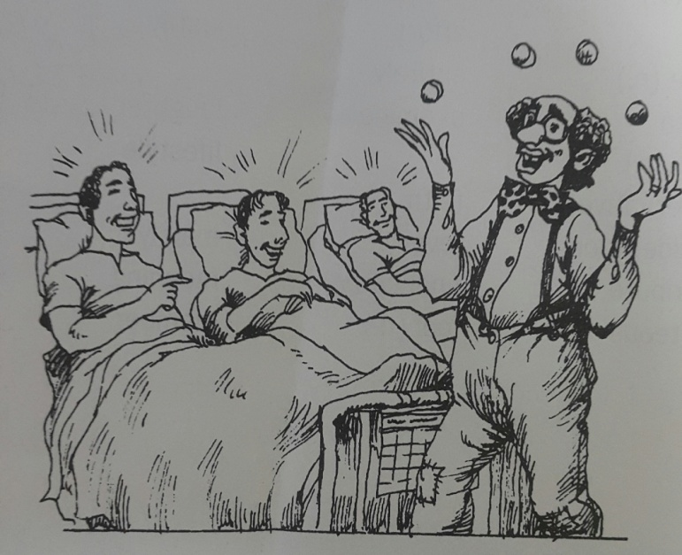  Laughter relieves pain and helps us relax. A well-developed sense of humor counteracts the negative emotions that can cause and aggravate illness.
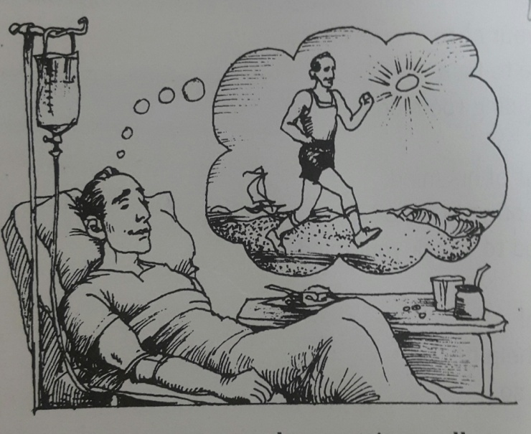  When we picture ourselves getting well, we help our body to heal itself because the body responds to the mind’s messages. Positive thoughts activate beneficial hormones that promote healing. | 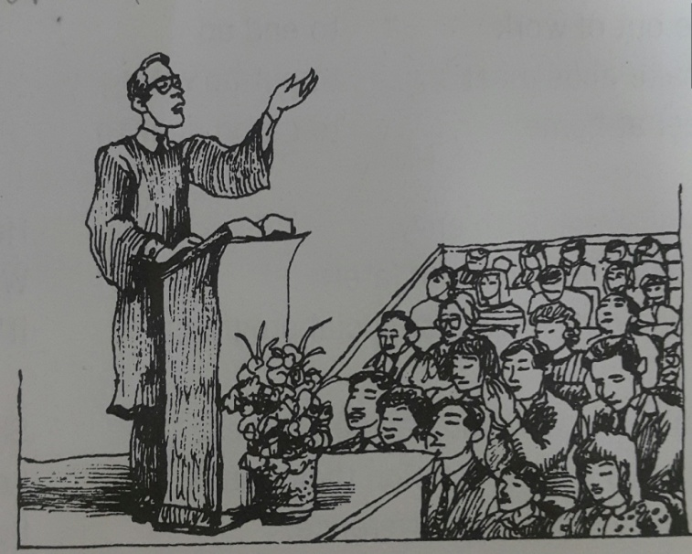  Studies show that people who have faith in a benevolent higher power have lower blood pressure, less heart disease, lower rates of depression, and generally better health than those who don’t believe.

This evidence supports the view that we can have greater success in overcoming illness and staying healthy if we combine the best of modern medicine with a positive lifestyle.

Worksheet #1-Vocaburaly Review

- Write the correct word next to its definition.
- Prescription • Insomnia • Stimulant • Immune
- Activate • Counteract • Aggravate

- Make worse. - ( )
- An inability to sleep; Chronic sleeplessness.- ( )
- Written instructions from a doctor to a druggist concerning the form and dosage of a drug to be issued to a giver patient.- ( )
- A drug that temporarily quickens some vital process.- ( )
- Relating to the condition of immunity.- ( )
- Act in opposition to.- ( )
- Put in motion or move to act.- ( )

- Find the word that has a similar meaning to the underlined word.

1) It has been known to heal and prevent various diseases.
- ailment ② complaint ③ affliction ④ disability
2) He has never suffered from any inveterate illnesses.
① Habitual ② customary ③ chronic ④ acute
3) She is a popular TV celebrity widely known for her roles as a charitable mother.
① helpful ② benevolent ③ generous ④ friendly

Worksheet #2 - Main Activity

- What is the best title for the passage?
- New therapies of chronic illness.
- A positive lifestyle improves your health.
- Positive thoughts promote healing
- Effect of the superiority of modern medicine.

- Circle T if the statement is true or F if it is false.
- Common ailments such as insomnia, backaches respond well to pills. ( T / F )
- A number of doctors have found that the patient’s state of mind can heal or aggravate illness. ( T / F )
- Combining the best of modern medicine with a positive lifestyle helps us to have greater success in overcoming illness. ( T / F )

Worksheet #3 - Main Activity

- According to numerous studies, a positive lifestyle is good for health because ____________________________________________.
- It can stimulate to immune system.
- People who live like that have higher blood pressure, higher rates of depression, and generally better health.
- Positive thoughts activate harmful hormones that aggravate illness.
- A well-developed sense of humor counteracts the positive emotions that can promote healing.

- What does it mean to have a positive lifestyle?
- It means that people have a poor diet and get regular exercise.
- It means a helpful way of life that contributes to sound and positive mental attitude such as pursuing of love, developing sense of humor, having positive thoughts, and having belief.
- Some people go to the PC room to relieve stress.
- It is vital that we have open communication and go to church regularly.

- Are you doing the things you should to stay healthy? Give some examples.
__________________________________________________________________________________________________________________________________________________________________________________________________________________

Worksheet #4 - Main Activity
★Interview your partner
- What would you like to recommend for to stay healthy?

- Have you ever tried it? If so, how did it work? If not so how does it work?

- To do so, what do we need?

- Which do you prefer? Doing with partner? Or doing alone?

★Presentation (example)

My partner’s name is Viki.
- She recommends Salsa dancing for my health.
- Actually she has been dancing for a week. As a kind of Aerobic exercise it helps blood circulation, has anti-aging effect and can be beneficial for weight loss.
- She said I just need cell phone or computer and can dance anywhere. Watching you tube, she learns dancing every day.
- She prefers dancing alone because she feels shy about her clumsy dance before people.
SOS Activity

A Positive Lifestyle Is Good For Your Health.
★ Fill in the blanks with the following words in a proper form.
ⓐ picture ⓑ relieve ⓒ boost ⓓ counteract
ⓔ a growing number of ⓕ heal ⓖ lower rates ⓗ spirituality

______________ doctors are examining the connection between healing and ___________. They have found out the following facts.

● Love ___________ our spirits and the immune system to get well.
● laughter _____________ pain and helps us relax just like a pain-killer. A sense of humor _____________ the negative emotions that can cause illness.
● When we ____________ ourselves getting, our body responds to the mind’s messages and __________ itself
●A healthy religious life helps people to have lower blood pressure ___________ of depression

