■ Listening ☐ Speaking ☐ Reading ☐ Grammar ☐ Writing

Topic: British Royal Wedding: Traditional to Modern

Instructor:  Emily Kwon (Youyoung) | Level:  Intermediate | Students:  12 students | Length:  30 Minutes

Materials:
- Picture of Cinderella Wedding Ceremony (Computer and Projector, if available)
- Audio file
- White board and board markers
- Worksheet #1 New Vocabulary (12 copies)
- Worksheet #2 Phrase Match, Discussion Questions (12 copies)
- Worksheet #3 Script (12 copies)
- SOS Worksheet – Wordsearch (12 copies)

Aims:
- Main Aim: Ss will be able to improve their listening skills by listening to the news report.
- Secondary aim: Ss will be able to understand proper vocabulary and expressions by doing a ‘fill-in-the-blank’ activity.
- Personal aim: I would like to give Ss a chance to be exposed to the current social issue and be able to talk about the topic in English in the real life.

Language Skills:
- Listening: Ss will listen to the short and simple news article.
- Speaking: Ss will discuss about the main idea and comprehensive questions.
- Reading: Ss will read the definition of the words and understand them.
- Writing: Ss will write the correct words in the underlined area.

Language Systems:
- Lexis: New vocabularies in the worksheet
(royal, diverse, inclusive, lavish, gospel, Feminist, Wedding Party, Actress, biracial, etc.)
- Function: Giving Information
- Discourse: News Article

Assumptions:
Students already know
- How the class arranged and prepared (4 Students at each table)
- How the Royal Wedding looks like
- The basic knowledge about the Wedding
- Their discussion groups and partners

Anticipated Errors and Solutions:
- If students are hesitant to speak out loud about their thoughts,
- Encourage them to speak freely and give some advice
- If some students need more time for each work,
- Give them an extra minute or make other students who finished early to helped them
- If certain students dominate the talking time,
- Make Ss to take turns when answering questions.

References:
- Listening file recorded and scripts written from:
https://www.englishclub.com/efl/listening-news/royal-wedding-2018
- Worksheets:
https://quickworksheets.net/
- Picture of Cinderella Wedding
https://www.deviantart.com/engigen/art/cinderella-s-wedding-170802332

Lead-In
Materials: None

Time | Set Up | Student Activity | Teacher Talk
1 min | Whole class | Answering teacher’s questions | Good morning! How are you guys today?  Did anyone has an experience in attending a wedding ceremony before or have you seen a wedding ceremony in the movie? Did you like it? Why?

Pre-Activity
Materials: Visual Aid(Picture), worksheet #1 (12 copies)

Time | Set Up | Student Activity | Teacher Talk
5 min  2 min  5 min  3 min | Pairs  Whole  Class  Whole  class | Answering teacher’s questions and students talk each other.  Answering teacher’s questions  Students complete the worksheet#1  Students start matching the words with definition  Students check answers | - Spark Interest  - Guiding Questions (Eliciting)  (Show the picture of Cinderella)  Please everyone, look at the screen (or the picture). With your partner, talk about the Cinderella’s wedding ceremony. For 2 minutes, share your thoughts with partner about the Royal wedding, how it would be different from the normal wedding.  (After 2 min.,)  OK, class, times up. Let’s take turns from the front and one person from each group shares their idea about Royal Wedding.  - Additional Information  (After sharing ideas, write the topic: ‘British Royal Wedding: Traditional to Modern’ on the board)  Recent royal wedding in the UK  had lots of attentions from the global media since its traditional factors have been changed to modern style.  - CCQ  So, recently, how has the royal wedding changed?  - Pre-teach Vocabulary  Instruction  Before listening, we are going to learn some new vocabularies first.  We are going to read the definition s find out the right words from the word bank.  (Hand out worksheet#1)  Please try to match the words with the its definitions. If you are having trouble, you can use dictionary. ,  Demonstration  Let’s solve the first word together.  Look at #1. Can anyone guess what the definition is describing? “Yes, it’s Royal.” I will give you 4 minutes to solve them all, work on your own.  ICQ  What do you do with the words?  Can you use dictionary?  Are you working alone?  How much time do you have?  Monitoring  (Walk around to see how Ss are doing. Answer questions if Ss have any.)  (Give time warning) You have 1 minutes/30 seconds left.  Time’s up  Check answers  It is time to check the answers together.  After checked, give a compliment.

Main Activity
Materials: Listening audio file, Worksheet #2 and #3 (12 copies each)

Time | Set Up | Student Activity | Teacher Talk
5 min  3 min  3 min  3 min  5 min  3 min | Individual/Pairs  Whole  class  Individual  Whole  class  Groups  Whole Class | Students complete worksheet #2  Students listens to the audio  Students shout the answers together.  Students listens to the audio  Students listen and fill out the blanks.  Students check answers  Students see the worksheet#2  Students discuss in groups  Students present their ideas. | - Listening for Main idea  As I boarded here, today’s topic is the “British Royal Wedding: Traditional to Modern.  Instruction  After listening to the audio once, we want to find out some main ideas of the News Report by matching some phrases in your new worksheet. Only look at the top section where it says ‘Main Ideas.” You want to listen full report first and work on the worksheet.  (Hand out the worksheet #2)  I will give you 3 minutes after the listening and please match the main ideas with your partner.  ICQ  Do you work with your partner?  How much time do you have for matching the phrases?  Are you working before listening?  Okay everyone, please pay attention to the Audio, first.  (Play the News Report)  Ok, everyone please work in a pairs to find out matching phrases.  (Monitoring and Give time warning) Time is up.  Check answers  Let’s check answers together. Great job everyone.  - Listening for Details  Instruction  Now, let’s listen again for the details.  (Hand out Worksheet #3)  While you are listening to the  News report, fill in the blanks on  your script. Work individually.  ICQ  What do you do while listening?  Are you working in pairs?  (Play the audio)  Do you need to listen again?  (If yes, play again)  Check answers  Let’s check answers together. Great job everyone  - Production - Discussion  Instruction  Okay everyone, now we will be working on groups of 4 in the each table for the discussion. Please look at the bottom of the worksheet#2.  (See if everyone is on the right page.)  I will give you 4 minutes to discuss about 2 questions in the bottom of the worksheet within your groups. Write down one or two sentences, representing your group’s opinion.  ICQ  How much time will you have for the discussion?  How many questions are you answering to?  Are you writing down the final opinion  Ok, start.  Monitoring  (Walk around and check if everyone is speaking and following the instructions)  (Give time warning)  You have one minute left.  Presentation  It’s time to listen to each group’s idea about 2 questions. One representative from each group will present. Do we have any volunteers? (If no, take turns)  Great ideas. Good job everyone.

Post Activity
Materials: White board and board Marker

Time | Set Up | Student Activity | Teacher Talk
1 min  1 min  2 min | Whole class  Whole class | Students listen and answer questions  Students listen and ask questions & answers | - Error Correction  (If there’s any, fix grammatical and pronunciation that students made, and correct them)  - Feedback  How did you feel about the news report?  Do you have any questions?  - Conclusion  (Conclude today’s lesson by checking key vocabularies, and their understanding of the topic)  I appreciated your great participation today and everyone did a very good job. I hope you now have some ideas about recent changes in British Royal Wedding.  Thank you very much.

SOS Activity
Materials: Wordsearch worksheet (12 copies)

Time | Set Up | Student Activity | Teacher Talk
4 min  1 min  1 min | Individual | Students complete the worksheet  Students check their answers with partners.  Student listen to teacher | - Wordsearch Game  Instruction  We are going to play the Wordsearch Game using the vocabularies we learned today.  (Hand out worksheet)  In the lettered box, you are to find out 9 words presented in the bottom on your own. You can make circles as you find the word listed. Words can be shown in a shape of horizontal, vertical and diagonal but orders are not in backwards. You have 3 mins.  ICQ  How many words are you finding?  Are you working in a group?  How much time will you get?  (After 2 minutes with time warning)  Okay, Please check your answers with your partners.  Review  Does anyone have questions?  Good Work everyone!

- Picture

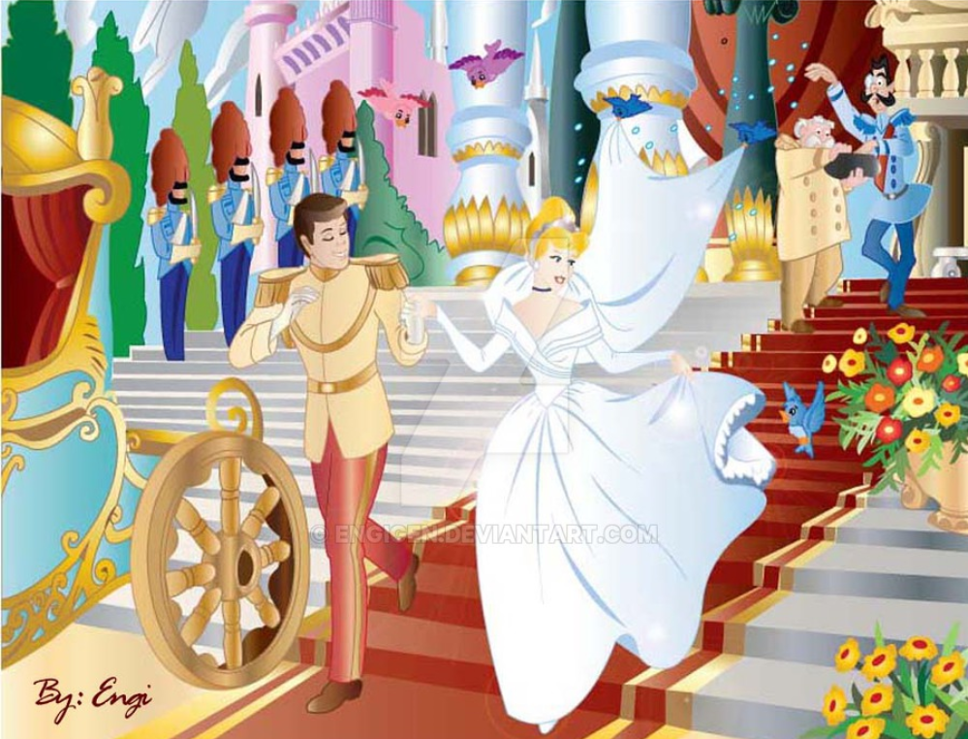

- Worksheet #1

Pre-Activity – New Vocabulary (worksheet #1)

Word Bank
- Lavish b. Biracial c. Divorce
d. Feminist e. Gospel Choir f. Inclusive
g. Wedding party h. Diverse i. Royal

Instruction)

- : Having the rank of and relating to a king, queen or other sovereign
- : Having a wide variety (e.g., of people)
- : Taking care not to exclude people or goups
- : Overly rich and decorative
- : Christian music in the style of American blues and jazz
- : One who believes strongly that women are equal to men
- : The people who stand up with the bride and groom at a wedding
- : A formal separation of husband and wife
- : Consisting of, representing, or combining members of two separate racial groups

Pre-Activity – New Vocabulary (worksheet #1) Answer Key

Word Bank
- Lavish b. Biracial c. Divorce
d. Feminist e. Gospel Choir f. Inclusive
g. Wedding party h. Diverse i. Royal

Instruction)

- i : Having the rank of and relating to a king, queen or other sovereign
- h : Having a wide variety (e.g., of people)
- f : Taking care not to exclude people or goups
- a : Overly rich and decorative
- e : Christian music in the style of American blues and jazz
- d : One who believes strongly that women are equal to men
- g : The people who stand up with the bride and groom at a wedding
- c : A formal separation of husband and wife
- b : Consisting of, representing, or combining members of two separate racial groups

- Worksheet #2

Main Ideas- Matching Phrases (After the first Listening)

- American actress Meghan Markle made history last weekend _______ | - symbolizing her strong feminist beliefs.
- The wedding of Prince Harry to Meghan Markle has _______ | - when she became the first biracial woman to marry into the British royal family.
- Markle also chose to walk down part of the aisle of St. George’s Chapel alone,_________ | - been described as both “diverse” and “inclusive.”

Discussion Topic (Post-Activity)

- Why would Meghan Markle not be considered a “traditional” woman to marry into the British royal family?

- Millions of people around the world, including about 30 million Americans, tuned in to watch the royal wedding. Why do you think so many people are obsessed with royalty in these modern times?

- Worksheet #2 Answer Key

Main Ideas- Matching Phrases (After the first Listening)

- American actress Meghan Markle made history last weekend ___b____ | - symbolizing her strong feminist beliefs.
- The wedding of Prince Harry to Meghan Markle has ___c____ | - when she became the first biracial woman to marry into the British royal family.
- Markle also chose to walk down part of the aisle of St. George’s Chapel alone, ____a_____ | - been described as both “diverse” and “inclusive.”

- Worksheet #3 (Gap fill)

Royal Wedding Described as “Diverse” and “Inclusive”

American actress Meghan Markle last weekend when she became the first biracial woman to marry into the British royal family. Unlike past royal weddings that have been for being overly lavish and traditional, the wedding of Prince Harry to Meghan Markle has been described as both “ ” and “inclusive.” The bride, mother Doria Regland is a black American, invited a young black cellist, an preacher, and a gospel choir to be part of the service. Markle, a divorced woman who is three years older than Prince Harry, also chose to part of the aisle of St. George’s Chapel alone, symbolizing her strong feminist beliefs. Children of the as well as children of Markle’s Canadian friends were included in the wedding party.
양식의 맨 아래
- Worksheet #3 (Script)

Royal Wedding Described as “Diverse” and “Inclusive”

American actress Meghan Markle made history last weekend when she became the first biracial woman to marry into the British royal family. Unlike past royal weddings that have been criticized for being overly lavish and traditional, the wedding of Prince Harry to Meghan Markle has been described as both “diverse” and “inclusive.” The bride, whose mother Doria Regland is a black American, invited a young black cellist, an African American preacher, and a gospel choir to be part of the service. Markle, a divorced woman who is three years older than Prince Harry, also chose to walk down part of the aisle of St. George’s Chapel alone, symbolizing her strong feminist beliefs. Children of the royal family as well as children of Markle’s Canadian friends were included in the wedding party.
양식의 맨 위

- SOS Activity- WordSearch
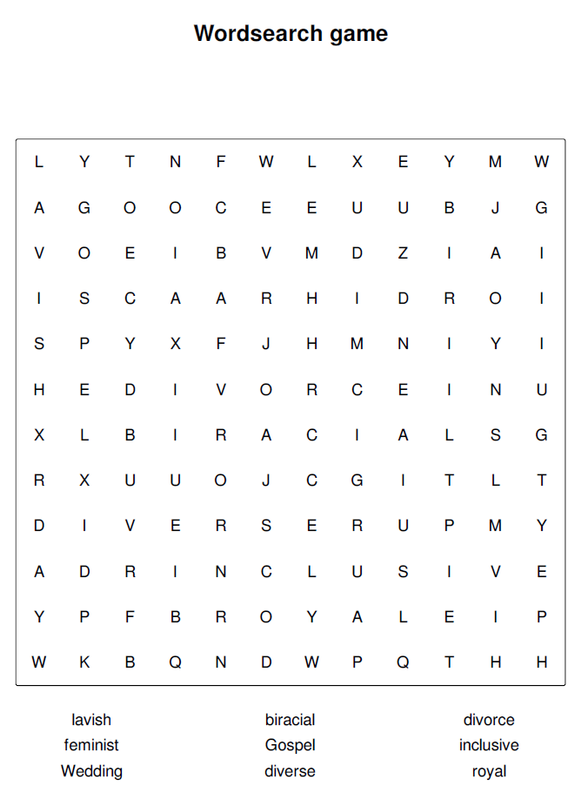
- SOS Activity- WordSearch Answer Key

