☐ Listening ☐ Speaking ☐ Reading ☐ Grammar ☐ Writing

Topic: Emoji effects

Instructor:  Lizzie(노진실) | Level:  Intermediate | Students:  12 | Length:  30 Minutes

Materials:
〮Computer
〮Images
〮Listening MP3 file and speaker
〮White board and markers
〮Before listening worksheet #1 : Predict meaning(12copies).
〮Fill in the blank worksheet #2(12copies)
〮Match phrase #3(12copies)
〮TRUE of FALSE worksheet #4
〮Discussion paper

Aims:
〮Main aim : Ss will be able to improve their listening skills by listening and understanding the articles.
〮Secondary aim : Students can discuss why people use emoji.
〮Personal aim : I would like to give them my instructions short and simple and understanding Other’s opinion.

Language Skills:
〮Reading : Ss will read script of topic
〮Listening : Ss will listen to the article about why people use emoji
〮Speaking : Ss will discuss “”Will emoji become new language?”
〮Writing : Ss will take notes on details of the text

Language Systems:
〮Lexis : new vocabulary in the article. (convey, phenomenon, literacy, institution, constrte, etc.)
〮Function : giving information
〮Discourse : news article

Assumptions:
Students already know
〮How the class is organized and operated. (3-4 students at each table)
〮The basic effects of using emoji.
〮Four language skills and language systems
〮Which partner/group they belong to in for partner/group discussion time

Anticipated Errors and Solutions:
〮If some students keep quiet for fear of upsetting other people during discussion
- Encourage them to speak and advise them to be clear about the point.
〮If certain students dominates the discussion
- Ask them to give other students a chance to speak.

References:
〮SOS activity crossword puzzle generator.
(https://worksheets.theteacherscorner.net/make-your-own/crossword/)
〮English definitions
〮Listening file & Script

Lead-In
Materials: None
Time | Set Up | Student Activity | Teacher Talk
1 min | Whole class | Answering teacher’s questions | Good morning class! How are you today?  Do you use emoji when you texting or posting some pictures on SNS?  What emoji do you usually use?  Why?

Pre-Activity
Materials: computer, images, screen, visual aid, worksheet#1, white board, board marker
Time | Set Up | Student Activity | Teacher Talk
2 min | Pairs  Whole class  Pairs  Whole class | Discussing about the meaning of emoji  Worksheet #1  Worksheet #2  Students start writing down the words. | Procedure  - Prediction  Elicit  (Handout worksheet #1.)  Please, look at the worksheet. There are some sentences and emoji. With your partner, find the correct sentence this emoji has what meaning. Your goal is to figure out the probable meaning.  Now I will give you 2minutes to share your thoughts with your partner.  (After 2 minutes...)  Time’s up! Let’s talk together the answers. Which sentence is correct in number1?  Most of you know about the meaning.  Model  (Write the topic “Why people use emoji” on the board.)  Today’s topic is “”Why people use emoji”.  CCQ  What is good thing about using emoji?  Do you use emoji in different situation and people?  - New vocabulary  Instruction  We are going to learn new vocabularies before listening. First, read the definitions of words with the blanks and then fill in the blanks with the correct word from the list below. Work together with your partners. I will give 5mins to finish.  (Hand out worksheet #1)  Demonstration  Now look at the worksheet. Let’s solve #1 together. If I say question’s number, you are going to tell the answer. together. Good job class.  ICQ  What do you have to do now?  What do you write in the blanks?  Are you working in groups of pairs?  How much time do you have?  Let’s get started!  Monitoring  (Quietly walk around the classroom.  Make sure that students communicate well. Answer the question, if they ask.)  Give time warnings : 30seconds left.  (If they need more time give 1 more minute.)  Time’s up.  Check Answers  Let’s check the answers together.

Main Activity
Materials: worksheet #2, computer for listening, speaker
Time | Set Up | Student Activity | Teacher Talk
4min  3min  3min | Individual/Pairs  individuals  Individuals | Students complete worksheet #3  Students check their answers.  Worksheet #3  Students listen to the article and fill in the blanks in the worksheet. #4  Students prepare the speech. | - Over view of the article.  As I mentioned, today’s topic is “Why people use emoji”  Insruction  I will give you another worksheet to work on before listening. You can have an overview of the article. So you will match the phrase individually for 2 minutes.  (Hand out worksheet #2)  ICQ  Are you working in pairs?  Are you going to match the phrase?  How much time do you have?  Let’s get started!  Monitoring  (Quietly walk around the classroom. Check to see if the students are on track. Answer to questions.)  (After 2 minutes..)  Now you may share your answers with your partner. Write down the agreed phrase on your own paper. I will give you 1 minute.  (After 1 minute..)  Time’s up. You did a great job. Then let’s listen to the article. And check if your answer were correct.  - Listening to the article.  Introduction  I will give you  Listen carefully and without taking a note. After listening, we will look see the worksheet again to find out correct answer.  ICQ  Are you working individually?  Do you need to take a note while listening?  What is the title of subject will we listen?  Check answers  Now check your answers on your own worksheet #3.  (Check answers with teacher)  - TURE or FALSE  I will give you another worksheet to do.  Now we are going to listen to the article one more time. You have to check TRUE or FALSE while listening. Work individually please.  (Distribute the worksheet#4)  ICQ  What do you have to do while listening?  Are you working in group?  (Teacher plays listening files. Let students to fill the blank while listening.)  Do you need to listen again?  If yes, play it one more.  Monitoring  (Quietly walk around the classroom. Check to see if the students are on track. Answer to questions.)  Check answer  Check the answers together. Please read aloud each sentences slowly and correctly with answer by all students in rotation.  Go through the all the answers on the worksheet #4  - Discussion  Instruction  Now, we will have discussion in 4groups.  Each group will discuss “Will emoji become a new language?” Your group should reach to an agreed conclusion. Each group needs a writer and a presenter to present your opinion. I will give you 5 minutes to discuss.  ICQ  What is topic of your discussion?  Are you working in groups?  Do you need a writer and presenter?  How much time do you have?  Let begin!  Monitoring  (Quietly walk around the classroom.  Check to see if the students are on track. Answer to question.)  Presentation  (After 5 minutes..)  It’s time to listen to each group’s presenter about their discussions.  Please stand up and report your opinion.  Speak loudly and clearly.  Other students have to pay attention to the presenter.

Post Activity
Materials: White board, marker, computer screen

Time | Set Up | Student Activity | Teacher Talk
3min |  |  | - Error correction  Do error correction about grammar and pronunciation during discussion and speech.  - Feedback  How do you feel today’s lesson?  Is it interesting?  - Conclusion  Summarize today’s lesson by checking new learned vocabulary and their understanding of the topic.  You did a great job today! Try to keep in mind of the content and vocabulary we’ve learned. Thank you for participating in class and have a good day!

SOS Activity
Materials: Crossword puzzle worksheet (11 copies)

Time | Set Up | Student Activity | Teacher Talk
5min  2min | Individual  Whole class | Students complete the crossword puzzle using today’s newly-learned vocabularies in sentences.  Students check answers | Instruction  Now we are going to complete the  crossword puzzle using the words we learned today. So Read the definition on the bottom and write down the word on the puzzle. Work individually please. You will have 5 minutes to do so.  (Hand out crossword worksheet)  ICQ  What words will go in puzzle?  Are you working in group?  How much time will you have?  Let’s get started!  Monitoring  (Quietly walk around the classroom. Check to see if the students are on track. Answer to questions.)  (After 3 minutes..)  You have 2 minutes left.  (After 2 minutes..)  Time’s up. You did a great job.  Check answer  Each student will go around and read each answer.

Listening script
Love them or hate them, emojis are everywhere, spreading through our texts, social media posts, and emails. They're in our inboxes, on the big screen, and even being used as evidence in courtrooms.
There is emoji for when you don’t really know what to say, but don’t want to be rude by not responding [Thumbs up], and for when you just don’t really want to respond at all. “I love emoji because I don’t like to make small talk,” one woman said. There are emoji sequences to express real-life concepts, too.
While many people see emoji as a relatively new phenomenon, in reality the use of symbols to convey meaning is one of the most basic institutions in the evolution of human language and shared knowledge. It is the oldest form of literacy.
The field of semiotic theory has long recognized the importance and value of symbol systems as part of communication. Emoji, the latest iteration, are no different.
Adding a winking face emoji ( ) helps to construe tone and indicate a joke rather than a serious statement.
It should be noted that different from emoticons, Emojis not only represent human emotions, they also represent various types of situations, objects, humans and places. This includes from hospitals, to plates of spaghetti, families with children, extraterrestrials and even weather conditions.
Along with this, a diversity of academic investigations exists to analyze the impact of Emojis in our culture. One of them was created by Dr. Owen Churches, from the University of Flinders in Australia and he revealed something decisive: the human brain reacts to emojis in the same way as it does to real human faces.

Pre-Activity – worksheet #1 Prediction

Translate this emoji sentence:
- My television is broken. I've been kicking it around like a soccer ball. I should call a repair man later.
- I'm watching the World Cup. Call me later.
- I don't usually watch television until after I browse the Internet, exercise and make my evening phone calls.
- Can you watch the World Cup and talk later?

Translate this emoji sentence:
- My phone is dying. Do you have a charger?
- Cell phones have radiation. Hope you unplug.
- Can you save me from work?
- High-five for me. I got a new phone because the old one died.

Translate this emoji sentence:
- Going on a family cruise but I'm afraid of the water because I can't swim.
- The family is afraid of going on a cruise, getting stranded and having to swim home.
- Family cruises are hard to book. Maybe we'll just go swimming instead.
- We're having a family reunion on a cruise but we all get sea sick.

Pre-Activity – worksheet #1 Prediction (Answer key)
- A bold statement is the answer.

Translate this emoji sentence:
- My television is broken. I've been kicking it around like a soccer ball. I should call a repair man later.
- I'm watching the World Cup. Call me later.
- I don't usually watch television until after I browse the Internet, exercise and make my evening phone calls.
- Can you watch the World Cup and talk later?

Translate this emoji sentence:
- My phone is dying. Do you have a charger?
- Cell phones have radiation. Hope you unplug.
- Can you save me from work?
- High-five for me. I got a new phone because the old one died.

Translate this emoji sentence:
- Going on a family cruise but I'm afraid of the water because I can't swim.
- The family is afraid of going on a cruise, getting stranded and having to swim home.
- Family cruises are hard to book. Maybe we'll just go swimming instead.
- We're having a family reunion on a cruise but we all get sea sick.

Pre-Activity -Worksheet #2
Fill in the blanks with the words below. Matching the definition

  - A man tried to bring forth ___________________ for his innocence.
  - Her words _____________ no meaning to me
  - In those days a _____________ test was required for immigrants.
  - A rainbow is a natural ____________________
  - The ______________ of events led up to the war.
  - He would encourage her to ______________ her true feelings
  - A Study on the Method of _______________ Approach on Environmental Meaning
  - I did not know how to _______________ his statement.
  - I realized she was telling the truth on _________________-
  - Bernard works at the same _________________ as Arlette.

- Evidence sequence phenomenon convey institution literacy semiotic construe investigation reveal

Pre-activity Worksheet #2(Answer key)

  - A man tried to bring forth evidence for his innocence.
  - Her words convey no meaning to me
  - In those days a literacy test was required for immigrants.
  - A rainbow is a natural phenomenon
  - The sequence of events led up to the war.
  - He would encourage her to reveal her true feelings
  - A Study on the Method of semiotic Approach on Environmental Meaning
  - I did not know how to construe his statement.
  - I realized she was telling the truth on investigation
  - Bernard works at the same institution as Arlette.

Main-Activity Worksheet #3
1.____ Love them or hate them, emojis are everywhere, spreading through our texts, social media posts, and emails.
2.____ There is emoji for when you don’t really know what to say, but don’t want to be rude by not responding [Thumbs up], and for when you just don’t really want to respond at all.
3.____ While many people see emoji as a relatively new phenomenon, in reality the use of symbols to convey meaning is one of the most basic institutions in the evolution of human language and shared knowledge.
4.____ The field of semiotic theory has long recognized the importance and value of symbol systems as part of communication. Emoji, the latest iteration, are no different.
5.____ It should be noted that different from emoticons, Emojis not only represent human emotions, they also represent various types of situations, objects, humans and places.
6.____ Along with this, a diversity of academic investigations exists to analyze the impact of Emojis in our culture. One of them was created by Dr. Owen Churches, from the University of Flinders in Australia and he revealed something decisive:
  - “I love emoji because I don’t like to make small talk,” one woman said. There are emoji sequences to express real-life concepts, too.
  - Adding a winking face emoji ( ) helps to construe tone and indicate a joke rather than a serious statement.
  - This includes from hospitals, to plates of spaghetti, families with children, extraterrestrials and even weather conditions.
  - They're in our inboxes, on the big screen, and even being used as evidence in courtrooms.
  - It is the oldest form of literacy.
  - The human brain reacts to emojis in the same way as it does to real human faces.
Main activity - Worksheet #3 (Answer key)
1.d Love them or hate them, emojis are everywhere, spreading through our texts, social media posts, and emails.
2.a There is emoji for when you don’t really know what to say, but don’t want to be rude by not responding [Thumbs up], and for when you just don’t really want to respond at all.
3.e While many people see emoji as a relatively new phenomenon, in reality the use of symbols to convey meaning is one of the most basic institutions in the evolution of human language and shared knowledge.
4.b The field of semiotic theory has long recognized the importance and value of symbol systems as part of communication. Emoji, the latest iteration, are no different.
5.c It should be noted that different from emoticons, Emojis not only represent human emotions, they also represent various types of situations, objects, humans and places.
6.f Along with this, a diversity of academic investigations exists to analyze the impact of Emojis in our culture. One of them was created by Dr. Owen Churches, from the University of Flinders in Australia and he revealed something decisive:

Main activity - Worksheet #4
After listening
Answer TRUE or FALSE from the following sentences.

- emoji is being used in courtrooms (T/F)

- emoji as a relatively new phenomenon (T/F)

- , Emojis only represent human emotions (T/F)

- There are emoji sequences to express real-life concepts, too. (T/F)

- the human brain reacts to emojis in the same way as it does to real human faces.(T/F)

Main activity - Worksheet #4(Answer key)
- emoji is being used in courtrooms (T/F) T

- emoji as a relatively new phenomenon (T/F) F

- , Emojis only represent human emotions (T/F) F

- There are emoji sequences to express real-life concepts, too. (T/F) T

- the human brain reacts to emojis in the same way as it does to real human faces.(T/F) T

Main activity – Discussion paper
Team1
Discussion topic : Will emoji become a new language?
Opinion :
Reason:
1)
2)
3)
Team2
Discussion topic : Will emoji become a new language?
Opinion :
Reason:
1)
2)
3)
Team1
Discussion topic : Will emoji become a new language?
Opinion :
Reason:
1)
2)
3)

SOS activity – Crossword puzzle
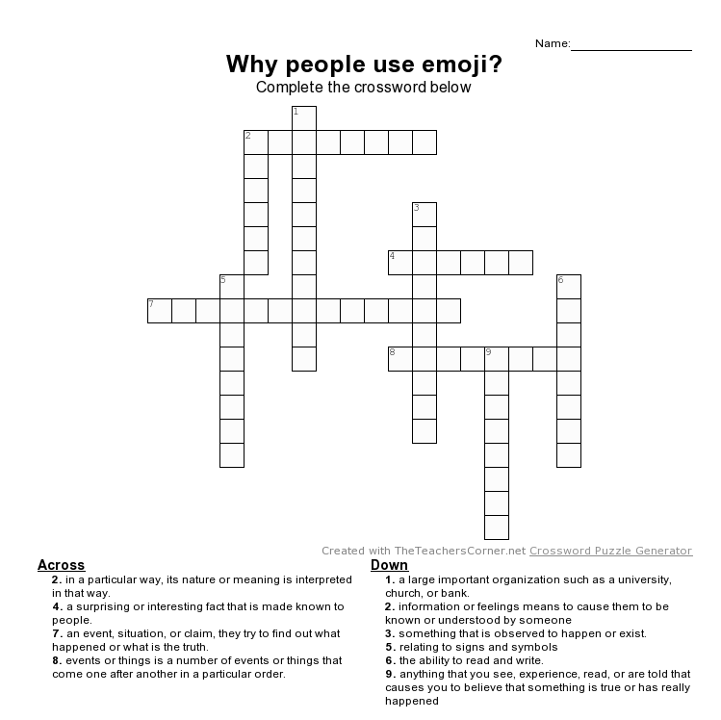
SOS activity – Crossword puzzle(Answer key)
Across 2.construe 4. Reveal 7. investigation 8. Sequence
Down 1. Institution 2. Convey 3.phenomenon 5. Semiotic 6. Literacy 9. evidence

