■ Listening ☐ Speaking ☐ Reading ☐ Grammar☐ Writing

Topic: Money can buy happiness

Instructor:  Christina Lee | Level:  Intermediate | Students:  11 | Length:  30-40 Minutes

Materials:
●Realia: The picture of a man with money
●White board and board markers
●Vocabulary worksheet (11copies)
●Before listening worksheet
:true or false questions (11copies)
●Fill in the blanks worksheet (11copies)
●Discussion topic worksheet (11copies)
●Computer for audio file

Aims:
●Main aim: Students will be able to improve their listening skills by listening to and understanding the topic in the article.
●Secondary aim: Students will be able to share viewpoints of how money affects the people by listening article and speaking their opinions
● Personal aim: Student are to express themselves regarding the topic and develop abilities to
listen others carefully

Language Skills:
●Reading: Ss will read scripts of topic
●Listening: Ss will listen to the article about money can buy happiness
●Speaking: Ss will discuss on “Can money buy happiness?”
●Writing: Ss will take notes on details of the next

Language Systems:
●Phonology: [f], [p]
●Lexis: New vocabularies in the article
(Happiness, Cambridge University, Spending habits, Personality Spending, Good and service)
●Function: Giving information
●Discourse: Article

Assumptions:
Student already know
●How the class is organized and operated (3-4 at each table)
●Four language skills and language systems
●Perception that money can’t buy happiness

Anticipated Errors and Solutions:
If the some students keep quiet due to being shy during discussion
- Encourage them to speak by providing a friendly, relaxed and open-mind atmosphere
If the students may not be able to pick up details form the listening
- Chunk listening(pause-play-pause-play)
If the students find difficulty to fill-in-the-blank activity,
- Demonstrate with one or two words by filling in the blank

References:
●Listening File
https://www.naturalreaders.com/
●Listening script
http://home.ebs.co.kr/speakinge/replay/4/list?vodSort=NEW&courseId=BK0KAKC0000000014&stepId=01BK0KAKC0000000014&searchCondition=shwLectNmSrch&searchKeyword=12%EC%9B%94&searchStartDt=&searchEndDt=

Lead-In
Materials: None
Time | Set Up | Student Activity | Teacher Talk
1min | Whole  class | Answering teacher’s question. | Good morning! How are you today?  Do you have something you have wanted to buy?  What are those? Why you haven’t bought?  How do you feel if you buy?

Pre-Activity
Materials: Board, Board markers, Visual Aid, Worksheet #1(11copies),
Time | Set Up | Student Activity | Teacher Talk
3min  4min  2 min | Whole  class  Pairs  Whole  Class | Answering teacher’s question  Student complete  Worksheet#1  Student check the answers together | Procedure:  - Eliciting  Elicit  (Show the picture of man with money)  What do you see?  Do you think he is happy?  Why do you think so?  Do you believe money can give happiness to the person?  Model  Write the topic “Money can buy happiness” on the board  CCQ  Do you feel happy if you spend money in what you want?  - New vocabulary  Instruction  “We are going to learn the new vocabulary before listening. I will give you a worksheet. First, read the definitions of words at the bottom part in the worksheet and then fill in the crossword puzzle with the word in the box on the top of worksheet. Work together with your partners. I will give 4mins to finish.”  (Distribute the worksheet #1)  Demonstration  Please look at the worksheet #1. Let’s solve #1 together. What can be… right….  Now, work with your partner  I will give you 4 minutes to finish  ICQ  What do you write in the blanks?  Are you working alone?  How much time do you have?  “Let’s get it started”  Monitoring  (Monitor discreetly. Answer students if they ask questions)  (Give time warnings: You have 1minute left)  Time’s up!  Check Answers  Let’s check the answers together  (Write the answers down on the board to check answer)

Main Activity
Materials: Worksheet #2,#3 #4(11 copies), Listening file from computer, Board, Board markers,

Time | Set Up | Student Activity | Teacher Talk
3min  4min  1min  3min  4min  5min | Pairs  Individually  Individually  Individually  Whole class  Group | Students guess whether the sentences are true or false  Students listen to the article  Students check their answers  Students listen to the article and fill in the blanks in the worksheet  Student check answers  Students in group talk about the discussion topic | - Prediction  Today’s topic is “Money can buy happiness”  Instruction  I will give you another worksheet before listening. We can have an overview of the article by doing this activity. With your partner, guess whether the sentences are true or false. Then share your ideas for one or two questions briefly in the worksheet which answer is correct. I will give 3 minutes.  (Distribute the worksheet #2)  ICQ  Are you working in pairs?  Do you guess if the sentences are true or false?  Do you share your ideas about all questions?  How much time do you have?  Let’s start  Monitoring  (Monitor discreetly. Answer students if they ask questions)  (Give time warnings: You have 1minute left)  “Okay, class, the time is up. I think you are doing well. Then let’s listen to the article and check the answers. See if your prediction is right or wrong  .  - Listening for the main idea  Instruction  “Listen carefully without taking note. After listening, we will look the worksheet again and find out correct answer.  ICQ  Do you need to take a note while listening?  What is the topic of the article will be listening?  (play the audio file)  (If the students want to hear the audio, play one more time.)  Check answer  “Now, Check your T/F worksheet by yourself”  (Write the answers down on the board to check answer)  - Listening for detail  Fill in the blank  Instruction  “Now, we are going to listen to the article one more time. You have to fill the blanks with the right words while listening. Work individually please.”  (Distribute the worksheet #3)  ICQ  Do you fill in the gaps while you listening or after listening?  Are you working in group?  (Teacher plays the audio file. Let students to fill the blanks while listening.)  “Do you need to listen again?”  If yes, play it again  Check answer  “Check the answers together.  Please read aloud each sentences slowly and correctly by all students in rotation  Go through the all the answers in the worksheet #3  - Free production  (Discussion and speech)  Instruction:  “Now, we will have discussion in three groups. Each group will discuss “Can money buy happiness? Do you agree or disagree? Please write down three reasons why you agree/disagree. I’ll give 5 minutes  ICQ  Are you working in groups?  Do you need to write 4 reasons to agree/disagree?  How much time do you have?  “Let’s begin”  Monitoring  Monitor discreetly, Answer students if they ask questions  (Give time warnings: You have 1minute left)  Time’s up  Presentation  “It’s time to listen to each group’s discussions and opinions. Presenters of each group please stand up and present your group’s opinions.  Speak loudly and clearly. Audience, show respects to the presenter and pay attention”

Post Activity
Materials: Board, Board marker
Time | Set Up | Student Activity | Teacher Talk
1min  1min | Whole class  Whole class | Listen and understand  Students will mentions about today’s activity | - Error Correction  (do error correction about grammar and pronunciation during discussion and speech)  - Feedback  “How was the class? What do you feel of the new topic?”  - Conclusion  (Conclude today’s lesson by checking the newly learned vocabulary and their understanding of the topic. )  “Class, you did a great job today, try to keep in mind of the content and vocabulary what we learned today, Thank you for participating in class and have a good day.”

SOS Activity
Materials: Word Search worksheet (11 copies)
Time | Set Up | Student Activity | Teacher Talk
5min  2min | Individually  Whole  Class | Students complete the Word Search worksheet with words relating money  Students check answers | - Word Search  Instruction  Now, we are going to complete the word search using the words related money. So, see the vocabularies, find them and circle the words. Work individually please. You will have 5 minutes to do so.  (Hand out the worksheet)  ICQ  Are you working in a group?  How much time do you have?  You may start now.  Monitoring  (Quietly walk around the classroom. Check to see if the students are on track. Answer to questions)  (After 4 minutes,)  You have 1 minute left.  Times up!  Check answer  (Distribute answer-checked worksheet)  Each student will check answers

Visual Aid for Eliciting

#Worksheet 1
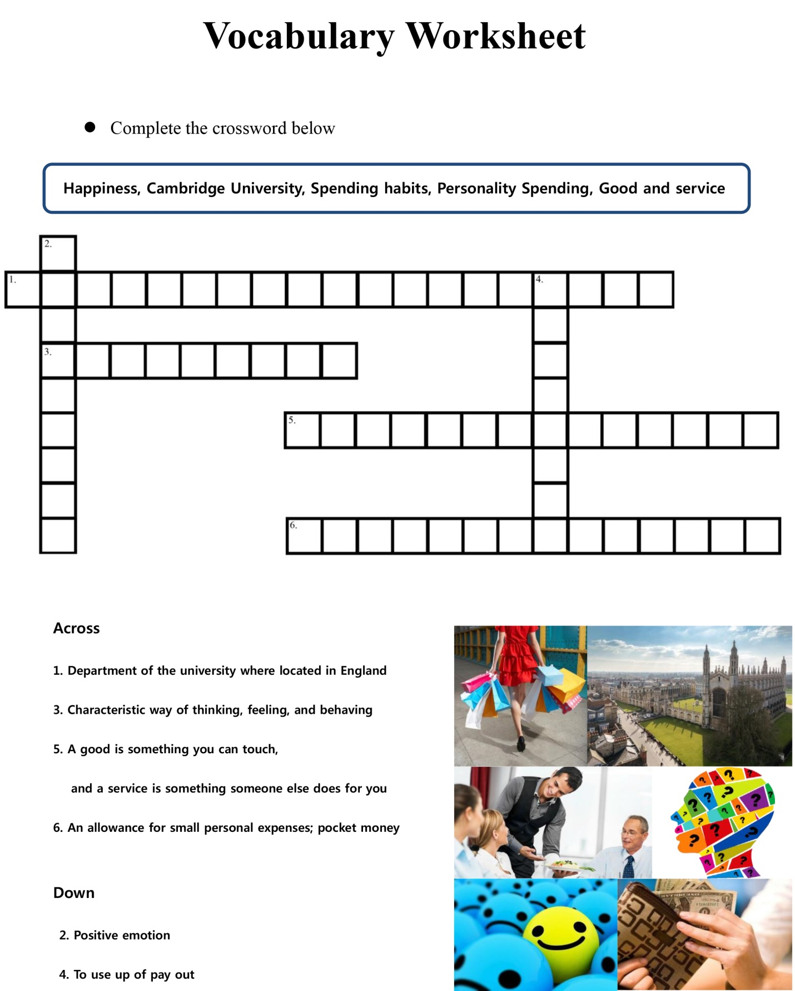

Worksheet #2

Before Listening

Answer true or false from the following sentence.

- Many people believe that money cannot buy happiness(T/F)

- Spending money can increase people’s happiness when it is spent on good and service that does not fit people’s personalities(T/F)

- The Beatles(The English pop group) told us that money can’t buy us love(T/F)

#Worksheet 3
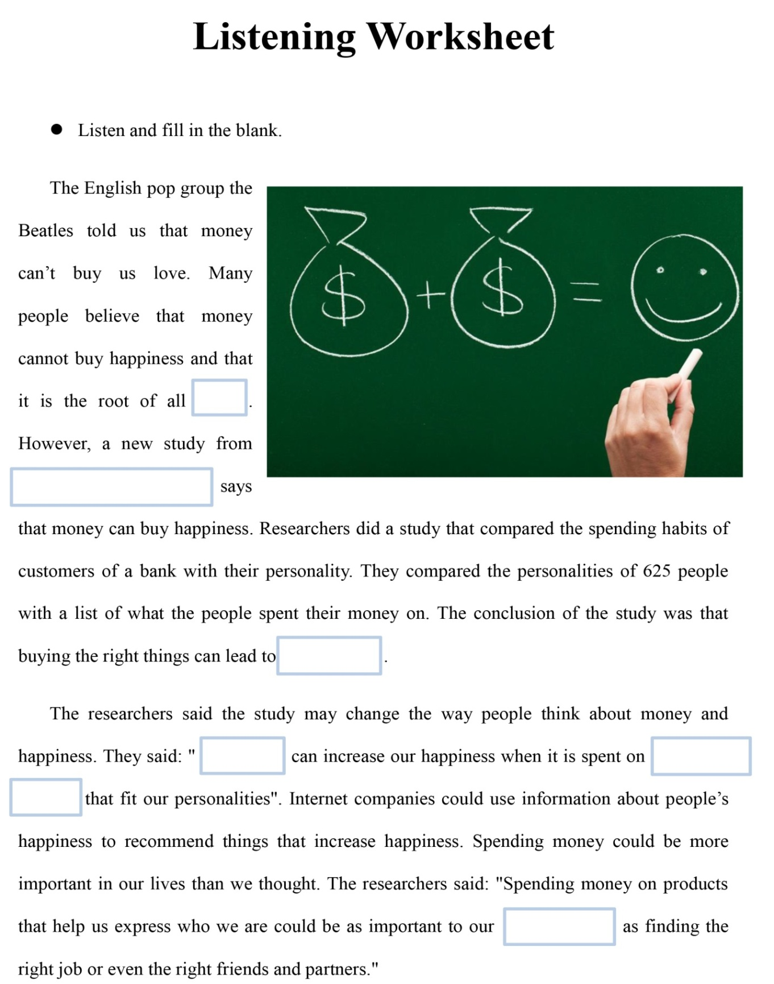
Worksheet#4

Discussion Topic

☞ Do you agree that Money can buy happiness?

If you agree, what are the reasons?

-

-

-

If you disagree, what are the reasons?

-

-
-

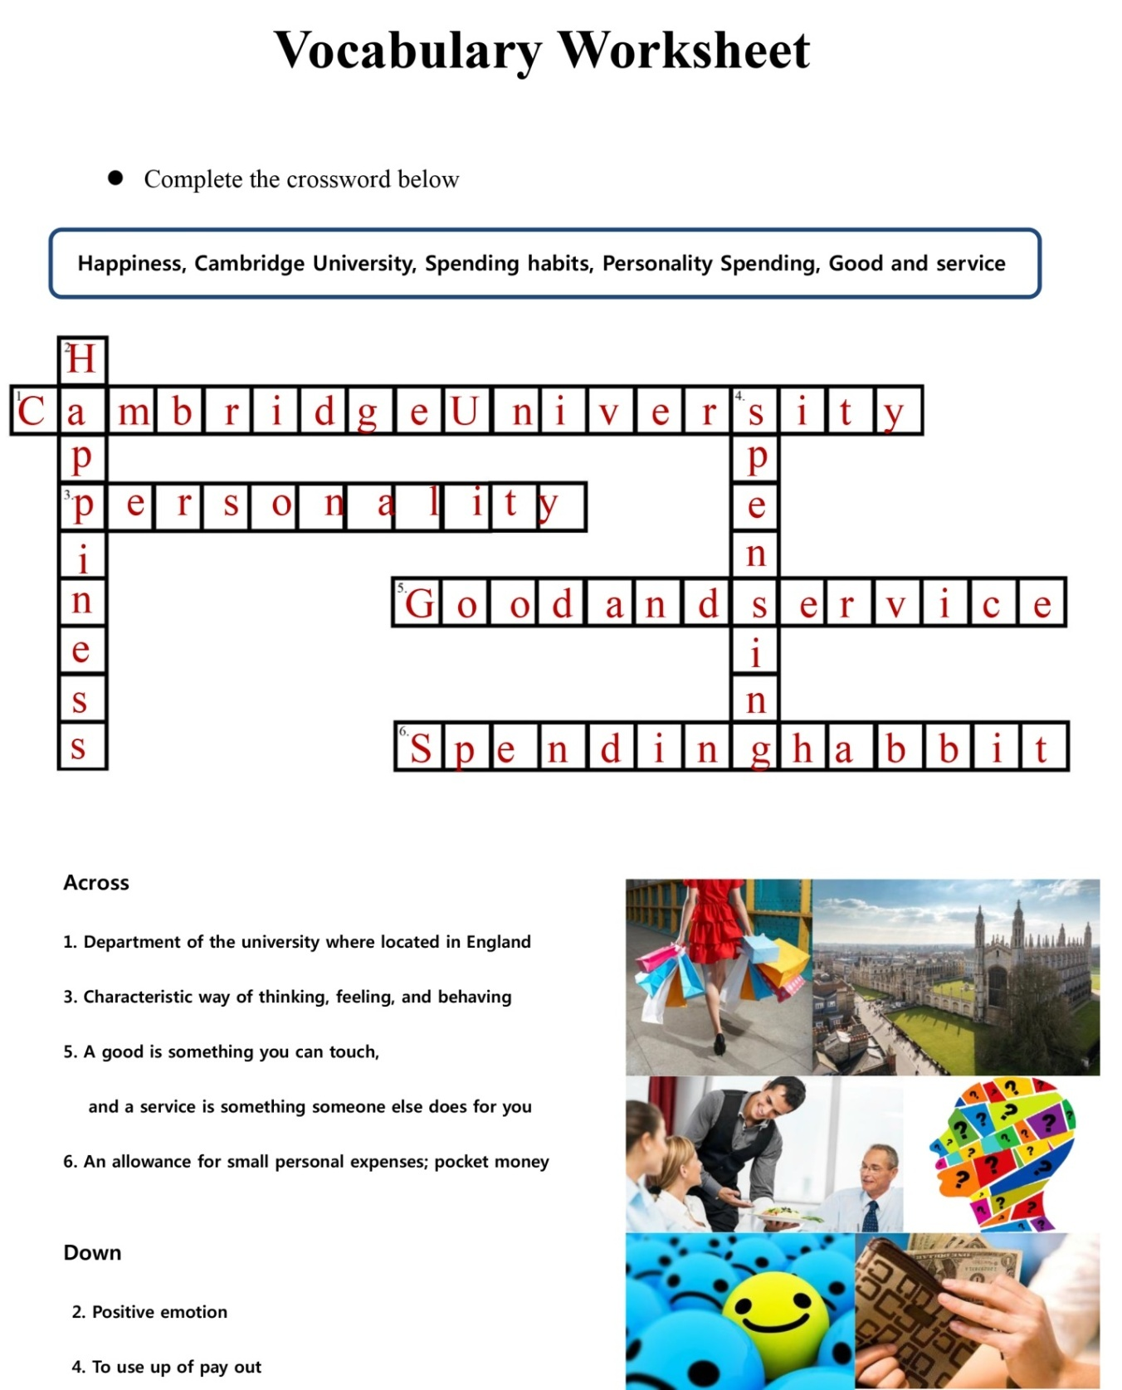

Before Listening

Answer true or false from the following sentence.

- Many people believe that money cannot buy happiness(/F)

- Spending money can increase people’s happiness when it is spent on good and service that does not fit people’s personalities(T/)

- The Beatles(The English pop group) told us that money can’t buy us love(/F)

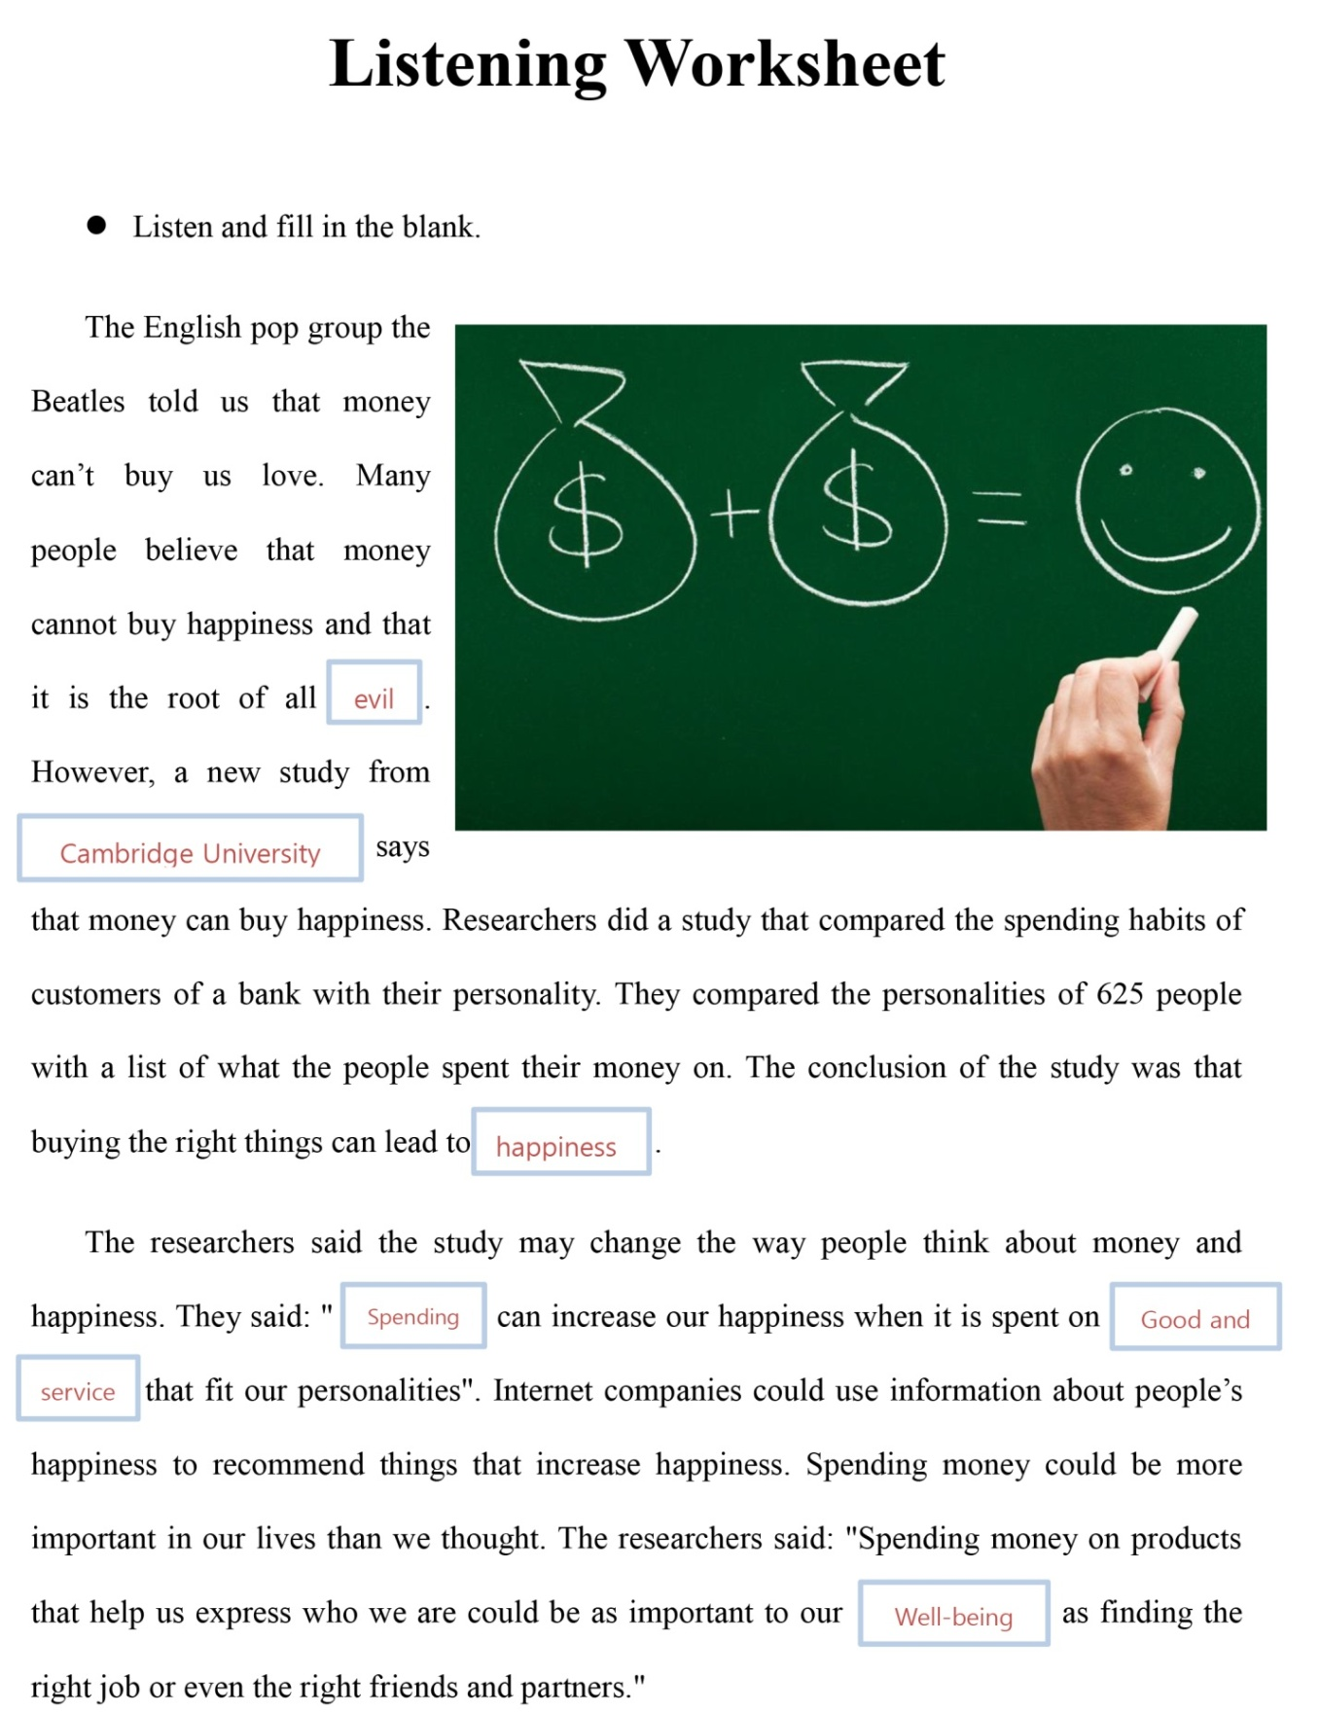

Discussion Topic

☞ Do you agree that Money can buy happiness?

If you agree, what are the reasons?

- Helps to strengthen your relationship with family and friends

- Getting luxurious items

- Money relieves stress

If you disagree, what are the reasons?

- Money can make depression

- Money doesn’t buy kindness

- It will never be enough

