■ Listening ☐ Speaking ☐ Reading ☐ Grammar ☐ Writing

Topic: Top 5 beautiful harbor in the world

Instructor:  chan | Level:  Intermediate | Students:  9 | Length:  35mins

Materials:
Computer
Projector and screen for projection
Listening file and speaker
Worksheets
White board and board maker
Blank papers

Aims:
Main Aim : Students will improve their listening skill by completing worksheet on an audio file.
Secondary Aim : Students will learn new vocabulary by completing a fill-in-the-blank worksheet
Personal Aim : I want students to understand top5 beautiful harbor in the world through whole lesson.

Language Skills:
Listening: Ss will listen to the audio file.
Speaking: Ss will discuss about top 5 beautiful harbor in the world
Reading: : Ss will read script.
Writing: Ss will take note on details of audio file.

Language Systems:

Lexis: New vocabularies in the article.
Function: Discussion
Discourse: Self-test result, seeing photos and listening

Assumptions:
Students already know
- How the class is set up and run
- They already know many different harbor in the world

Anticipated Errors and Solutions:

- If students need linguistic help to express their opinion during discussion I will encourage them to look at the context clue
- If a certain student contributes too much to the discussion I will introduce the round robin form of discussion to that group
- If students find more than one match for the phrase matching
I will give them linguistic clues.

References:

http://blog.naver.com/PostView.nhn?blogId=s5shinil&logNo=20109460813
http://blog.naver.com/PostView.nhn?blogId=amlee74&logNo=100102602385
https://www.pandotrip.com/top-10-vibrant-harbor-cities-25279/
https://www.fodors.com/news/photos/worlds-15-best-waterfront-cities

Edited script recorded by Chan.

Lead-In
Materials: None
pictures of typical harbor
Time | Set Up | Activity Teacher Talk | Student
1min | Whole class | Good morning, Everybody?  How are you feeling today?  (Asking all students answer) | Answering teacher’s questions.

Pre-Activity
Materials: Visual Aid, Board, Board makers, worksheet #1

Time | Set Up | Teacher Talk | Student Activity
3mins  3mins  1min | 3 group  Individually  Whole class | Procedure  1. Prediction  Elict  (Show students 5 typical photos:#1-#5)  In the photos, We saw a beautiful city and port. Do you think this picture beautiful?  Do you know What’s name of port cities?  Now, I will give you 2 minutes to share your thoughts.  (After 2 minutes…)  Time’s up! One person from the team must write down name of port city.  (After 3 group write down, the teacher checks them one by one)  Most of you have the similar answer.  Model  (Write the topic “ Top 5 Harbor in the World” on the board)  Today’ topic is “ Top 5 Harbor in the World”  CCQ  Do you like the chaming port?  Do you know all beautiful port in the world?  2. New Vocabulary  Instruction  Before listen to article, we will learn some new vocabulary related with our lesson topic. Let’s fill in the blank with proper meaning.  I will hand out a worksheet.  (distribute worksheet #1 )  Demostration  “Let’s look at the page 1”  “There are …. “  Instruction  Work alone on this activity.  And I will give you 3mins to work it out.  ICQ  Are you working in groups?  How much time we have?  Let’s start!  Monitoring  Check student’s atmosphere.  And ask them to see if there are any questions.  (Give time Warnings: You now have 1 minute/30 seconds left)  Time’s up.  Check answer  Let’s check all answer together. | Discussing about that probable topic of today’s class  Student complete Worksheet #1  Students start to fill out each answers  Students check answers.

Main Activity
Materials: worksheet #2 , #3, Audio file , Speaker

Time | Set Up | Teacher Talk | Student Activity
4mins  3mins  2mins  4mins  2mins | Whole class  Whole class  Individually  groups | 1. Overview of the article  Today’ topic is “ Top 5 Harbor in the World”  (distribute students worksheet #2)  Instruction  “Please check the new worksheet. And read the title at the top of the page.”  So you will match the phrases individually for 2 minutes.  ICQ  What are you doing now?  Can you match the phrases?  How much time do you have?  Let’s start.  Monitoring  Check student’s atmosphere.  And ask them to see if there are any questions.  (After 2 minutes…)  Have you an overview of the article ?  Let’s listen to the article.  2. Listening for Main Idea  Instruction  Now, we will listen to an audio file in detail. In this audio file, we will listen about top 5 harbor in the world.  Please listen carefully for 3 minutes and fill in the blank.  You can work it during listening. Right after listening, check the correct answers.  ICQ  After listening, are you working alone?  Do you fill in the blank while listening?  Will you correct your answers while you’re listening?  Let’s begin(Play audio file)  (Play listening file one more)  Check answer  Check answers together.  3. Prodution.  Instruction  (distribute students worksheet #3)  Now, we will have discussion in three groups. Each group will discuss about today topic, and then choose only one harbor in 5 harbor, draw the picture about a port with the pens for 4 minutes.  ICQ  Are you working in groups?  Want do you need to discuss?  Can you draw the picture to harbor?  “Let’s start”  Check the picture  Check the together. | Speak out the title of worksheet #2  Listening  s  Students in groups talk about the discussion topic, and then draw the picture  Ss Explaining the picture

Post Activity
Materials: None

Time | Set Up | Teacher Talk | Student Activity
3mis | Whole class | 1. Feedback  Where is the most beautiful port in the world?  Why has become the most beautiful port in the world?  What new vocabularies did we learn today?  From each other, have your discussion answres with the class.  2. Conclusion  “Class, You did great job today.  Please remember what we learned and discuss. Thank you for participating in class and have a good day” | Students listen and answer to the teacher’s questions.

SOS Activity
Materials: worksheet #4

Time | Set Up | Teacher Talk | Student Activity
3mins  5mins | Whole class | Instruction  Now, Let's play a fun word-matching game  We are going to complete the cross word using the word. This problem is related to port city in Korea. You can connect the correct answers.  Work alone on this activity.  And I will give you 3mins to work it out.  I will hand out a worksheet.  (Distribute Ss worksheet #4)  ICQ  Are you working alone?  How much time you will have?  Let’s start!  Monitoring  Check student’s atmosphere.  And ask them to see if there are any questions.  (Give time Warnings: You now have 1 minute/30 seconds left)  Time’s up. You did a great job.  Check the picture  Check the together | Make a sentence  Speak out sentence

『 typical photos:#1-#5』 These picture : the eyes are pleasant and feel good.
1.
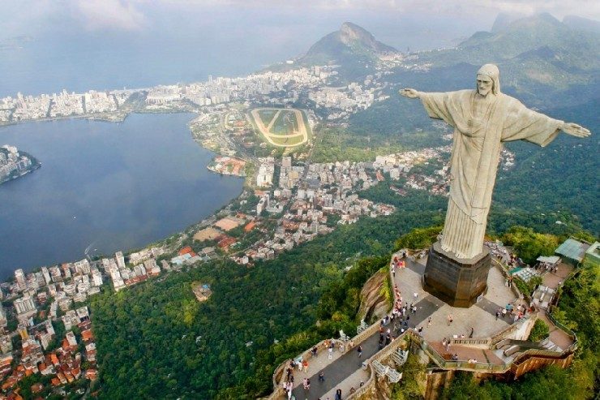
2. 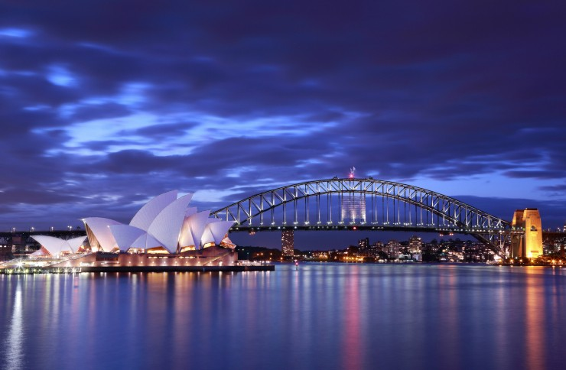

3.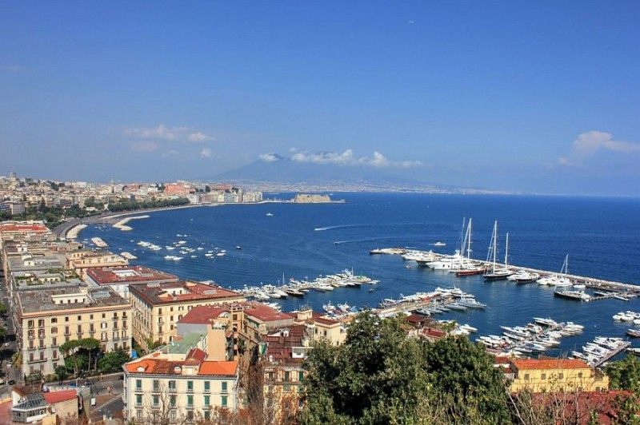
4. 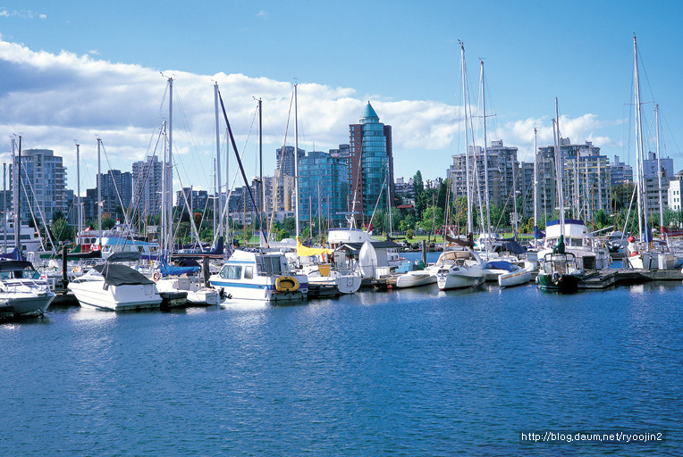

5.
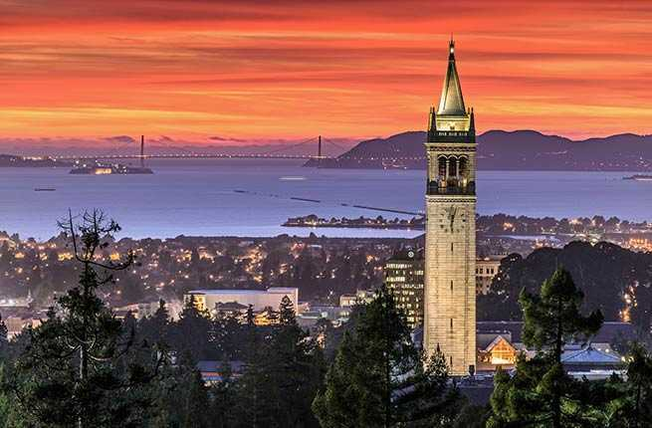

Worksheet # 1 (matching definition)

Fill in the blank with proper meaning. Match each definition.

[ WORD ] [ EXAMPLE ]
A : boat that transports passengers and sometimes also vehicles, usually across rivers or short stretches of sea
B: place or society is full of people from many different countries and cultures
C : calm and quiet
D : a long, narrow stretch of water that has been made for boats to travel along or to bring water to a particular area
E : . a part of a coast where the land curves inwards
F :. used as an auxiliary to express habitual or accustomed actions, states
G : If someone bustles somewhere, they move there in a hurried way, often because they are very busy.
H : a building or feature which is easily noticed and can be used to judge your position or the position of other buildings or features .
I : long passage in a building or train, with doors and rooms on one or both sides.
Canal〔 〕
Bustling〔 〕
Ferry 〔 〕
Bay 〔 〕
Corridor〔 〕
Landmark 〔 〕
Accommodation 〔 〕
Cosmopolitan〔 〕
serene 〔 〕

Worksheet # 2. Port Introdution (with audio file)

Each port is as follows. There is a blank in the introduction to each port, so please listen carefully.
There are five countries with beautiful ( )in the world, and the harbor has a famous city and beautiful ( ), so many people visit here every year for business and sightseeing. In general, the world's five most beautiful ( ) are known as Napoli of Italy, Sydney of Australia, Rio de Janeiro of Brazil, San Francisco of USA, , and Vancouver of Canada.

1. Sydney, Australia

One of the most vibrant Australian cities has an extensive harbor system as well as popular Sydney Harbour Islands. The group of islands ( ) one of the most exciting Australian cities. It includes Cockatoo Island, ( ) as UNESCO world-heritage site. Sydney Harbour Island tour is a popular activity, which introduces to the history and the main ( )
2. Napoli
. One of the most ( ) cities in Italy is Naples, a city blessed with natural wonders, from its volcanic backdrop to its rich blue sea. Naples boasts some of the world’s most important archaeological treasures; its historic center has been named a UNESCO World Heritage Site

3. Rio de Janeiro, Brazil

Harbor of Rio de Janeiro is considerede to be one of the natural wonders of the world. In 1502, when the Portuguese ( ) discovered the bay, they were amazed by the astonishing bay. Weird shaped mountains and rocks were never seen before by the Europeans. Today it is one of the most recognizable sites in Brazil.
4. Vancouver
Captivating natural beauty and a distinctly ( ) flair make Vancouver one of the world's most unique waterfront cities. The city balances its well-preserved wildlife with a host of tourist attractions, and offers something for every traveler. Visit Stanley Park to explore 1,000 acres of ( ) forests and oceanfront. Take a ferry to Granville Island, a waterside hotspot with a bustling food and crafts market and about a dozen studios and galleries. For an authentic taste of Chinese food and culture, visit Chinatown.

5. San Francisco
Few places compare to the city by the bay, and San Francisco makes the most of its waterfront location. Visitors can explore lush gardens or oceanfront trails at Golden Gate Park, or stop by the historic Ferry Building for ( ) bay views and a taste of local cuisine. Science lovers will enjoy Exploratorium, a pier-side museum with supersize experiential ( ) and a glass Bay Observatory.

Worksheet # 3 . Drawing Picture

Worksheet # 4 (matching definition)

Matching with proper meaning. You can connect the correct answers.
.

[ Port City ] [ City’s Features ]
heavy chemical industry
Shipyard
steel industry development
Ocean Expo
squid production area
Salt water
nearby Seoraksan
coastal beautiful island
Octopus
Sokcho
Tongyeong
Incheon
Yeosu
Donghae
Ulsan
Geoje, Chosun,
Mokpo
Pohang

