■ Listening ☐ Speaking ☐ Reading ☐ Grammar ☐ Writing

Topic: Wild animals; their homes, marks and security

Instructor:  SEUNG HEE LEE  (Chris) | Level:  Beginner (L2) | Students:  10 | Length:  35 Minutes

Materials:

*Realia: the pictures of a raccloon and a beaver (10 copies)
*White board and board markers
* A notebook for the audio file
*Vocabulary worksheet (10 copies)
*Pre activity worksheet (10 copies with 10 markers)
* Fill in the blanks worksheet (10 copies)
*SOS activity worksheet (10 copies)

Aims:
*Main Aim: Ss will get acuainted with wild animal’s living by listening the text.
*Secondary Aim: Ss will listen to the different pronunciation of ‘---s’ by Fill in the blanks.
*Personal Aim: To help Ss feel secured in the God’s sufficiency

Language Skills:
*Reading: Ss will read the text by Fill in the blanks.
*Listening: Ss will listen and distinguish the pronunciation differences.
*Speaking: Ss will discuss about their rooms / a raccoon and a beaver
*Writing: Ss will write sentences about marks of a raccoon and a beaver.

Language Systems:
*Phonology: ‘----s’ sounds /z/, /s/, /dz/, /tʃ /, /iz/
*Lexis: New vocabularies in the text
(tame, wild, shelter, webbed feet, bear cub, chew, drill, insect etc.)
*Grammar: Irregular plurals
*Discourse: Scientific story

Assumptions:
Students already know
*How the class is set up and run
*Four language skills and Five language systems
*Plurals and three personal verbs with ‘----s’

Anticipated Errors and Solutions:
*If students hardly find out the marks of a raccoon and a beaver (a prediction activity)
→ show the picture of a bear and a bear cub’s foot prints.
*If students miss some parts of Fill in the blanks
→prepare one more slow speed audio file.
*If any students finish early from the activity
→give them SOS activity worksheet.

References:
-Science (3rd edition by bju press.com)
-Listening audio file
www.naturalreader.com

Lead-In
Materials: board, board markers

Time | Set Up | Student Activity | Teacher Talk
2min. | Whole  class | Answer the teacher’s question | Good morning! How are you today?  What does ‘home’ mean to you?  (Boarding Ss’s idaeas)

Pre-Activity
Materials: 10 sheets of paper, 10 markers

Time | Set Up | Student Activity | Teacher Talk
5min.  5min  2min. | Whole  class  Each  Whole  class | Draw the pictures of their own rooms and marking distinguishable points from that  Start writing down the words.  Check their answers. | * Eliciting  What or which elements make you feel comfortable while you are in your room?  What kinds of habit do you have to keep it comfortable?  * Instruction  (Distribute the paper and markers)  Please draw your own room illustrating with things inside of it.  And mark some specific points that can tell it’s my room.  I’ll give you 3 minutes.  * Problem solving  (If Ss seem lost, show demo on the board.)  *ICQ  What are you going to draw?  What do you do with a marker?  How much time to do?  *2nd Instruction  (Pair them)  Share with your partner ‘Why’  * Pre teach-New Vocabulary (Instruction)  We are going to learn the new vocabulary before listening. I will give you a worksheet. First, read the definition of words with the blanks and then fill in the blanks with the correct word from the list below. I’ll give you 5 minutes to finish.  (Distribute the Fill in the blanks worksheet)  * Demonstration  Please look at the paper, and we solve #1 together.  * ICQ  What are you going to do?  Are you doing alone? (Yes)  How much time do you have?  Okay, now do it.  * Monitoring  Monitor discreetly. Give time warning.  Time is up.  * Check answers  (Quickly finish it.)  Do you have any question from new vocabularies?  Okay, great job, everyone!

Main Activity
Materials: 1.Pictures of a raccoon and a beaver(10 copies), a picture of a bear and a cub(1 copy)
2. Fill in the blank worksheet (10 copies)
3. Answered Fill in the blank worksheet for each, board, board marker

Time | Set Up | Student Activity | Teacher Talk
3min.  5min.  5min. | Pairs  Each  Whole  class | Guess the result sentences and write them down in the back of the sheet.  Listen to the audio file.  Repeat after the teacher’s speaking. | 1. Get the big picture  * Eliciting  Have you been to any National Park?  Have you seen any marks, prints of animals?  How did they look like?  * Instruction  You will work on pairs. I’ll give you 2 pictures. Discuss with your partner what kinds of marks can be guessed from the pictures. And write the sentence in the back of the paper. You have 3 minutes.  * Problem solving  (If necessary, demonstrate how the picture of a bear and a cub’s foot print brings an answer ; By the picture we can guess, they are mother and baby bears.)  (Distribute the pictures)  * ICQ  Are you working in pairs? (Yes)  Do you draw the picture? (No)  Then what do you do? (Write a sentence)  How many minutes do you have? (3)  Time’s up. The best answer is…  A raccon’s foot print looks like a baby’ hand print.  A beaver leaves a sharp point of a wood.  Did anyone get the similar answer?  Great job!  2. Listening for the main idea  * Instruction  Now you are going to listen to the text twice. At the first listening, just listen.  At the second listening, you fill in the blanks. The words are easy, so please concentrate on your listening rather than writing. You have 5 minutes for doing all these.  * ICQ  How many times do you listen?  When do you write your answer, first or sencond listening?  How much time will it take?  (Distribute the worksheet and listening)  * Check answers  (Move directly to the 3rd activity)  3. Pronunciation drill  Now we are going to pronounce each  blank word a few times.  Repeat after me and find out pronunciation  rules together.  (Expain on the board)  * Rules  1. ---a,b,d,e,g,l,m,n,o,r,u,y,w ; /z/  2. ---c,k,p ; /s/  3. ---d ; /dz/  4. ---t ; / tʃ/  5. ---s ; /iz/

Post Activity
Materials:

Time | Set Up | Student Activity | Teacher Talk
5min. | Whole  class | Listen to the teacher and give feedback. | * Error correction  If any of you have diffciulties to pronounce some words, stop by me after the class.  * Feedback  Can pronounce correctly make any  difference?  What impression did you get from the  story?  *Conclusion  You must feel hard to learn a new  Language in the beginning. It pushes you  to change your way of thinking and lots of  work to do. Plus you have to go on for your  career. I’d like to end the class here with sharing one Scripture verse.  Matthew6:26  Look at the birds of the air; they do not sow or reap or store away in barns, and yet your heavenly Father feeds them. Are you not much more valuable than they?

SOS Activity
Materials: Worksheet (10 copies)

Time | Set Up | Student Activity | Teacher Talk
3min. | Some  or  all | Answer the extra activity worksheet. | (Reach to anyone who finishes the task  earlier than others and give the worksheet.)  If they show interest, continue to do this  activity in the next time.

New Vocabulary Worksheet

1. A dwelling place for protection ( )
2. Usually a small animal having the body divided into 3 parts and pairs of legs
( )
3. a baby bear ( )
4. The animal’s character, without the savageness or fear of humans ( )
tame wild shelter webbed feet bear cub chew drill insect
5. The opposite meaning of ‘tame’ ( )
6. To crush or grind with the teeth ( )
7. Duck’s foot print showed that it has ( )
8. To pierce or bore a hole in something ( )

New Vocabulary Worksheet (Answer)

1. A dwelling place for protection ( shelter )
2. Usually a small animal having the body divided into 3 parts and pairs of legs
( insect )
3. a baby bear ( bear cub )
4. The animal’s character, without the savageness or fear of humans ( tame )
tame wild shelter webbed feet bear cub chew drill insect
5. The opposite meaning of ‘tame’ ( wild )
6. To crush or grind with the teeth ( chew )
7. Duck’s foot print showed that it has ( webbed feet )
8. To pierce or bore a hole in something ( drill )

Visual Aid
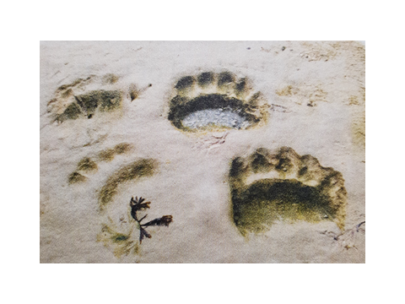
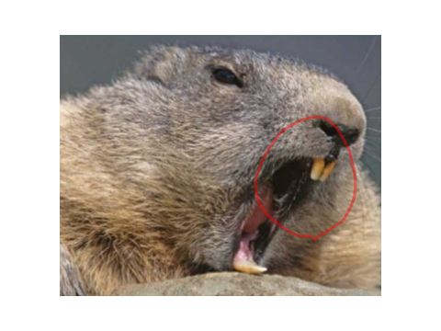

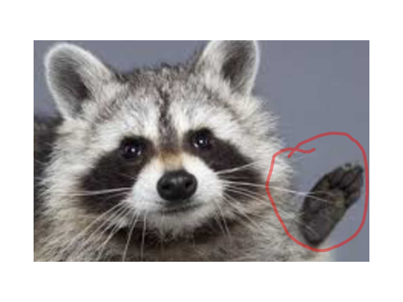

Wild anmals ; their homes, marks, and security

Tame ( ) live with people. But some animals do not live with people. These animals are wild animals. God ( ) care of wild animals. He ( ) them what they need. Wild animals make their own ( ). Beavers make a home in the water. Birds make nests to lay their ( ) in. Spiders spin ( ) that catch food. Every animal has a shelter, or home. A shelter is a place where an animal can be safe.

Many ( ) you do not see wild animals. They may hide from people. You might not be able to see an animal’s home. But you may see ( ) that show where the animal has been. A print ( ) the shape of an animal’s foot. Animals leave prints in snow, sand, or soft ground. A raccoon print ( ) like a child’s hand. Some birds prints show webbed feet. The shape of a print ( ) us know which kind of animal made it. The size of a print also tells us ( ) about the animals. A mother bear makes a larger print than her bear cub does. Tracks are prints that help us know what an animal was doing or where it was going.

A mark is a clue that shows something about an animal. Prints and ( ) are kinds of marks. But an animal ( ) other ( ) too. It may leave marks on trees and other plants. A beaver ( ) on trees and cuts them down. It ( ) the trees to build a home. The beaver leaves a sharp point of wood. The chewed tree is a mark. This kind of mark show that the beaver was there. A woodpecker drills ( ) in trees. It is looking for insects to eat. You can see the marks where the woodpecker looked for food. This kind of mark tells you what the woodpecker ( ) to eat. God ( ) care of wild animals. But you are more important to God than the animals are. He will take care of you.

Wild anmals ; their homes, marks, and security (Answer)

Tame ( animals) live with people. But some animals do not live with people. These animals are wild animals. God (takes) care of wild animals. He ( gives) them what they need. Wild animals make their own (homes). Beavers make a home in the water. Birds make nests to lay their (eggs) in. Spiders spin (webs) that catch food. Every animal has a shelter, or home. A shelter is a place where an animal can be safe.

Many (times) you do not see wild animals. They may hide from people. You might not be able to see an animal’s home. But you may see (clues) that show where the animal has been. A print (shows) the shape of an animal’s foot. Animals leave prints in snow, sand, or soft ground. A raccoon print (looks) like a child’s hand. Some birds prints show webbed feet. The shape of a print (helps) us know which kind of animal made it. The size of a print also tells us ( things) about the animals. A mother bear makes a larger print than her bear cub does. Tracks are prints that help us know what an animal was doing or where it was going.

A mark is a clue that shows something about an animal. Prints and (tracks) are kinds of marks. But an animal (leaves) other (marks) too. It may leave marks on trees and other plants. A beaver (chews) on trees and cuts them down. It (uses) the trees to build a home. The beaver leaves a sharp point of wood. The chewed tree is a mark. This kind of mark show that the beaver was there. A woodpecker drills (holes) in trees. It is looking for insects to eat. You can see the marks where the woodpecker looked for food. This kind of mark tells you what the woodpecker (likes) to eat. God (tatkes) care of wild animals. But you are more important to God than the animals are. He will take care of you.

SOS Activity

1. Find 4 irregular plurals from the text.

2. Can you change the singular words below into plurals? (They are irregular.)
* wolf, wife
* fish, sheep
* glass, tax, bench. dish
* tomato, potato
* baby, city
* man, woman

SOS Activity (Answer)

1. Find 3 irregular plurals from the text.
people (person)
feet (foot)
these (this)

2. Can you change the singular words below into plurals? (They are irregular.)
* wolf, wife (wolves, wives)
* fish, sheep (fish, sheep)
* glass, tax, bench. dish (glasses, taxes, benches, dishes)
* tomato, potato (tomatoes, potatoes)
* baby, city (babies, cities)
* man, woman (men, women)

