SPEAKING LESSON PLAN
Topic: Picture Differences
Instructors: SoJeong Kim + Christina Lee Level: Intermediate (Adults)
Students: 12 Length: 40 minutes

MATERIALS
- White board
- Markers
- Picture worksheet
- Preposition Vocabulary worksheet
- SOS worksheet if needed

AIMS
- Main: Students will improve their speaking skills by using preposition words to describe in detail of differences between two pictures.
- Secondary: Students will be able to build their problem solving skills by working with other students to find differences.
- Personal: I want to give clear directions and build rapport with my students.

LANGUAGE SKILLS
- Reading: preposition vocabulary sheet
- Speaking: discussion, giving detailed information
- Writing: writing down differences they find
- Listening: following instructions, listening to details

LANGUAGE SYSTEMS
- Lexis: preposition words (before, across, above, around, to, at, on, near, through, until, after, beside)
- Function: to explain differences and to describe in detail.
- Discourse: picture difference image.

ASSUMPTIONS
Students already know:
- Students can identify/name all the items in the picture
- Students have some idea of common preposition words
- Four language skills and language systems.

ANTICIPATED ERRORS AND SOLUTIONS
- If some students have difficulty using words to describe differences, monitor carefully and provide additional preposition words to describe their images.
- If some pairs are having difficulty finding differences, provide some hints and clues to guide them to identify differences.

REFERENCES
- https://www.sporcle.com/games/Cutthroat/spot-the-difference-i
- http://www.englishforeveryone.org/Topics/Crossword-Puzzles.htm
- http://www.tlsbooks.com/prepwordsearch1.html

LEAD IN
Materials: None
Time | Set Up | Student Activity | Teacher Talk
2 min | Whole class | Answering teacher’s questions | Good morning class! How is everyone today?  Do you think you all have a good eye? Can you find differences that look similar? Do you have an eye for detail?

PRE-ACTIVITY
Materials: White board, markers, Preposition Vocabulary worksheet
Time | Set Up | Student Activity | Teacher Talk
5 min  10 min  5 min | Pairs  Individually  Whole class | Discussing general idea of topic  Students fill out preposition vocabulary worksheet  Check answers with everyone | Procedure:  1. Spark Interest  What does it mean to have a good eye? To be able to see clearly? Or be able to pay attention to detail? Please with your partner discuss if you both think you have a good eye for detail. Do you see things as a whole picture or pay attention to close detail? I’ll give you 2 minutes to quickly discuss.  ICQ:  What are we doing now?  How much time do you have?  2. New Vocabulary  Instruction:  Before we get started, here is a fun crossword that includes preposition words for you to be able to use when describing in detail. I would like you to work alone and fill out the crossword as much as you can in 10 minutes. There is a word bank down below.  (pass out preposition vocabulary worksheet)  Demonstration:  Across is left to right, down is up and down. (Board if needed). Let’s do the first one together. Number one, across is a two letter word. The clue is: …..  ICQ:  What are we doing now?  Are you working with a partner?  How much time do you have?  Monitor:  Monitor discreetly, making sure students are filling out crossword puzzle independently and answer any questions.  (after 10 minutes)  Okay time’s up!  Check answers:  Let’s check our answers together.

MAIN-ACTIVITY
Materials: Picture difference worksheet
Time | Set Up | Student Activity | Teacher Talk
2min  10 min  3min | Whole class  Pairs  Whole class | Answering teacher’s questions  Students find the differences and write down in the picture worksheet  Check answers with everyone | - Prediction  Do you think you are an detail-oriented person?  Have you ever experienced to find differences between two pictures? Did you enjoy that?  Imagine that What if you have only one picture and your partner has same picture but slightly different? How can you find the differences between two pictures?  I’ll give 2 minutes. Brainstorm with your partner  ICQ:  Are you working alone?  How much time do you have?  2. Info gaps  Instructions:  Today, we will be working to find differences between two pictures. You and your partner have what it seems like the same picture but it is slightly different. Do not show your picture to your partner.  To find the differences, ask questions about what you see, including prepositions as much as you can. Only speaking can be used. No gestures, no drawings.  Please write down as many differences as you can. I’ll give you 10 minutes.  Hand out picture difference worksheet(A or B)  Demonstration:  Let’s do the first one together.  (Teacher has picture A.Do it with one student who has the picture B).  I would ask the question such as “Is there a clock on the wall? Next to the picture frames? What time is it? Mine is at 1:30”  ICQ:  Can you show your picture to your partner?  Can you use gestures?  How much time do you have?  You may begin  Monitor:  discreetly monitor Students making sure they are following the rules  (after 10 minutes)  Okay time’s up!  (If they need more time, give them an extra minute  Check answers:  Let’s check our answers together.  Please raise your hand if you and your partner found more than 5 differences. 7 differences? How about more than 10?  (to the pair with the most findings) Ok, can you tell me all the differences you’ve found?

POST-ACTIVITY
Materials: White board, markers
Time | Set Up | Student Activity | Teacher Talk
3min | Whole class | Answering teacher’s questions | - Error Correction  Write sentences on the board that Students misspoke during the role plan activity.  (ex: count one to one→ count one by one)  Correct any misuse of prepositions students used  (ex: on, above, top of)  - Feedback  Did you have fun? How do you feel?  - Conclusion  Thank you for participating in this class and try identifying details outside the classroom. Don’t forget to keep in mind the prepositions we learned today!

SOS ACTIVITY
Materials: SOS word search worksheet
Time | Set Up | Student Activity | Teacher Talk
5 min  1min | Individually  Pairs | Find words in the puzzle  Check answer | Instructions:  Look at the preposition words in bolded letters. Use your good eye to find the words within the scattered box. Some words can be found side to side, up and down, and diagonally.  I’ll give you 5 minutes and you will work alone.  (Hand out SOS word search worksheet)  Demonstrate:  Let’s try to find the first word together……  ICQ:  What are we going to do?  Are you working in pairs?  How much time do you have?  You may start  Monitoring: monitor students making sure they are following the rules  (after 5 minutes)  OK, Times up!  Check answer: Have students compare answers with each other. Words that couldn’t be found they can work on finding together and giving each other hints.

Picture Differences Worksheet

With your partner, can you find the differences? Use descriptive and preposition words to describe in detail what you see in your photo. Write down as many differences as you can down below!

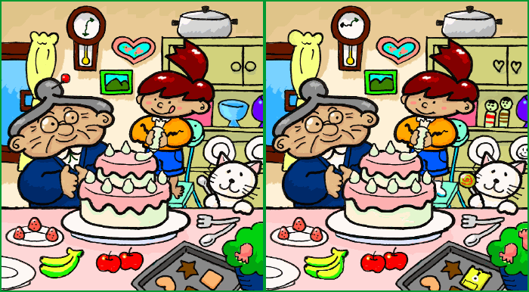

Picture Differences Worksheet
ANSWERS
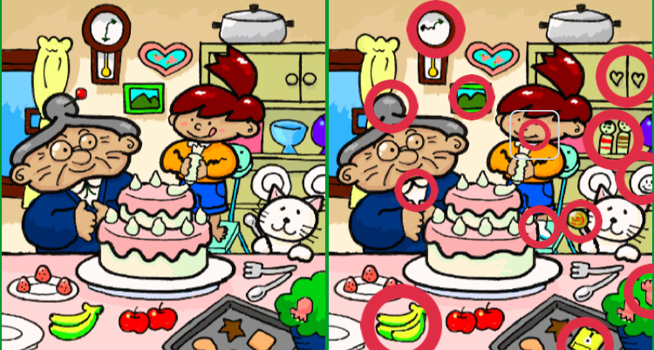

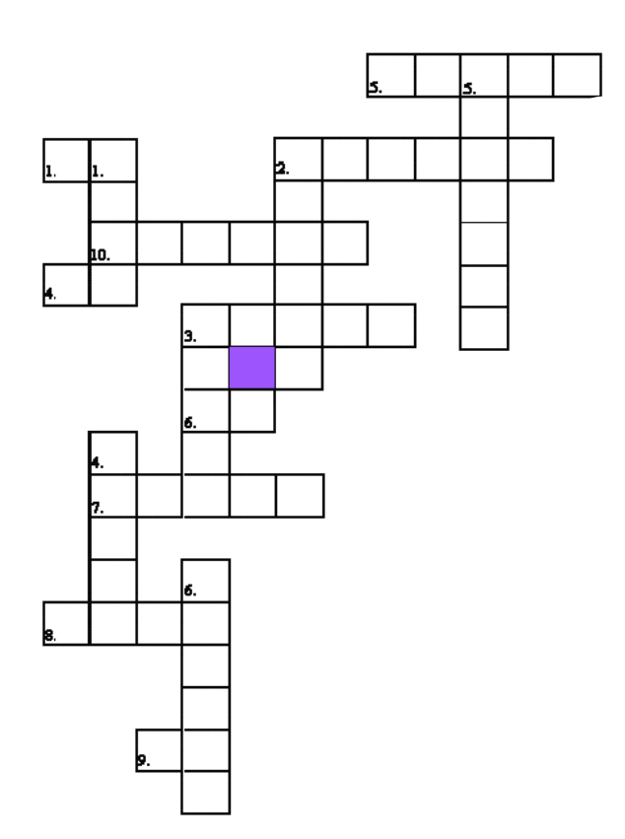
Preposition Vocabulary Crossword Sheet
Directions: use the clues below to fill in the crossword puzzle with the correct words.
Across:
1) We learn English _____ the Community College.
2) 27 comes __________ 28.
3) Water flows ________ a bridge.
4) Fish swim ______ the ocean.
5) Lunch comes __________ breakfast.
6) Alyosha is going _____ the mall.
7) The temperature in Antarctica can fall to 125 degrees __________ zero. That’s cold!
8) A synonym for “close to”.
9) The computer sits _____ the desk.
10)It’s a good idea to look both ways before you walk __________ the street.
Down:
1) John is taller ______ Linda.
2) The mouse is __________ the computer.
3) The library doesn’t close ________ 8:30 pm.
4) The lights shine ______ us. 5) We used our windshield wipers as we drove ____________ the pouring rain.
6) Everyone stood __________ the fire to get warm.

Word Bank:
Before across above around to at
On near through until after beside
Than under in below

Preposition Vocabulary Crossword Sheet ANSWERS
Across:
1) At
2) Before
3) Under
4) In
5) After
6) To
7) Below
8) Near
9) On
10) Across
Down:
1) Than
2) Beside
3) Until
4) Above
5) Through
6) Around

SOS Word Search Sheet
Directions: Find and circle the preposition words in the word puzzle.
Words can go horizontally (side to side), vertically (up and down), or diagonally!

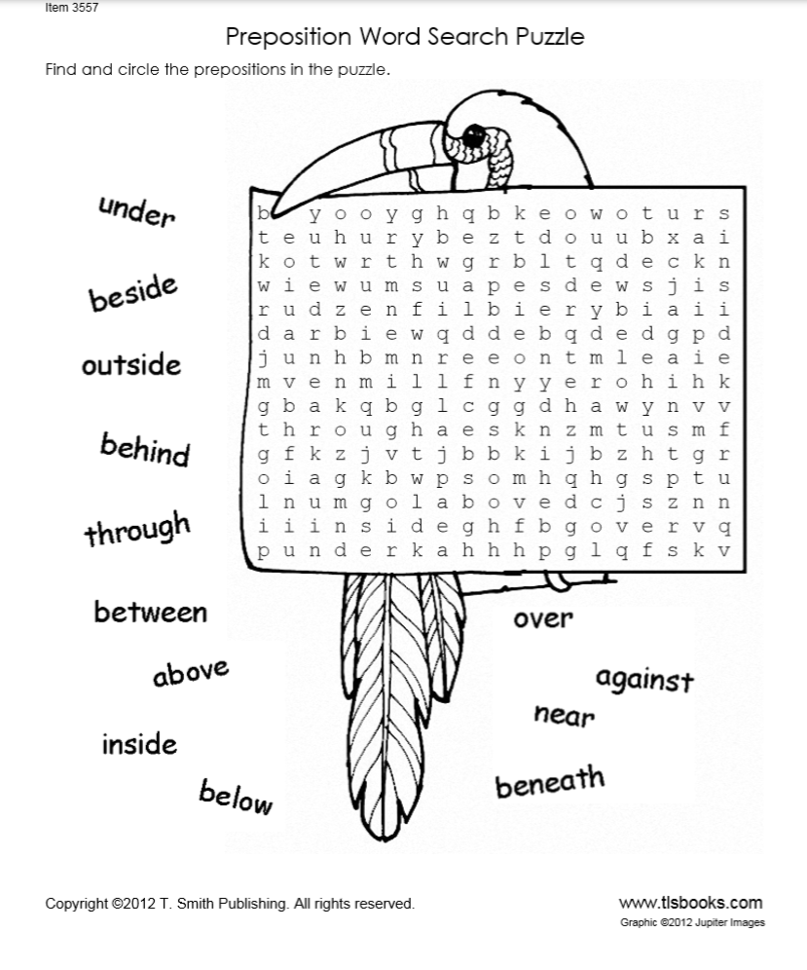

SOS Word Sheet ANSWERS

