☐ Listening ☐ Speaking ☐ Reading ☐* Grammar ☐ Writing

Topic: Articles ( a / an / the )

Instructor:  Lucie Jeong  Lizzie Noh  Chloe Shin | Level:  Intermediate | Students:  12 | Length:  40 Minutes

Materials:
White board and board markers
PPT slides
Substitution table
Practice Worksheets #1
SOS worksheets #2

Aims:
Main aim- Ss will be able to use the articles (a, an, the) properly by making their sentences to complete the story during their chain activity.
Secondary aim- Ss will be able to use their articles (a, an, the) properly by filling their worksheets and by playing a board game.
Personal aim- I want the students to practically use their articles in the right spot and correcting their errors during this class.

Language Skills:
Reading: Ss will read their worksheets to answer the question.
Listening: Ss will listen to teacher’s instructions.
Speaking: Ss will share their sentences during the chain activity.
Writing: Ss will complete their worksheet.

Language Systems:
Phonology: drilling
Grammar: use of the articles (a, an, the)
Function: giving advice

Assumptions:
Students already know
The existence of the articles (a, an, the)

Anticipated Errors and Solutions:
Students may have a hard time drilling
- Teacher can encourage group work to discuss the use of articles as a group
Students may need more time to complete the worksheet
- Be flexible with the time
If students don’t know how to play a board game,
- I will explain to students with examples.

References:
Painless Grammar by Rebecca Elliot Ph.D (p.180)
www.google.co.kr/search?q=a+an+the+worksheet&source=lnms&tbm=isch&sa=X&ved=0ahUKEwi1_NLE2rbcAhUHIIgKHTraDNgQ_AUICigB&biw=1600&bih=731#imgrc=ZGAy0o0yiM1STM:&spf=1532400236173 (SOS worksheet)
https://en.islcollective.com/resources/printables/worksheets_doc_docx/article_a_an_and_the_game_board/articles-articles-indefinite/6138 (Board game)
Worksheets made by Chloe, Lizzie and Lucie

Lead-In
Materials: none
Time | Set Up | Student Activity | Teacher Talk
1 min | Whole class | Answering teacher’s questions | Good morning everyone! How are you feeling today? What was the first grammar you’ve ever learned? Do you remember them?

Pre-Activity
Materials:
Board, Board markers, PPT slides
Time | Set Up | Student Activity | Teacher Talk
3 min  5 min  5 min  5 min  20 min  3 min | Whole class  Whole class  As a group  Whole  class  Whole  class  Whole  class | Answering teacher’s questions  Building up their own sentence using grammar rules.  Ss will discuss as a group  Share their opinions based on the ideas they just discussed  Ss will listen carefully to teacher’s explanation and instructions  Listen to the teacher’s instructions and practice the table | Procedure:  Eliciting  Elicit  (Boarding the word ‘apple’)  Look at the word can you think of a sentence with this word? Let’s review your sentence. Did you say ‘a’ apple or ‘an’ apple? Why did you say that?  - Do  Guided warmer activity  Today we are going to make a story as a class. The sentence must have the word (a, an, the) contained and the details of the story should be connected. Your first sentence will be given and remember that we should stick to the topic.  Demonstration  To get it straight, let’s pay attention to the example. If my first sentence is ‘I like biting an apple.’ (board the sentence) the next person ready should start their sentence with the phrase ‘I like biting the apple when I have a loose tooth.’ (board the sentence) To prepare your sentence, you can take a note. It’s okay to make a funny or even creepy sentences as long as the sentence contains the articles.  ICQ  What are we doing now?  Is there a grammar rule for the sentences?  Can we take notes?  Procedure  - Recall  Instruction  Did you enjoy the story we just made? Let’s make a group of 2 or 3 to discuss the grammar we just used. What do you think is the topic today? Do you know any grammatical rules about that? If you do, you can share the things you know as a group. I will give about 5 minutes to discuss as a group.  ICQ  What are we doing now?  How much time do we have?  Are we doing that alone?  “Let’s get it started.”  Monitoring  Monitor discreetly. Answer students if they ask questions. Try to roam around the class to make sure everyone understood what they are doing.  Give time warning:  1 minute. 30 seconds left.  (Be flexible with the time.)  “Time’s up.”  - Reflect  Great job everyone! Now can have a group presenter to share what you’ve discussed? What do you see in the form of this sentence? (Ss mention the word ‘article’.) What was the difference when we used a/an? What was the difference when we pronounced the/the?  Can anyone remember the sentence we used? ( If they remember, board them and show the rules occurring in the sentence.) What do you see in the form of this sentence? Do you guys see the rules here? (Let students tell of each word and board the part of speech/ form under the sentence using different colored marker.)  - Conclude  Meaning part 1  I think we all got the concept that we use a, an, the in the sentence. Today we are going to learn the use of the articles. Let’s start with ‘a’ and ‘an’. (Board the title- the use of the article – a/ an) Can you guess some time when you use an? How about a?  (Ss actively giving examples.)  We use ‘a’ before nouns beginning with consonant words. (board- consonant) even if the sound is made by a vowel. Consonants are all the letters of the alphabet except a,e,i,o,u and sometimes y.) Can you name some consonants?  (Ss give some examples.)  That’s right. For example, we say  A bat, a hat, a cat, a university a yo-yo, a 100 dollar bill.  Form part 1  We use ‘an’ before nouns beginning with the vowel sounds. (board- vowel) Vowels are a,e,i,o,u and sometimes y.  For example, we say  An oasis, an M&M an honor (silent h), an apple, an F, an hour (silent h).  The rules we should remember is that  - This rule applies to the first sound, not the first letter. That’s why silent ‘h’ words come together with the article ‘an’.  - If there is a word to describe the noun, we use a/an according to the describing word. A perfect example for that can be  a book- an easy book  an umbrella- a new umbrella  There are some times when we don’t use a/an at all.  - In front of a pronoun  A Seoul (x) A Sunday  - When it’s plural  A cats (x) A teeth (x)  - In front of uncountable verb  A milk (x) a peace (x)  - In front of a possessive noun  A your baby (x) A my computer (x)  Meaning part 2  I think we practiced enough about ‘a’ and ‘an’. Now let’s learn the use of ‘the’. Can you guess when we use the articles ‘the’? (Listen to Ss’ answer.) Let’s find out.  We use ‘the’ when we make a sentence with the exact object.  Form part 2  - When you repeat the noun  There is a baby. The Baby is cute.  - When the object is clear for the speaker and the listener.  Open the window, please.  - In front of one and only nature object  The earth goes around the sun.  - In front of river, ocean ‘s name or the directions  People go to the south.  - In front of the musical instrument  I play the piano well.  There are sometimes when we don’t use ‘the’ at all.  - Use as a appellation  (The X) Waiter, bring me a cup of coffee.  - In front of sports  I play (the x) soccer.  - In front of meals or subjects you study  I have (the x) lunch at twelve.  I like (the x) math very much.  - When a place is used as it’s supposed to be  (school, church, bed)  I go to (the x) bed at 9 pm.  - By+ transportation  We go to the park by (the x) bus.  Drilling  A Book, university, European, man I don’t know, sth per a day  An Apple, egg, MP3 player, hour  The Man who’s my teacher Moon which is the only one, right, violin  Simple repetition drill  (Show the table to the class)  Okay. Let’s listen to what I say, and don’t repeat.  CCQ  Do you repeat after me?  (Point the substitution table while reading)  Now let’s listen and repeat.  (Point the substitution table while reading and repeating.)

Main Activity
Materials: board marker and 11 copies of the worksheets, A board of game
Time | Set Up | Student Activity | Teacher Talk
2mins  3min  2mins  3mins  3mins  6mins  1min | Whole class  Individually  Whole class  Whole class  Individually  Whole class  Pair or group  Whole class | Ss will listen the teacher’s instructions  Do the worksheet alone | Controlled practice 1  Instruction  Do the worksheet questions number 1 to 7. Choose the correct answer individually. You have 3 minutes.  ICQ  How much time do we have?  What do we do?  Are we doing that alone?  (Pass out the worksheet and run task)  “Let’s get it started.”  Monitoring  Monitor discreetly. Answer students if they ask questions. Try to roam around the class to make sure everyone understood what they are doing.  Give time warning:  1 minute. 30 seconds left.  (Be flexible with the time.)  Time’s up  Let’s check the answer together.  Tell the answer in a clockwise direction.  Controlled practice 2  Instruction  Do the worksheet question number 8 to 15. Choose the correct answer individually. You have 3 minutes.  ICQ  How much time do we have?  What numbers of question will you answer?  Do you work in pair?  (Pass out the worksheet and run task)  “Let’s get it started.”  Monitoring  Monitor discreetly. Answer students if they ask questions. Try to roam around the class to make sure everyone understood what they are doing.  Give time warning:  1 minute. 30 seconds left.  (Be flexible with the time.)  Time’s up  Let’s check the answer together  Less controlled practice  Instruction  We will do a board game. I will give a board game worksheet. Pair or group with person next you. Then, roll the dice using cellphone. And If you roll the dice and you will get to the square, you should read the question with the correct answer. If you get there first, you will win. You can move to the right, I will give you 6 minutes.  Demonstration  Look at the screen. For example, I roll the dice and get 1,  “Please wash an apple.”  ICQ  What will you do?  Who do you work with?  How much time do you have?  (Pass out the worksheet and run task)  “Let’s get it started.”  Monitoring  Monitor discreetly. Answer students if they ask questions.  Give time warning:  1 minute. 30 seconds left.  (Be flexible with the time.)  Time’s up  Feedback  Who is winner?  Good job everyone!  ( Go to SOS activity before post activity.)

Post Activity
Materials: none
Time | Set Up | Student Activity | Teacher Talk
3 min | Whole  class | Students listen to teacher and answer. | Error Correction  (Correct any mistakes from the activity)  Feedback  Did you have fun today?  How did you feel with activities?  Conclusion  Thank you for participating in this class.  I hope you enjoyed today.  Please don’t forget what we learned today and try to say and use with no mistakes with a, an and the.

SOS Activity
Materials:
Time | Set Up | Student Activity | Teacher Talk
3 min  5 min  2 min | Whole  Class  In pairs.  Whole  class | Listening to teacher with worksheet  Fill in the blanks  On worksheet  Students answer  To teacher. | Instruction  OK, now we are going to do the last activity for today. I’m going to hand out worksheet first.  (Hand out worksheet)  You can see the blanks on the left and pictures on the right. You will fill the blanks with ‘A, An, The’ and put numbers on right pictures.  Demonstration  First, Let’s try number1 together. What do you think for number one? Yes, it’s a teacher. Then where is a teacher on the picture? Yes, It’s right here.  (pointing at worksheet)  So I’m going to give you 5 minutes to work with your partners.  ICQ  Are you working alone?  How much time do you have?  Ok, start now.  (Give them time warning.  1 minute left, 30 seconds….. Be flexible. )  Check the answers  Ok, I can see everyone finished. Let check the answers together. I’m going to say the numbers, and you will tell me the answers all together.  Number 2…….  (Students answer)  Alright, you did great job!

Worksheet #1
- I have (a, an, x) red umbrella.
- I eat three meals (a, an, x) day.
- She has (a, an, x) onion.
- I like (a, an, x) Tom very much.
- It is (a, an, x) yellow chair.
- There are (a, an, x) elephants.
- This is (a, an, x) my ax.
- I go to church on (a, an, x) Sunday.
- There is (a, an, x) university there.
- We have three (a, an, x) cats.
- He is (a, an, x) European.
- I drink two glasses of milk (a, an, x) day.
- (A, An, X) kate is (a, an, x) honest girl.
- I want (a, an, x) egg and (a, an, x) sugar.
- (a, an, x) alligator has (a, an, x) long tail.

Worksheet #2
1. ( The, x ) S(s)un is hot.
2. I like ( the, x ) math.
3. ( The, x ) S(s)ky is blue.
4. They go to ( the, x ) bed at ten.
5. You like ( the, x ) moon.
6. Close ( the, x) window.
7. We play ( the, x ) violin well.
8. They have ( the, x ) lunch.
9. Tom and Eric go to ( the, x ) west.
10. Birds fly in ( the, x ) sky.
11. I go to ( the, x ) church every Sunday.
12. I can speak ( the, x ) English.
13. We go to the park by ( the, x ) bike.
14, They play ( the, x ) soccer together.
15. Boys like ( the, x ) science.

ANSWER KEY
1. a
2. a
3. an
4. X
5. a
6. an
7. X
8. X
9. a
10. a
11. X
12. X
13. X, an
14. an, X
15. an, a

ANSWER KEY
1. The
2. X
3. The
4. X
5. X
6. the
7. the
8. X
9. the
10. the
11. X
12. X
13. X
14. X
15. X

< A, An, The, X >

- There is ____________ baby. ____________ baby is cute.
- Give me ___________ sugar, please.
- They go to ____________ school.
- I study math for ____________ hour ____________ day.
- I have ____________ breakfast every morning.
- There are birds in ____________ sky.
- I play ____________ guitar very much.

- I play ____________ baseball after school.
- We see ____________ European there.
- I have an eraser. ____________ eraser is new.
- It is windy. Close ____________ door.
- There is ____________ onion in the kitchen.
- I have ____________ lunch with my friends.
- He goes to ____________ bed at 10.
- They study ____________ science.

ANSWER KEY

- There is a baby. The baby is cute.
- Give me X sugar, please.
- They go to X school.
- I study math for a hour the day.
- I have X breakfast every morning.
- There are birds in the sky.
- I play the guitar very much.

- I play X baseball after school.
- We see X European there.
- I have an eraser. The eraser is new.
- It is windy. Close the door.
- There is an onion in the kitchen.
- I have X lunch with my friends.
- He goes to X bed at 10.
- They study X science.

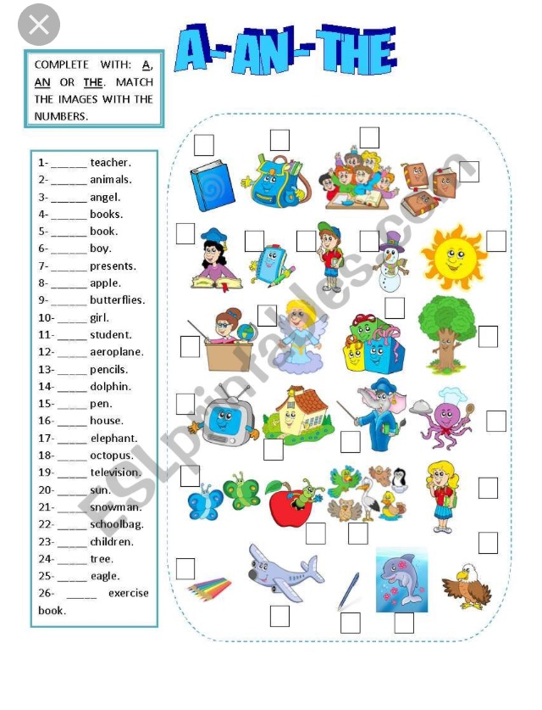
SOS ANSWER KEY

- A
- An
- An
- The
- A
- A
- The
- An
- The
- A
- A
- An
- The
- A
- A
- A
- An
- An
- A
- The
- A
- A
- The
- A
- An
- A

