☐ Listening ☐ Speaking ■ Reading ☐ Grammar ☐ Writing

Topic: How to get respect from my pet

Instructor:  Chloe Shin | Level:  Intermediate | Students:  10 | Length:  35 Minutes

Materials:
● White board, makers
● Worksheet #1 for pre-teaching Vocabulary
● Text worksheet
● Worksheet #2 for main idea question and answer
● Worksheet #3 for detail question and answer
● Worksheet #4 for free production
● color pencils, crayons and worksheet for drawing
●SOS activity worksheet

Aims:
● Main aim: Students will develp intensive reading skill by answering questions
to find the main idea and detailed information.
● Secondary aim: Students will be able to talk about their imagination and idea about
pet's new trained skills by sharing their drawing with class.
● Personal aim:
- I want my students to imagine about their pet's new skills.
- I want to give my students simple and clear instructions.

Language Skills:
● Reading: matching worksheet, reading text to find main idea, detailed information
● Listening: pair discussion to answer the question, listening to teacher's instructions.
● Speaking: presenting their drawing in free production and answering the guiding question.
● Writing: answering worksheets

Language Systems:
● Phonology: pronunciation of new vocabulary words
● Lexis: treat, solution, behavior, loyal, basic, ignore, patience, reward
● Grammar: making answers with sentences.
● Function: presenting their ideas
● Discourse: reading text

Assumptions:
● Students know what skimming and scanning are.
● Students have imagined about their pet or pet's skills.

Anticipated Errors and Solutions:
● If students need more time to finish their activities
→ Be flexible with the time and give them more time to finish.
● If some students finish their worksheets or task earlier than others
→ Give them SOS activity worksheet ( It not used in the class, give it as homework)
● If students can't draw or don't want to draw
→ Tell them they can just write Key work on worksheet and present

References:
- Reading for Vocabulary Level D
- naver dictionary for vocabulary
- worksheet made by Chloe
- SOS worksheet (crossword maker)
//www.education.com/worksheet-generator/reading/crossword-puzzle/

Lead-In
Materials: None
Time | Set Up | Student Activity | Teacher Talk
1 min | Whole  class | Listening and answering  the teacher's questions. | Good morning, everyone! What is your favorite animal? Then What do you want for pet? I wanted cat, but our family already live with dog. Does anyone have pets?

Pre-Activity
Materials:board, markers, worksheet #1
Time | Set Up | Student Activity | Teacher Talk
3min  2 min  1 min  2 min  1 min  3 min  1min | Whole  class  in pairs  Whole  class  Whole  Whole  class  individually  Whole  class | Listening and answering  the teacher's instruction.  Students discuss in pairs.  Listening and answering  the teacher's instruction.  Students listening to teacher  reading and answering all together.  Working on the  worksheet #1  each students read and answer for each questions. | 1. Prediction  If you have, what is the best thing about living with them?  (students answer good things about living with pet)  Then, there must be one thing or some things that they make trouble. Or if you dont have any pet, you can talk about with your imagination. For example, like because they are friendly but I'm afraid of cleaning their poop.  Talk about this with your partner. You have 2 minutes.  ICQ  Are you working alone?  What are you going to do?  How much time do you have?  “Ok, you may start.”  (after 2 minutes)  Now we will talk in whole class. What is good things about living with pet? And what is tuff things? Then what do you think, how can you make them to listen to you? Good!  Today's topic is  “How to get respect from my pet”  (Write the topic on the board)  2. Pre-teaching Vocabulary  Before read the text, let's learn some new vocabulary. I'm going to handout worksheet.  Instruction  You'll preview vocabulay by answering these questions. number 1 and number 2. You are going to do by yourself. I'll give you 3 minutes to finish.  Demonstration  Let's try each ⓐs together first. Let's read numer1 ⓐ all together. What's the answer? Right. It's 'treat'.  Then let's try number2 ⓐ. let's read together. So wha't the answer? Right. it's treat.  ICQ  What are you going to do?  Are you working alone?  How much time do you have?  Alright, Let's start!  (Monitoring discreetly)  (Give time warning, 1 min, 30 seconds...)  Let's check the answers together. You are going to read out loud the definition and answer. Let's do in clockwise.

Main Activity
Materials: Worksheet #2, #3, #4, blank paper, crayon, color pen
Time | Set Up | Student Activity | Teacher Talk
1 min  3 min  2 min  1 min  3 min  3 min  5 min  3 min | Whole  class  individually  individually  Whole  class  individually  Whole  class  individually  Whole  class | Listening to teacher  Read the text individually  answer the questions  on worksheet #2  check the answers with everyone.  answer the questions on worksheet #3  Listening to teacher  drawing picture  Students presenting | 1. Skimming for the main idea  Now I'm going to give you another worksheet.  (Handout worksheet #2)  But first, you are going to read the text to find the main idea. Read by yourself for 3 minutes.  ICQ  What are you doing?  Are you working alone?  How much time do you have?  Ok, start!  (monitoring,  time warning 1 minute, 30 seconds left...)  Time's up!  So now, find the answers on the worksheet. You are going to do individually for 2 minutes.  ICQ  Are you working in pairs?  How much time do you have?  (after time's up)  Alright, let's check the answers together.  (pick one student first) Could you give me the answer for number 1?  (finish checking answers with each students)  2. Scanning for details  (Hand out worksheet #3)  This time, scan the text and find the answers to the questions on the worksheet. You will do this alone and then check with your partner. You have 3 minutes.  ICQ  What are you doing?  Are you working alone?  How much time do you have?  Start, Now.  (monitor discreetly and help if they need)  “Do you need more time?”  (Give time warning)  Let's check the answers together.  3. Free production  Now, we are going to do fun activity. I'm going to give you another papaer.  (Handout blank paper)  Did everyone get paper?  Alright. we are going to draw a picture of  “my pet's super ability”  It means, if you can train them any ability, what would you train? Or what would you want for their skills?  It can be anything even though it cannot be happened.  demonstration  I'll show you example,  (showing my picture)  I draw a dog with holding a trash bag. because I like cook or cleaning, but I don't like throwing trash out. So if my dog can do anything, I want him to help me with dumping trash can.  Did you get it?  You are going to work individually for 5 minutes and then you are going to present. You can color your picture also.  ICQ  What are you doing?  Are you working in pairs?  How much time do you have?  Let's start, Now!  (monitor discreetly,  help them if they can't think what do draw)  (Give time warning,  Be flexible with time)  Let's share your pictures.  (after everyone is done with presenting)  Great job! eveyone!

Post Activity
Materials: Board and markers
Time | Set Up | Student Activity | Teacher Talk
3 min | Whole  class | Try to make students self-correct and then give them right answer. | Error Correction  Alright, now we are going to review some  erros. (Board sentences with error and ask  students to try to self-correct first, and then  give them the right answer.)  Feedback  Did you have fun today?  How did you feel with activities?  Conclusion  You did great job today. Please dont forget  vocabulary we learned today and how you  should treat animals or pets.  Thank you so much!

SOS Activity
Materials: worksheet #5
Time | Set Up | Student Activity | Teacher Talk
1 min  3 min | Whole  class  individually | Listening and answering  to teachers instruction  work on crosswords | Instruction  I'm going to give you the last worksheet.  (Handout worksheet #5)  It's a crossword. There are definitions  below the blanks.You are going to fill out  those crossword's blanks with the right  definitions.  Demonstration  First let's do Down number 1 . What is the  answer for this? right it's solution. So you  are going to write on down 1. you are  going to work individually for 3 minutes and  then we are going to check the answers  together.  ICQ  What are you doing?  Are you working alone?  Ok, Start!  (monitor discreetly, give time warning)  Time's up!  let's check the answers together.  (after check all answers)  Good job everyone!

Worksheet #1
Vocabulary Preview
1. Choose and write the correct word next to its definition.
reward treat behavior loyal solution ignore

ⓐ special delicious food :
ⓑ an answer to a problem :
ⓒ to give a gift for doing a good job :
ⓓ being trustworthy and honest to another :
ⓔ to not pay attention to :
ⓕ how one follows rules :

2. Write the word from the box that best completes each word group.
treat patience basic loyal solution

ⓐ candy, cookie,
ⓑ answer, fix,
ⓒ simple, necessary,
ⓓ calmness, reserve,
ⓔ honest, trustworthy,

ANSWER KEY
Worksheet #1
Vocabulary Preview
1. Choose and write the correct word next to its definition.
reward treat behavior loyal solution ignore

ⓐ special delicious food : treat
ⓑ an answer to a problem : solution
ⓒ to give a gift for doing a good job : reward
ⓓ being trustworthy and honest to another : loyal
ⓔ to not pay attention to : ignore
ⓕ how one follows rules : behavior

2. Write the word from the box that best completes each word group.
treat patience basic loyal solution

ⓐ candy, cookie, treat
ⓑ answer, fix, solution
ⓒ simple, necessary, basic
ⓓ calmness, reserve, patience
ⓔ honest, trustworthy, loyal

Your Dog the Celebrity

Dogs are great. They are friendly, loyal, and smart. You can play with them and they will love you. They are man’s best friend. Until they poop on your rug. Or eat your garbage! Then dogs are not so great. A bad dog can be a big problem. But there is a solution. Train your dog well!
Training starts when your dog is a puppy. In the wild, dogs live in groups called packs. There is one leader in each pack. You need to show your puppy that you are the leader. You don’t need to hurt the dog. Just show it that you are stronger.
After your dog respects you, you can teach it important behavior. It should know a few basic things. Only go to the bathroom outside. Come when you call its name. And sit when you say sit. This part is easy. you just need patience and dog treats.
When your dog does a good thing, give it a treat. If it does a bag thing ignore it, or act like you are angry. Hitting a dog does not help. The dog will become scared and might attack people later. It’s better to reward good behavior.
Does your dog behave well now? Then it’s time for the fun stuff. Dogs are smart. They can learn many tricks and skiils. You can teach your dog how to roll over or shake hands. Or even how to play dead! Maybe your dog will be so smart that it can win a dog show! The most well-trained dogs compete in shows. The winners get fame and money. Train your dog well and it can be a star!

worksheet #2

Reading Comprehension Questions for Main idea

1. choose the beast answer.
This story is about .
a. good dogs
b. training dogs
c. rewarding dogs
d. bad dogs

2. Circle T for true or F for false.
a. Playing dead is a basic part of a dog’s training. ( T/F )
b. With the right training, dogs can learn many different tricks.
( T/F )
c. If your dog is well-trained, it could win a dog show. ( T/F )
d. If your dog is a star then he could be a big problem. ( T/F )

ANSWER KEY
worksheet #2

Reading Comprehension Questions for Main idea

1. choose the beast answer.
This story is about b .
a. good dogs
b. training dogs
c. rewarding dogs
d. bad dogs

2. Circle T for true or F for false.
a. Playing dead is a basic part of a dog’s training. ( T/F )
b. With the right training, dogs can learn many different tricks.
( T/F )
c. If your dog is well-trained, it could win a dog show. ( T/F )
d. If your dog is a star then he could be a big problem. ( T/F )

worksheet #3
Reading Comprehension Questions for Details
- You make a dog respect you by .
a. living in a pack
b. rewarding bad behavior
c. hurting it
d. being strong

2. A well-trained dog will .
a. eat the garbage
b. respect you
c. hurting it
d. being strong

3. A good way to respect your dog is to .
a. ignore it
b. give it treats
c. show it your anger
d. hit it

4. Imagine you have your own pet and he/she is not trained at all. How would you train them?

ANSWER KEY
worksheet #3
Reading Comprehension Questions for Details
1. You make a dog respect you by a .
a. living in a pack
b. rewarding bad behavior
c. hurting it
d. being strong

2. A well-trained dog will b .
a. eat the garbage
b. respect you
c. hurting it
d. being strong

3. A good way to respect your dog is to b .
a. ignore it
b. give it treats
c. show it your anger
d. hit it

4. Imagine you have your own pet and he/she is not trained at all. How would you train them? Or How would you get their respect?

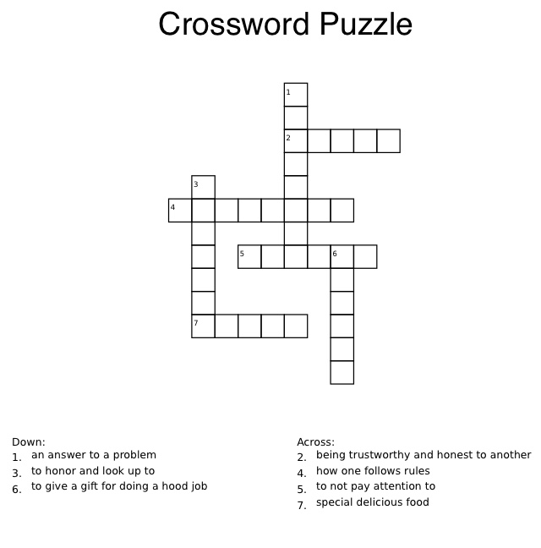

reward treat respect ignore loyal behavior solution

ANSWER KEY
down 1. solution Across 2. loyal
3. respect 4. behavior
6. reward 5. ignore
7. treat

