■ Listening ☐ Speaking ☐ Reading ☐ Grammar ☐ Writing
Topic: At a Hotel

Instructor:  Hera (Yirae Chang) | Level:  Intermediate | Students:  8 students | Length:  35 minutes

Materials:
- Computer
- Picture #1
- White board and board markers
- Worksheet (#1, #2, #3)
- Video (Audio file)

Aims:
- Students will be able to understand and use the words which is related to Hotel.
- Students will be able to use what they learn through this lesson to real life.

Language Skills:
- Listening: Ss will listen to conversation.
- Speaking: Ss will do role play and present their opinion and idea after group work.
- Reading: Ss will read the definition of the words and understand them.
- Writing: Ss will write words or sentences after they are listening to the video.

Language Systems:
- Lexis: Vocabularies (Front desk, Bellhop, Doorman, Housekeeping, Room service, Hallway, Valet parking, Shuttle bus)
- Function: Role play
- Discourse: Script of conversation

Assumptions:
Students already know
- How the class arranged and prepared (8 Students at each table)
- The basic knowledge about making reservation for hotel
- Their conversation with groups and partners

Anticipated Errors and Solutions:
- If students may not able to follow the passage easily
- Let them listen again until they get the gist of the content
- If some students may not be able to pick up details
- Chunk the listening
- If students need more time for each work
- Give them more time or Cut-off plan (Cut the post-activity)
References:
- www.youtube.com/watch?v=684W6lo8JTw
- www.youtube.com/watch?v=FJrRiVjeOMc

Lead-In
Materials: None
Time | Set Up | Student Activity | Teacher Talk
1 min | Whole class | Answering teacher’s questions | Present :  “ Good morning! How do you feel today? Is there anyone having a plan to go travel? Do you travel abroad, where do you normally stay in?”

Pre-Activity
Materials: Picture #1, Worksheet #1, Video
Time | Set Up | Student Activity | Teacher Talk
2 min  4 min  5 min | Whole class  Individual  Whole  class | Guessing and answering teacher’s questions  Worksheet #1  Watching the video | Practice :  Elicit  (Show picture)  “Look at these picture. Do you come up with something? What do you think these words imply?”  (Wait for Ss’ responses)  “Yes, these are in relation with the Hotel.”  “Today, we are going to learn about useful words and expressions which are related to Hotel.”  “We are going to check new vocabularies first. Please try to rearrange the letters to create a vocabulary word. If any confusing, you can refer explanation below.  “How can ‘KSEDTNORF’ be the right word? It is where you check in at a hotel as a guest. I will give you 4 minutes to solve them all.”  ICQ  How much time do you have?  MORNITORING  (Walk around to see how Ss are doing. Answer questions if Ss have any.)  (Give time warning)  “You have 30 seconds left.”  (after 30 seconds)  “Time’s up! It is time to check the answers together.”  (Show video)

Main Activity
Materials: Video, Worksheet #2, Worksheet #3
Time | Set Up | Student Activity | Teacher Talk
3 min  5 min  3 min  10 min | Individual  Pairs  Whole class  Groups | Worksheet #2  Students talk each other.  Presenting their opinion  Worksheet #3  . | Practice :  (Hand out the worksheet #2)  “While you are listening to the audio, please fill in the blanks on your script. Work individually.”  ICQ  What do you going to do while listening?  (Play the video 0:50-1:58)  MORNITORING  (Walk around to see how Ss are doing.)  “Do you need to listen again?” (If yes, play again)  “Let’s check answers together.  Great job everyone.”  (Check the answer)  “Okay everyone, Pair up, please. Please share key words or sentences on your script with your partner. After that, One representative from each group will present. I will give you 5 minutes”  ICQ  Are you working alone?  How much time do you have?  MORNITORING  (Walk around check if everyone is speaking and following the instructions)  (Give time warning) “You have one minute left.”  (After one minute)  “Time’s up. It is time to listen to each pair’s key words and sentences. Do we have any volunteers?” (If no, take turns)  (After their presentation)  “Good job everyone.”  Production :  “Okay everyone, we will have a role play from now on. The four of you will be hotel front desk clerks and the others will be hotel guests. The front desk clerks get hotel information cards and the guests get role-play prompts. The guests will go from hotel to hotel and book a room in each hotel. You can hold a script during the activity. Please refer the scripts on worksheet #2. I will give you 10 minutes”  ICQ  Are you working alone?  How much time do you have?  What are you going to do fill out?  MORNITORING  (Walk around check if everyone is speaking and following the instructions)  (Give time warning) “You have one minute left.”  (After one minute)  “Time’s up. Good job everyone.”

Post Activity
Materials: None
Time | Set Up | Student Activity | Teacher Talk
1 min  1 min | Whole class  Whole class | Students present about each pairs’ role play.  Students listen and ask questions & answers | Feedback  “It is time to review the role play. Let’s check what was good and what needed to improve together.”  “Do you have any questions?”  Error Correction  (If there’s any, fix grammatical and pronunciation that students made, and correct them)  Conclusion  (Conclude today’s lesson by checking key vocabularies, and their understanding of the topic)  “I appreciated your great participation today. Thank you very much.”

Picture #1

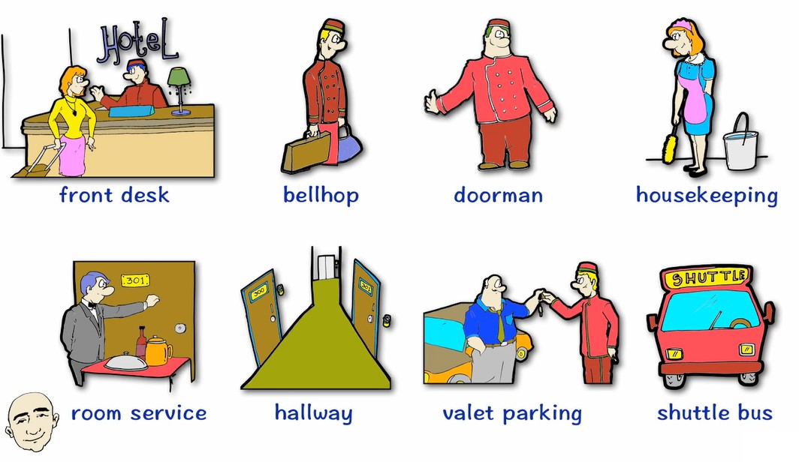

Worksheet #1

VOCABULARY SCRAMBLE : Rearrange the letters to create a vocabulary word.
Shuttle bus / Valet parking / Housekeeping / Hallway
Bellhop / Doorman / Room service / Front desk

1. K S E D T N O R F
: This is where you check in
2. O P H L L E B
: He takes your bags to the room
3. R O O D A M N
: He is there to help you
4. E E P I N G K E S U O H
: She cleans your room
5. O R O M S E R I V C E
: He delivers food to your room
6. A Y W L A L H
: The rooms are along the hall way
7. L A V E T P R A K N G I
: They will park your car
8. T T L E U H S U B S

: It will pick you up and drop you off

Worksheet #2
Please fill in the blanks on your script.

Guest: Hi, I’d like to make a ___________.
Front desk: Yes, of course. When would you like to _____ __?
G: On the 3rd of November.
F: And how many ______ would that be for?
G: For three nights.
F: And what ____ __ ____ were you looking for?
G: A ______ ____. It’s for my husband and me.
F: We do have one ______ ____ available for those dates. It’s $80 a night, so that comes to $240 ___ ___ _____ ______.
G: Yes, that’s fine.
F: Great. Can I take your ____?
G: Yes, it’s Sarah Banks
F: Thank you, Ms. Banks. Can I just take a ______ ____ from you to ____ ___ _______?
G: Yes of course, here you are.
F: Okay Ms. Banks, that’s ___ ________. Is there anything else I can help you with?
G: Yes, could I have a ____________ _______ to me?
F: Yes of course, what’s the email?
G: It’s s dot banks at gmail dot com.
F: Okay, I’ll send that over to you now.
G: Excellent, thank you very much.
F: You’re welcome. __ ____ _______ __ seeing you.
G: Thank you, goodbye
F: Goodbye.

Worksheet #3

ROLE PLAY

[Hotel front desk clerks : Role-play Prompts]

 |  | Price |  | Available Rooms |  |  | Price | Available Rooms
Single |  | $120.00 |  | 802, 1107 |  | Single | $120.00 | 203,204,206
Double |  | $160.00 |  | 708, 904 |  | Double | $165.00 | 604, 708
Suite |  | $220.00 |  | 1201 |  | Suite | $230.00 | None
 | Price |  | Available Rooms |  |  |  | Price | Available Rooms
Single | $110.00 |  | 708, 904 |  |  | Single | $95.00 | 605, 708
Double | $145.00 |  | 802, 1108 |  |  | Double | $125.00 | 203,204,206
Suite | $190.00 |  | 1401 |  |  | Suite | $150.00 | 501

Worksheet #3

ROLE PLAY

[Hotel guest : Role-play Prompts]

You are traveling alone. You would like a single room. You would like to pay with cash. You will be staying 2 nights. You would like a wake-up call for 7:00 A.M. |  | You are traveling with two friends. You would like a double room. You would like to pay with credit card. You will be staying 1 night. You would like a wake-up call for 6:30 A.M.
You are traveling with your husband/wife. You would like a single room. You would like to pay with credit card. You will be staying 2 nights. You would like a wake-up call for 6:00 A.M. |  | You are with your brother. You would like a double room. You would like to pay with cash. You will be staying 2 nights. You don’t want a wake-up call.

