Activity or Task Based Lesson XXX Language Based or Presentation, Practice, Production PPP Based Lesson
Storytelling Lesson Plan Puppet Play Presentation

Topic: Stories About Magic.

Instructor:  Sujin | Students Competency Level and Student ages  7-9 years old | Number of Students:  10 students | Lesson Length:  50 minutes
Materials: (List the Names of all materials used in the lesson. Materials must be shown at the end of this document)
- Whiteboard and Markers.
- Cell Phone and Bluetooth Speaker.
- “Bibidi Babidi Boo” Cinderella Song.
- Lyrics Of “Bibidi Babidi Boo”
- The Storybook of “Cinderella”
- Picture Flash Cards:
- “Cinderella”
- “Aladdin and the Magic Lamp”
- “The Magic School Bus”
- “Make Your Wish” Worksheet.
- “Make Your Mom’s Wish” Assignment.
- “Dream, Princess” Song.

Lesson Objectives: The main objective of the lesson is to let Ss practice describing their wishes and dreams and describe why they need the magic and how it benefits them.

Aims: (What students will be able to achieve by participating in the activities of the lesson. (Ss gain or get by doing…)
- Practice speaking skills by sharing your wish within a group.
- Improve writing skills by writing down your wish and the reason why you want to achieve it.
- Improve speaking skills by sharing your ideas with your partners.
- Improve listening skills by listening to your partners’ wish.

Language Skills: (Lists what activities language skills students will be using by participating in the activities of the lesson.)
- Reading: (Where did reading occur in the lesson?)
- When Ss reads handout on “Cinderella”.
- Listening: (Where did listening occur in the lesson?)
When Ss listen to other Ss’ “Make Your Wish” presentation.
When teacher talks about magic stories.
- Speaking: (Where did speaking occur in the lesson?)
When Ss do presentation on “Make Your Wish” Worksheet.
- Writing: (Where did writing occur in the lesson?)
When Ss fill out “Make Your Wish” Worksheet.
Assumptions: (What students must already be able to do and what concepts must already be mastered before the lesson in order to achieve the aims of the lesson.)
- All Ss are aware of the movies, the novels, the story books that will be introduced.
- All Ss probably have their memory of having fantasy in the magical stories.
- All Ss can think of one of two wishes.
- All Ss will enjoy and also have fun.
- Ss are able to create future tense sentences to describe their wish.

Anticipated Errors and Solutions:(What things might go wrong in the lesson and what the solution will be.An SOS activity should also be included)
- If Ss may not have enough ideas. Inspire them by sharing more details of each magic story.
- If the activity lasts too long Ss divide the class into group, and do group presentation.
- If the activity finished too soon Teacher suggests to sing “Bibidi babidi boo” song together.
- If Ss may not understand the instruction: T helps them to explain more of examples.
- If certain Ss are shyT encourages them, give positive feedback, and change roles for them.

References:
www.google.com
www.naver.com
www.youtube.com
princess.disney.com

Lead-In or Pre-Task Part (Warm-Up Part to activate and create interest in the lesson.)
Materials: (List the Names of all materials used in the Lead-Inor Pre-Task Partof the lesson. Materials must be shown at the end of this document)
- “Bibidi Babidi Boo” Cinderella Song.
- Lyrics Of “Bibidi Babidi Boo”
- “Cinderella” Story Handout
Time: | Classroom Set Up: | Student Activity and Goals: | Teacher Procedure & Instructions:
1min  3min  1min  3min  2min | Whole  Whole  Whole  Group  Group | Greeting from teacher  Ss listen to music and become interested.  S responds.  S listen to the story of “Cinderella”  Think of one favorite magic story. | Greeting.  T plays “Bibidi Babidi Boo”.  Asks Ss where the song comes from?  T tells story of “Cinderella”  T asks Ss to discuss their favorite magic stories within groups.

Pre-Activity or Task Familiarization Part (Presentation Partfor Presenting the language structure to be covered in the lesson. Prepares students for the communication activity.)
Materials: (List the Names of all materials used in the Pre-Activity or Task Familiarization Part of the lesson. Materials must be shown at the end of this document)
- Picture Flash Cards.
- Cinderella
- Aladdin and the Magic Lamp
- The Magic School Bus
Time: | Classroom Set Up: | Student Activity and Goals: | Teacher Procedure &Instructions:
5min.  5min. | Whole  Group | Ss listen to T’s talk and try to catch up words related to magic.  Ss listen and try to figure out how to fill out “Make Your Wish” Worksheet | T talks about stories on the flash cards.  T divides the class into groups.  Ok, now it’s your time to think of your wishes. With your partner, Image what you would like to do, if you can use magic.

Main Activity or Task Realization Part(Practice to Production Part Teacher lead practice of the language presented and move to communication based more student centered activity)
Materials: (List the Names of all materials used in the Main Activity or Task Realization Part of the lesson. Materials must be shown at the end of this document)
- “Make Your Wish” Worksheet

Time: | Classroom Set Up: | Student Activity and Goals: | Teacher Procedure &Instructions:
2min.  10min.  5 min.  5 min. | Groups  Groups  Group A  Group B | Ss listen to T and look at two worksheets above.  Idea sharing within groups.  Filling out worksheet.  Presentation of group A.  Presentation of group B. | T divides the class into groups.  T gives out “Make Your Wish” Worksheet.  T tells Ss to list their wishes.  T asks Ss how to make your wish come true.  T asks Ss how the magic benefits you.  T asks Ss how to create own lyrics.  T looks around the classroom and help students who need help.  T listens and responds to group A presentation.  T facilitates class feedbacks.  T listens and responds to group B presentation.  T facilitates class feedbacks.

Post Activity or Post Task Part (Wrap-Up Part to Close the Lesson on a high note to and consolidate language learned in a communication based activity new situation.)
Materials: (List the Names of all materials used in the Post Activity or Post Task Part of the lesson. Materials must be shown at the end of this document)
- Cellphone
- Bluetooth Speaker
- “Dream, Princess” song
- “Make Your Mom’s Wish Come True” worksheet.

Time: | Classroom Set Up: | Student Activity and Goals: | Teacher Procedure &Instructions:
2min.  2min.  5min.  1min. | Whole  Whole  Whole  Whole | Ss listen and think of what’s good about the activity.  T plays the “Dream, Princess” song.  Listen to homework.  assignment on “Make Your Mom’s Wish Come True”  Worksheet.  Clap hands together. | T asks how student enjoyed the activity.  T tells Ss about how happiness can be related to your big dreams.  T explains teachers’ example of worksheet.  T asks Ss to bring homework home and ask moms questions below.  How I’m going to make it come true with magic? How will it benefit your mom?  Congratulate and T appreciates Ss participation.

- Lyrics of Bibidi Bobidi Boo
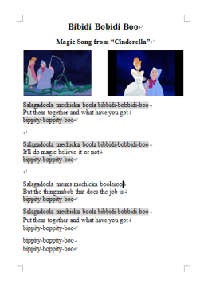

- The Story book of “Cinderella”
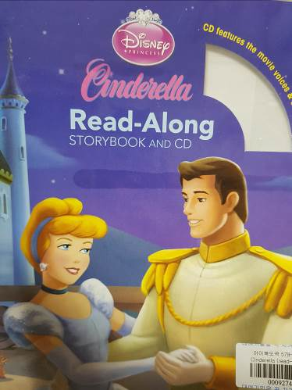
- Picture Flash Cards
Cinderella
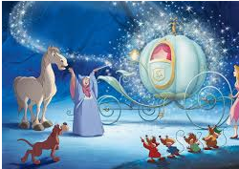
Aladdin and the Magic Lamp

The Magic School Bus
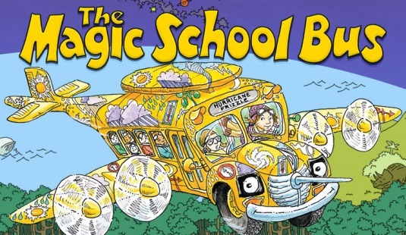

“Make Your Wish” Worksheet
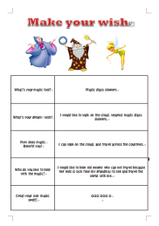

“Make Your Mom’s Wish” Worksheet.
