□Activity or Task Based Lesson XXX Language Based or Presentation, Practice, Production PPP Based Lesson
□Storytelling Lesson Plan □Puppet Play Presentation
Topic: How to Make Chocolate

Instructor:  Sally | Students Competency Level and Student ages  7-8 years old, Elementary | Number of Students:  9 | Lesson Length:  50 min
Materials:(List the Names of all materials used in the lesson. Materials must be shown at the end of this document)
- Chocolate
- Pictures:
- Cacao Pods
- Cacao Seeds
- Cacao Beans
- Cocoa Powder
- Conche
- Chocolate Candies
- The Process of Making Chocolate Worksheet
- Terms Worksheet
- Whiteboard and a Marker

Lesson Objectives (What do you want the students to know (new skill or knowledge that you want them to gain)? And What do you want them to be able to do?
Ss will enjoy learning how to make chocolate and will be able to explain about chocolate.
Aims:(What students will be able to achieve by participating in the activities of the lesson. (Ss gain or get by doing…)
Ss will get interested in chocolate by by participating in the activities of the lesson.
Ss will improve listening and speaking skills by responding to teacher and sharing opinions in class
Ss will improve presentation skills by present process and terms in front of other student.
Ss will gain writing skills by writing new words.
Language Skills:(Lists what activities language skills students will be using by participating in the activities of the lesson.)
- Reading: (Where did reading occur in the lesson?)
Whiteboard, worksheet
- Listening:(Where did listening occur in the lesson?)
Teacher talk, discussion, presentation of other students
- Speaking: (Where did speaking occur in the lesson?)
Group discussion, answering teacher, presentation
- Writing: (Where did writing occur in the lesson?)
Worksheet
Assumptions:(What students must already be able to do and what concepts must already be mastered before the lesson in order to achieve the aims of the lesson.)
Ss have tried chocolate and heard of cacao before.
Ss are curious about new terms and enjoy learning them.
Ss understand the contents of making chocolate from the lesson.
Ss are confident to give a presentation about new terms.
Anticipated Errors and Solutions:(What things might go wrong in the lesson and what the solution will be. An SOS activity should also be included)
Teacher can give students more examples when they have difficulty understanding new terms.
Teacher needs to encourage a student who is not confident to give a presentation.
If the presentation is too long, teacher will cut the unnecessary parts.
References:

Lead-In or Pre-Task Part (Warm-Up Part to activate and create interest in the lesson.)
Materials: (List the Names of all materials used in the Lead-In or Pre-Task Part of the lesson. Materials must be shown at the end of this document)
- Chocolate

Time: | Classroom Set Up: | Student Activity and Goals: | Teacher Procedure &Instructions:
1min  2min  1min  2min  3min | Whole  Whole  Whole  Ss  Ss | Ss greet the teacher.  Respond  Respond  Respond  Ss try chocolate and respond. | Greeting.  Share what T likes about chocolate.  Show some chocolates and ask Ss if they like chocolate.  Ask Ss what their favorite chocolate food is.  Ask Ss to tell memorable event involving chocolate.  Asks Ss to try chocolate and talk about how it tastes and how it smells.

Pre-Activity or Task Familiarization Part (Presentation Part for Presenting the language structure to be covered in the lesson. Prepares students for the communication activity.)
Materials: (List the Names of all materials used in the Pre-Activity or Task Familiarization Part of the lesson. Materials must be shown at the end of this document)
- Pictures:
- Cacao Pods
- Cacao Seeds
- Cacao Beans
- Cocoa Powder
- Conche
- Chocolate Candies
- The Process of Making Chocolate Worksheet

Time: | Classroom Set Up: | Student Activity and Goals: | Teacher Procedure &Instructions:
5min  1min  3min  10min | Whole  Group  Group  Whole | Listen and see  Move into groups  Listen what T says  Discuss the order of the process of making chocolate and put the cards in the right places on worksheet and review together | Introduce each picture and elicit ss respond.  Place pictures on board in order.  Divide Ss into 3groups  Give instruction and T demonstrates by showing the worksheet for the process of making chocolate first.  Hand out worksheet and picture cards.  Ask Ss to talk about the order of the process of making chocolate and fill out the worksheet.  Review the worksheet with Ss.

Main Activity or Task Realization Part (Practice to Production Part Teacher lead practice of the language presented and move to communication based more student-centered activity)
Materials: (List the Names of all materials used in the Main Activity or Task Realization Part of the lesson. Materials must be shown at the end of this document)
- Pictures:
- Cacao Pods
- Cacao Seeds
- Cacao Beans
- Cocoa Powder
- Conche
- Chocolate Candies
- The Process of Making Chocolate Worksheet

Time: | Classroom Set Up: | Student Activity and Goals: | Teacher Procedure &Instructions:
1min  3X  12min  3min | Whole  Groups  Groups  Whole | Ss get ready for presentation  Everything below happens three times  Ss do activity. One group at a time other group watches listens and enjoys.  Listen what T says | T gives instruction for each group to come to front and present how to make chocolate.  Everything below happens three times  T monitors presentation.  Gives encouragement to each group and facilitate class feed back.  Gives Ss positive feedback and comments

Post Activity or Post Task Part (Wrap-Up Part to Close the Lesson on a high note to and consolidate language learned in a communication-based activity new situation.)
Materials: (List the Names of all materials used in the Post Activity or Post Task Part of the lesson. Materials must be shown at the end of this document)
- Terms Worksheet
- Whiteboard and a Marker

Time: | Classroom Set Up: | Student Activity and Goals: | Teacher Procedure &Instructions:
1min  4min  1min | Ss  Ss  Ss | Complete filling in the blanks  Ss say and review together.  Applaud | Hand out terms worksheet and ask them to find each word to match each right sentence.  T asks Ss to fill in the blanks.  Ask Ss what they write down on terms worksheet.  Review the worksheet with Ss  T expresses congratulations and thanks for the great accomplishment for SS.

< The Process of Making Chocolate >

Cacao Pods Cacao Seeds
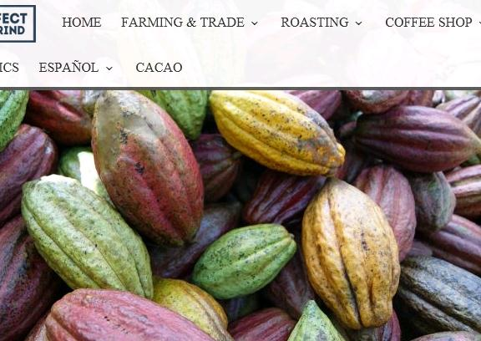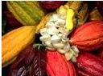

Cacao Beans Cocoa Powder
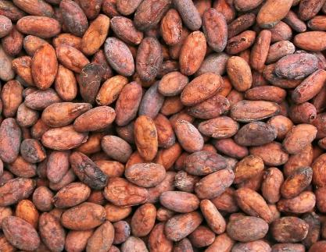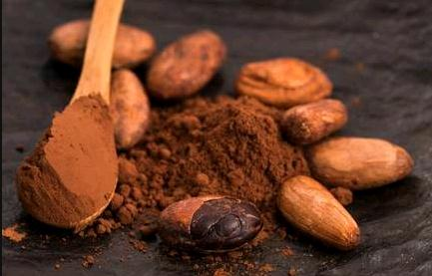

Conche Chocolate Candies
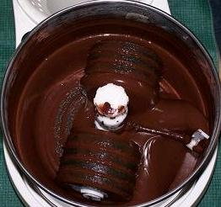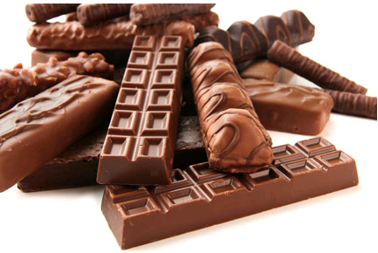

< Terms Worksheet >

♫ How to make chocolate ♪

1. The cacao pods must be picked. Then they are ( ) for six days.

2. The pods are split open. The ( ) are removed and dried.

3. The dried beans are sent to chocolate ( ).

4. The seeds are ( ) and ( ) into powder.

5. The ( ) is mixed with sugar, milk, or other ingredients to make different kinds of chocolate.

6. Next, the chocolate is heated in a special machine called a ( ).

7. Finally, the chocolate is ( ) slowly,( ) again, and ( ) to its final hardness.

* Choose from the following words the word that *

factories fermented cooled warmed

seeds conch rosted factories ground

