☐ Activity or Task Based Lesson XXX Language Based or Presentation, Practice, Production PPP Based Lesson
☐ Storytelling Lesson Plan ☐ Puppet Play Presentation

Topic, Story Title, or Puppet Play Name:
Who Am I
Instructor:  Seul | Students Competency Level and Student ages  7-8 years old, Elementary | Number of Students:  12 | Lesson Length:  60 minutes
Materials:(List the Names of all materials used in the lesson. Materials must be shown at the end of this document)
- Whiteboard and Markers
- Yon Yonson MP3
- Yon Yonson Lyrics
- Cell Phone as a Speaker
- Character Cards
- Snow White
- The Little Mermaid
- Cinderella
- Peter Pan
- Pinocchio
- The little prince
- Yon Yonson (demo)
- Question Card
- Teacher Poster (demo)
Lesson Objectives(What do you want the students to know (new skill or knowledge that you want them to gain)? and What do you want them to be able to do?
- Ss will feel comfortable with and practice introducing oneself and asking questions to each other.
Aims :
- Improve speaking skills by participating in the activities and answering teacher.
- Activate, increase interest, and participate with fun in an English communication activity by presenting themselves to teacher and students.
- Improve listening skills by participating in an activity, responding to teacher.
- Improve writing skills, interaction and communication skills by doing the presentation
Language Skills:(Lists what activities language skills students will be using by participating in the activities of the lesson.)
- Reading: (Where did reading occur in the lesson?)
Animal cards
- Listening:(Where did listening occur in the lesson?)
Presentation, activity, teacher talk
- Speaking: (Where did speaking occur in the lesson?)
Activity, answering teacher, presentation
- Writing: (Where did writing occur in the lesson?)
Making their own cards
Assumptions:(What students must already be able to do and what concepts must already be mastered before the lesson in order to achieve the aims of the lesson.)
- All Ss probably enjoy question and answer for their Character Card.
- All Ss know animals and their characteristics and enjoy guessing who they are.
- All Ss enjoy expressing themselves on Poster and make guess for each other.
Anticipated Errors and Solutions:(What things might go wrong in the lesson and what the solution will be. An SOS activity should also be included)
- Ss don’t know the animal on their card. -> Explain in easy words.
- Ss don’t make a right guess. -> Give some hints.
References:

Lead-In or Pre-Task Part (Warm-Up Part to activate and create interest in the lesson.)
Materials: (List the Names of all materials used in the Lead-In or Pre-Task Part of the lesson. Materials must be shown at the end of this document)
- Whiteboard and Markers
- Yon Yonson MP3
- Yon Yonson Lyrics
- Cell Phone as a Speaker
Time: | Classroom Set Up: | Student Activity and Goals: | Teacher Procedure & Instructions:
1min  2  1  1  2  2  1 | Whole  Whole  Ss  Whole  Whole  Whole  Whole | Ss greet the teacher  .`  Ss listen to music  Ss answer to teacher  Ss look on the board  Ss listen to music and look on the board  Ss look and sing  Ss listen to teacher.` | Greeting.  Teacher introduces the song and turns on the music.  Ask Ss what did you hear from the song?  Write down what Ss mention on board  Teacher turn on the music and writes key sentence on board ( ex. My name is.. I come from… I work in… )  Teacher show the Lyrics and Ss sing together.  Introduce the topic(Who Am I) and Teacher will demonstrate that there are more ways to ask and answer about myself, introduce your friend.

Pre-Activity or Task Familiarization Part (Presentation Part for Presenting the language structure to be covered in the lesson. Prepares students for the communication activity.)
Materials: (List the Names of all materials used in the Pre-Activity or Task Familiarization Part of the lesson. Materials must be shown at the end of this document)
Character Cards
- Snow White,
- The Little Mermaid
- Cinderella
- Peter Pan
- Pinocchio
- The little prince
- Yon Yonson (demo)
Time: | Classroom Set Up: | Student Activity and Goals: | Teacher Procedure & Instructions:
1  2  1  1  5 | Whole  Whole  Whole  Whole  Ss | Ss respond to instruction.  Ss watch teacher and respond  Students respond  Ss respond to instruction.  Students start milling around the classroom and start greetings by shaking hands and asking questions. | T introduce the activity that S become a famous story character and make greetings to each other. To make it more fun, the other should guess who it is.  T show Character Card of Yon Yonson and demonstrate a greeting as: “Hello, nice to meet you. My name is Yon Yonson. I come from Wisconsin, I work at a lumber mill there.” and also demonstrate that S would respond either “Hello, What’s your name?” or “Hello, you are 000. Nice to meet you!” Make it funny and exciting.  Teacher hand out Character cards to Ss. Tell students not to share the card.  Give students instructions to get in pair with other group and do greetings but not saying the name. If they both guess right who they are, they exchange the card set and find other pair for greetings.  Teacher observe and facilitate students communication, give some hints if needed.

Main Activity or Task Realization Part(Practice to Production Part Teacher lead practice of the language presented and move to communication based more student centered activity)
Materials: (List the Names of all materials used in the Main Activity or Task Realization Part of the lesson. Materials must be shown at the end of this document)
- Teacher Poster (demo)
- Question Card
Time: | Classroom Set Up: | Student Activity and Goals: | Teacher Procedure & Instructions:
2  3  2  7  1  2  12X  2 | Whole  Whole  Whole  Whole  Whole  Whole  Whole | Ss respond and answer  Ss watch teacher.  Ss respond to T.  Ss prepare the poster.  Ss respond  Ss respond to teacher  Everything below happens for each student.  Ss do activity. | Ask Ss if they enjoyed greetings as a character. Facilitate students review and feedback toward others.  Teacher introduce the main activity now, present Teacher Poster and demonstrate how to make their own poster. It consists of your picture, collage of words or drawings of what you like, what has meaning to you.  Teacher hand out sheets of paper, ask each Ss draw and write a poster.  Teacher walk around and facilitate student prepare.  Gather the Posters when it’s ready.  T gives instructions for each Ss to come to front and pick a poster, introduce that person without mentioning name. Other Ss can make a guess for each poster.  Ss who made the right guess pick a question card, and the introducing Ss should answer on behalf of the person. S on the poster answers whether it is True or False.  Everything below happens for each student.  T facilitate Ss making guess and answer.

Post Activity or Post Task Part (Wrap-Up Part to Close the Lesson on a high note to and consolidate language learned in a communication based activity new situation.)
Materials: (List the Names of all materials used in the Post Activity or Post Task Part of the lesson. Materials must be shown at the end of this document)
- Whiteboard and Markers
- Yon Yonson Lyrics
Time: | Classroom Set Up: | Student Activity and Goals: | Teacher Procedure & Instructions:
2  2  2  1 | Whole  Whole  Ss  Whole | Student respond  Student do activity.  Students present.  Students applaud | Praise students and give feedbacks on activity, facilitate peer reviews for each other.  Show Yon Yonson Lyrics again and Ss make a new verse on the song.  Share the new verse and sing a few.  Clap hands for celebrating.

Material Details:

Yon Yonson MP3
My name is Yon Yonson,
I come from Wisconsin,
I work in the lumber mills there;
Every girl that I meet when I walk down the street say,
“Hello, what’s your name?”
and I say-

Yon Yonson Lyrics
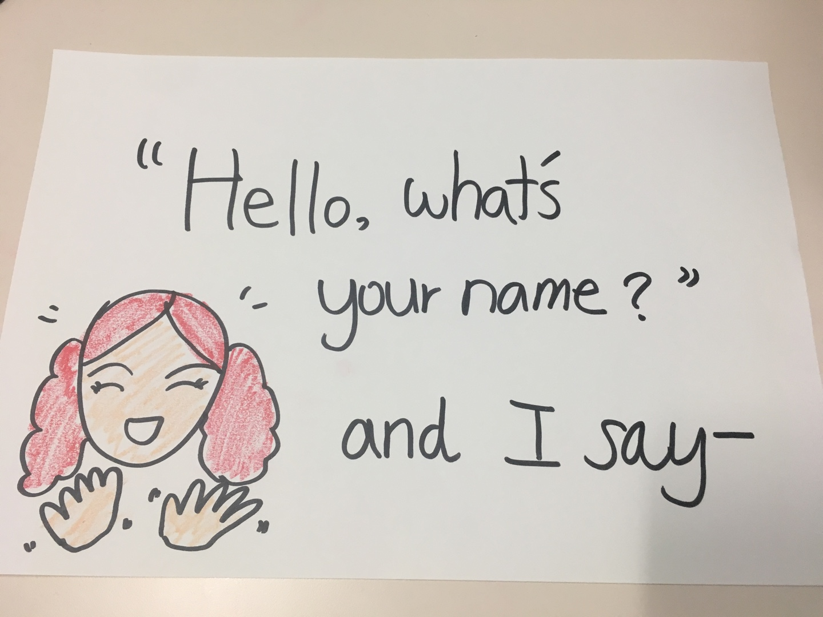
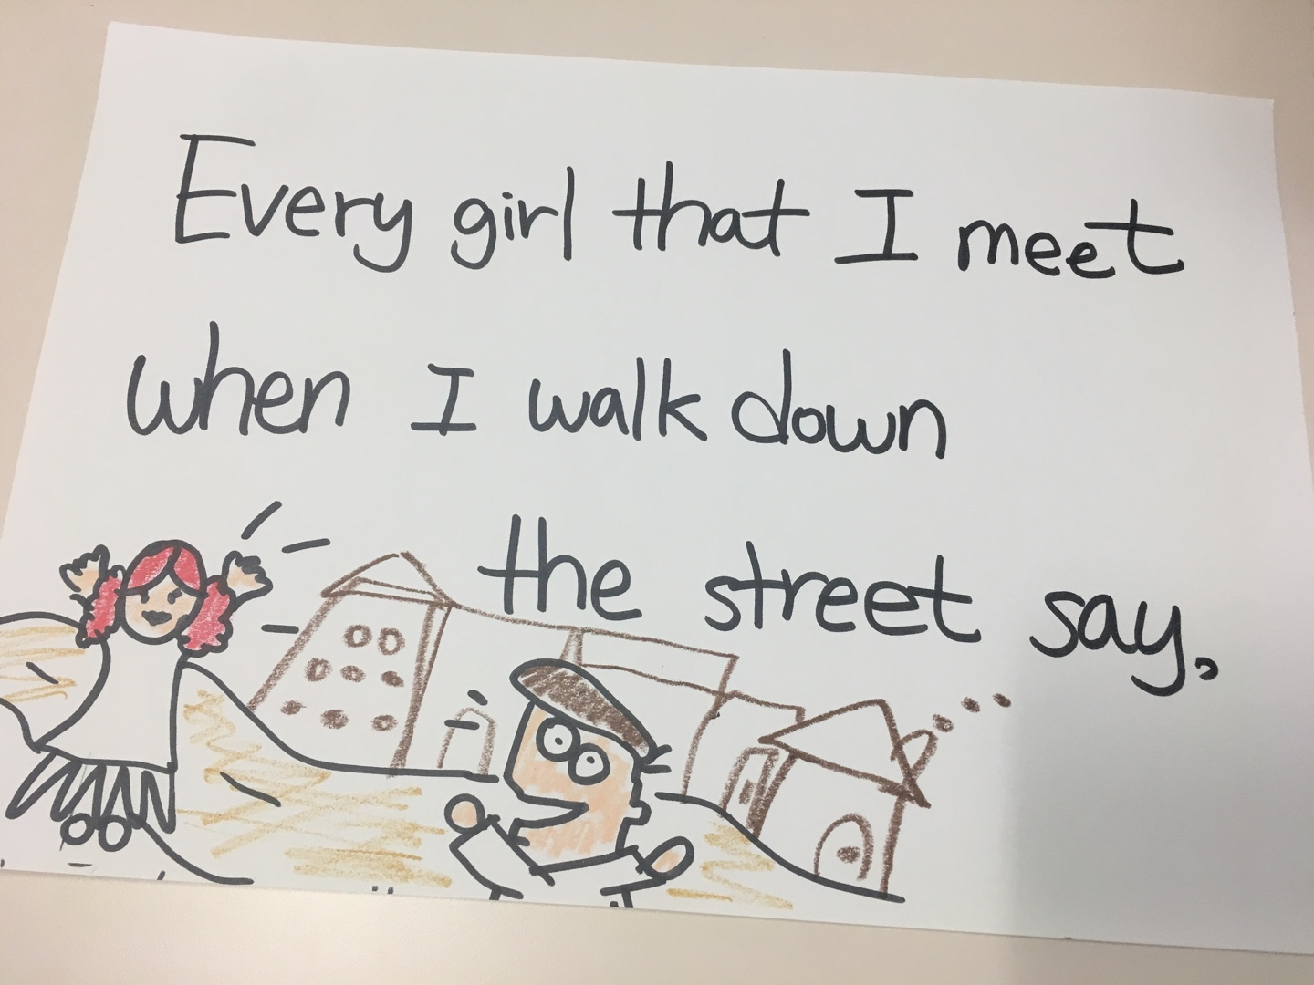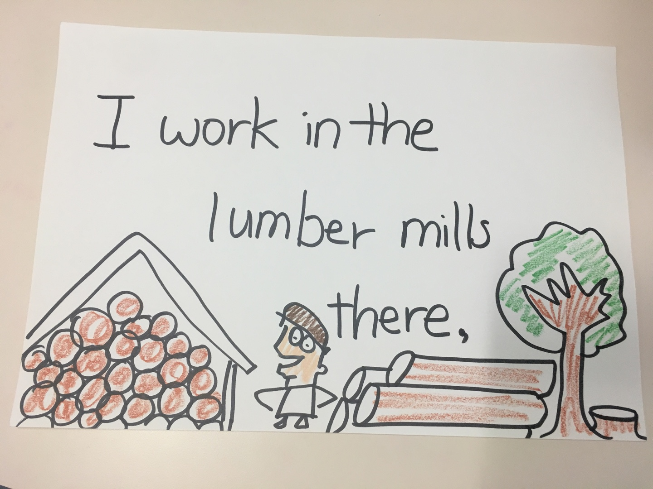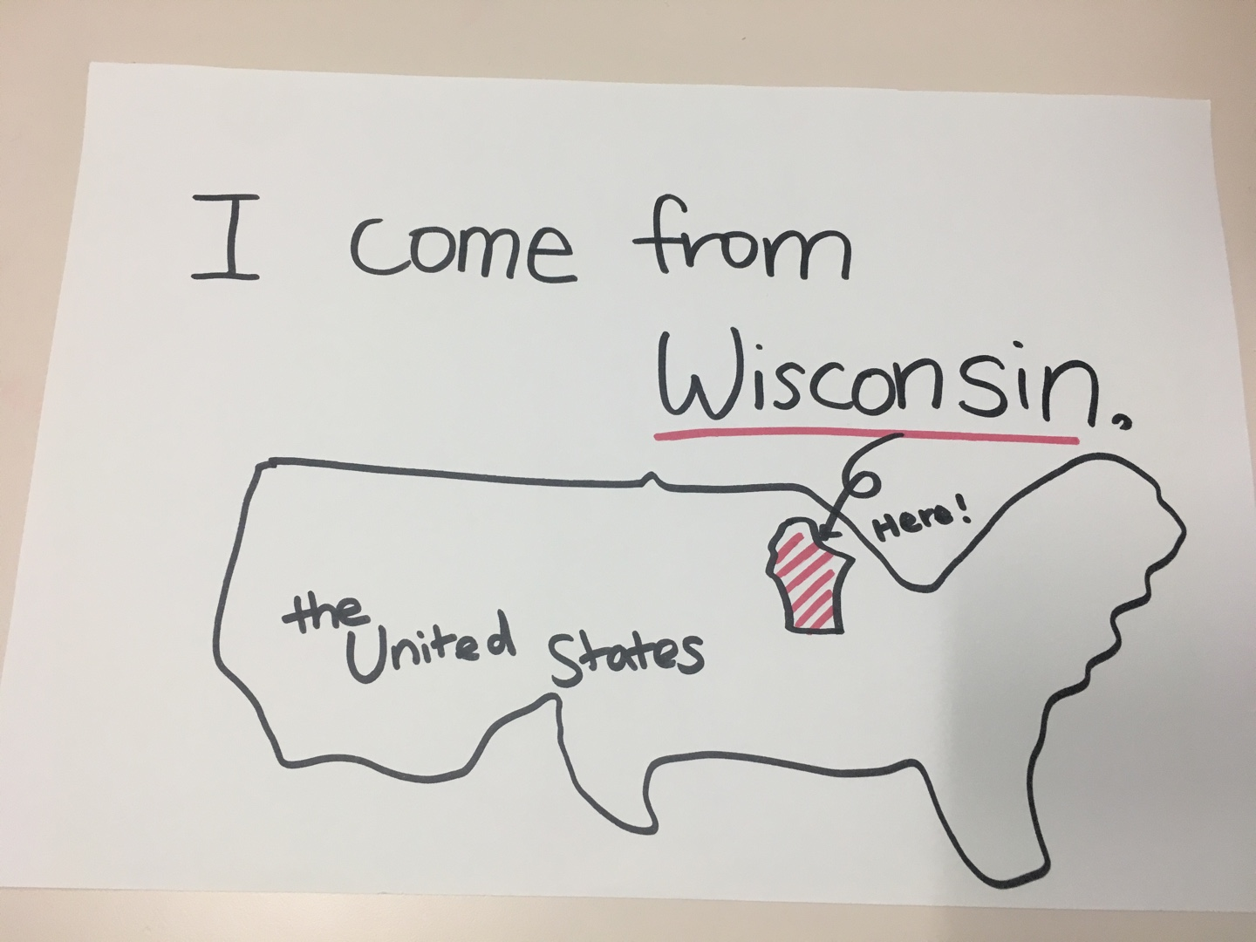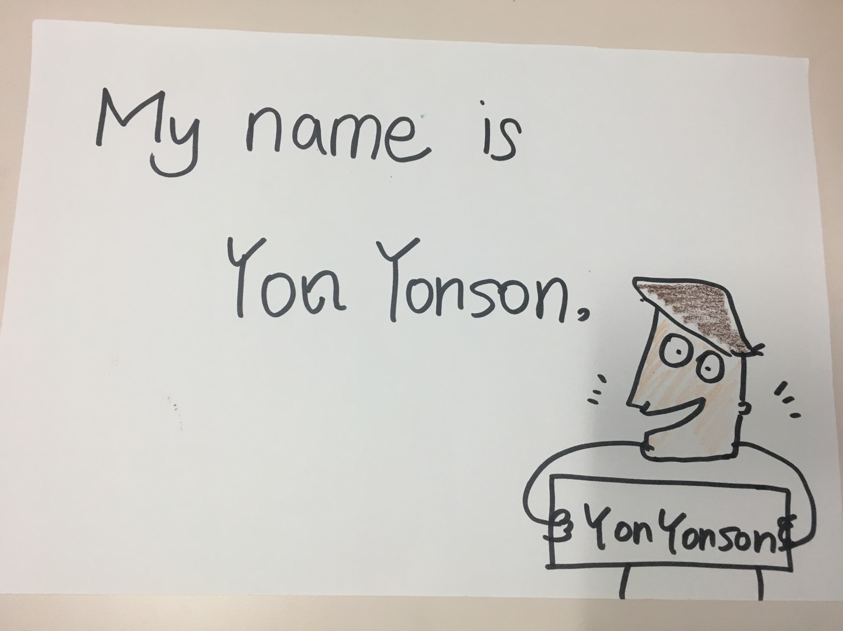

Character Card (Folded, Opened, texts)

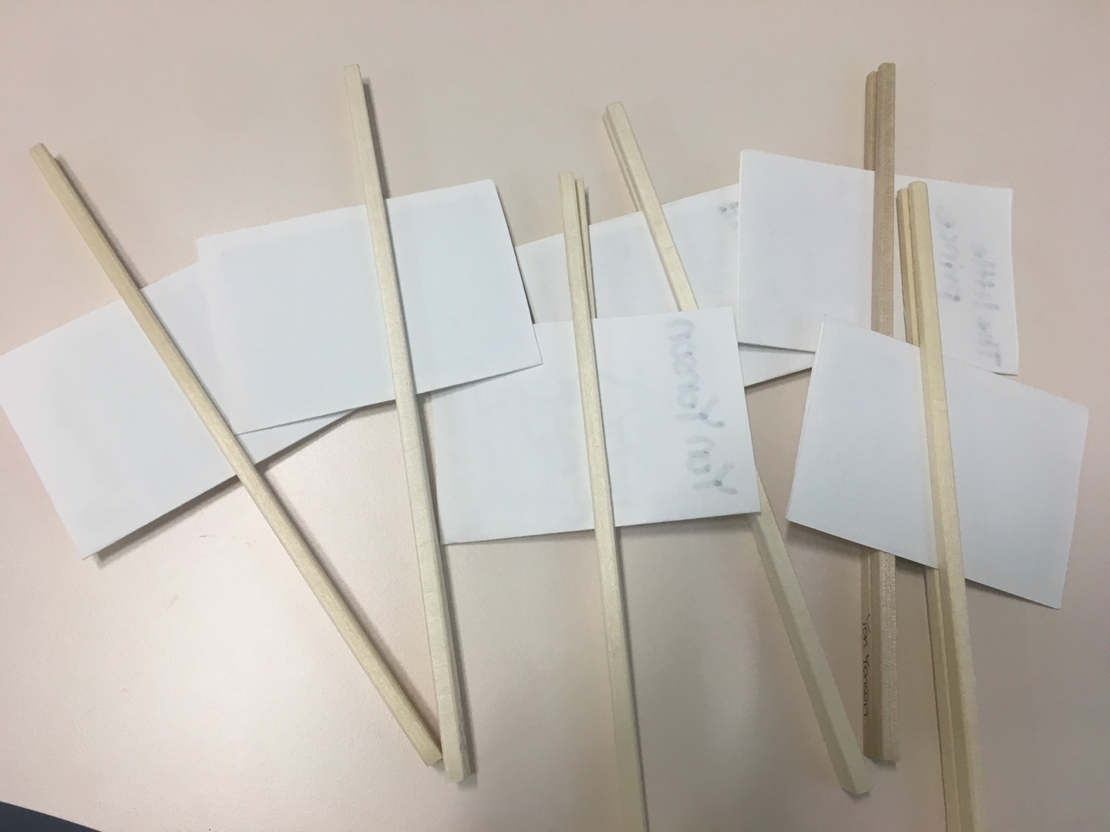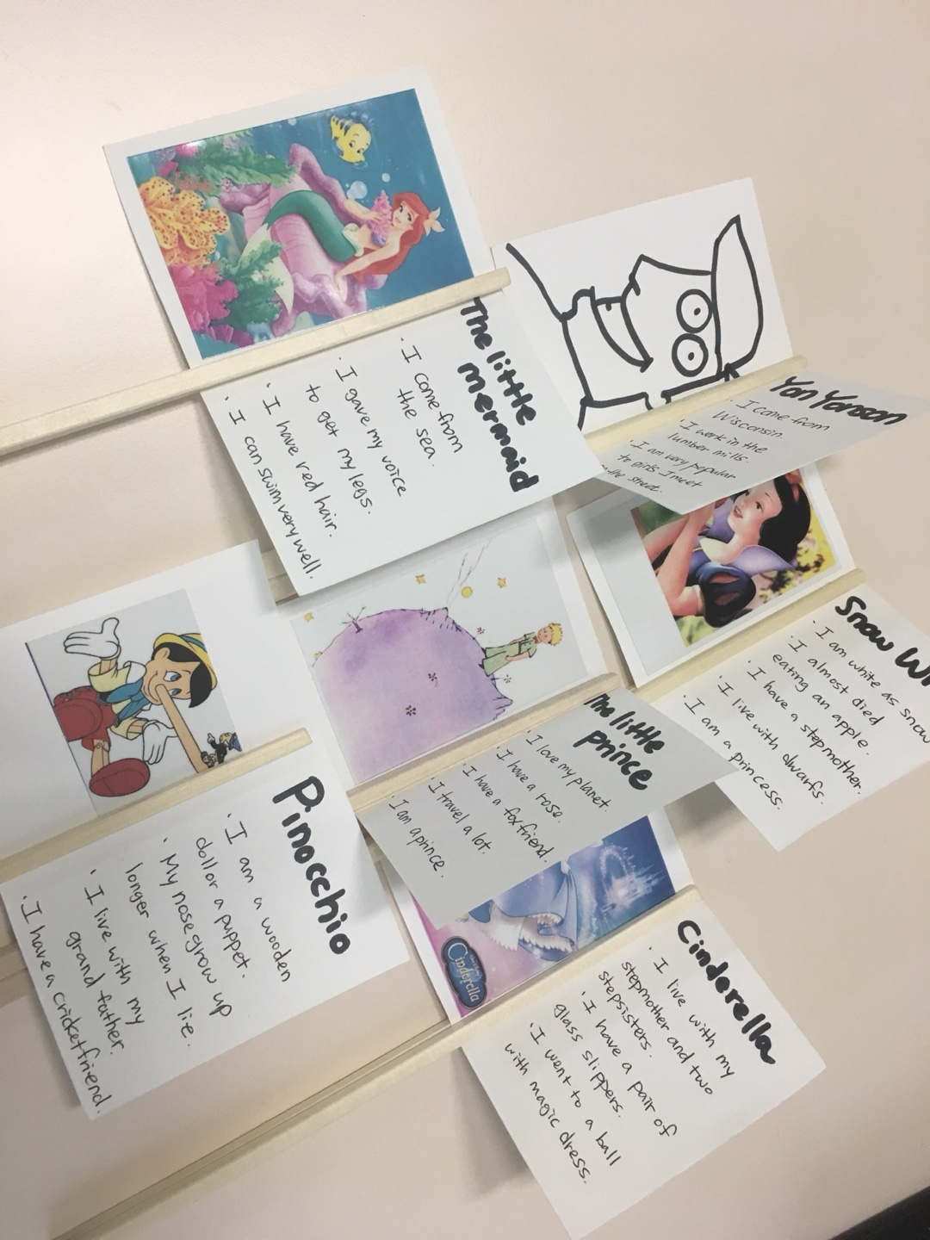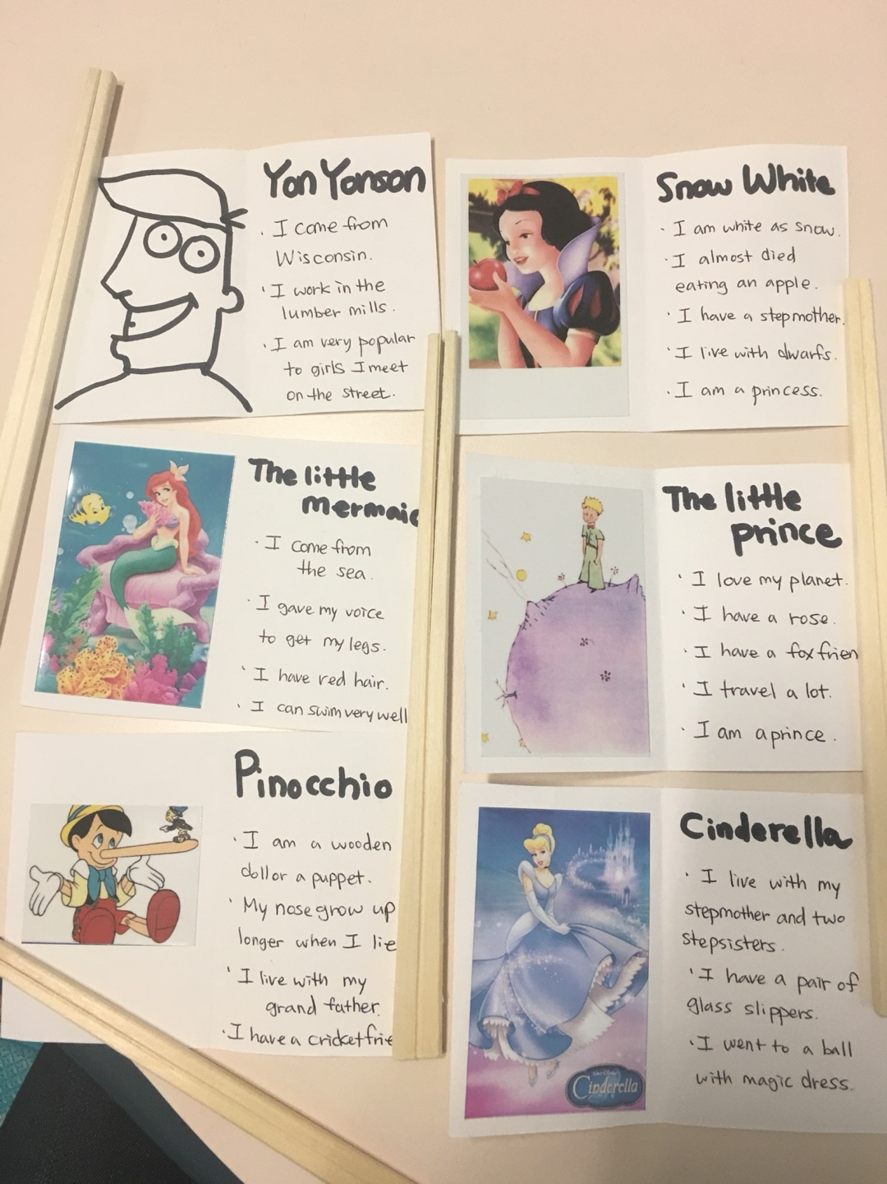

Question Card
- Who do you live with?
- Where are you from?
- Where do you live?
- When is your birthday?
- What is your hobby?
- What are you good at?
- What is your favorite food?
- What season do you like most?
- How old are you?

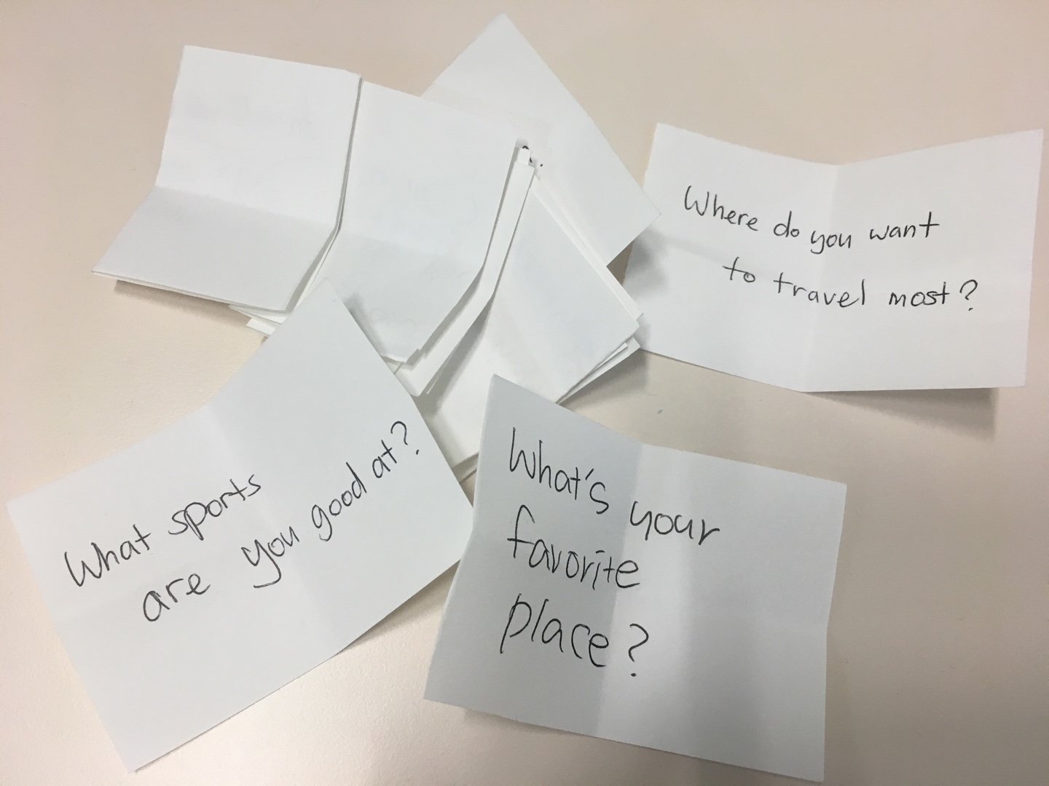

Teacher Poster (demo)

